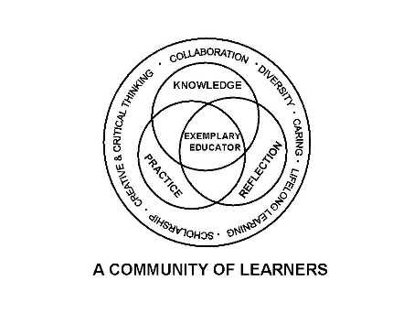

University Committee on Initial Educator Licensure

Minutes

December 13, 2024

**Teams Meeting**

**1:00 – 3:00pm**

1. Sub-Committee Meetings 1:00-1:45pm
   * + Assessment and Accreditation (P. Fix)
       1. Coalition for Equity
          1. Meeting with Bill Curtain

Legislative Ideas

Review Research questions

* + - * 1. Subscoring Policy working group meeting

Monday Dec 16*th* @ 10am

Create agenda

Multiple measures working group

* + - 1. Student Teaching Evaluation
         1. Discussion for questions regarding domain 3
    - Placements and Partnerships (K. Gross)
      1. Debrief regarding Student Teaching Orientation
         1. Spring Orientation Planning

Professional Expectations – Set a Tone for next semester

* + - * 1. Discussion Orientation prior to Term start – Candidates in schools prior to NIU classes start

Survey results discussion

Any legal or liability issues-Research prior documentation

Supervisors are possibly not on contract yet for course

Some Supervisors are hired prior to course date start

Some start 8/16 contract dates

Fall Dates vs Spring Dates contracts

Programs-How many impacted

* + - Curriculum, Policies, and Procedures (R. Rupnow)
      1. IPES Standards-Review and provide programs with direction
         1. Discuss responses from programs/departments for process/updates/feedback for process moving forward
      2. Review CRTL feedback from ISBE
      3. Possible Use/Procedure for Curriculog Teacher Licensure Tag
    - Diversity, Equity, and Inclusion (C. Taines)
      1. Develop a reporting structure regarding implementation/progress
      2. Sample Process has been provided to CLAS and CEDU DEI staff members and now will gain feedback from University DEI office/Director
      3. Transportation Equity

1. 1:45 pm Approval of Agenda
2. Approval of Minutes from November 15, 2024
3. New Business
   1. Grow Your Own Illinois-We See the Teacher In You
      * Presentation by Bill Pitney
4. Reports
   1. University Office of Educator Licensure and Preparation
      * Reminders-Deadlines/Processes
      * ISBE Updates
        1. CRTL
   2. Assessment and Accreditation – P. Fix
   3. Placements and Partnerships – K. Gross
   4. Curriculum, Policies, and Procedures – R. Rupnow
   5. Diversity, Equity, and Inclusion –C. Taines

VII. Announcements

* 1. Next meeting date scheduled for January 17, 2025, Virtual meeting 1-3pm

1. Adjournment