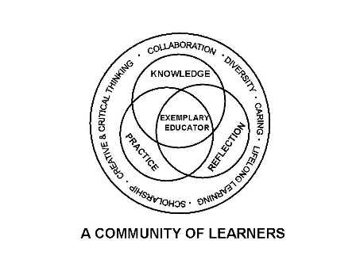

University Committee on Initial Educator Licensure

Agenda

September 20, 2024

**Teams Meeting**

**1:00 – 3:00pm**

1. Sub-Committee Meetings 1:00-1:45pm
   * + Assessment and Accreditation (P. Fix)
       1. Coalition for Equity
       2. Student Teaching Evaluation discussion for questions regarding domain 3
     + Placements and Partnerships (K. Gross)
       1. Debrief regarding Student Teaching Orientation
          1. Professional Expectations – Set a Tone for next semester
          2. Discussion Orientation prior to Term start – Candidates in schools prior to NIU classes start

Any legal or liability issues-Research prior documentation

Supervisors are possibly not on contract yet for course

Some Supervisors are hired prior to course date start

Programs-How many impacted

* + - Curriculum, Policies, and Procedures (R. Rupnow)
      1. IPES Standards-Review and provide programs with direction
      2. Review CRTL feedback from ISBE
    - Diversity, Equity, and Inclusion (C. Taines)
      1. Program support for Policy and Process Development regarding DEI support
      2. Develop a reporting structure regarding implementation/progress
      3. Transportation Equity

1. 1.45 pm Approval of Agenda
2. Approval of Minutes from August 30, 2024
3. Reports
   1. University Office of Educator Licensure and Preparation
      * Reminders-Deadlines/Processes
      * Annual Report Template and prepopulated Data will be uploaded in October
   2. Assessment and Accreditation – P. Fix
   3. Placements and Partnerships – K. Gross
   4. Curriculum, Policies, and Procedures – R. Rupnow
   5. Diversity, Equity, and Inclusion –C. Taines
4. New Business

VII. Announcements

* 1. Next meeting date scheduled for October 18, 2024, Virtual meeting 1-3pm
  2. Teams/Record Keeping update over the summer

1. Adjournment