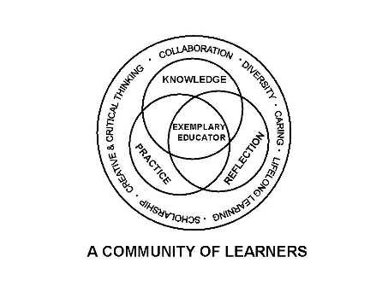

University Committee on Initial Educator Licensure

Minutes

August 30, 2024

**Teams Meeting**

**1:00 – 3:00pm**

1. 1:00 pm Approval of Agenda 1st – Rachel Warren; 2nd Nancy Dominguez-Fret **APPROVED**
2. Approval of Minutes from April 19, 2024 (no May meeting held) 1st – Paul Fix; 2nd – Rachel Warren **APPROVED**
3. Reports
   1. Introductions
   2. University Office of Educator Licensure and Preparation
      * New Legislation
        1. Allows ISBE to using passing scores for subsections independently – ISBE will need time to determine if they will and how they will implement, and coordination with Pearson for scoring reports
        2. No Content Test Required prior to Student Teaching, but Content Test is required prior to Licensure
      * CRTL Update-Draft Submissions
        1. Draft Due in August 2024
        2. Expected by November 30, 2024, ISBE and West Ed Feedback
        3. June 2025 – Final plans due with implementation by October 2025
        4. Evaluation by ISBE will be done regularly
      * IPES Alignment timeline
        1. Matrices due for ISBE Review by March 1, 2026, for June 30 Approval date
      * CAEP Timeline
        1. CAEP Self Study to be submitted February 2025
        2. July 2025 Public Comments
        3. August 2025 Respond via Addendum
        4. Site Visit November 2025
        5. January 2026 Rejoinder submission
      * Placements
        1. Template is uploaded to the Placements SharePoint
      * Annual Report Data
        1. Uploaded in BlackBoard in October 2024
   3. Choose Subcommittee Preference via excel file in UCIEL-Voting/Attendees Team – Link in Chat and emailed to all attendees
   4. Assessment and Accreditation – (Paul Fix)
      * Review of prior year accomplishments
      * Subcommittee Tasks/Priorities
        1. Content Test Equity Issues
   5. Placements and Partnerships – (Kelly Gross)
      * Review of prior year accomplishments
      * Subcommittee Tasks/Priorities
        1. Plan Student Teaching Orientation
        2. Candidate Support – DRC Collaboration
        3. Cooperating Teacher Symposium - Support
   6. Curriculum, Policies, and Procedures – (Rachel Rupnow)
      * Review of prior year accomplishments
      * Subcommittee Tasks/Priorities
        1. By-Laws; Public Facing document review
        2. CRTL Alignment
        3. IPES Alignment
   7. Diversity, Equity, and Inclusion – (Cynthia Taines)
      * Review of prior year accomplishments
      * Subcommittee Tasks/Priorities
        1. Candidate Support in Placements
           1. Prevention
           2. Intervention
        2. Transportation Equity
        3. Undocumented Students
   8. Links for sub-committee meetings for this week – placed in the chat by members running the meeting
      * Elect Subcommittee Chair
      * Discuss upcoming tasks
   9. Return to Meeting of the Whole for sub-committee meeting Chair Notifications
4. Sub-Committee Meeting Reports
   * + Assessment and Accreditation (Vote)
       1. Chair – Paul Fix
       2. DEI Rep – Mariah Spencer
       3. Focus – Content Test Equity Gaps; Student Teaching Evaluation Survey Review
     + Placements and Partnerships (Vote)
       1. Chair - Kelly Gross
       2. DEI Rep – Mary Lynn Doherty
       3. Focus – Student Teacher Orientation Feedback and Spring STO Planning
     + Curriculum, Policies, and Procedures (Vote)
       1. Chair – Rachel Rupnow
       2. Focus – CRTL Service Course list to contact departments about IPES and CRTL Feedback Review
     + Diversity, Equity, and Inclusion (Vote)
5. New Business
   1. Student Representative
      * Submit candidates to Mike Eads for this academic year
   2. Vote: Chair
      * No nominations from the floor
      * Mike Eads – 1st Kelly Gross; 2nd James Cohen **APPROVED**

VII. Announcements

* 1. Next meeting date scheduled for September 20, 2024, Virtual meeting 1-3pm

1. Adjournment 1st Kelly Gross: 2nd Betsy Kahn **APPROVED**