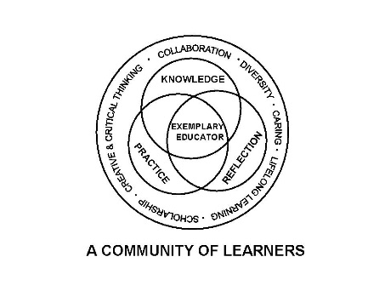

University Committee on Initial Educator Licensure

Minutes
May 9, 2025
Teams Meeting
1:00 – 3:00pm

- Sub-Committee Meetings 1:00-1:45pm

    - Assessment and Accreditation (P. Fix)
      - Go over standard 1 from Carrie Zacks
      - Update on Legislation for content test
      - Discussion on student teaching model updates
    - Placements and Partnerships (K. Gross)
      - Orientation Fall 225
      - Travel Survey
      - Statement on Early placement start dates
    - Curriculum, Policies, and Procedures (E. Kahn)
      - Review of suggested syllabus statement (draft) addressing the reporting of problematic situations in clinicals, student teaching, etc.
      - Discussion of any issues involved in developing the CRTL alignment document
    - Diversity, Equity, and Inclusion (C. Taines)
      - Inclusion of statement for syllabi and teacher ed orientation materials
      - Discuss bills currently in the state legislature HB3247 SB13

- 1:45 pm Approval of Agenda Taylor Atkins Betsy Kahns

- Approval of Minutes from April 18, 2025 Taylor Atkins and Amy Boyles Passed

- Reports

  - University Office of Educator Licensure and Preparation
    - Reminders-Deadlines/Processes
      - May 13th dates to post will go through entitlement process
      - CRTL templates due 5/15/2025

    - ISBE Updates
edTPA update SB1947
Right Start and ILTS vouchers update
ISAC practice test voucher extended until 6/30/2025
  - Assessment and Accreditation – P. Fix Content test legislation update- this topic has been dropped. Carrie Zack presented the document for review. Will be tackling student teaching evaluation to update for next year to the new Danielson model. Meeting Beginning of July to start looking at it.

  - Placements and Partnerships – K. Gross Student teacher Orientation Friday August 22 8:20-8:45 check in; Survey for coordinators for student travel problems; procedure recommendation for early start recommendations.- 1st reading will be in fall.

  - Curriculum, Policies, and Procedures – E. Kahn Looked at the syllabi language

  - Diversity, Equity, and Inclusion –C. Taines Went through some bills being tracked

- Old Business
  - Second reading of the updated Student Teacher evaluation Cynthia Taines E.Taylor Atkins Motion passed
  - Incident reporting language -Alicia Schatteman Mike Eads proposed to table the voting on the language
VII. Announcements
  - Next meeting date scheduled for August 29, 2025, Altgeld 203 meeting 1 - 4pm
  - Chair elect Kelly Gross for next year. Need one for the following year.

- Adjournment Cynthia Taines Amy Boyles

