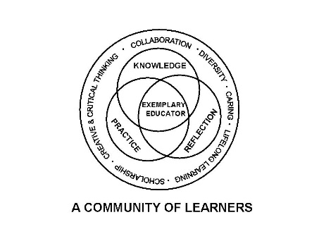

University Committee on Initial Educator Licensure

Minutes
April 18, 2025
Teams Meeting
1:00 – 3:00pm

- Sub-Committee Meetings 1:00-1:45pm

    - Assessment and Accreditation (P. Fix)
      - Update on the content test legislation
      - Address suggestion about the ST evaluation
    - Placements and Partnerships (K. Gross)
    - Curriculum, Policies, and Procedures (E. Kahn)
      - Review of suggested syllabus statement (draft) addressing the reporting of problematic situations in clinicals, student teaching, etc.
      - Discussion of any issues involved in developing the CRTL alignment document
    - Diversity, Equity, and Inclusion (C. Taines)
      - Quick review of reporting process
      - Inclusion of statement for syllabi and teacher ed orientation materials
      - Equity-related bills currently in the state legislature

- 1:45 pm Approval of Agenda Kelly Gross 2nd Rachel Warren motion passed

Approval of Minutes from March 21, 2025 Donna Werderich James Cohen motion passed

- Reports

  - University Office of Educator Licensure and Preparation
    - Reminders-Deadlines/Processes
      - Summer 2025 completers were due in SharePoint March 31, 2025
      - CRTL templates due 5/15/2025 ISBE is currently considering updating some of the guidance on CRTL. No changes to the current timeline.
      - Updates on Tuition Waivers and Placement files
    - ISBE Updates
edTPA update more information from ISBE on where they are on edTPA. Current requirements would be extended until August 2029, with pilot on the new program being available in 2026.
Right Start and ILTS vouchers have been sent to programs
ISAC practice test voucher extended until 4/30/2025
any syllabi statement should be a recommendation from UCIEL.

  - Assessment and Accreditation – P. Fix talked about continuing work of content test and coalition. Coalition meeting held last month. Sub scoring policy is continuing to be written. Transparency in the testing-asking that all bias review committee information be disclosed.
  - Placements and Partnerships – K. Gross fall orientation will be Friday August 22. Email will be coming soon. Previewed procedure language for early clinical dates (recommended procedural steps); two surveys 1. On travel support needs for the advisers to fill out and one for the students to fill out.

  - Curriculum, Policies, and Procedures – E. Kahn Placed the recommended statement of student rights for syllabi and handbook. Can vote to endorse this statement to be included in the syllabi. Will let Alicia look at it and vote on it in May. NOTE: Send out Draft language to everyone in UCIEL

  - Diversity, Equity, and Inclusion –C. Taines Bill: Equity in Higher Education Funding – funding higher education based on student needs. HB3247- Intended to ensure free public education for undocumented students in K-12 level.

- New Business
  - First reading of the updated Student Teacher evaluation Get file from chat for wording. Large changes in section 3A,B and C- May 2nd reading and revisions and officially adopt the changes. NOTE: Send out document or link to document and that there will be a final vote in May meeting
  - Amy Buhrow-implementation plan for indirect and disclosures for professional licensure and processes
VII. Announcements
  - Next meeting date scheduled for May 9, 2025, Virtual meeting 1 - 3pm
  - Chair elect Kelly Gross for next year. Need one for the following year.

- Adjournment Kelly Gross Amy Boyles

