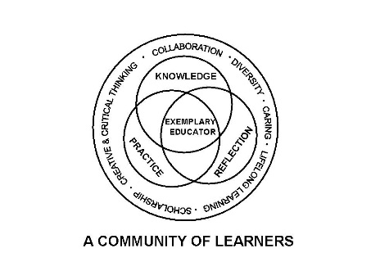

University Committee on Initial Educator Licensure

Minutes
March 21, 2025
Teams Meeting
1:00 – 3:00pm

- Sub-Committee Meetings 1:00-1:45pm

    - Assessment and Accreditation (P. Fix)
      - Setting agenda for next Wednesdays coalition meeting
    - Placements and Partnerships (K. Gross)
      - Travel Stipends for Clinicals and Student Teachers- putting together a survey to send out
    - Curriculum, Policies, and Procedures (E. Kahn)
      - Develop syllabus language for the incident reporting
    - Diversity, Equity, and Inclusion (C. Taines)
      - providing initial guidance on incident reporting for teacher candidates in their clinical and student teaching placements Revision of Process and resubmission to align with policy language

- 1:45 pm Approval of Agenda Paul Fix John Navar Approved

- Approval of Minutes from February 21, 2025 Steven Howell John Havar approved minutes with change passed

- Reports

  - University Office of Educator Licensure and Preparation
    - Reminders-Deadlines/Processes
      - Placement Files for Spring 25 available in SharePoint no later then April 1
    - ISBE Updates
edTPA update

Incident reporting for licensure candidates- Provost office asking to align on and off campus reporting. UOELP sent out to the committee chairs a process book on what the steps should look like. Hopefully the committees will take it back to the subcommittees. Asked Policy and Procedure to create language for the area to put in the syllabi.

Part 1 Entitlement forms please see the deadlines as put in the chat.

CRTL templates due on May 15 for the people

  - Assessment and Accreditation – P. Fix Thank you for those filling out witness slip for the Bill. It moved on to the next step. Set the agenda for the Coalition meeting for next Wednesday. 1.Review all content test adjustments made at the end of January 2. Sub scoring policy working group 3. Updates on bill itself 4. Update on letter sent to legislators 5. Subcommittee to look at longer term changes

  - Placements and Partnerships – K. Gross explore possibility to come up with better ways for programs to train their cooperative teachers -expand CT symposium

  - Curriculum, Policies, and Procedures – E. Kahn committee was working on the syllabus language. A draft has been made- a final copy will be presented at the next meeting. Appreciating Antoinette’s added clarity on the CRTL charts that are being submitted.

  - Diversity, Equity, and Inclusion –C. Taines

- New Business
VII. Announcements
  - Next meeting date scheduled for April 18, 2025, Virtual meeting 1 - 3pm
  - Chair elect Kelly Gross for next year. Need on for the following year. Kelly Gross is Chair elect for 24-25 so need a Chair elect for 25-26. Want to make sure before the final meeting one is in place.
Paul Fix won Presidential award for Staff Excellence this year.

- Adjournment John Evar James Cohen passed

.

