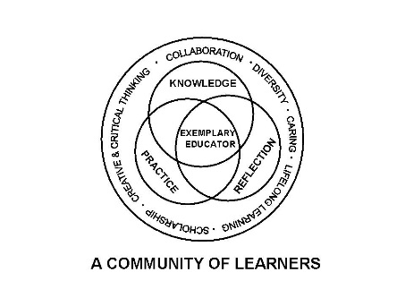

University Committee on Initial Educator Licensure

Minutes
February 21, 2024
Teams Meeting
1:00 – 3:00pm

- 1:45 pm Approval of Agenda 1st James Cohen 2nd Paul Fix APPROVED

- Approval of Minutes from January 14, 2024 1st Cynthia Taines 2nd James Cohen/Paul Fix APPROVED

- Reports

  - University Office of Educator Licensure and Preparation
    - Reminders-Deadlines/Processes
      - Part I forms due February 25th
      - Annual Program Report due February 3rd
      - Placement Files for Spring 25 available in SharePoint April 1st deadline is strict.
      - Staffing Changes
      - CAEP asked for an extension to reporting. Extension to July 30, 2025. Virtual site visiting Feb 4-6, 2026. Now working with AAE to help assist with the process.
    - ISBE Updates
CRTL spring is implementation and planning for CRTL programs have received the final template. Due by May 15 to UOELP. ISBE has not release any information yet on what would be required.
edTPA September-Legislation to create a buffer for new teacher performance-Begin 2027 or 2028 a 3 year pilot. Current deadline of August 2025 be extended. Currently in Legislation and will keep you up to date as we get more information
Kaplan Prepare for Illinois’ Future Program
ISAC/ILTS test prep updates Pearson is the official company that distributes the test. Beginning Jan 28 there is one free practice test that is distributed at registration. All registration fees have been reduced. People with 2 unsuccessful tests that are within a specific window and are close to a passing score and both attempts have to be taken after January 28, 2025 have the ability to take the test again for free retakes.
  - Assessment and Accreditation – P. Fix Letter to legislator drafted by Coalition. Targeting key areas like educational committees and key leadership in both chambers. Issues with contact test not being equitable and want to have that looked at.
HB2950-mandates all ILTS bias review are made public including names and titles of people on it and agendas and minutes. 2. Requires all new test after 2017 accessed for non-uniformity. If passing rate from old test to new test decreases by 10% or more it is a bad test. 15% or more within a demographic group that new test is non-uniform. It will be mandated that 1 to 2 committees will be made to review the new test for nonuniformity. While review is happening candidates that took non-uniform test, they can take the most recent uniform test for free 3. If test in nonuniform candidates who have taken the test multiple time and have not passed if their scores in all of the subsection are passing, they will pass the test. If the nonuniform and an individual has passed everything else the individual can apply for a one-year certificate to teach while they study to pass the test.

  - Placements and Partnerships – K. Gross ISU reached out to change the cooperative teacher requirements from 3 years down to two years. Discussed the pros and cons. Will reach out to ISU to ask for more data. As a committee hesitant to support that. Potential for a slippery slope.
Travel stipends for teachers and clinical-survey was done two or three years ago. CLAS has a fund for this. A new survey will be drafted to ask students.
Procedure for chain of command for incidents in school. Will ask DEI for more clarity on what they are asking for and if there is a particular incident and what are the procedures now.
Video supervision of teachers. Some supervisors are videoing in instead of being on campus to watch the teachers. There isn’t enough money to reimburse supervisor to run all over.

  - Curriculum, Policies, and Procedures – E. Kahn CRTL template. Debating if there is a way to provide assistance to others filling out the template. If it is practical and what needs need to be fulfilled. Filling these out by program -in many cases some of the items (standards) in the original templates were being covered by service courses. The data the program is then using is going to be generated in there are how was the service programs be involved. Antoinette will follow up with ISBE to see how to report the service course

  - Diversity, Equity, and Inclusion –C. Taines Process to support teacher candidate while in the field for bias or other incidents. Process needs to be aligned with the universities process already established and need to be consistent across all areas. There is already an incident for on-campus – adding to make sure everyone knows there is a duty to report. Program coordinator or supervisor can report on the candidate’s behalf or the candidate can report themselves. Ultimately UOELP will be the one to contact the candidate school in regard to the report. This can be any kind of negative incident not just bias. There is a couple report types they can choose from to filled out.

- New Business
  - Discussion-Faculty Senate/UCIEL Bylaws Update there is no new updates on this.
VII. Announcements
  - Next meeting date scheduled for March 21, 2025, Virtual meeting 1 - 3pm

- Adjournment James Cohen Paul Fix

