GRADUATE COUNCIL MINUTES UNAPPROVED

693rd, Meeting May 5, 2025

MEMBERS PRESENT: Arado, Becker, Cooke, Fickling, Finley, Fletcher, Garver, Gericke,

Kelly, Klis, Notebaert, Ricklefs, Rohl, Scherer, Swingley, A. Wu, K.Wu, Xia

MEMBERS ABSENT: Barnes, Biokoro, Chen, Floyd, Lundstrum, McFarland, Sivakumar,

Sosin

OTHERS PRESENT: Doane, Laudick, Reyman, Matuszewich, Van Dijk Called to Order

Interim Dean Reyman called the meeting to order at 10:01 am.

Approval of Minutes

* A motion to approve the minutes from April 7, 2025, was made by Arado, seconded by Garver, approved unanimously.

Announcements

* Reyman thanks graduate council for their service and support during AY24-25.
* Reyman shares with graduate council that Dr. James Ahern has been hired as the Dean of the Graduate School at NIU and will start on July 16.
* Enrollment Update: Total graduate enrollment data for Fall 2025 is up more than 3% from this time last year.

Committee Reports

* Reyman summarizes the Graduate Colloquium report
  + 46 proposals from 19 different departments were reviewed. 42 proposals were approved for funding and 4 were not approved.
* Reyman summarizes the Honorary Degree Committee Report
  + Two nominations were reviewed and put forward to the president and will be reviewed for approval at the board of trustees meeting in June.
* Reyman presents Anthropology Department Criteria change
  + A motion to approve the Department of Anthropology’s Graduate Faculty Membership Department Criteria changes by Scherer, seconded by Rohl. Approved unanimously.

New Business

* Reyman summarizes the Complaint Resolution Proposal
* A motion to approve Standards Agenda item B, Fickling seconded by Scherer. Approved unanimously.
* Reyman summarizes the Leave of Absence/Continuous Enrollment Proposal
* Friendly Amendment to edit language by Kevin Wu.
* A motion to approve Standards Agenda item A, Becker seconded by Garver. Approved unanimously.
* Curriculum Changes from the Executive Committee presented by chair of the executive committee Garver.
* Garver summarized curriculum changes proposed by each college; all motions were passed unanimously.

Adjournment

* Adjourned at 10:44 am Minutes
* Minutes respectfully submitted by: Kayla Doane, The Graduate School



April 21, 2025

**MEMORANDUM**

**TO:** Graduate Council

**FROM:** Dr. Jessica Reyman, Interim Dean of the Graduate School 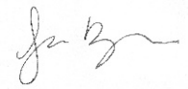

**SUBJECT:** Graduate Committee Report: Graduate Colloquium

The Graduate Colloquium committee met on April 17, 2025, to review graduate colloquium proposals for the 2025-2026 fall and spring semesters. There were 46 proposals sent in by 19 different departments. Forty-two proposals were approved for the funding requested. Four proposals were not approved.





April 15, 2025

**MEMORANDUM**

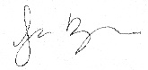**To:** Graduate Council

**From:** Jessica Reyman

Interim Dean

**Subject:** Honorary Degree Committee

The Honorary Degree committee met on April 3, 2025, via Microsoft teams. Two nominations were reviewed during the meeting. The committee’s recommendation will be delivered to the President and the Board of Trustee’s for approval.



## ANTHROPOLOGY

**Graduate Faculty Membership Criteria Revised version submitted January 2025**

**PROVISIONAL MEMBERSHIP:** For this category of membership on the Graduate Faculty, a person must have a Ph.D. in anthropology or a related discipline and demonstrate initiation of a research program. The latter may be demonstrated by a record over the past 8 years meeting one of the following criteria: 1) one refereed publication; or 2) two of the following: a non-refereed professional publication, paper presentation at a national or international meeting, submission of an article to a refereed publication, submission of a research grant to an appropriate agency.

**FULL MEMBERSHIP:** For Full Membership on the Graduate Faculty, a person must have a Ph.D. in anthropology or a related discipline or have a master’s degree in Anthropology or a related discipline and commensurate experience in a profession related to Anthropology such as a Director of a Cultural Resource Management project, Museum Director, or Tribal Historic Preservation Officer. They must also exhibit evidence of establishing a program of research and scholarship in anthropology, the results of which have been judged favorably by the person's peers. This is to be demonstrated by a record over the past 8 years meeting one of the following criteria: 1) the publication of at least two refereed journal articles or book chapters or one scholarly book (reviewed in an appropriate anthropological journal);

2) the publication of one refereed journal article or book chapter and two presentations at a national or international professional meeting; 3) having directed, led or managed the installation of four exhibits for display at a museum, or 4) having been actively involved in field work or museum curation and the production of reports related to that work.

**SENIOR MEMBERSHIP:** For Senior Membership, a person must have a Ph.D. in anthropology or a related discipline and demonstrate an ongoing program of research and scholarship in anthropology, the results of which have received favorable peer review.

Favorable peer review may be established by meeting one of the following criteria: 1) publication of 4 refereed journal articles and/or book chapters, or 2) publication of 2 refereed journal articles and/or book chapters and either (a) one scholarly book (reviewed in an appropriate journal) or (b) 2 presentations at national or international meetings that were invited or selected for publication. At least half of this production must be during the last 8 years. Also, active involvement in graduate education is required at this level and must be demonstrated by at least one of the following during the past 8 years: serving on a thesis committee, directing a thesis, teaching at the 500 or 600 level, or similar experience teaching or mentoring graduate students.

**GRADUATE FACULTY SCHOLAR:** For Graduate Faculty Scholar Membership, a person must have either a Ph.D. in Anthropology or a related discipline or have a master’s degree in Anthropology or a related discipline and commensurate experience in a profession related to Anthropology such as a Director of a Cultural Resource Management project,

Museum Director, or Tribal Historic Preservation Officer. The discipline in which the person has a graduate degree may include disciplines judged by the department to be complementary to Anthropology for the purpose of teaching or mentoring Anthropology graduate students with interdisciplinary interests. Their program of research and scholarship in anthropology over the last 8 years should meet one of the following criteria:

1. the publication of at least two refereed journal articles or book chapters or one scholarly book (reviewed in an appropriate anthropological journal); 2) the publication of one refereed journal article or book chapter and two presentations at a national or international professional meeting; 3) having directed, led, or managed the installation of four exhibits for display at a museum; or 4) having been actively involved in field work or museum curation and the production of reports related to that work.

Department Committee: Department Chair: College Dean: Graduate School:

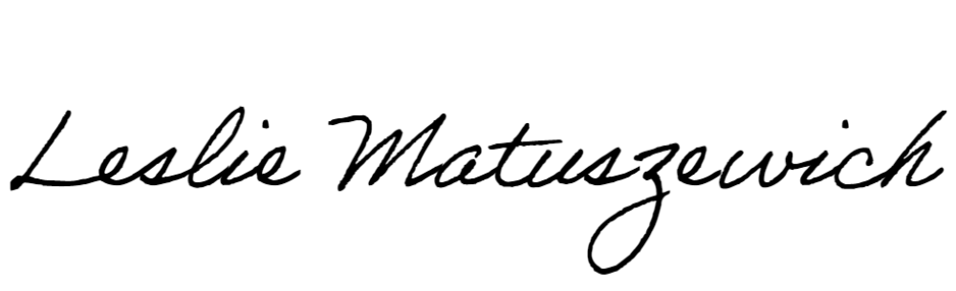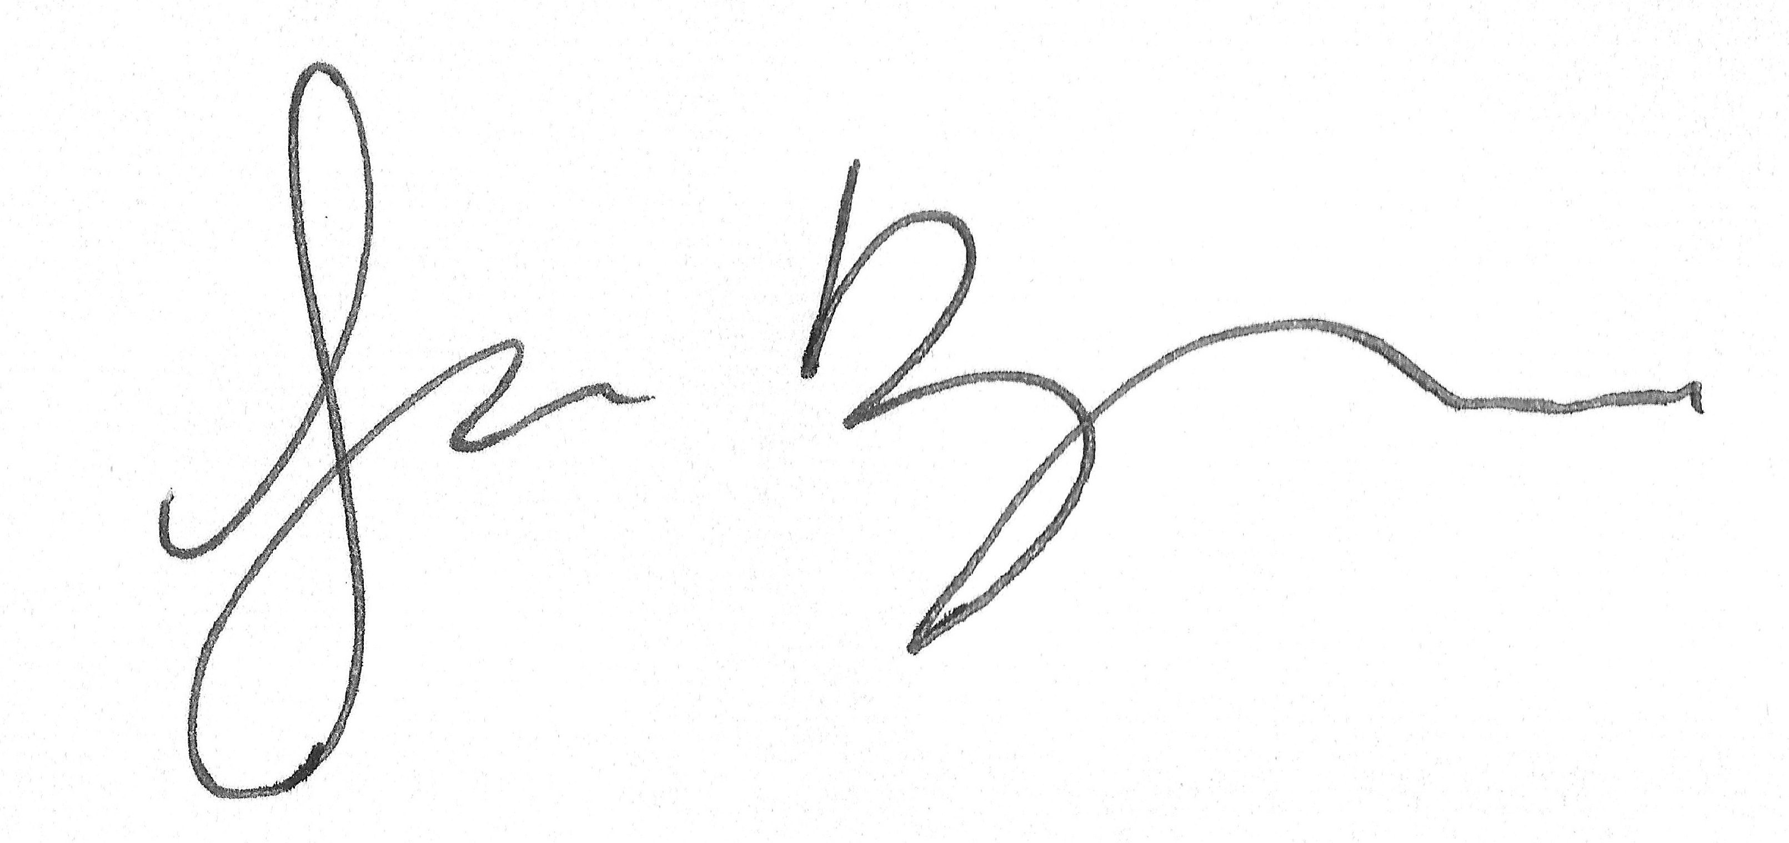

**AGENDA**

**Standards Committee of the Graduate Council April 14, 2025**

**10:00 – 11:00 AM**

#### via Microsoft Teams

* 1. Discussion items
     1. Leave of Absence and Continuous Enrollment revision proposal
     2. Complaint Resolution new catalog proposal

**Under NOTICES**

**Formatted:** Space After: 0 pt

# Leave of Absence

Graduate students may need to seek a leave of absence for personal, family, financial, or other compelling reasons. Students may request a leave of absence from the university, to be approved by the graduate program director. An approved leave of absence is required for any degree-seeking student who has been previously enrolled and will be away for one Fall or Spring ~~semester~~term or more and wishes to return. ~~A leave of absence, which~~ ~~relieves students from the continuous enrollment requirement, may be granted to any~~ ~~student who has been enrolled in a course numbered 699 or 799.~~

~~Graduate students who are ineligible for a leave of absence because they have not enrolled~~ in thesis or dissertation hours may cease to enroll for up to three terms (Fall, Spring, ~~Summer) before their admission is revoked.~~

Graduate students must have completed one full term of enrollment prior to the leave, must be in good academic standing, and must be within their degree time limit in order to request a leave of absence. To request a leave of absence, students must complete the [form](https://apps.niu.edu/its/asp2/onbaseforms/gradschool/RcGrLeave.aspx) available at the Graduate School website. Students may request a leave of absence for up to six terms (including Fall, Spring, and Summer). ~~T~~The request should be received and approved ~~before the end of the first term for which the student plans not to enroll~~prior to the start of the leave of absence.

When a leave of absence is granted, the leave does not exempt a student from the Limitation on Time policy. (See “General Requirements” section of this Catalog.)

**Under GENERAL REGULATIONS**

# Continuous Enrollment

~~Most students, both full- and part-time, prefer to pursue an advanced degree without~~ interruption in time. Degree-seeking students should enroll each Fall and Spring term in order to maintain continuous enrollment. Those students who interrupt their studies for one term or more should ~~especially~~ note the maximum time period allowed to fulfill all requirements for the degree sought~~. (S~~(S~~s~~ee the sections entitled “Limitation of Time” elsewhere in this ~~c~~Catalog.) Students who need to take one term or more away during their studies should request a leave of absence (See “Leave of Absence”).

Students availing themselves of the services of the academic staff or the facilities of the university in any way that directly or indirectly relates to fulfilling degree requirements or receiving course credit must be enrolled. For example, a student must be enrolled in the term in which a comprehensive examination is taken. Also, once a student has begun work on a thesis, dissertation, or other activity under course number 699 or 799, it is expected that such work progress each ~~academic~~Fall and Spring term, and enrollment must be continuously maintained in course number 699 or 799 until a final grade is received for the activity and the required documentation of the activity is formally approved by the ~~Graduate~~

~~SchoolGraduate School~~Graduate School~~Graduate School~~ (if applicable), unless a leave of absence is obtained, as described in the section “Requirements for Graduate Degrees.” A student working on a thesis, dissertation, or related activity should enroll in 699/799 for the Summer term if receiving mentoring or instruction as described in the syllabus.

If ~~such~~ continuous enrollment ~~in courses numbered 699 or 799~~ is not maintained, and a leave of absence is not granted, then the student will be discontinued from their program ~~student’s admission to the program will be canceled~~. ~~(See “Readmission/Reentry” in this~~ ~~catalog.)~~

A student who has not been enrolled in any course credits for three consecutive terms (Fall, Spring, Summer) and who does not have an approved leave of absence must submit a reentry request to return to their degree program with approval from the program (see “Reentry”).

A student is not required to be registered in the term of graduation simply in order to graduate, if the student is not otherwise required to enroll under the policies of the previous paragraph. However, in order to make use of academic or nonacademic services of the university, a student is required to be enrolled for the corresponding term.

**Under REQUIREMENTS FOR GRADUATE DEGREES**

### Course Number 699

A student who has formally begun the thesis or its equivalent must register in course number 699 in each subsequent Fall and Spring term until the thesis or equivalent is submitted to and formally approved by the [Graduate School](http://www.niu.edu/grad). Registration for this purpose may be in absentia. In any ~~semester or~~ term a student may enroll in 699 for the maximum number of hours stated in the course description; during a master’s program students may register for an unlimited number of thesis hours. However, only the last 6 hours completed will count toward the degree. If circumstances prohibit continuing progress on the work, a graduate student may request a leave of absence from the office of the dean of the Graduate School. If a student interrupts registration in a course numbered 699 without obtaining a leave of absence, then the student’s admission to the degree program will be terminated. (See the “Leave of Absence” policy located in the “General Requirements” section of this Catalog.)

A student must be in good academic standing, both overall and in the degree program, to be eligible to submit a thesis for review and acceptance by the Graduate School.

### Dissertation Requirements

...

A student who has formally begun the dissertation or its equivalent must register in course number 799 (doctoral dissertation). In any ~~semester or~~ term, a student may enroll in 799 for the maximum number of hours stated in the course description; during a doctoral program students may register for an unlimited number of dissertation hours. Once a student has begun registration in course number 799, the student must continue to register in course number 799 in each subsequent Fall or Spring term until the dissertation is submitted to and formally approved by the Graduate School. Students must complete a minimum total of 12 semester hours of course number 799 for the doctoral degree. Registration for this purpose may be in absentia. The designation of a dissertation advisor should be approved by the conclusion of the term in which a student first registers for 799. A student who fails to complete this procedure will, upon recommendation of the ~~department~~program, have all accumulated hours in the dissertation course converted to audit (no credit).

...

Rationale:

* Currently, continuous enrollment is only required for students registering for 699/799. Thus, the leave of absence request form is currently utilized only for students enrolled in 699/799 credits.
* Removes continuous enrollment requirement for Summer for students who are not taking courses or working on theses, dissertations, or other activities for 699/799 credits during the summer.
* To encourage progress toward degree and to support communication between program and student about planned leaves of absence, the revision makes continuous enrollment required for all students and makes the “leave of absence” request available to any graduate student requesting a leave from a program. With an approved leave of absence, students are able to return at the conclusion of the leave without additional approval.
* The revision also clarifies that any student who has not been enrolled in any course credits for three consecutive terms (Fall, Spring, Summer) and does not have an approved leave of absence will be required to obtain an approved Reentry request prior to returning to the program.

#### Complaint Resolution

Northern Illinois University is committed to building an enhanced campus community. The NIU community is guided by [The Northern Pact](https://www.niu.edu/student-affairs/involvement/pact/index.shtml) and the [Student Code of](https://niu.edu/conduct/student-code-of-conduct/index.shtml) [Conduct](https://niu.edu/conduct/student-code-of-conduct/index.shtml) and students are encouraged to adhere to both. Students should refer

to [Complaint Resolution](https://www.niu.edu/disclosures/complaint-resolution/index.shtml) for further details and resources if they believe a university employee’s actions have adversely affected them in the academic or educational setting.

Rationale:

NIU is a member of the National Council for State Authorization Reciprocity Agreements (NC SARA). We received a notification from NC-SARA that effective January 1, 2026, the existing [Responsibilities for Resolving Complaints](https://nc-sara.my.site.com/Policy/s/policy-modification-proposal/a36PQ000000AyR7YAK/pmp240619-responsibilities-for-resolving-complaints) requirement for all SARA- participating institutions will be expanded. The new requirements will be as

follows: Institutions operating under SARA policies shall provide their and SARA’s complaint resolution policies and procedures to all students taking courses under SARA policies on the institution’s website and in the institution’s catalog or equivalent information provided either in print or electronically to students when they enroll. NIU’s website has a link to our [Complaint Resolution](https://www.niu.edu/disclosures/complaint-resolution/index.shtml) information in the footer of the homepage. Prior to January 1, 2026, we need to also provide a link to this information either in our course catalogue or equivalent information needs to be provided in print or electronically to students when they enroll. We recommend adding the proposed language to our academic catalog under “General

Regulations” <https://catalog.niu.edu/content.php?catoid=61&navoid=3201> .

**AGENDA**

## Graduate Council Meeting

**7th Meeting / Academic year 2024-25 TEAMS ONLY**

**10:00 – 12:00 p.m., Monday, May 5, 2025**

1. **ANNOUNCEMENTS**

#### Consent Agenda –

*College of Health and Human Sciences*

COMD 601 – Course Change COMD 602 – Course Change COMD 603 – Course Change COMD 605 – Course Change COMD 607 – Course Change COMD 610 – Course Change COMD 611 – Course Change COMD 618 – Course Change COMD 644 – Course Change COMD 670 – Course Change COMD 671 – Course Change COMD 674 – Course Change COMD 684 – Course Change COMD 687 – Course Change COMD 690 – Course Change COMD 691 – Course Change COMD 692 - Course Change COMD 695 - Course Change COMD 699 - Course Change COMD 700 - Course Change COMD 772 - Course Change COMD 775 - Course Change COMD 784 - Course Change GERO 542 - Course Change NURS 720 – Course Deletion

College of Education

SESE 792 - Course Change EPFE 520 – Course Deletion SESE 521 – Course Deletion SESE 547 – Course Deletion SESE 549 – Course Deletion SESE 553 – Course Deletion SESE 562 - Course Deletion SESE 563 - Course Deletion SESE 564 - Course Deletion SESE 565 - Course Deletion SESE 576 - Course Deletion SESE 587A - Course Deletion SESE 587E - Course Deletion

SESE 587N - Course Deletion SESE 587W - Course Deletion SESE 591 - Course Deletion SESE 593 - Course Deletion SESE 600 - Course Deletion SESE 604 - Course Deletion

College of Business

MGMT 512 – Course Deletion MGMT 528 – Course Deletion MGMT 620 – Course Deletion MGMT 630 – Course Deletion MGMT 633 – Course Deletion MGMT 638 – Course Deletion MGMT 645 – Course Deletion MGMT 648 – Course Deletion MGMT 650 – Course Deletion MGMT 661 – Course Deletion MGMT 680 – Course Deletion MGMT 690 – Course Deletion OMIS 525 – Course Deletion OMIS 640 – Course Deletion OMIS 649 – Course Deletion OMIS 679 - Course Deletion OMIS 684 – Course Deletion OMIS 692 – Course Deletion

1. **DISCUSSION AGENDA**
   * ***Section A – For inclusion in the 2026-2027 Catalog*.**
     1. **College of Business** – *No Curricular Items*
     2. **College of Education –** No Curricular Items
     3. **College of Engineering** – No Curricular Items

#### College of Health and Human Sciences –

PK-12 Health Education Endorsement – Program Change High School Endorsement in Health Ed – Program Deletion

#### College of Liberal Arts and Sciences –

*CYBR 505 – New Course*

*PhD Computer Science – Program Change MS in Computer Science – Program Change MS in Cybersecurity – New Program*

#### College of Visual and Performing Arts *–*

*ARTS 531 – New Course ARTS 532 – New Course ARTS 533 – New Course*

1. **UNFINISHED BUSINESS**
2. **NEW BUSINESS**
3. **ADJOURNMENT**