**ATHLETIC BOARD MEETING**

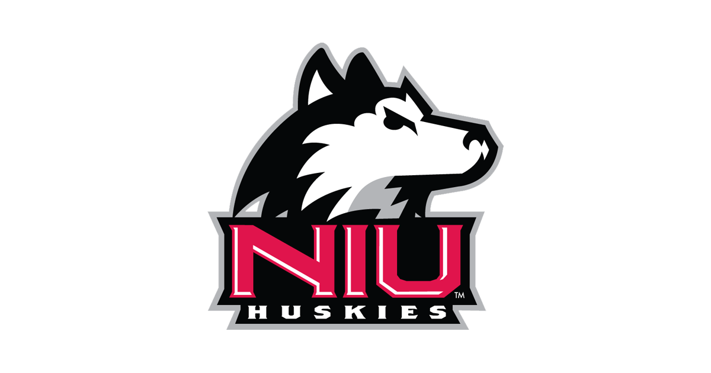

**December 4, 2024 – 2:00 pm**

Present: Courtney Hughes (Chair), Ehsan Asoudegi, Emily Belcher, Wonock Chung, Chad Fitz, Aaron Fogleman, Sean Frazier, Skyler Gill-Howard, Kari Hickey, Paul Kassel, Rob Kerschke, Brian McCormick, Katy Ramage, Glenn Roby, Laura Sala

Guests: Chris Barker, Sr. Assoc. AD/Development & Revenue Generation; John Cheney, Deputy AD/Executive Assoc. AD/Operations; Matt Gonzalez, Sr. Assoc. AD/Facilities & Events; Randi Napientek, Sr. Assoc. AD/Director of SAASS; Courtney Vinson, Sr. Assoc. AD/Sports Administration/SWA

1. **Call to Order** – C. Hughes called the meeting to order at 2:01pm.
2. **Approval of Previous Meeting Minutes** – B. McCormick moved to approve; K. Hickey seconded; motion carried unanimously.
3. **Faculty Athletics Representative** – There were a few new representatives that joined the Board since the last meeting: Wonock Chung, representing KNPE; Chad Fitz, representing Alumni Association Board of Directors; Emily Belcher, representing SPS; Skyler Gill-Howard, student-athlete representative (football); and Kati Ramage, student-athlete representative (softball).

C. Hughes discussed issues around student-athlete well-being. Part of the position as Faculty Athletics Representative (FAR) is to focus on student well-being; FARs from all MAC institutions met recently at the MAC meetings and discussed items the MAC Student-Athlete Well-Being Committee felt were important issues impacting their well-being (i.e. day-to-day stressors). C. Hughes felt this information was relevant to this group since the Board plays a role in policy making. The feedback on items impacting student-athlete well-being were fairly common across the various schools, things like sleep deprivation, local/state/national elections (big issue this fall), gambling, and harassment. The NCAA conducted a study last year through Signify, using AI to identify different types of online harassment/abuse student-athletes were receiving through various social media apps (document in Teams folder). Women’s basketball suffered from the highest volume of harassment, followed by men’s basketball, baseball, then football. Abuse ranged from racism, violence, sexual abuse, etc. The staggering number of threats student-athletes were receiving through social media found in the Signify study has generated further interest by several groups, including the Mid-American Conference (MAC), to determine the social/emotional impact on student-athlete well-being. C. Hughes will be collaborating with Dr. Michelle Demry in Psychology to conduct a study for the MAC surveying all student-athletes in the MAC ages 18 and up, to see what types of harassment they may be experiencing, delving more into specifics that weren’t necessarily addressed in the Signify study like what types of social media are being used and impact. C. Hughes noted that anyone on the Board that may be interested in assisting can reach out to her directly.

1. **Athletics Director Update** – S. Frazier provided the Athletic Director update (document in Teams folder). Football just wrapped up their regular season with a 7-5 record and will find out what Bowl game they will be participating in this Sunday. With the wrap up of football, Athletics has fully transitioned to their winter sports. Men’s basketball won their game against Benedictine last night, moving to a 3-6 record. They will play again this Saturday against Northern Iowa. Women’s basketball is currently 3-3, with a diverse group of seasoned and new players this year. Wrestling just won a close match against Ryder, coming down to one point between the East and West division winner rivals from last year. Their next match will be on December 17th against SIUE. Gymnastics will be hosting their Red & Black intrasquad match on December 8th. This meet is a preview before their season officially kicks off on January 10th. Other updates included:

* NIU Athletics 2023-24 Annual Report available online (linked in Word document)
* Victor E. Threads officially launched their online store (linked in Word document), which is a great addition to the storefronts at the Convocation Center (event based), the Recreation Center (daily hours), and mobile trailers (event based)
* S. Frazier recently conducted a walk-through with President Freeman of the NIU Recreation Center. They have been receiving a lot of positive feedback and continue to improve the facilities and programming based responses from the student population.

1. **Liaison Reports:**
2. **Diversity Integration Group (D.I.G.)** – G. Roby/C. Vinson – C. Vinson noted that the main thing they are currently working on is finalizing the D.I.G. action plan. The group also concluded a Cultural Experience trip to North Carolina where a small group of student-athletes were able to learn more about African American history in the area in conjunction with the NIU football game. D.I.G. also created and distributed a calendar for observation of various holidays.
3. **Finance and Facilities** – K. Hickey/L. DeRango/M. Gonzalez – M. Gonzalez provided a quick overview of the first meeting for the Finance and Facilities working group, which met on October 29th. The group did around the table updates on what is going on in each of their areas. For Athletics, the main updates included the completion of the men and women’s basketball locker rooms, progress toward the completion of the Chick Evans Nelson Tennis Center locker rooms, the installation of an ADA ramp at softball, and the start of repair/replacement of the first two lanes of the track in the Convocation Center.
4. **External** **Affairs** – B. McCormick/R. Sedevie/C. Barker – B. McCormick provided the update for the External Affairs working group:

* Licensure – successful first run with the EA Sports College Football 2024 video game
* Ticketing – implementation of 815 plan (community Rec membership, Pup Club membership, as well as tickets to all ticketed sporting events)
  + Working through the process of integrating into the Rec software
* Collaboration of Huskie Athletic Fund with Van Wagner – two-pronged approach to sponsor/donor cultivation
  + Successful activation with a number of clients (i.e. Channel C, College of Business, Northwestern Medicine, DeKalb Chamber Leadership program, etc.
* MMR Partner – football on-field logo sponsor with Jersey Mike’s (first in the MAC to do this season)

1. **Athletic Department Reports:**
2. **SAAC Initiatives** – R. Napientek provided the group with an overview of the Huskie Experience (student development program)/SAAC Initiatives (student-athlete advisory committee) from Fall 2024 (file in Teams folder).

* Community service initiatives:
  + Student-athletes recorded over 2,300 community service hours in Fall
  + Canned Food Drive – collected 368lbs of food to donate to Barb City Food Mart and the Huskie Food Pantry
  + School Supply Drive – donated 1,170 school supplies to local schools and attendees of the Women’s Basketball Education Day
  + Ronald McDonald House Pop Tab Collection – to date, collected 305lbs of pop tabs; only need 485lbs more to be a part of the Thanks a Million Program and recognition in the Central DuPage Hospital House
  + Other initiatives: “High-Five Friday”, Middle School Mentor Program, Operation Christmas Child

Additional highlights from the provided document:

* Programming
  + MAC Mental Health Week & MAC Initiatives
  + Campus/Community Partnerships (Title IX and Healthy Relationship Presentations, Domestic Violence Awareness Month, etc.)
  + Financial Literacy events
  + Career Programming (partnered with Career Services to provide programs through the month of September)
* Community Engagement
  + Faculty Staff Spotlights at football, men and women’s basketball
  + Extra Yard for Teachers – partnered with CFP to award $1,100 to teachers in the DeKalb community funding four different grant programs
* Civic Engagement – NIU student-athletes did a tabling event in the Hall of Champions to get the word out about voting, earning a spot as one of the most engaged campuses in civic engagement
* Leadership
  + SAAC initiated cross-over sports events “Dawg Duel Days” where student-athletes participate(d) in dodgeball and Spike Ball tournaments in an effort toward building a stronger community amongst themselves
  + Chi Alpha Sigma Honor society will be starting in the Spring, with the induction of the first class of student-athletes who are Juniors or Seniors with a 3.5 cumulative GPA or above

1. **Huskies Invest Recap** – C. Barker provided a recap of this year’s Huskie Invest fundraiser (document in Teams folder). They had another successful year, raising a total of $1,062,263 across a total of 1,012 total gifts. To put into perspective the growth in gifts, last year there were only 455 total gifts. S. Frazier remarked that the original goal when Huskies Invest started in 2017 was $100,000, and that it took everything just to hit that mark. Now, they are celebrating the 4th year of raising over $1 million. Capturing that data really shows how far this initiative has come. C. Barker added that it takes 10 months leading up to this event to make it happen, noting that it is not a small feat and requires a ton of cultivation and stewardship. New to the Huskies Invest fundraiser this year was the AD Challenge. For the female sports programs, women’s golf had the most overall dollars raised with $117,723, while softball had the most overall gifts with 57. For the men’s programs, men’s golf raised the most overall dollars with $139,668, and wrestling had the most overall gifts with 157. G. Roby asked what impact NIL had on fundraising initiatives, whether it helped raise awareness in bringing money into the department. S. Frazier responded that NIL has had a definite impact on fundraising as there are some people who have stopped or reduced general giving in lieu of sponsoring NIL. C. Hughes added that she felt some people might also start feeling donor fatigue with asks coming so frequently for so many things. S. Frazier answered that while that is true, they have come up with engagement plans and ways to add to premium experiences, so the donor base feels more of a return on their investments. He also noted that NIU does a great job of educating donors on what their dollars are being used for.
2. **Bowl Scenario** – J. Cheney talked about potential Bowl scenarios. NIU will find out about the Bowl they will be participating in this Sunday, December 8th. J. Cheney noted that the Bowl selection process is complex, with several determining factors including conference tie-ins, TV contracts, participants in the College Football Playoffs, timing, etc. J. Cheney suspects that the Bowl NIU will be attending will likely be the week before or the week of Christmas, adding that having a game later in December would be better for the student-athletes as it would have less impact on finals.

1. **Announcements/Adjournment** – G. Roby made a motion to adjourn; B. McCormick seconded; meeting closed at 2:59 pm.