# NIU Office of the Ombudsperson

# **Annual Report for Academic Year 2024-2025**

Submitted by Sandy Cox, Ombudsperson

niu.edu/ombuds



Contents

About Our Office 4

Mission and Vision 5

Mission 5

Vision 5

Value of an Ombuds Office 6

A Visit to Our Office 7

Data 8

Changes to Data Collection 8

Visitors by Classification 8

Visitor Concerns 9

Top Five Reasons for Visits per Category 9

Additional Work of Our Office 11

Services by Type 11

Facilitated Discussions/Mediations by Semester 11

Goals/Trends 12

Reflections 13

Our Office of the Ombudsperson is a confidential, informal, neutral, and independent resource for assisting in navigating concerns that impact success and well-being at NIU. Our office serves our entire campus community including faculty, staff, students, and administrators.

As a confidential resource, members of our office do not disclose who visits our office or the content of the conversations, and we do not keep records on visitors, visits, and interactions. The only exceptions to confidentiality are concerns for risk of harm to self or others and mandated reporting specific to child/elder abuse.

Pursuant to Article 20 of the bylaws of NIU, the university ombudsperson is a direct report to the president and is evaluated by the University Council.

The NIU Office of the Ombudsperson adheres to the [standards of practice](https://ioa.memberclicks.net/assets/docs/SOP-COE/IOA_Standards_of_Practice_English.pdf) and [code of ethics](https://ioa.memberclicks.net/assets/docs/SOP-COE/IOA_Code_of_Ethics_English.pdf) outlines by the International Ombuds Association.

## About Our Office

Sandy Cox serves as the NIU Ombudsperson. To contribute to cost savings measures, the Executive Assistant/Program Coordinator remains vacant.

Ombudsperson Cox reports to NIU President Lisa C. Freeman and is structured under the President’s Office as part of University Services.

Our role is providing direct services to visitors; facilitated conversations and mediation; training and outreach; review and consultation on policies and procedures; sharing of nonidentifiable visitor themes and patterns to administration; collaborative feedback conversations with leadership; and participation in committees and meetings as appropriate.

**In the 2024/2025 Academic Year, 803 individuals engaged in services through the NIU Ombudspersons Office. NIU Faculty consisted of 55% of the visitors, students were 33% and other individuals were 12% of the visitors.**



## Mission and Vision

### Mission

Our mission is to provide a safe, welcoming, informative, and inclusive service to all NIU students and employees. We listen, help navigate paths to resolution of concerns, identify relevant policies and practices, and bridge resources for support. We assist the university in identifying trends of concerns and informing administrators and governing bodies regarding those concerns. We conduct ongoing reviews of policies and procedures to recommend changes that can potentially improve our university community. 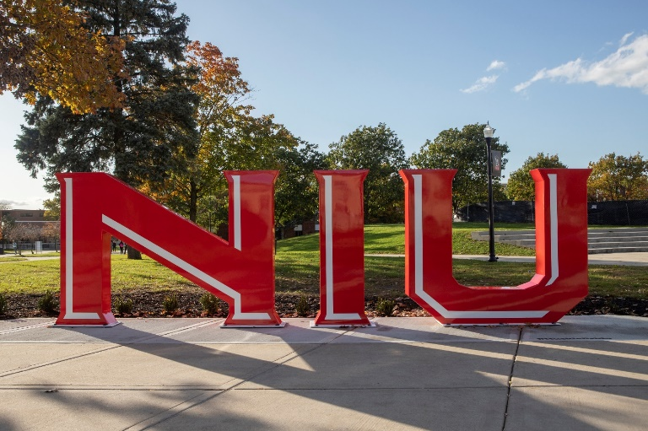

**Vision**

The office of the Ombudsperson’s vision is to support an environment of respect, dignity, wellness, accountability, integrity and understanding for the NIU community. We hope to provide a safe space and meaningful assistance to those who are on the continuum of challenging experiences at NIU.

## Value of an Ombuds Office

Our ombuds office has excellent value to students, employees, and the entire university. We provide value by:

1. Being a neutral party in which individuals experience an impartial perspective that helps them navigate their situation or concern.
2. Providing an informal space for visitors to express their concerns and explore the resources they have available to utilize, understanding they are in control of what they do or do not choose to do.
3. Minimizing the need for formal processes when appropriate or assisting visitors to understand and work through formal processes.
4. Positively impacting the retention of students by helping navigate concerns that impact success and well-being.
5. Identifying themes and patterns and offering ideas for supporting and addressing concerns that often positively impact the workplace and student environments.
6. Supporting staff and faculty to navigate their concerns in a more timely and concise way to minimize impact on work.
7. Offering opportunities for individuals or groups to learn skills to manage challenging situations and conflicts and develop positive communication skills which impact healthier environments.
8. Offering facilitated conversations and/or mediations that often keep issues from escalating.
9. Providing a nonjudgmental space for individuals to feel empowered to voice their concerns, feel heard and understood, and develop a plan to help navigate issues in the future.
10. Providing “shuttle diplomacy,” which means sharing information with relevant others to assist the visitor with addressing their concerns and desired outcomes when they feel unable to do so.

A Visit to Our Office

Visitors to our office engage in services through phone calls, emails and in-person contact. Email to [ombuds@niu.edu](mailto:ombuds@niu.edu) is the primary way in which visitors reach our office. Visitors are offered various modalities of services that include in person, Teams, phone, or email correspondence. Most visitors request Teams meetings(76%).

In the first meeting with our ombudsperson, the guiding principles of our office are covered. Those principles include independence, impartiality/neutrality, informality, and confidentiality. We discuss that though our ombuds office professionals are employed by NIU, our office is structured to be independent so that it can function from a neutral and impartial perspective. We explain that our ombudsperson’s role is not to advocate for individuals or the university, but to advocate for best practices, policies, procedures and positive experiences for all employees and students. We also explain that we are informal and do not serve notice to the university, investigate on behalf of individuals or the university, or engage in a formal process or legal advice and guidance. We seek to keep up to date with policies and procedures and formal processes to best assist our visitors. Lastly, we remind visitors that we are confidential except for individuals having thoughts of harm to self or others. Explanation that we gather nonidentifiable information for the annual report and Title IX Clery reporting is provided.

Visitors to our office often seek someone who will listen without judgment to their concerns and experiences. We discuss hopeful outcomes and explore numerous ways to navigate their situation to attempt to achieve a positive outcome. This often includes developing skills, practicing difficult conversations, assistance with developing written correspondence, and connecting to potential resources for assistance. At times, visitors or supportive resources request facilitated discussions and/or mediation services. In these situations, all parties involved must agree to a facilitated conversation or mediation. The ombudsperson requests to speak with all involved individually prior to a group meeting.

**Data**

### Visitors by Classification

**Our office provided services to 803 individuals for the 2024-2025 academic year**. The ranking of the classification of visitors to our office is as follows:

**Employees consisted of 55% of the visitors, students 33% and other 12% this year.**

### Visitors by Type of Service

Facilitated conversations and mediations nearly doubled from last year. Only **8 %** of the outcomes of the facilitated conversations or mediations resulted in continued formal processes.

### Top Reasons for Visits Per Category

The following further clarifies the top reasons visitors engaged with NIU ombuds services this past year by category.

|  |  |
| --- | --- |
| CATEGORIES | REASONS |
| Employment | Supervisor Styles/Behavior/Relationship with Employees Peer/Colleague relationships Career Progression/Classification/Work Duties Ethics,/Values/Legal/Differing beliefs Safety/Health/Wellness/Physical Conditions Modifications of employment Inadequate Staffing |
| Classroom Instruction | Grade Appeal Withdrawals for wellness concerns Quality of Instruction Course Syllabus Personality Conflicts Policy |
| Faculty and Staff Performance | Unprofessionalism Tenure Process Underperformance Equitable evaluation concerns Lack of compassionate communication supervisor to supervisee Intimidation Derogatory Comments Retaliation Discrimination |
| Student Conduct | Academic Misconduct Behavior that violates student concduct code Accessibility Accomodations Conflicts Discrimination Policy/Behavior Classroom Disruption Records |
| Student Academic Status | Withdrawals  Academic Advising  Class Scheduling Probation/Dismissal  Thesis/Dissertation Expectations/Relationship with Academic Mentors |
| Financial | Emergency Funding Challenges to Employee Daily Living Needs Tuition/Housing Financial Aid Housing |
| Miscellaneous | Interpersonal Concerns Title IX Concerns/Bias Concerns Policy Issues/Development Incivility |

­­­­­­­­­­­­­­

### Additional Work

Meeting with visitors is the primary service of our office. However, we engage in a wide range of other services. There was diminished outreach and training provided this year due to the decrease in staffing and the increase in visitors and the complicated nature of visitor concerns. The office actively participated in shared governance committees, presidential commissions, and advisory committees as time permitted.

* Training in Academic Departments (7)
* Outreach Presentations (11)
* Administrator Consultations (23)
* Consultation with University of Galway, Ireland for Sexual Violence Prevention Pilot Implementation (ongoing)
* Review of policies and procedures (Medical Withdrawal/Grade Appeal/Sexual Violence)

## Trends

* Compassion

A sizable number of visitors indicated a sense of lack of compassion, being one of the most distressing experiences at NIU. This was often correlated to conversations with supervisor and supervisee communication. Many expressed a sense of not being heard and/or treated with dignity nor an understanding of life outside of NIU impacting life at NIU. Employees facing discipline, changes in work roles or termination/lay off often expressed concerns over the lack of kindness and compassion in interactions through this process. Students often expressed experiences of interactions with faculty in which they did not feel understood nor supported in their challenges to be successful and well. Visitors also reported compassion fatigue in their work with colleagues and students.

* Wellness

The current and complicated challenges within the various environments in which we live, and work have influenced greater challenges to wellness for all. A considerable number of visitors have reported anxiety related to the stability of their jobs, their financial aid, their immigration status, financial changes within and outside the university as well. Morale has often been a word utilized to encompass various issues. The experience through the Ombudsperson office is that there is conflict between the responsibility of workplace and personal responsibility in creating individual wellness and a culture of wellness.

* Complicated Concerns

Visitors often presented layered concerns when meeting with the Ombudsperson. For example, students with grade appeals often also had concerns related to bias or academic misconduct accusations. Employees would be concerned about supervisor/colleague behavior, changes in their employment role and/or status but also distressed by the reported negative experience around communication on it. The increase in facilitated conversations and mediations also spoke to the nature of the complex presentation of issues. Most visitors to the office were able to receive the necessary support in one meeting. However, this past year, there was a noticeable increase in return visitors to the office.

**Goals**

* Support efforts to enhance employee and student wellness through campus wide initiatives and individual interactions with visitors.
* Seek opportunities for feedback and training on compassionate practices in work and learning settings.
* Foster collaborative relationships to continue to develop trust and integrity in the assistance of individuals and groups to prevent further distress in their experiences at NIU.
* Consulting with the University of Galway, Ireland to solidify the final stages of implementation of the pilot program for preventing sexual violence and maintain the positive international collaboration.
* Support leadership through complex concerns that arise in areas and/or individuals.
* Generate with collaborators, a greater online presence of supportive resources for those experiencing challenges at NIU.
* Continue to engage in professional development to ensure best practices through our office.

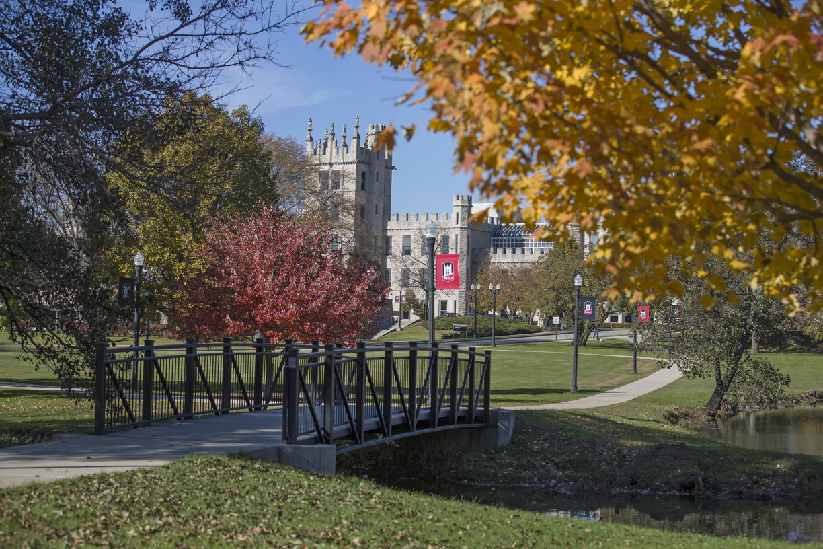

**Refections**

It has been a year of meeting with many interesting, caring individuals with various levels of distress. The times in which we are living have impacted individuals experiences within the work and learning environment. The majority of the visitors to the office were committed to finding positive outcomes for all in complicated situations. I have admired the many who were willing to be open to having challenging conversations and receiving feedback. Compassion and wellness are pillars to a strong, healthy culture. I strive to encompass those values in my work. I believe a greater focus on individual accountability for practicing compassion and engaging in wellness behavior and clear, meaningful initiatives by the university to support such will greatly impact the overall experience at NIU. My three years at NIU have showed me that NIU is committed to the well-being and success of the entire Huskie community. It has been my pleasure to be a part of the Huskie community.

