# NIU Office of the Ombudsperson

# **Annual Report for Academic Year 2023-24**

Submitted by Sandy Cox, Ombudsperson

niu.edu/ombuds



Contents

About Our Office 4

Mission and Vision 5

Mission 5

Vision 5

Value of an Ombuds Office 6

A Visit to Our Office 6

Data 8

Changes to Data Collection **Error! Bookmark not defined.**

Visitors by Classification 8

Visitor Concerns 9

Top Five Reasons for Visits per Category 9

Additional Work of Our Office 11

Services by Type 11

Facilitated Discussions/Mediations by Semester 11

Goals 12

Reflections 13

Acknowledgements 14

Our Office of the Ombudsperson is a confidential, informal, neutral, and independent resource for assisting in navigating concerns that impact success and well-being at NIU. Our office serves our entire campus community including faculty, staff, students, and administrators.

As a confidential resource, members of our office do not disclose who visits our office or the content of the conversations, and we do not keep records on visitors, visits, and interactions. The only exceptions to confidentiality are concerns for risk of harm to self or others and mandated reporting specific to child/elder abuse.

Pursuant to Article 20 of the bylaws of NIU, the university ombudsperson is a direct report to the president and is evaluated by the University Council.

The NIU Office of the Ombudsperson adheres to the [standards of practice](https://ioa.memberclicks.net/assets/docs/SOP-COE/IOA_Standards_of_Practice_English.pdf) and [code of ethics](https://ioa.memberclicks.net/assets/docs/SOP-COE/IOA_Code_of_Ethics_English.pdf) outlines by the International Ombuds Association.

## About Our Office

Ombudsperson Sandy Cox staffs the office. The Program Coordinator/previous Executive Assistant position was filled for a brief time, but most of the year it has been an empty position. To contribute to cost savings measures, the plan is for this position to remain unfilled for the upcoming year.

Ombudsperson Cox reports to NIU President Lisa C. Freeman and is structured under the President’s Office as part of University Services.

Our role is providing direct services to visitors; facilitated conversations and mediation; training and outreach; review and consultation on policies and procedures; sharing of nonidentifiable visitor themes and patterns to administration; collaborative feedback conversations with leadership; and participation in committees and meetings as appropriate.



## Mission and Vision

### Mission

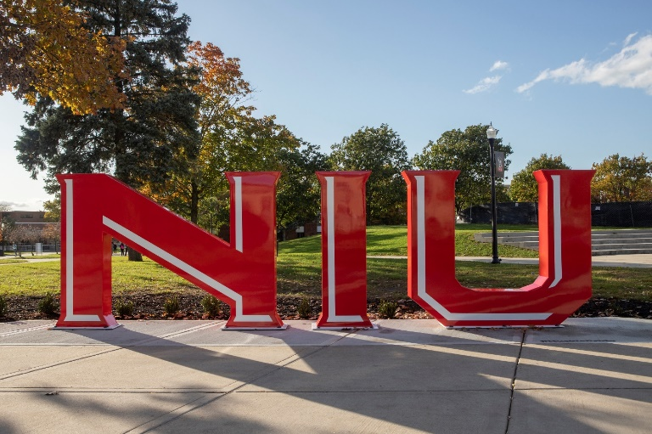Our mission is to provide a safe, inclusive service to all NIU students and employees. We listen, help navigate paths to resolution of concerns, identify relevant policies and practices, and bridge resources for support. We assist the university in identifying trends of concerns and inform administrators and governing bodies regarding those concerns. We conduct ongoing review of policies and procedures to recommend changes that can potentially improve our university community.

### Vision

The office of the Ombudsperson continues to have the vision of being a proactive office in serving individuals who are on the continuum of challenging experiences at NIU. The focus remains to encourage individuals to seek services early to avoid the development of greater challenges and distress. The vision of the office is to also be part of the support of enhancing NIU’s efforts to best support student and employee success and wellbeing.

## Value of an Ombuds Office

Our ombuds office has great value to students, employees and the entire university. We provide value by:

1. Being a neutral party in which individuals experience an impartial perspective that helps them navigate their situation or concern.
2. Providing an informal space for visitors to express their concerns and explore the resources they have available to utilize, understanding they are in control of what they do or do not choose to do.
3. Minimizing the need for formal processes when appropriate or assisting visitors to understand and work through formal processes.
4. Positively impacting the retention of students by helping navigate concerns that impact success and well-being.
5. Identifying themes and patterns and offering ideas for supporting and addressing concerns that often positively impact workplace and student environments.
6. Supporting staff and faculty to navigate their concerns in a more timely and concise way to minimize impact on work.
7. Offering opportunities for individuals or groups to learn skills to manage challenging situations and conflicts and develop positive communication skills which impact healthier environments.
8. Offering facilitated conversations and/or mediations that often keep issues from escalating.
9. Providing a nonjudgmental space for individuals to feel empowered to voice their concerns, feel heard and understood, and develop a plan to help navigate issues in the future.
10. Providing “shuttle diplomacy,” which means sharing information with relevant others to assist the visitor with addressing their concerns and desired outcomes when they feel unable to do so.

A Visit to Our Office

Visitors to our office engage in services through phone calls, emails and in-person contact. Email to [ombuds@niu.edu](mailto:ombuds@niu.edu) is the primary way in which visitors reach our office. Visitors are offered various modalities of services that include in person, Teams, phone, or email correspondence. Most visitors request Teams meetings.

In the first meeting with our ombudsperson, the guiding principles of our office are covered. Those principles include independence, impartiality/neutrality, informality, and confidentiality. We discuss that though our ombuds office professionals are employed by NIU, our office is structured to be independent so that it can function from a neutral and impartial perspective. We explain that our ombudsperson’s role is not to advocate for individuals or the university, but to advocate for best practices, policies, procedures and positive experiences for all employees and students. We also explain that we are informal and do not serve notice to the university, investigate on the behalf of individuals or the university, or engage in a formal process or legal advice and guidance. We seek to keep up to date with policies and procedures and formal processes to best assist our visitors. Lastly, we remind visitors that we are confidential except for individuals having thoughts of harm to self or others. It is also explained that we gather nonidentifiable information for the annual report and Title IX Clery reporting.

Visitors to our office often seek someone who will listen without judgment to their concerns and experiences. We discuss hopeful outcomes and explore numerous ways to navigate their situation to attempt to achieve a positive outcome. This often includes developing skills, practicing difficult conversations, assistance with developing written correspondence, and connecting to potential resources for assistance. At times, visitors or supportive resources request facilitated discussions and/or mediation services. In these situations, all parties involved must agree to a facilitated conversation or mediation. The ombudsperson requests to speak with all involved individually prior to a group meeting.

Data

### Visitors by Classification

Our office provided services to 727 individuals for the 2023-2024 academic year. The ranking of the classification of visitors to our office is as follows:

Employees consisted of 54% of the visitors this year, students 33% and other 13%.

### Visitors by Type of Service

### Visitor Concerns

The collection of data typically gathered by ombuds offices are organized into seven categories. They include employment, student academic status, faculty and staff performance, student conduct, financial, classroom and miscellaneous. Below are the categories, ranked from highest to lowest, for visitor concerns.

#### FALL 2023

1. Employment
2. Classroom
3. Faculty and Staff Perfomance
4. Miscellaneous
5. Student Academic Status
6. Student Conduct
7. Financial

#### SPRING 2024

1. Employment
2. Classroom
3. Faculty and Staff Performance
4. Miscellaneous
5. Student Academic Status
6. Student Conduct
7. Financial

### Top Five Reasons for Visits per Category

The following further clarifies the top five reasons visitors engaged with NIU ombuds services this past year by category.

|  |  |
| --- | --- |
| CATEGORIES | REASONS |
| Employment | Morale Supervisor Skills/Relationship with Employees Personality Conflicts Working Conditions Inadequate Staffing |
| Classroom Instruction | Grade Appeal Quality of Instruction Course Syllabus Personality Conflicts Policy |
| Faculty and Staff Performance | Unprofessionalism Intimidation Derogatory Comments Retaliation Discrimination |
| Student Conduct | Academic Misconduct Discrimination Policy/Behavior Classroom Disruption Records |
| Student Academic Status | Withdrawals  Academic Advising  Class Scheduling Probation/Dismissal  Thesis/Dissertation |
| Financial | Emergency Funding Tuition/Housing Raise/merit  Financial Aid Housing |
| Miscellaneous | Interpersonal Concerns Disability Accommodations Safety Issues Ethical Considerations Policy Issues/Development |

### Additional Work of Our Office

Meeting with visitors is the primary service of our office. However, we engage in a wide range of other services. The charts below identify the diverse services we have provided this past year. We also actively participate in shared governance committees, presidential commissions, and advisory committees.

#### SERVICES BY TYPE

#### FACILITATED DISCUSSIONS/MEDIATIONS BY SEMESTER

­­­­­­­­­­­­­­

## Goals

* Seek to develop a better understanding of the reporting of “morale” concerns and better define the underlying factors.
* Collaborate with Brian Smith and Cathy Doederlein to implement a pilot program of morale exploration/understanding. This includes identifying a few areas on campus to invite them to participate in the pilot for understanding and intervention.
* Continue to seek more opportunities and collaborations for provision of outreach and training. Developing insight and skills into addressing concerns early in the process/experience will be an intentional focus.
* Continue collaborative relationship with the University of Galway, Ireland and assist in the piloting of their Sexual Violence Prevention program at NIU.
* Expand standing meetings with leadership across campus to discuss themes and patterns from visitors to the office and to explore how the office can best support their students and employees.
* Continue to engage in professional development to ensure best practices through our office.

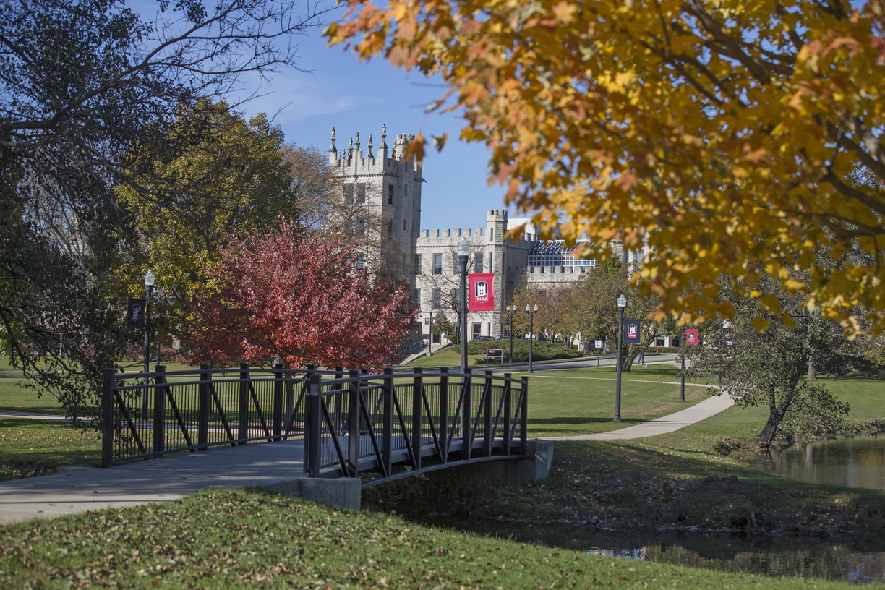

## Reflections

This past year continued to be a positive, successful year. The goal of the office being proactive in addressing visitor concerns to prevent growing challenges showed progress. There was a decrease in need for formal mediation processes and more involvement in facilitated conversations to assist individuals collaborating to a positive resolution. There was a decrease in human resource process concerns from visitors with the exceptional work of Cathy Doederlein in the new Human Resources position of Director of Employee Experiences. This year brought more multi-layered concerns needing more extensive services. Visitors have continued to consistently express gratitude with their experiences of feeling heard, confidentiality and assistance in navigating a wide range of concerns.

Morale continued to be identified as a central theme in visitors’ experience at NIU. It is important to remember that many of the visitors in the office are experiencing distressful experiences at the university and this can impact the perception of morale. Morale is complicated. It is often a common word used to describe a multitude of feelings and experiences. Morale is often viewed as a top-down issue, but it is a collective responsibility. The hope is to be intentional in exploring others experience of morale and identifying ways to support a positive morale campus culture.

I have continued to be impressed by employee’s commitment to students’ success and wellbeing and students’ commitment to being successful and well. The role of the Ombudsperson has a unique perspective and ability to support employees and students through all their experiences. I have learned something new every day and feel fortunate to be able to assist individuals who seek support through the office.

## Acknowledgements

I would like to express my sincere gratitude to all the visitors to the Office of the Ombudsperson. The vulnerability and openness that was shared is valued highly. I also want to acknowledge the gratitude I have for leadership support and colleague collaborations. I remain overwhelmed with appreciation for being the NIU Ombudsperson.

