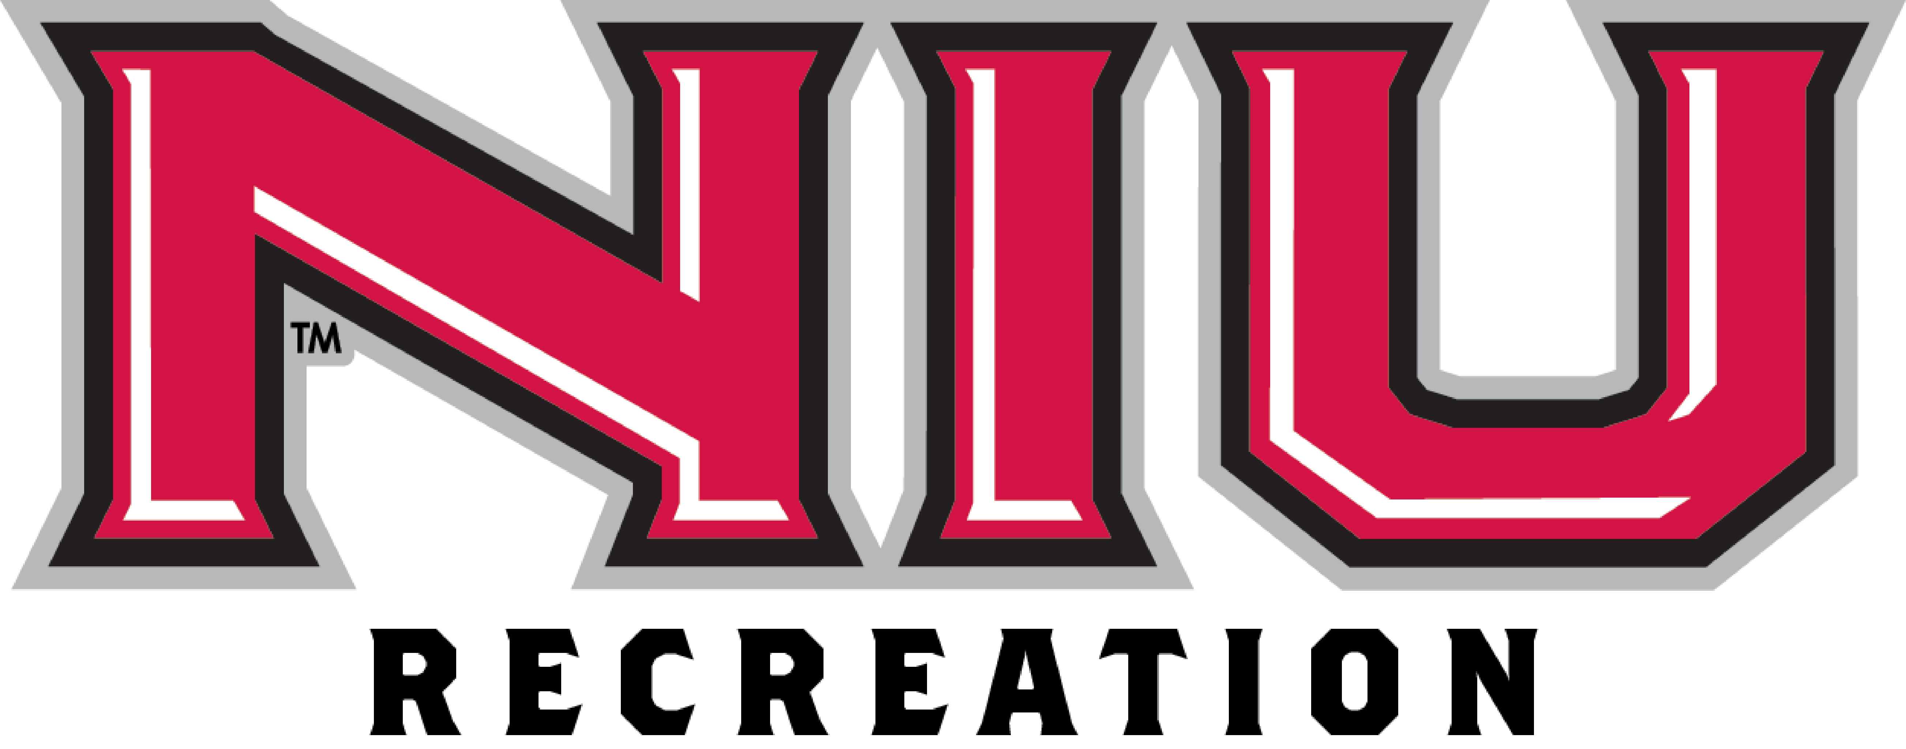

Graduate Assistant, Outdoor Adventures (2)

NIU Recreation
The department of NIU Recreation’s main facility is located at the Student Recreation Center at the crossroads of Annie Glidden Rd. and Lucinda Rd. in DeKalb, IL. The Recreation department offers a comprehensive recreation program and services for the campus community featuring Intramural Sports, Fitness, Nutrition, Open Recreation, Outdoor Adventure, and Sport Club activities.

Department Why
We create conditions for success by facilitating opportunities and building a culture that inspires optimal health and well-being.

Our Promise
Have fun. Live well. Feel your best.

Intercollegiate Athletics Mission
To inspire and sustain excellence in the P.A.C. principle of “Promoting Athletes to Champions” while developing champions in the classroom, in competition and in life.

The Position
This full-time (20-hour) Graduate Assistant will report to the NIU Recreation Assistant Director for Outdoor Adventure. The successful candidate will be responsible for assisting in the overall administration and management of the Outdoor Adventure program (equipment rentals, outdoor adventure trips, special events and teambuilding programming) including staff training, program development, risk management, supervision, assessment, and marketing.

Responsibilities
- Written Communication: Develop and maintain a written employee manual for the Adventure Center and Outdoor Adventure staff.
- Oral Communication: Provide clear and concise instruction to staff and participants including policy review, trip procedures, gear requirements, planning and preparation, etc.
- Program Development/Implementation/Evaluation: Assist in program development, implementation, and evaluation of the Adventure Center rental, Outdoor Adventure trips, and teambuilding programs. Identify new activities to enhance the overall program and encourage participation.
- Collaboration: Serve on department, divisional or campus-wide committees, as assigned.
- Teamwork/building: Attend and participate in regular meetings such as full-staff meetings and student staff meetings..
- Leadership: Provide leadership within Recreation department by providing support to student staff, the Assistant Director of Outdoor Adventure, and the other graduate and full-time staff. Participation in professional conferences, workshops, and other developmental opportunities as available.
- Creativity: Assist in market development and implementation for the promotion of Outdoor Adventure activities, Adventure Center rental, and team building programs. Develop new activities and events.
- Group Facilitation: Provide on-site supervision and coordination of special events/conferences that promote the Outdoor Adventure program and department.
- Assessment/Evaluation: Assist in developing and assessing participation data, program evaluations, and learning outcomes, and prepare semester reports that include recommendations for improvement.
- Supervision: Recruit, hire, train, supervise, schedule, and evaluate Adventure Center and Outdoor Adventure student personnel.
- Crisis Management: Assist in the development, implementation, and oversight of a risk management and emergency response program for the Adventure Center and Outdoor Adventure programs.
- Organizational/Analytical: Assist in documenting and maintaining program and personnel information, database management, inventory, and facilitation of personnel payroll.
- Budgeting: Assist in budget development (including personnel, equipment purchases and maintenance, and marketing).
- Research: Assist in conducting research (i.e., benchmarking, surveys, focus groups etc.) to further develop programs, policies, and procedures and make recommendations for improvements.
- Other: Assist in other departmental activities and perform other duties as assigned.

Requirements
- Bachelor’s degree, preferably in Kinesiology, Physical Education, or Recreation.
- Admitted to NIU’s graduate school and enrolled in a graduate course of study.
- Preference will be given to graduate students pursuing a degree in Sport Management, Environmental Education, Kinesiology and Physical Education or Adult and Higher Education.
- This position is designated as security sensitive. In compliance with the Illinois Campus Security Act, before an offer of employment is made, the university will conduct a pre-employment background investigation, which includes a criminal background check.
- Current certifications in CPR/AED, First Aid, and Blood Borne Pathogens.

Qualifications
- Strong experience working in an adventure program setting.
- Strong background in areas of rock climbing, camping, backpacking, paddling sports, snow sports, biking, etc.
- Obtain a Wilderness First Responder certification within six months of beginning employment.
- Experience working with students of diverse educational, racial, ethnic, and cultural backgrounds.
- Good organizational skills and ability to work independently.
- Good written and oral communication skills.
- Ability to supervise others and work in a dynamic, changing, and diverse environment.
- Genuine interest in gaining experience and knowledge to enhance chosen career.

Preferred Qualifications
- Experience working in a customer/client environment.
- Professional certifications in climbing, kayaking, Wilderness First Responder (WFR), Wilderness Education Association (WEA), Leave No Trace (LNT) and/or related certifications.
- Experience in student employee supervision and evaluation.
- Experience working with diverse student and community groups.
- Genuine interest in gaining experiences and knowledge to enhance career development in the Outdoor Adventure field in a Recreation and wellbeing environment.

Compensation includes
- 9-month, 20 hours per week (except when university closures for holidays, etc.) with potential summer employment.
- Hourly pay at $17.31* per hour (paychecks distributed semi-monthly).
- Start Date: August 16, 2021 with potential summer employment prior to August 16th.
- Tuition: Full tuition waiver (excluding student fees, any off-campus fees, the cost of books, etc.)
- No housing offered in residence hall and no meal plan.
- Other Benefits: If funds are available, assistance in professional development costs.

*Payrate subject to change prior to official contract

Contact Information
Christine Lagattolla, Assistant Director for Outdoor Adventure, NIU Recreation
Student Recreation Center
DeKalb, IL 60115
Phone: 815-753-9422, Email: clagattolla@niu.edu

Application Materials
To apply send a letter of application, resume, and a list of three current references including names, addresses, e-mail addresses, and phone numbers to: Northern Illinois University, Student Recreation Center, Attn: Christine Lagattolla Assistant Director of Outdoor Adventure, DeKalb, IL 60115. Electronic applications must be submitted in Word format to clagattolla@niu.edu. The position is open until filled.

Northern Illinois University is an equal opportunity institution and does not discriminate on the basis of race, color, religion, sex, age, marital status, national origin, disability, or status as a disabled or Vietnam-era veteran. The Constitution and Bylaws of Northern Illinois University afford equal treatment regardless of political views or affiliation, and sexual orientation. NIU recognizes Dual Career issues.

About NIU
Chartered in 1895, NIU is a comprehensive teaching and research institution with a student enrollment of approximately 17,000. Located in one of the most dynamic regions of the country, DeKalb is 65 miles west of Chicago, Illinois. NIU is included in the Doctoral/Research Universities-Extensive category of the Carnegie Foundation for the Advancement of Teaching and is a member of the National Association of State Universities and Land-Grant Colleges. NIU has a diverse student population with 735 international students representing 118 nations. Approximately 3,500 students live on campus in residence halls and apartments. NIU Recreation is a department in the Division of Intercollegiate Athletics. The department offers open recreation, aquatics, group fitness classes, intramurals, sport clubs, outdoor recreation, nutrition counseling, and personal training services. The staff includes 7 full-time professional; 1 part-time professional; 1 full-time support staff, 8 graduate assistants, and interns.

