NIU Task Force on Artificial Intelligence

in Academic Affairs

Summary Report of Working Group Findings

Academic Year: 2024–2025

# Overview

The NIU Task Force on Artificial Intelligence (AI) was established during the 2024-2025 academic year to investigate the challenges and opportunities related to AI usage across Academic Affairs. This task force worked to coordinate development of policies and practices while ensuring alignment with the university's mission and values. The task force gathered information, analyzed current AI practices, and developed recommendations for responsible AI integration in academic contexts. Three working groups were convened, each focusing on a distinct domain: Ethical Guidelines and Evaluation, Academic Support Services, and Teaching and Learning. This summary report synthesizes their findings,

outcomes, and recommendations to guide NIU’s strategic and responsible adoption of AI in Academic Affairs.

# Working Group 1 – Ethical Guidelines and Evaluation

**Co-Chairs:** Andrea Guzman, Assoc. Professor, Communication; Sarah Garner, Ethics and Compliance Officer, Title IX Coordinator and Records Officer

**Members:** Bob Barton, Chief Information Security Officer, DoIT; David Gunkel, Professor & Interim Chair, Communication, CLAS; Celeste Latham, Associate Vice President for Facilities & Resources; Sherril Morris, Associate Dean, CHHS; Reza Rajabi, Asst. Professor of Marketing, CBUS; Cody Schmitz, Registrar.

**Focus:** Develop ethical guidelines and evaluation frameworks for AI use in academic affairs.

## Executive Summary

This working group focused on developing ethical guidelines and best practices regarding the creation and use of artificial intelligence within NIU academic affairs. To accomplish this goal, members gathered and reviewed reports and guidelines regarding ethical issues and questions pertaining to AI as developed by higher education institutions and by other expert sources (i.e. UNESCO, U.S. government). The working group then identified the most relevant ethical issues to NIU and its stakeholders. Ethical guidelines were developed around NIU’s mission, vision, and core values.

### Key Accomplishments

* Created a comprehensive ethical framework (see Appendix A) grounded in NIU’s

mission, vision, and values.

* Identified core principles: transparency, equity, accountability, and alignment with institutional goals.
* Integrated a prioritization framework for evaluating AI initiatives based on student outcomes and academic efficiency.

### Challenges

* Managing the breadth of AI applications and aligning them with diverse stakeholder needs.
* Synthesizing vast external resources into a context-specific framework for NIU.

### Recommendations

* Finalize and disseminate the ethical guidelines (Appendix A).
* Develop campus-wide messaging and training materials (e.g., FAQs, case studies).
* Encourage future working groups to adapt the framework for specific domains like research and administration.

# Working Group 2 - Academic Support Services

**Co-Chairs:** Kimberly Shotick, Assistant Professor and Student Success Librarian, ULIB; Matt Mattox, Director, HASC

**Members:** Ashley Bartelt, Director, Writing Center; Brandon Lagana, Director, Navigate; Andy Jeon, Assistant Professor, Marketing, CBUS; Reza Rejabi; Assistant Professor, Marketing, CBUS; Chris Isley, Assistant Director, Student Athlete Academic Support Services; Zac Schoenrock, Coordinator, Math Assistance Center, Math Sciences, CLAS; Amanda Hirsch, Assistant Director for Teaching Excellence and Support, CITL; Eric Hoffman, Coordinator of Networked Writing and Research, English, CLAS

**Focus:** Evaluate and pilot AI tools to enhance student academic support.

## Executive Summary

This working group sought to enhance academic student support with the adoption of AI tools. The working group surveyed NIU academic support units and identified several key considerations in tool selection, including human-centered design, data privacy, institutional relevance, and social and environmental responsibility. A rubric was developed to evaluate tools against these criteria.

### Key Accomplishments

* Conducted surveys of support units and departments to assess AI readiness and needs.
* Authored a white paper (see Appendix B) summarizing national trends, internal findings, and a rubric for evaluating AI tools (included in Appendix B).
* Developed a pilot implementation plan for AI-enhanced student support services.

### Key Insights

* AI can improve access, personalization, and efficiency in student services.
* Concerns include data privacy, ethical use, cost, and staff readiness.

2

* Mission AI (EdSights) pilot showed promising engagement and outcomes.

### Recommendations

* Use the developed rubric to evaluate and rank AI tools.
* Form a cross-functional implementation group to oversee pilots, training, and assessment.
* Establish a centralized inventory of AI tools and promote transparent communication.

# Working Group 3 - Teaching and Learning

**Co-Chairs:** Andrea Radasanu, Assistant Vice Provost for Student Enhancement; Stephanie Richter, Director of Teaching Excellence and Support, CITL

**Members**: Alicia Schatteman, Vice Provost for Academic Affairs; Ann Dzuranin, Professor, Accountancy, CBUS; Brian Bender, Instructor, Operations Management and Information Systems, CBUS; Carrie Zack, Associate Director, AAE; Cindy York, Associate Professor, Educational Technology, Research & Assessment, CEDU; Jim Slagstad, Graduate Student, CBUS; Melissa Fickling, Associate Professor, Counseling, Adult & Higher Ed, CEDU

**Focus:** Promote AI literacy and integrate it into the academic curriculum.

## Executive Summary

This working group established an AI literacy framework that outlines key knowledge and skills and proposed an AI Community of Practice for the 2025-2026 academic year. Also proposed are continued work on adoption or creation of an AI literacy module for students that addresses initial AI literacy outcomes. A foundation for AI literacy was laid with shared governance groups but will need to continue that work in accordance with NIU policy.

### Key Accomplishments

* Developed an AI Literacy Framework (see Appendix C) outlining essential knowledge and skills.
* Proposed a 2025–2026 AI Community of Practice (see Appendix D) and a new

“Teaching with AI” specialization of faculty mentors.

* Conducted a syllabus audit revealing inconsistent AI policy adoption across courses.

### Collaborations

* Partnered with the Office of Accreditation, Assessment and Evaluation and the Center for Innovative Teaching and Learning
* Engaged with shared governance bodies (e.g., Baccalaureate Council, General Education Committee).

### Recommendations

* Integrate AI literacy into general education and departmental curricula.
* Launch and assess an AI literacy module via the Career Launchpad platform.
* Revise syllabus guidelines to reflect ethical and pedagogical best practices.

3

### Cross-Cutting Themes

* Ethical Implementation: All groups emphasized the importance of transparency, data privacy, and human-centered design.
* AI Literacy: There is a shared need for ongoing education and professional development for faculty, staff, and students.
* Collaboration: Effective AI integration requires cross-unit coordination and shared governance involvement.
* Scalability and Sustainability: Future efforts must consider cost, infrastructure, and long-term support.

## Recommended Next Steps

1. Submit ethical guidelines for shared governance approval.
2. Launch AI literacy initiatives and community of practice.
3. Pilot selected AI tools in academic support using the evaluation rubric.
4. Establish an AI oversight committee to coordinate efforts and monitor progress.

4

# Appendix A

## Artificial Intelligence in Academic Affairs: Ethical Guidelines and Evaluation

**Developed by the Ethical Guidelines & Evaluation Working Group**

Curiosity and Creativity

**Responsible Innovation:** Foster a culture of accountable teaching, learning, and AI use that prioritizes all people and their rights and addresses potential risks while maximizing benefits.

**AI Literacy:** Foster the development of AI training & curricula that enable faculty, students, and staff to make informed decisions regarding the use and effects of AI.

**Opportunity**: Ensure that all faculty, students, and staff— regardless of background, ability, discipline, or status—have equitable opportunity to AI tools, resources, and training.

Equity and Inclusion

**Multidisciplinary:** Promote diverse participation in the implementation of AI systems to ensure that a wide range of perspectives and needs are considered.

**Bias Awareness:** Raise awareness among the university community about the potential for bias in AI and provide training on how to identify and address it.

**Community**

**Responsibility:** Prioritize the well- being and autonomy of the individuals whose data is used in AI applications.

**Equability:** Ensure that the deployment, access to, and use of AI does not disadvantage or harm any individual or group.

Ethics and Integrity

**Accountability:** Establish clear lines of responsibility for the development and use of AI. Individuals, groups, or administrative units must be accountable for AI's outcomes and impacts.

**Human Oversight:** Design and use AI systems with appropriate human

oversight. Critical decisions that have lasting impact on students, faculty, staff, or the wider university community (e.g., admissions, grading, qualifications) must not rely solely on AI output without review and judgment.

**Ethical Training:** The university has a duty to develop or make available training on AI ethics, responsible innovation, and the potential societal impacts of AI. All members of the university community involved in the development or use of AI have the personal responsibility to complete AI training.

**Transparency:** Assess multiple factors to prioritize transparency and determine appropriate disclosures of the use of AI. Consider the use case for an AI technology, the sensitivity of the data being put into AI supported applications and/or created by them, and the effect on the stakeholders.

Service and Stewardship

**Privacy:** Consider the sensitivity of when selecting and using AI applications. Exercise extreme caution with vulnerable populations and any personally identifiable information.

Care and attention should also be paid to how a particular AI application stores, uses, and learns from that data.

**Protection & Security:** Review data protection measures as early as possible in preparing to select and/or implement AI applications to ensure appropriate safeguards, including consultation with subject matter experts.

**Environmental Impact:** Consider the environmental impact of AI technologies, including energy consumption and resource utilization. Promote the development and use of sustainable AI practices.

# Appendix B

## Leveraging AI to Advance Student Success: A Framework for Evaluation and Implementation

Kimberly Shotick1, Ashley Bartelt2, Brandon Lagana3, Andy Jeon4, Reza Rejabi5, Chris Ilsley6, Zac Schoenrock7, Amanda Hirsch8, and Eric Hoffman9

1University Libraries

2HASC Writing Center

3Navigate

4, 5Department of Marketing

6Student Athlete Academic Support Services

7Math Assistance Center

8Center for Innovative Teaching and Learning

9Department of English

### Executive Summary

As a part of the AI Task Force Working Group, the AI Academic Support Services Task Force seeks to enhance academic student support with the adoption of AI tools. The Task Force conducted a comprehensive review of current needs, challenges, and opportunities at Northern Illinois University. This white paper summarizes national trends, survey ﬁndings from academic support units, and a review of existing tools, ultimately guiding the development of a rubric for evaluating AI technologies within this context.

AI presents a transformative opportunity to improve student access to resources, boost academic preparedness, and increase career readiness through personalized, scalable, and timely interventions. These systems can offer accurate, judgment-free support across academic, ﬁnancial, and personal domains, potentially improving student outcomes and well-being.

However, the implementation of AI in student support services requires thoughtful planning. The Task Force identiﬁed several key considerations in tool selection, including human-centered design, data privacy, institutional relevance, and social and environmental responsibility. A rubric was developed to evaluate tools against these criteria.

The Task Force underscores the importance of clear, ongoing communication with stakeholders to ensure transparency, build trust, and maintain alignment as AI tools are explored and potentially implemented. By focusing on ethical, data-informed, and collaborative approaches, NIU is positioned to responsibly leverage AI to strengthen its student success infrastructure.

Key next steps:

* 1. Consulting with Academic Affairs to determine direction, especially considering the current vacancy in the Huskie Academic Success Center.
  2. Using the rubric to evaluate and rank AI tools that meet institutional goals.
  3. Presenting top-ranked tools to Student Success leadership for consideration.
  4. Coordinating a cross-functional working group to support the pilot, training, assessment, and communication.

### Introduction

As part of the university’s strategic efforts to explore and responsibly implement artiﬁcial intelligence (AI) in student academic support, the AI in Academic Support Task Force advanced two key institutional goals:

1. Task one, reviewing the initial recommendations of the AI Action Team (Spring 2024), which identiﬁed current strengths, potential risks, and areas for growth, and
2. task four, designing and implementing a pilot program for AI-enhanced academic support services, such as personalized learning tools and automated administrative systems, to evaluate their practical applications and beneﬁts.

To guide this work with evidence and stakeholder insight, the Task Force developed and distributed a campus-wide survey targeting academic student support units and department chairs. The purpose was to better understand the current landscape of student needs, existing challenges faced by support units, and the perceived opportunities and concerns related to AI integration.

This white paper summarizes the survey ﬁndings alongside national trends in AI implementation in higher education. These insights directly informed the development of an evaluation rubric designed to assess AI tools proposed for academic support, with a focus on effectiveness, equity, transparency, and alignment with student success outcomes. Following an overview of the external landscape to contextualize the use of AI technologies in student support, this paper will summarize key research ﬁndings and offer recommendations aligned with the university’s strategic goals. As a next step, the evaluation rubric (Appendix B) will be applied to assess potential AI tools, with the goal of selecting a candidate for a pilot implementation in the fall semester.

### External Landscape: Contextual Background

Since the launch of ChatGPT in November 2022, AI has taken a central role in shaping the trajectory of academic support in higher education. While instructional technologies and administrative tools have received more consistent attention (Bibi & Atta, 2024; Nguyen, 2025; Zhu et al., 2025), student-facing academic support services like tutoring, writing, and advising centers are increasingly integrating AI to expand access, improve efficiency, and enhance student learning through personalized and scalable means (Jothikumar et al., 2025; Thomas et al., 2024; Qin et al., 2025; Wu & Yu, 2023). This literature review synthesizes current research, institutional practices, and emerging trends in AI-enhanced academic support in higher education by clarifying key technological models; mapping institutional implementations; and addressing ethical, pedagogical, and practical challenges.

#### Foundations of AI in Academic Support

While the concept of AI emerged in the 1940s and 1950s, AI application in academic support contexts accelerated at the end of the 20th century and included the development

of specialist systems like intelligent tutoring systems (ITS), rule-based systems designed to mimic human tutoring by providing personalized feedback based on student user input (Wenger, 1987). Although initially limited in scope, ITS research evolved to incorporate Bayesian networks, machine learning, and natural language processing (Conati et al., 2018), increasing their sophistication and laying the groundwork for more dynamic systems that can respond to students’ needs using features like pedagogical agents (Johnson & Lester, 2016). Today, ITS offer students adaptive and personalized content sequencing and feedback based on their performance data (Conati et al., 2018; Qin et al., 2025). Often embedded in ITS or learning analytics dashboards, Open Learner Models (OLMs) further enhance transparency by allowing students to monitor their learning progress and adjust strategies accordingly (Conati et al., 2018). However, scholars like Baker (2016) caution that these systems cannot replicate the motivational, contextual, and affective dimensions of human academic support and that their greatest potential lies in augmenting instruction when implemented thoughtfully.

The last decade has seen the accelerating expansion of AI beyond the classroom and into co-curricular and academic support spaces. Libraries were early adopters of rule-based chatbots to streamline reference services (Fruehauf et al., 2024; Hamad & Shehata, 2024). Writing support tools like Grammarly and Turnitin have integrated natural language processing to automate grammar checking and citation assistance (Wu & Yu, 2023). While these tools often functioned independently from the human-led pedagogies practiced by learning support professionals (Graefen & Fazal, 2024; Wu & Yu, 2023), recent surveys suggest that academic support units like tutoring, writing, and advising centers are now frontline sites for AI experimentation and deployment as part of centralized guidance and training initiatives (Fruehauf et al., 2024; MLA/CCCC Joint Task Force, 2024; Thomas et al., 2024).

### AI Models and Technologies Across Institutional Contexts

In practice, higher education institutions deploy a diverse range of AI technologies across administrative, academic support, and instructional domains, creating a layered ecosystem of implementation. They span foundational approaches like machine learning and deep learning, which support more advanced tools like large language models (LLMs), generative AI, and learning analytics platforms (LAPs). These technologies in turn power applications like ITS, OLMs, chatbots, and virtual assistants, each designed to personalize student support, improve access, and streamline services.

Many systems now integrate multiple AI types, enabling scalable, adaptive learning and more responsive academic services across campuses and within preexisting systems like learning management systems (LMS) or customer relationship management systems

(CRMs). For instance, LAPs are widely used by administrative units to aggregate student data and generate predictive insights that can inform proactive outreach and resource allocation (Chiu, 2025; Holstein et al., 2020). Tools like EAB Navigate have integrated AI- driven message content generators, report assistants, and knowledge bots to help staff efficiently communicate with students and scale personalized support (EAB, n.d.). These tools allow institutions to enhance service delivery while improving return on investment through time savings and increased staff capacity (Garg & Agrawal, 2021).

Chatbots, both rule-based and generative, serve as frontline responders in many institutions, particularly in library, advising, and IT contexts where they offer 24/7 assistance for frequently asked questions, triage support, and enhance service navigation (Hamad & Shehata, 2024; Ma et al., 2024). These tools are frequently integrated into library systems to help students navigate resources, locate materials, and manage citation queries. In advising contexts, chatbots assist students with course registration questions, deadline reminders, and policy explanations (Kuhail et al., 2023). Some universities also embed chatbots within broader service portals to help students access tutoring, counseling, and ﬁnancial aid services from a centralized interface (Fruehauf et al., 2024). These applications can reduce staff workload while extending support access for students outside of traditional business hours. However, they may also provide inconsistent or outdated responses, may cause "search fatigue," and may decrease student trust (EAB, 2025).

Academic support services like writing centers and tutoring programs are increasingly adopting hybrid human-AI models that pair human interaction with scalable support technologies like generative AI. These systems provide AI-generated prompts, diagnostics, and content suggestions that tutors and other academic support professionals can adapt in real time to support individualized learning (Holstein et al., 2020; Wang et al., 2024).

Stanford's Tutor CoPilot, for example, improves student learning outcomes by equipping tutors with strategy recommendations during live appointments; this especially beneﬁts novice tutors, whose students demonstrated up to a 9-point gain in topic mastery in a controlled trial (Wang et al., 2024). Scholars note that hybrid AI-human systems allow academic support staff to focus on high-judgement, interpersonal interactions while AI supports scalable, low-stakes assistance, which is particularly beneﬁcial in triage-style advising or tutoring systems (Garg & Agrawal, 2021; Thomas et al., 2024). These personalized tools also support student belonging and increase opportunities for meaningful engagement, factors that are consistently linked to improved retention across diverse student populations (Tinto, 1993).

Faculty and instructional units continue to employ AI in instructional design through ITS and Open Learner Models (OLMs). ITS platforms, which are widely used in math (Heffernan & Heffernan, 2014; Liu et al., 2025) and computer science (Conati et al., 2018; Qu et al., 2024), offer adaptive content sequencing and feedback based on student performance data (Conati et al., 2018; Qin et al., 2025). The University of California, San Diego has also integrated AI tutors into nanoengineering and computer science courses, offering guided assistance without revealing solutions to promote independent problem-solving (Patringenaru, 2025). Other models like PersonAlized Conversational tutoring agEnt (PACE) are designed to use large language models (LLMs) to blend learning style theory with content instruction to implement targeted learning strategies that meet students individual learning styles and encourage critical thinking (Liu et al., 2025). OLMs, often embedded in ITS or learning analytics dashboards, increase transparency by allowing students to monitor their learning progress and adjust study strategies accordingly (Dwyer & Laird, 2024). In other cases, institutions like Northern Arizona University are partnering with outside companies like Packback (n.d.) and Logically.app (Nguyen, 2024) to guide writing development through formative feedback and support research by helping students identify and evaluate sources more efficiently.

While none of these examples encapsulates the totality of AI implementation across institutions, they reﬂect how institutions are tailoring AI usage to the goals and capacities of different actors and domains. Whether through large-scale analytics systems or discipline-speciﬁc tools, the current landscape demonstrates that AI is reshaping academic support in ways that are both decentralized and deeply embedded in student success infrastructure.

### Strengths and Concerns in AI-Enhanced Academic Support

AI holds much transformative potential in academic support, particularly in terms of personalization, increasing access, equity, and scaling feedback and outreach mechanisms. Bowen and Watson (2024) describe AI as a "proliﬁc idea generator" that can scaffold dynamic learning environments and increase students' engagement with their own ideas (p. 47). ITS and generative AI provide real-time feedback and adaptive guidance, supporting differentiated learning pathways that meet students where they are. For example, PACE blends personalized learning theory support with content instruction (Liu et al., 2025) while hybrid human-AI models like Stanford’s Tutor CoPilot enhance tutoring session quality and maintain a human connection (Chiu & Rospigliosi, 2025; Fruehauf et al., 2024; MLA/CCCC Joint Task Force, 2024; Wang et al., 2024). AI chatbots can also impact student learning outcomes, particularly in higher education, with some like Wu and Yu (2023) ﬁnding them most impactful in short-term interventions. Used strategically, these systems can be especially valuable for multilingual learners, ﬁrst-generation students, and

those with irregular schedules, enabling greater ﬂexibility and around-the-clock engagement. Moreover, they have the potential to allow institutions to proactively support students at scale without compromising individual responsiveness (Chiu, 2025).

Despite these advantages, concerns remain about the ethical, pedagogical, and operational implications of AI integration. Generative AI models risk replicating bias found in training data, potentially marginalizing students based on language or cultural background (Davalos & Yin, 2024; Liang et al., 2023; MLA/CCCC Joint Task Force, 2023; Taneja et al., 2024), contributing to institutional mistrust and academic harm.

Pedagogically, heavy reliance on AI may weaken students’ development of critical thinking, collaboration, and metacognitive skills (Graefen & Fazal, 2024; Nguyen, 2025; Taneja et al., 2024), competencies that academic support professionals traditionally foster; students’ may also struggle without access to these potentially proprietary tools upon graduation.

Regarding discipline-speciﬁc content, ITS that incorporate LLMs risk generating inaccuracies or non-curricular content that students do not have the skills to identify or strategies for handling critically (Levonian et al., 2025). At the institutional level, researchers raise concerns about data privacy and transparency (Agarwal, 2024; Ismail, 2025; Rospigliosi, 2021). AI technologies like chatbots, often embedded in CRM or LMS, collect or have access to large amounts of student data, which necessitates clear communication about what data is collected, how it is used, and who has access, which is essential for maintaining institutional accountability and student trust (Ismail, 2025; MLA/CCCC Joint Task Force, 2024).

Such risks are compounded by a growing burden on academic support staff, faculty, and other student-facing employees, who are increasingly expected to serve as both AI literacy educators and frontline troubleshooters. While some institutions like the University of South Florida (Fruehauf et al., 2024) have launched robust professional development initiatives to prepare staff for this evolving role, others report limited training and unclear guidance (Fruehauf et al., 2024; Thomas et al., 2024). Staff must navigate complex questions about when and how students can or should use AI tools, often without formal policies or centralized institutional support. Research and case studies consistently show that early involvement of academic support staff in AI planning and implementation correlates with stronger outcomes for students and staff alike (MLA/CCCC Joint Task Force, 2024). To sustainably support AI-enhanced learning, higher education must invest in comprehensive, discipline-aware professional development that empowers staff to use, critique, and teach with AI in ways that align with core learning values.

### Internal Landscape: Survey Findings

In order to better understand the needs and experiences of academic student support units at NIU and identify how Artiﬁcial Intelligence (AI) can enhance student success, the working group administered two surveys: one to academic student support units in February-March of 2025 (see Appendix B-1), and one to department chairs in March 2025. The surveys deﬁned AI in the context of student support, such as intelligent tutoring systems (ITS) that personalize learning, boost engagement, or streamline administrative tasks related to student support.

#### Survey Methodology

Survey questions were collaboratively developed by the AI in Academic Support Services Task Force and reﬁned by Kimberly Shotick. The ﬁnalized instrument was built in Qualtrics, using logic branching to tailor question pathways based on respondents' answers. Most questions were open-ended to encourage detailed, qualitative responses.

The Task Force identiﬁed a list of relevant individuals and units, and a distribution list was created in Qualtrics. The survey was disseminated directly through the platform, with several follow-up reminders sent to encourage participation. Due to a low initial response rate, the deadline was extended and a second round of distribution targeted individuals who had not yet completed the survey.

Upon closure, survey results were exported as a CSV ﬁle and shared with Task Force

members for analysis and discussion.

### Key Findings: Academic Student Support Units

The ﬁrst survey was sent to Advising, Career Services, CEET Learning Center, Center for Student Assistance, Commuter Programs and Off-Campus, Cultural Resource Centers, DoIT, Huskie Academic Success Cetner, Math Assistance Center, Navigate, Office of Online Learning in CITL Student Athlete Academic Support, Student Wellness, Title IX, TRIO, University Libraries, and the Writers Workshop. There were six completed responses representing Career Services, CEET Learning Center, Commuter Programs and Off- Campus, Huskie Academic Success Center, Math Assistance Center, and University Libraries.

A majority of the responding units (4/6) are not currently using AI/AI-enhanced technologies for academic student support. Reasons for not adopting AI/AI-enhanced technologies include lack of familiarity with available technology, cost, and lack of institutional best- practices and guidance around ethics and privacy issues related to AI technologies.

The units using AI technologies reported applying them to student-facing services such as

tutoring and resume review, as a supplement to services provided by staff.

AI technological capabilities that units indicated interest in include automated scheduling, predictive analytics, assessment, and data analysis.

Units were also asked to identify the greatest needs that the students they serve face. These needs include familiarity with NIU resources, information literacy, access to technology, personalized attention, motivation, ﬁnancial and well-being needs, and the need for on-demand services (Figure 1).

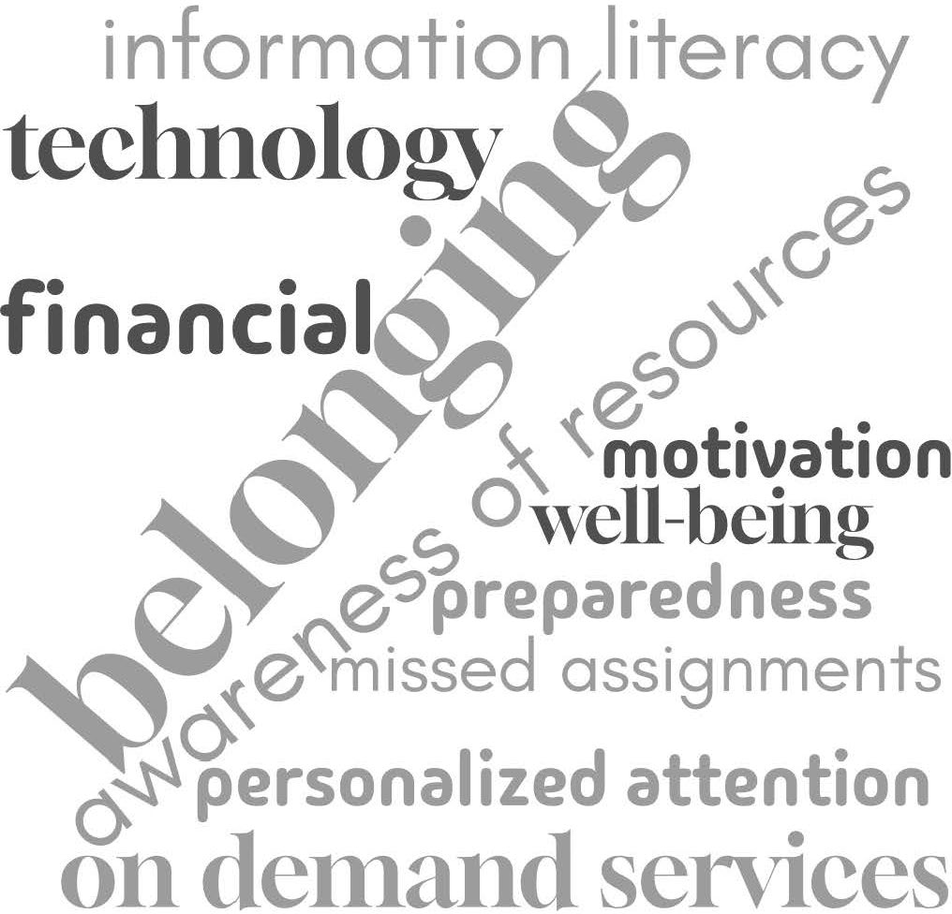

*Figure 1: Word cloud representing student challenges reported by support units*

### Key Findings: Academic Departments

Recognizing that faculty have ﬁrst-hand expertise with students’ academic needs, the survey was adapted and sent to department chairs. The survey was distributed via a distribution list within Qualtrics to 41 individuals representing department chairs, the Dean of Libraries, and the Director of the Law Library. Five responses were completed representing Computer Science, World Languages & Cultures, Philosophy, Curriculum and Instruction, and Mathematics. The responses reﬂected a mix of hesitancy and engagement with AI for student support, with some units looking to actively incorporate AI tools into their department’s student support services.

In response to the question, “what student academic support tasks currently are time consuming (or burdensome) for your department?” several responses reﬂected the desire for Navigate to automate alerts and emails to students. Other tasks included tracking and reporting data for assessment, tracking progress toward degree completion, and course scheduling based on needs.

When asked about student challenges, respondents reported attendance, use of generative AI that goes against academic honesty and AI policies, and underpreparedness (Figure 2). Departments reported that faculty address these challenges in a variety of ways, including using Navigate to submit alerts and providing departmental tutoring to better support students. Departmental challenges generally focused on funding to provide sufficient quality support services such as tutoring and hiring instructors to offer more variety in the schedule to meet student needs. While some of these challenges are outside of the scope of this project, they help provide context for the challenges that impact students and departments.

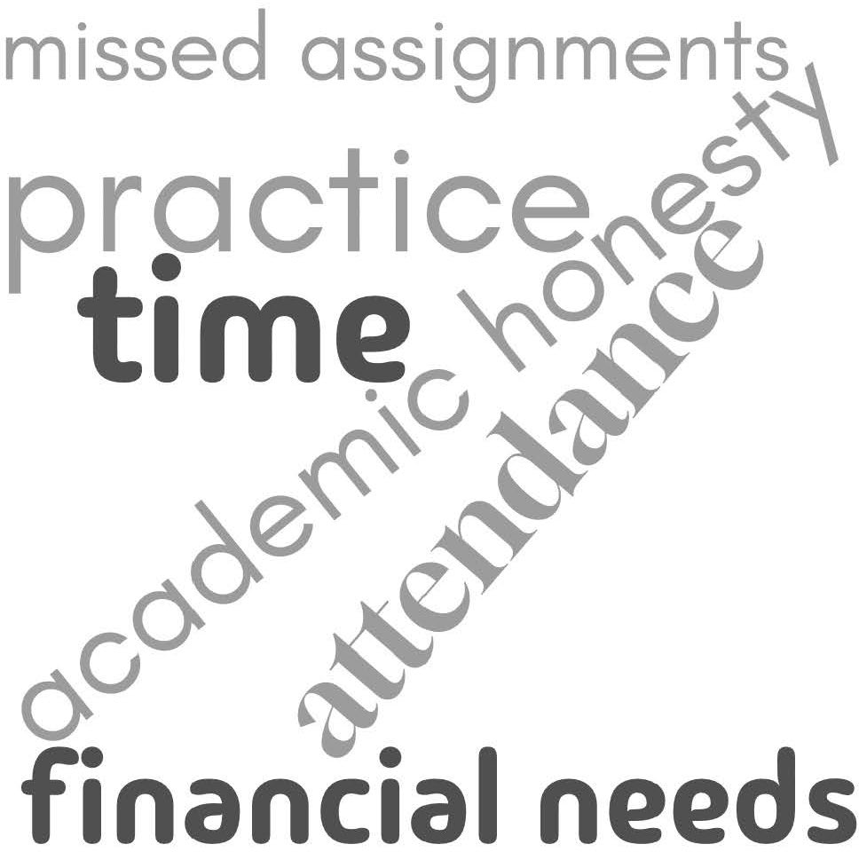

*Figure 2: Word cloud representing student challenges reported by academic departments*

The survey results for both groups indicate apprehension over adoption of AI technologies. When taken together, about 73% of responding department chairs and academic support service units responded “No” to the question “Have you integrated AI/AI-enhanced student support technologies into your unit/department?” (Figure 3).

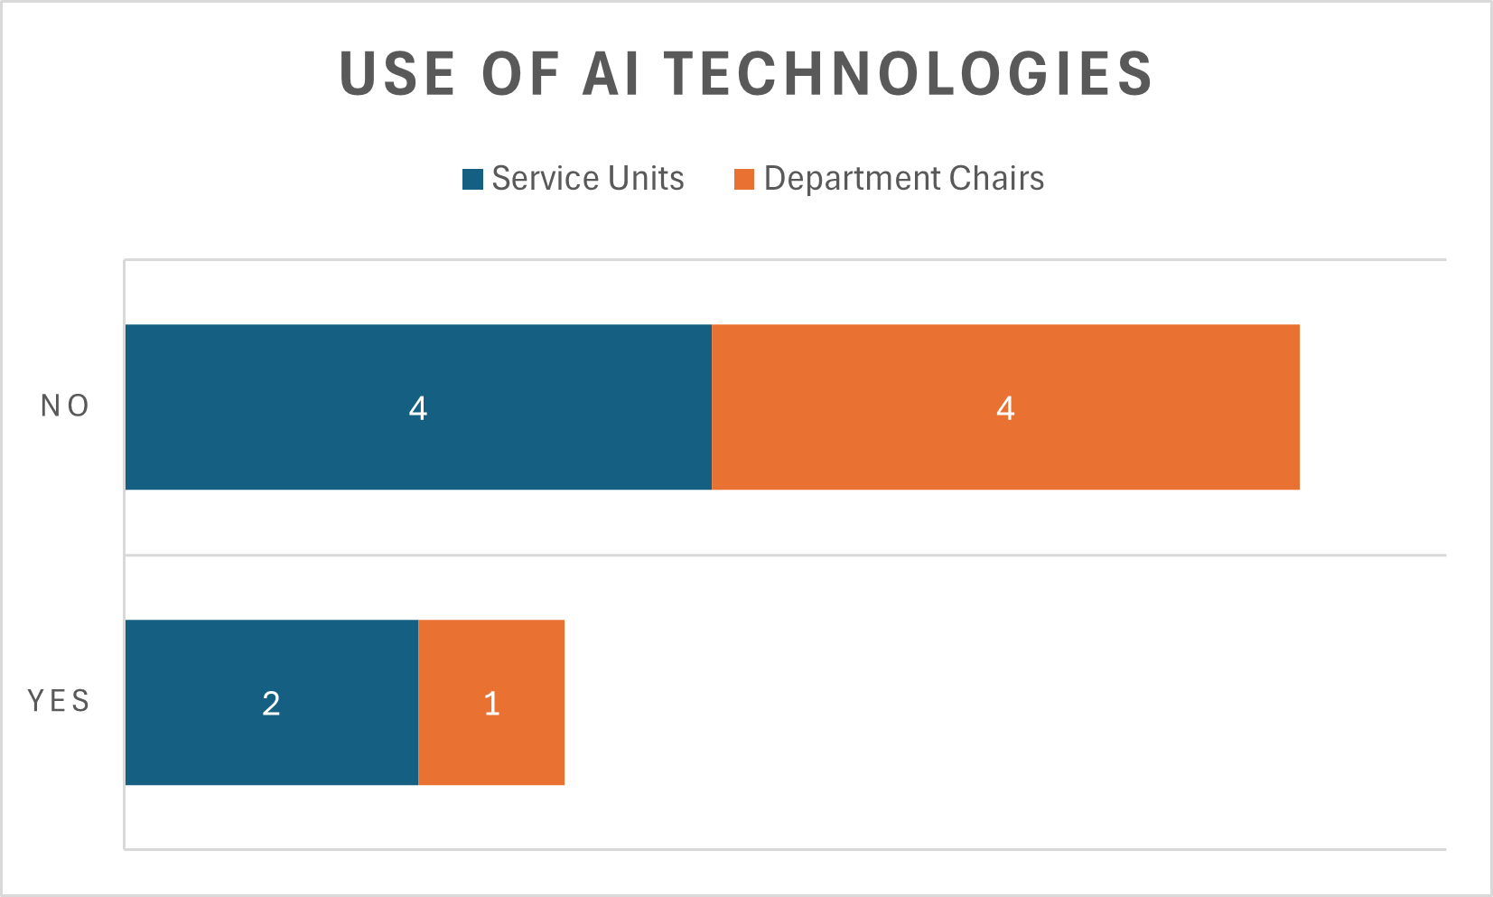

*Figure 3: Units and Departments use of AI technology for student support*

### Analysis and Recommendations

With a stronger understanding of both the internal and external AI landscape in academic support, several key recommendations emerged. These guide effective communication about existing tools, help prevent redundancy, outline strategies for sustaining this work, identify areas in need of further research, and inform the selection of AI-enhanced tools to support student learning.

### Addressing Knowledge Gaps and Hesitancy

In order to communicate clear expectations around the uses of AI at NIU, including effective practices, ethics, and understanding the overall goals for AI, this section summarizes themes from the AI survey related to addressing the knowledge gaps that may contribute to hesitancy. Recommendations are embedded within each item in the following sections.

#### Increasing Knowledge and Awareness

Clarifying the expectations/use cases/boundaries of acceptable use was an overarching theme with many respondents expressing that they did *not* know “enough” about AI and its applications. This indicates a need for educational initiatives to increase awareness and understanding of AI technologies and their beneﬁts.

Related to clarifying expectations, the need for Training and Support in implementing AI tools was a related concern identiﬁed by several respondents. Providing regular sharing of expectations around AI and continuing professional development around NIU’s uses of AI

might be an initial way to support AI promoters and detractors to bring greater clarity and cohesion to the AI landscape at NIU.

Some individuals **expressed AI Hesitancy or resistance due to** limited information or ﬁrst- hand use of AI tools or the potential for inappropriate academic uses among students.

What could be a highlight point to begin to reduce hesitancy or resistance is a focus on the

learning beneﬁts of AI tools, e.g., scalability of creative works (Bowen & Watson, 2024). Bowen and Watson argued for creating dynamic learning environments where students actively engage with projects, experiment with ideas, and reﬁne their work efficiently. They describe AI as a "proliﬁc idea generator” (p. 49) that can be used to encourage creativity and enhance students’ original works.

Addressing these concerns with clear and data-informed examples of positive AI applications can help mitigate resistance.

### Using Resources Efficiently

As different areas of the university begin to utilize AI in their areas, it is important to make sure that we eliminate redundancy when possible. AI does not always come in a one-size ﬁts-all package. While Grammarly may be helpful in a writing center environment, it would not be useful for helping in a math tutoring environment, which would require very different computational capabilities. With so many different needs for AI across campus, keeping a running list of what is currently being used, or subscribed to, will be extremely helpful in reducing the need for multiple paid services that overlap with each other. For example, if the Math Assistance Center was utilizing an AI to assist in math or statistics tutoring, there would be no need for anyone to request a subscription to an AI that specializes in statistical calculations for research, since we already have an active subscription on campus that can serve that purpose. Providing a centralized, easy to access list for all employees who might need to utilize AI could help with their initial search for something to suit their needs. Also, providing details on what specialized use each AI is being used for would help to make sure that we are not paying multiple subscriptions for AIs that serve the same function. Including information on free AI tools units or departments are using can also help identify free-to-use services for other departments seeking technological solutions.

#### Ethical Use and Privacy

To ensure the ethical and effective use of AI, it is recommended to establish clear guidelines that encompass transparency, accountability, and continuous monitoring for concerns.

**Establishing clear guidelines for ethical use of AI** might include how concerning messages typed into a chatbot are monitored and followed-up protocols. Understanding how the university might assume liability (or not) for information shared which could be considered to fall under mandatory reporting. For example, is a chatbot considered a mandatory reporter?

**Developing clear data governance policies** will serve to keep user privacy and conﬁdential. It is important to engage stakeholders via action teams or communities of practice that can serve as AI ambassadors – communicating the beneﬁts of AI and addressing concerns peer-to-peer.

It is also recommended that programs and departments include plans to **monitor and assess AI systems and functionality** regularly for ethical compliance and effectiveness.

Privacy and ethical considerations are featured in the rubric, available in Appendix B, in order to carefully assess AI technologies in line with NIU values.

### Communicating Use Cases and Reducing AI Anxiety

**Cost** is a signiﬁcant barrier identiﬁed by several respondents. Communication of the potential return on investment (ROI) and long-term cost savings that AI can bring are potentially salient concepts for messaging in addition to its impact on the learning process and potential to support student success in the classroom (e.g., developing appropriate A.I. skills to translate into post-college life).

**Data Privacy** and **Ethical Implications** associated with AI are additional areas of concern identiﬁed from the limited respondent sample. Ensuring transparent communication about data handling and privacy measures will be a crucial consideration. This element is reﬂected in the rubric developed by the Task Force (see Appendix B).

**Currency of Information** is essential for student users in order for them to have conﬁdence in the AI tools and so that we can ensure students receive appropriate levels of care and effective support. Conversely, inconsistent or outdated information only adds to “search fatigue” (EAB, 2025).

### Developing User Cohorts

Although respondents’ use cases of AI at NIU presently focused on process streamlining as a useful beneﬁt (e.g., self-scheduling of student appointments and analyzing data), communication strategies could be enhanced by identifying user cohorts and to conduct informal interviews to identify speciﬁc proofs of concept that can illustrate the beneﬁts of a peer-to-peer approach. It is particularly important to move from AI in the abstract to

speciﬁc uses that can serve as a starting point for additional ideas for integrating AI

effectively and appropriately into areas on campus.

### Addressing the Fear Factor of AI Replacing People

As we consider communicating the beneﬁts of AI, it will be crucial to **address the fear of AI replacing or displacing faculty and staff**. During the informal interviews with AI user cohorts, it will be important to identify:

* Where in the business or engagement process AI is used?
* What have been the results with regard to increased or enhanced engagement with your office/service?
* And, if applicable to the particular AI tool in use,
  + Does the office utilize a “live agent” to support the AI system for service to

students, stakeholders, etc.?

* + Who monitors the AI for concerning messaging or critical and immediate follow-ups?

### Mission AI Case Study

NIU’s Mission AI is a new feature for NIU undergraduate students that provides AI-assisted text messages and a chatbot to answer questions and connect students to campus services and information, pertaining to academic success, ﬁnancial matters, student life, and well-being, offering timely and accurate responses without requiring logins or app downloads.

Mission AI (EdSights) has signiﬁcantly improved student engagement and support at NIU. With a 95% opt-in rate and 48% active engagement, Mission AI has facilitated 22,590 student interactions through text messages. Targeted campaigns, such as "Balancing Work & School" and "Wellness Check-In," reached thousands of students, while follow-up initiatives addressed speciﬁc needs like housing insecurity and family support.

Additionally, EdSights' risk driver analysis ﬂagged 302 students for spring 2025 enrollment, and ﬁnancial and CSA referrals resulted in high response and enrollment rates. The integration of a knowledge base for quick responses and ongoing assessment ensures the platform's relevance and accuracy, positioning Mission AI as a vital tool for student success, persistence, and support.

Additionally, Mission AI addressed well-being by ﬂagging concerns related to Title IX, drop- out risks, violence reporting, and mental health issues, ensuring prompt outreach and intervention by NIU staff. These preliminary results aligned with scholarly ﬁndings that emphasized the transformative potential of AI in higher education, particularly in personalizing support and improving student outcomes (Gonzalez & Chiu, 2023).

Communicating these beneﬁts in cohorts of practitioners can be effective in mitigating

apprehensions that accompany adoption of new technology.

### Future Directions: Ongoing Committee and Implementation Strategy

To ensure the responsible, equitable, and strategic use of AI technologies in student support, we recommend the establishment of a **cross-functional, ongoing committee**. This section outlines areas of focus for an ongoing committee, along with both short- and long-term recommendations for the new committee to prioritize.

#### Role and Purpose of the Committee

One of the most pressing needs identiﬁed through this project is the lack of systematic knowledge about AI tool use across the institution. Faculty and staff engaged in academic student support outside of the classroom report using a variety of tools without a centralized way to share practices or evaluate outcomes. The proposed committee would ﬁll this gap by coordinating efforts across units, gathering data on existing tools, and promoting collaboration to reduce redundancy.

The committee would also advance research and evaluation practices to understand the full impact of AI-enhanced academic support. Speciﬁcally, it would:

* Map current use cases to determine where and how AI tools are already being implemented.
* Assess student impact by measuring effects on retention, engagement, equity, and access, using methods such as A/B testing, large-scale data analysis, and disaggregated outcomes by student population.
* Clarify ethical and privacy implications by investigating how student data is collected, stored, and used; examining mandatory reporting concerns; and evaluating fairness and bias in algorithmic decision-making. This work would inform the development of institutional policies that ensure transparency, equity, and student safety.
* Conduct cost-beneﬁt analyses to evaluate the long- and short-term ﬁnancial sustainability of AI tools, identify funding opportunities, and explore the potential for in-house development and capacity building.

The committee will also play a proactive role in promoting continuing professional education, encouraging ethical implementation practices, and reducing resistance through transparency and consistent communication. Together, these activities will guide the university’s AI strategy and ensure tools are selected, deployed, and supported in alignment with student success goals.

### Short-Term Tasks (Year One)

#### Create a centralized AI inventory.

O Collect and document all AI tools currently in use across units.

O Include purpose, cost, functionality, and feedback.

o Identify overlaps of practices among different AI tools – beyond functions.

#### Adapt Ethical Framework for academic student support Use.

O Address ethics, privacy, acceptable use, and mandatory reporting concerns.

o Coordinate with legal and IT for compliance.

#### Facilitate targeted training and professional development.

O Partner with CITL to deliver workshops on practical applications for departments providing academic student support.

o Create quick-start guides or toolkits for staff and faculty engaged in student support outside of the classroom.

#### Apply the evaluation rubric to existing/potential tools.

O Pilot rubric (Appendix B-2) on at least one tool.

o Use results to refine rubric and inform fall pilot selection.

#### Gather feedback from early adopters (user cohorts).

O Conduct brief interviews with units using AI tools.

o Document benefits, challenges, and unexpected outcomes.

#### Establish clear communication channels.

O Provide regular updates about committee work.

O Host open forums or Q and A sessions to address faculty/staff concerns.

### Long-Term Tasks (Year Two+)

#### Sustain and scale successful AI tools.

O Evaluate tools post-pilot and scale those with proven benefits.

O Seek sustainable funding, vendor partnerships, or in-house development options.

#### Monitor emerging technologies and assess them for alignment with university goals.

O Adapt policies as the landscape evolves.

O Foster a culture of experimentation and equity in AI use.

#### Encourage units to pilot tools aligned with their unique needs.

O Utilize AI tool inventory to strategically select tools for efficiency, scalability, and cross-platform functionality.

O Ensure tools support diverse student populations and reduce achievement gaps.

O Build in-house AI support capacity.

#### Leverage the committee's expertise in AI implementation and data analysis.

O Reduce reliance on external vendors and increase institutional resilience.

O Lead research and contribute to national conversations.

O Share findings on AI in academic support at conferences and in publications.

O Collaborate with peer institutions to benchmark practices.

### Proposed Committee Member Units

The core committee should be comprised of student-facing units that support student success. These units include Huskie Academic Success Center, University Libraries, Math Assistance Center, CEET, Advising, and SAASS. Other student-facing support units could be included at the recommendation of Academic Affairs. The committee should collaborate with key stakeholders including Title IX, CITL, DoIT, Navigate, and Faculty Senate.

### Next Steps

The Task Force’s next steps are contingent upon guidance from Academic Affairs, particularly in light of the current vacancy in the leadership of the Huskie Academic Success Center. Once direction is provided, the Task Force will move forward with evaluating AI tools that align with the university’s goals for enhancing academic student support.

Each tool will be assessed using the established rubric, ranked based on effectiveness, usability, and ethical alignment, and then presented to Student Success leadership for consideration. In parallel, a cross-functional working group should be convened to coordinate student success efforts at a broader level. This group will also play a key role in piloting the selected tool by supporting implementation, training, and impact assessment.

June

Confirm budget and leadership coordination

Consult with Academic Affairs

June-July

Form cross-functional implementation group

Rank and summarize findings

Evaluate AI tools using rubric

July-August

Begin training and ethical framework adaptation

Select tool (pending funding and approval)

Present top tools to Student Success leadership

Fall Semester

Monitor usage and assess impact

Ongoing Communication

Launch pilot

Winter-Spring

Make recommendations for next steps

Report findings

### Conclusion

AI is reshaping the terrain of academic support in higher education. While models and implementation strategies vary by context (e.g., academic support, instructional, administrative) the central themes of human-AI collaboration, data-informed outreach, and student-centered design remain consistent. Institutions are in a formative phase, experimenting with a range of tools from AI-integration into large-scale CRM like EAB’s Navigate to grassroots innovations in tutoring centers. By enabling personalized support and timely interventions, these technologies can address critical factors related to student well-being and mental health, aligning with foundational student success frameworks (Tinto, 1993).

However, thoughtful tool selection is essential. Any AI solution must prioritize human- centered design, uphold rigorous standards of data privacy, and meet the speciﬁc functional needs of our institution. Moreover, tools should be evaluated not only for performance but also for their social and environmental responsibility. Ensuring these

considerations are built into our decision-making will support the ethical and sustainable integration of AI in student success initiatives. As higher education continues to evolve in response to technological shifts, the most effective approaches will be those that prioritize ethical implementation, transparent communication, and the enduring value of human relationships in learning.

### References

Adetayo, A. J. (2023). ChatGPT and librarians for reference consultations.  
[*Internet Reference Services Quarterly*](https://doi.org/10.1080/10875301.2023.2203681), *27*(3), 131-147.

Agarwal, K. (2024). AI in education: Evaluating ChatGPT as a virtual teaching assistant. [*International Journal for Multidisciplinary Research*](https://doi.org/10.2139/ssrn.495678), *5*(4), 1-12.

Ahmad, S. F., Alam, M. M., Rahmat, M. K., Mubarik, M. S., & Hyder, S. I. (2022). Academic and administrative role of artiﬁcial intelligence in education. [*Sustainability*](https://doi.org/10.3390/su14031101), 14 (1101).

Baker, R. S. (2016). Stupid tutoring systems, intelligent humans. [*International Journal of Artiﬁcial Intelligence Education*](https://doi.org/10.1007/s40593-), *26*(2), 600-614.

Bibi, Z., & Atta, A. (2024). The role of ChatGPT as AI English writing assistant: A study of students’ perceptions, experiences, and satisfaction. [*Annals of Human and Social Sciences*](https://doi.org/10.35484/ahss.2024(5-I)39), *5*(1), 433-443.

Bowen, J. A., & Watson, C. E. (2024). *Teaching with AI: A practical guide to a new era of human learning*. Johns Hopkins University Press.

Chiu, T. K. F. (2025). Encouraging human-AI collaboration in interactive learning environments. [*Interactive Learning Environments*](https://doi.org/10.1080/10494820.2025.2471199), *33*(2), 921-924.

Conati, C., Porayska-Pomsta, K., & Mavrikis, M. (2018). [*AI in Education needs interpretable machine learning: Lessons from Open Learner Modelling*](https://doi.org/10.48550/arXiv.1807.00154). ArXiv.

Corbett, A. T., & Anderson, J. R. (1995). Knowledge tracing: Modeling the acquisition of procedural knowledge. [*User Modeling and Use-Adapted Interaction*, *4*](https://psycnet.apa.org/doi/10.1007/BF01099821), 253-278.

Davalos, J., & Yin, L. (2024, October 18). AI detectors falsely accuse students of cheating— with big consequences. [*Bloomberg Businessweek*](https://www.bloomberg.com/news/features/2024-10-18/do-ai-detectors-work-%20students-face-false-cheating-accusations).

Dwyer, M., & Laird, E. (2024, March). [*Up in the air: Educators juggling the potential of generative AI with detection, discipline, and distrust*](https://cdt.org/wp-content/uploads/2024/03/2024-03-21-CDT-Civic-%20Tech-Generative-AI-Survey-Research-ﬁnal.pdf). Center for Democracy & Technology.

EAB. (2025, March 20). *[Inside Navigate360’s Newest AI-Powered Student Engagement](https://eab.com/events/2024-innovative-applications-)*

*[Tools](https://eab.com/events/2024-innovative-applications-)* [Webinar]. EAB.

EAB. (n.d.) [*Navigate360: Higher ed’s leading CRM, powered by student-centric AI*](https://eab.com/navigate360-ai/).

Fruehauf, E., Beman-Cavallaro, A., & Schmidt, L. (2024). Developing a foundation for the informational needs of generative AI users through the means of established interdisciplinary relationships. [*Journal of Academic Librarianship*](https://doi.org/10.1016/j.acalib.2024.102876), *50*(3), 1-6.

Garg, V., & Agrawal, R. (Eds.). (2021). *Transforming management using artiﬁcial*

*intelligence techniques*. Routledge.

Graefen, B., & Fazal, N. (2024). From chat bots to virtual tutors: An overview of ChatGPT’s role in the future of education. [*Archives of Pharmacy Practice*, *15*](https://doi.org/10.51847/TOuppjEDSX)(2), 43-52.

Hamad, F., & Shehata, A. (2024). The potential of GPTs for enhanced information access and user services at academic libraries. [*IFLA Journal*, *2*](https://doi.org/10.1177/03400352241298958), 4-6.

Heffernan, N. T., & Heffernan, C. L. (2014). The ASSISTments ecosystem: Building a platform that brings scientists and teachers together for minimally invasive research on human learning and teaching. [*International Journal of Artiﬁcial Intelligence in Education*, *24*](https://doi.org/10.1007/s40593-014-0024-x), 470-497.

Hemachandran, K., et al. (2022). Artiﬁcial intelligence: A universal virtual tool to augment tutoring in higher education. [*Computational Intelligence and Neuroscience*, *2022*](https://doi.org/10.1155/2022/1410448)(1):

Holstein, K., Aleven, V., & Rummel, N. (2020). A conceptual framework for human-AI hybrid adaptivity in education. In I. I. Bittencourt, M. Cukurova, K. Muldner, R. Luckin, & E. Millán (Eds), [*Artiﬁcial intelligence in education*](https://doi.org/10.1007/978-3-030-52237-7_20)(pp. 240-254). Springer Nature.

Ismail, I. A. (2025). Protecting privacy in AI-enhanced education: A comprehensive examination of data privacy concerns and solutions in AI-based learning. In A. Mutawa (Ed.), [*Impacts of generative AI on the future of research and education*](https://doi.org/10.4018/979-8-3693-0884-4.ch006)(pp. 117-142). IGI Global.

Johnson, W. L., & Lester, J. C. (2016). Face-to-face interaction with pedagogical agents, twenty years later. [*International Journal of Artiﬁcial Intelligence in Education*, *26*](https://doi.org/10.1007/s40593-015-0065-9), 25-

36.

Jothikumar, K., Anisha, S., Varshini, S. A., Meenakshi, A. J., & Gomathi, V. (2025). AI tutors and virtual classrooms: Revolutionizing distance learning. In T. Murugan, K. Periasamy, & A. M. Abirami (Eds.), [*Driving quality education through AI and data science*](https://doi.org/10.4018/979-8-3693-8292-)(pp. 503-530). IGI Global.

Kuhail, M. A., Al Katheeri, H., Negreiros, J., Seffah, A., & Alfandi, O. (2023). Engaging students with a chatbot-based academic advising system. [*International Journal of Human-Computer Interaction*](https://doi.org/10.1080/10447318.2022.2074645), *39*(10), 2115-2141.

Lenovian, Z., Henkel, O., Li, C., & Postle, M.-E. (2025). Designing safe and relevant generative chats for math learning in intelligent tutoring systems. [*Journal of Educational Data Mining*, *17*](https://doi.org/10.5281/zenodo.14751365)(1), 66-97.

Liang, W. Yuksekgonul, M., Mao, Y., Wu, E., & Zou, J. (2023). GPT detectors are biased against non-native English writers. [*Patterns*, *4*](https://doi.org/10.1016/j.patter.2023.100779)(7), 1-4.

Liu, B., Zhang, J., Lin, F., Jia, X., & Peng, M. (2025, May 23). One size doesn’t ﬁt all: A

personalized conversational tutoring agent for mathematics instruction. [*Companion Proceedings of the ACM on Web Conference 2025*](https://doi.org/10.1145/3701716.3717527), 2401-2410.

Ma, W., Ma, W., Hu, Y., & Bi, X. (2024). The who, why, and how of AI-based chatbots for learning and teaching in higher education: A systematic review. [*Education and Information Technologies*, *30*](https://doi.org/10.1007/s10639-024-), 7781-7805.

MLA/CCCC Joint Task for on Writing and AI. (2023). [*MLA-CCCC Joint Task Force on Writing and AI Working Paper: Overview of the issues, statement of principles, and recommendations*](https://hcommons.org/app/uploads/sites/1003160/2023/07/MLA-CCCC-Joint-Task-%20Force-on-Writing-and-AI-Working-Paper-1.pdf). Modern Language Association, Conference on College Composition and Communication.

MLA/CCCC Joint Task Force on Writing and AI. (2024). [*Generative AI and policy development: Guidance from the MLA-CCCC Task Force*](https://hcommons.org/app/uploads/sites/1003160/2024/04/MLA-CCCC-Joint-Task-%20Force-on-Writing-and-AI-Working-Paper-2.pdf). Modern Language Association, Conference on College Composition and Communication.

Nguyen, A. (2024, May 23). Northern Arizona University and Logically.app (formerly Afforai) enhancing research with generative AI. [*Logically Blog*](https://afforai.com/blog/nau-%20and-afforai-enhancing-research-with-generative-ai).

Nguyen, M. (2023). Pedagogical divides: Human-centered learning and AI tools. [*College Composition and Communication*](https://doi.org/10.1007/s10805-), 75(1), 112-137.

Packback. (n.d.). Packback announces partnership with Northern Arizona University. [*The Packback Blog*](https://packback.co/news/packback-announces-partnership-with-%20northern-arizona-university/).

Patringenaru, I. (2025, February 27). Exploring the impact of generative AI on education, research and more. [*UC San Diego Today*](https://today.ucsd.edu/story/exploring-%20the-impact-of-generative-ai-on-education-research-and-more).

Qin, Q., Wang, J., & Zhang, S. (2025). Themes, knowledge evolution, and emerging trends related to the application of artiﬁcial intelligence in personalized learning: A scientometric analysis in CiteSpace. [*2025 The 14th International Conference on Educational and Information Technology*](https://doi.org/10.1109/ICEIT64364.2025.10976216), pp. 386-391.

Qu, Y., Letort, D., Evans, H., Abbas, N., Cai, R., Haj-Hussein, M., Biggs, A., & Durgin, J. (2024, October 13-16). [*Unlocking learning potential: Generative AI chatbots as student partners in online BS in computer science degree program*](https://doi.org/10.1109/FIE61694.2024.10893375)[Conference session]. 2024 IEEE Frontiers in Education Conference (FIE), Washington, DC, USA.

Rospigliosi, A. (2021). The risk of algorithmic injustice for interactive learning environments. [*Interactive Learning Environments*, *29*](https://doi.org/10.1080/10494820.2021.1940485)(2), 523-526.

Taneja, D., Prabagaren, H., & Thomas, M. R. (2025). AI in academia: Balancing integrity, ethics, and learning amid evolving norms of authorship and scholarship. In M. B. Garcia, J. Rosak-Szyrocka, & A. Bozkurt (Eds.), [*Pitfalls of AI integration in education: Skill obsolescence, misuse, and bias*](https://doi.org/10.4018/979-803373-0122-8.ch014)(pp. 319-340). IGI Global.

Thomas, D. R., Gatz, E., Gupta, S., Lin, J., Tipper, C., & Koedinger, K. R. (2024). Using generative AI to provide feedback to adult tutors in training and assess real-life performance. In D. Guralnick, M. E. Auer, & A. Poce (Eds.), [*Creative approaches to technology-enhanced learning for the workplace and higher education: Proceedings of “The Learning Ideas Conference” 2024*](https://doi.org/10.1007/978-3-031-73427-4_21)(Vol. 2, pp. 204-214). Springer.

Tinto, V. (1993). *Leaving college: Rethinking the causes and cures of student attrition* (2nd ed.). University of Chicago Press.

Tuyboyov, O., Turdikulova, B., Davlatova, R., & Norov, S. (2025). The role of AI-driven intelligent tutoring systems in enhancing mechanical engineering education. [*AIP Conference Proceedings*, *3268*](https://doi.org/10.1063/5.0257379)(1), 070038.

Wenger, E. (1987). *Artiﬁcial intelligence and tutoring systems: Computational and cognitive*

*approaches to the communication of knowledge*. Morgan Kaufmann.

Wu, R., & Yu, Z. (2023). Do AI chatbots improve students learning outcomes? Evidence from a meta-analysis. [*British Journal of Educational Technology*, *55*](https://doi.org/10.1111/bjet.13334)(1), 10-33.

Zhu, H., Cooper-Stachowsky, M., & Kamal, Z. H. (2025). Enhancing contextual understanding in AI-powered tutoring: Evaluating the Oliver System for effective learning support. [*2025 The 14th International Conference on Educational and Information Technology*](https://doi.org/10.1109/ICEIT64364.2025.10975875), pp. 530-535.

# Appendix B-1

## AI and Academic Student Support

Q1 We’re conducting a brief survey to better understand your unit’s needs and identify how Artificial Intelligence (AI) can enhance student success. The deadline has been extended and responses will be collected until March 14.

For this survey, think about AI in student support, such as intelligent tutoring systems (ITS) that personalize learning, boost engagement, or streamline administrative tasks behind the scenes. Your input will help the Academic Support Services Working Group at NIU tailor solutions to meet institutional needs. This survey supports our mission to pilot AI-enhanced academic support services and demonstrate their benefits. Thank you for contributing to this important initiative!

Working Group Members:

Kimberly Shotick, Co-Chair, Assistant Professor, University Libraries  
Matt Mattox, Co-Chair, HASC Director  
Amanda Hirsch, Assistant Director of Teaching Excellence and Support, CITL  
Eric Hoffman, Networked Writing & Research, Department of English  
Andy Jeon, Assistant Professor, Department of Marketing  
Brandon Lagana, Director of Planning and Assessment / Student Success Platform (Navigate)  
Reza Rejabi, Assistant Professor, Department of Marketing  
Zac Schoenrock, Coordinator, Math Assistance Center (MAC)

Q3 Have you integrated AI/AI-enhanced technologies into your unit?

*Display this question:*

*Have you integrated AI/AI-enhanced technologies into your unit? = Yes*

Q4 Please list the AI technologies and briefly describe their purpose.

*Display this question:*

*Have you integrated AI/AI-enhanced technologies into your unit? = No*

Q5 Are you currently considering implementing any new AI/AI-enhanced technologies?

*Display this question:*

*Are you currently considering implementing any new AI/AI-enhanced technologies? = Yes*

Q6 What challenges or factors have influenced your decision not to integrate AI/AI-enhanced technologies into your unit?

Q7 Please briefly list the technologies and their purpose.

Q8 AI technologies can streamline processes like data analysis, tracking, and HR tasks, allowing faculty and staff to focus on student success. What tasks currently are time consuming (or burdensome) for your team members?

Q9 What features or capabilities would you find valuable in an AI tool designed to support your work? For example, automated scheduling, predictive analytics, or personalized student support.

Q10 What are the most pressing needs or challenges faced by the students you support, and how does your team currently address them?

Q11 What concerns, if any, do you have about implementing AI-enhanced tools (e.g., cost, data privacy, training needs)?

# Appendix B-2

## Academic Student Support Services AI Tool Evaluation Rubric

The following rubric was developed as a tool to guide the selection of an AI tool to pilot in the fall 2025 semester in support of the Task Force on Artiﬁcial Intelligence in Academic Affairs' goal 4: “1.Design and implement a pilot program for AI-enhanced academic support services, such as personalized learning assistance or automated administrative processes, to demonstrate practical applications and beneﬁts.” The rubric was developed to reﬂect NIU’s values and meet the needs of students, faculty, and staff at NIU.

Values

* Curiosity and Creativity: Innovation and commitment to active learning and enhancing critical thinking.
* Equity and Inclusion: diversity and inclusion, environmental sustainability, bias
* Ethics and Integrity: Transparency, making sources visible, clarity with users about AI implementation, accuracy, IP considerations. data collection and protection, user ability to opt-out
* Service and Stewardship: integrity of the service unit and their ability to deliver quality services
* Fiscal Responsibility: budget considerations, efficiency
* Alignment: Alignment with institutional goals, student needs, and the needs of support units
* Human-centeredness: Usefulness of the AI to human endeavor, labor considerations, including people in AI—i.e., human-in-the-loop, concern for harms

Adapted from Mannheimer, S., Clark, J., Rossmann, D., Sheehey, B., Young, S. W. H., Bond, N., Shorish, Y., & Kettler, H. S. (2025, February 1). [*Viewﬁnder Toolkit*](https://osf.io/yue9s).

CC-BY

|  |  |  |  |  |  |
| --- | --- | --- | --- | --- | --- |
| **Category** | **Criteria** | **0 Not Appropriate for NIU** | **1 Meets some requirements but lacks in functional needs** | **2 Meets most requirements with minor issues** | **3 Meets all requirements**  **+ value-added**  **beneﬁts** |
| **Fiscal Responsibi lity** | Cost | Cost is prohibitively expensive | Cost is high, but there are beneﬁts that may outweigh the cost | Cost is low and/or the beneﬁt outweighs the cost | Cost is free and/or the beneﬁt greatly outweighs the cost |
|  | Efficiency | Tool adds signiﬁcant workload without reduction | Tool adds moderate workload, and somewhat frees up staff time for more impactful tasks | Tool adds some workload, but frees up staff time for more impactful tasks | Tool adds little-to-no workload and frees up staff time for more impactful tasks |
| **Ethics and Privacy** | Transparency | Documentati on on tool’s functions and policies are not available | Documentatio n on tool’s functions and policies are somewhat available/availa ble with limitations | Documentatio n on tool’s functions and policies are readily available | Documentatio n on tool’s functions and policies are readily available  tool is open source |
|  | Explainability | Tool’s decision making for output is neither inherently understanda  ble nor | Tool’s decision making for output is neither inherently understandabl e nor logically  explained | Tool’s decision making for output is either somewhat inherently understandabl e or is  somewhat | Tool’s decision making for output is either inherently understandabl e or is logically explained |

|  |  |  |  |  |  |
| --- | --- | --- | --- | --- | --- |
| **Category** | **Criteria** | **0 Not Appropriate for NIU** | **1 Meets some requirements but lacks in functional needs** | **2 Meets most requirements with minor issues** | **3 Meets all requirements**  **+ value-added**  **beneﬁts** |
|  |  | logically explained within or outside of the system | within the system, though some external explanation is available | explained within the system | within the system |
|  | Data Collection and Sharing | Does not list data that is collected and/or shared or collects and/or shares user data without explanation | Lists data that is collected and/or shared but provides little-to-no explanation | Lists data that is collected and/or shared but explanations are not always clear | Only essential data is collected and/or shared with explicit consent |
|  | User Control | Users have no control over how their data is collected or shared | Users have limited ability to opt out of data collection and/or sharing | Users have the ability to opt out of non- essential data collection and/or sharing | Users have the ability to opt out of data collection and/or sharing |
|  | Safety | Not compliant with NIST CSF, or lacking enough information  to make a | Somewhat compliant with NIST  CSF. Limited risk assessment practices. | Mostly compliant with NIST  CSF. Regular audits and compliance documentatio  n are | Compliant with NIST CSF. Regular audits and compliance documentatio |

|  |  |  |  |  |  |
| --- | --- | --- | --- | --- | --- |
| **Category** | **Criteria** | **0 Not Appropriate for NIU** | **1 Meets some requirements but lacks in functional needs** | **2 Meets most requirements with minor issues** | **3 Meets all requirements**  **+ value-added**  **beneﬁts** |
|  |  | risk assessment. |  | available, though there may be gaps. | n are available. |
| **Functionali ty** | Support | Support is not available | Support is available via documentation only | Limited support is available from the vendor and via documentatio n | Robust support is available from the vendor and via documentatio n |
|  | Accessibility | Conformanc e level WGAG 2.2 AA  “Partially Supports” and/or “does not support” for criteria | Conformance level WGAG 2.2 AA “Full support” for some criteria, and “Partially Supports” for others | Conformance level WGAG  2.2 AA “Full support” for most criteria | Conformance level WGAG  2.2 AA “Full support” for all criteria |
|  | Operating Systems | Works with few operating systems and/or does not work on mobile or other devices | Works with most operating systems and devices, but functionality is impacted by operating system and/or device | Works with most operating systems and across  devices | Works with all major operating systems and across devices |

|  |  |  |  |  |  |
| --- | --- | --- | --- | --- | --- |
| **Category** | **Criteria** | **0 Not Appropriate for NIU** | **1 Meets some requirements but lacks in functional needs** | **2 Meets most requirements with minor issues** | **3 Meets all requirements**  **+ value-added**  **beneﬁts** |
| **Human- centeredn ess** |  | Removes or discourages human interaction | Maintains human interaction, but neither supplements nor detracts from it | Supplements human interaction | Enhances human interaction |
| **Environme ntal and Social Responsibi lity** | Environment al impacts | No commitment to sustainability  ,  demonstrate d negative environment al impact | No commitment to reducing environmental impact | Commitment to reducing environmental impact | Commitment to Green AI with investment in sustainability |
|  | Bias | No consideratio n for bias | Minimal acknowledgem ent of biases | Some acknowledge ment and mitigation of biases | Active mitigation of bias through design elements and education |
|  | Equity and Inclusion | No evidence of support or features designed for diverse users | Little evidence of support or features designed for diverse users | Some inclusive elements designed for diverse users | Actively addresses diverse user needs through design features such as support for non-English  languages, |

|  |  |  |  |  |  |
| --- | --- | --- | --- | --- | --- |
| **Category** | **Criteria** | **0 Not Appropriate for NIU** | **1 Meets some requirements but lacks in functional needs** | **2 Meets most requirements with minor issues** | **3 Meets all requirements**  **+ value-added**  **beneﬁts** |
|  |  |  |  |  | ﬂexibility and  choice |
| **Notes: Describe how well the tool could meet the needs of students and student support units** | |  | | | |

# Appendix C

## NIU AI Literacies Framework

Artificial intelligence, especially generative AI, is reshaping how we work, learn, and

communicate. These tools can feel like “black box” magic, but they are grounded in human knowledge and shaped by human decisions and biases. Developing AI literacy is not just about learning to use these tools. It is about applying a critical lens to engage with them thoughtfully and responsibly.

The NIU AI Literacies Framework, developed by a university task force and inspired in part by the [Barnard College model,](https://er.educause.edu/articles/2024/6/a-framework-for-ai-literacy) provides a flexible and evolving path for learning. It is

designed for a general audience and supports users as they build awareness, apply AI tools, critically assess their impact, and explore creative possibilities. Users do not need to master one level before moving to another. The framework supports learners at any point in their journey.

Aligned with [NIU’s vision and values,](https://www.niu.edu/about/mission.shtml) the NIU AI Literacies Framework serves as both a foundation and a guide. It offers a structured yet adaptable approach to AI literacy that encourages curiosity, responsible use, and ethical reflection. Its goal is to prepare

individuals not just to use AI, but to shape its role in society.

This initiative also emphasizes the human aspect of AI. As technologies continue to advance, our commitment to ethical knowledge generation remains essential. Principles such as fairness, accountability, and transparency must guide our engagement. This framework supports individual’s development of critical thinking skills in addition to the skills needed to navigate the evolving AI landscape with intention and integrity.

## AI Literacy Framework

|  |  |
| --- | --- |
| **Level** | **Competencies** |
| **Level 1 Knowledge** | * Define key concepts and terms related to artificial intelligence, such as “artificial intelligence,” “machine learning,” large language   model,” and “neural network”   * Recognize the benefits and limitations of AI tools, including applications in daily life and ethical considerations, such as privacy and data security * Identify and explain the differences between various types of AI, as defined by their capabilities and computational mechanisms– |

|  |  |
| --- | --- |
| **Level 2 Use** | * Successfully utilize generative AI tools for desired outputs * Use AI tools in ways that take the important roles of humans into account (e.g., building upon, strengthening, enhancing and extending human skills and capacities, and freeing up humans to focus on the bigger picture) * Experiment with prompting techniques and iterate on prompt language to improve AI-generated output * Critically review AI-generated content with an eye toward potential “hallucinations,” incorrect reasoning, and bias. |
| **Level 3**  **Critical Analysis** | * Integrate AI concepts with knowledge from specific fields of study or professional interests * Examine the potential environmental, human, and societal impacts of AI * Critique AI tools and offer arguments in support of or against their creation, use, and application * Analyze ethical considerations in the development and use of AI, including issues of fairness, accountability, and transparency |
| **Level 4 Creation** | * Synthesize learning to conceptualize or create new ideas, technologies, or structures that relate to AI. Reaching this level could include the following: (1) Conceive of novel uses for AI; (2) build software that leverages AI tech; (3) Propose and explore theories related to AI and its future potential |

# Appendix D

## Teaching with Artificial Intelligence Community of Practice

### Overview

The NIU AI Community of Practice (CoP) is dedicated to exploring and advancing AI in ways that are ethical, equitable, and aligned with our campus mission and values.

By fostering collaboration and sharing of resources, the CoP equips the community to navigate AI’s complexities. Our goals are to:

* Provide a central hub for connecting NIU community members (including faculty, staff, and students) who work with, or are curious about AI, to learn from and with each other.
* Facilitate the discovery and sharing of AI use cases, needs, and approaches that support NIU’s mission and values.
* Promote understanding of AI’s risks and trade-offs to support teaching and learning.

### Structure

* Bi-weekly or monthly online meetings, recorded to compile a library visible to NIU community members (perhaps edited to individual presentations for granularity)
* Leadership
  + CITL for ongoing logistics
  + Representatives from each college (nominations/applications) + some other staff (Career Services, Student Affairs) and students
  + Reps responsible for X sessions (finding volunteers to lead presentations)
* Session structure
  + 1-2 presentations on their practices that integrate AI in teaching and learning, time for Q&A, general discussion
  + Faculty, staff, students
  + Industry partners on AI skills and priorities
* Sample topics:
  + Teaching students to use AI (prompting strategies, sample projects)
  + Transforming teaching approaches using AI (assessments, practice activities)
  + Using or creating AI-powered tools for teaching (increasing effectiveness, efficiency, analytics)
  + Hands-on practice with tools
  + Teaching with AI Book Club
* Microsoft Team for resource sharing & ongoing conversation