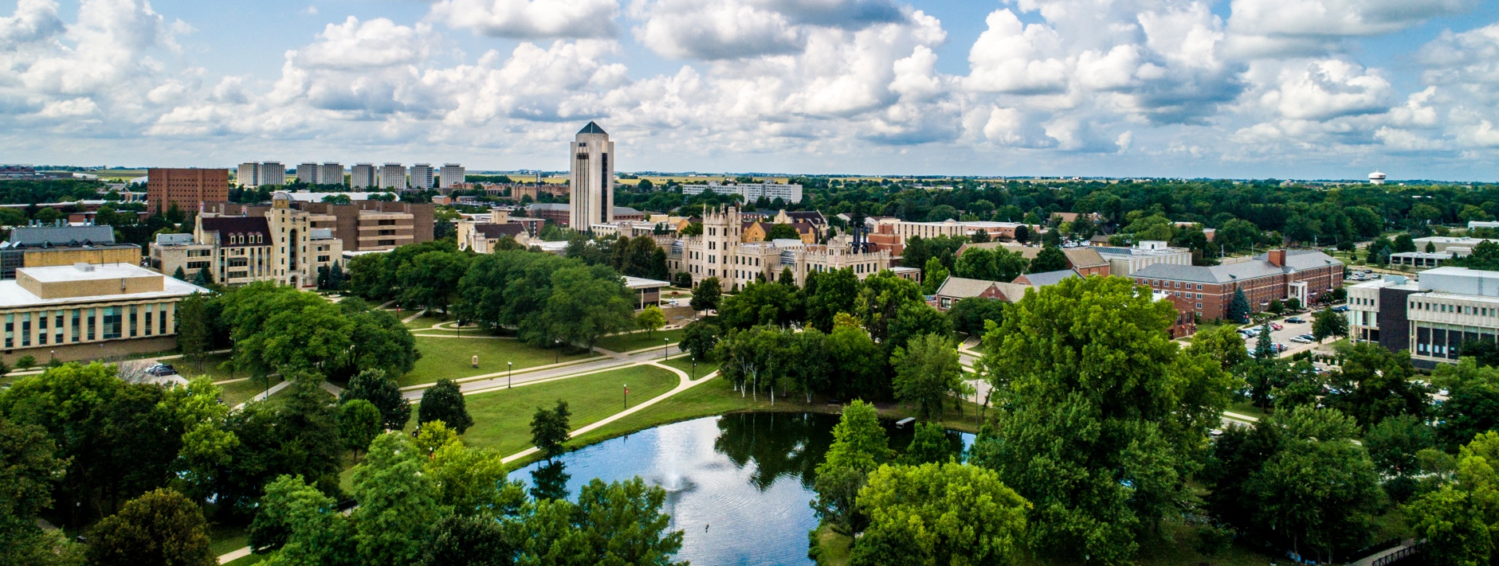

Northern Staff News

March/April 2026
niu.edu/operating-staff-council | osc@niu.edu

Table of Contents
President’s Corner………………………………………………………………….1
Finding the Fun in Higher Education ……………………………………………...2
Confessions of a New Editor……………………………………………………….2
Volunteers Needed for Commencement……………………………………………3
Workplace Guidance Committee is Here to Help You..……………………………3
Employment Changes………………………………………………………………3
Service Awards……………………………….…………………………………….5

OSC Meetings and Minutes can be found on our OSC website.
If you have any suggestions for future articles, please send an email to jessie.alex@niu.edu.

President’s Corner
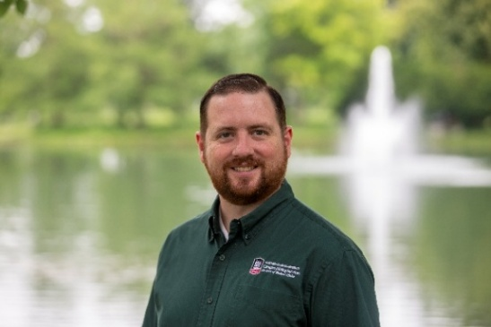
Greetings Operating Staff,
When I came to NIU, one of the most important factors for me was the tuition waiver. I had a strong desire to complete my bachelor’s degree, and I truly believe it is one of the most valuable benefits NIU offers its employees.
I share this because I understand how difficult it can be to take that first step whether you’re considering starting college for the first time or returning after a break. Even though finishing my degree was a key reason I joined NIU, it still took me years to begin my journey.
There were many reasons for the delay: Not having enough time, not wanting to stretch myself too thin while adjusting to a new role and the uncertainty brought on by COVID-19. I also worried about feeling out of place as an older student in a classroom of 18- to 22-year-olds. While some of these reasons were valid, others, in hindsight, feel more like excuses now.
One of my biggest regrets is that I didn’t push myself to start sooner. Waiting has cost me opportunities, and I have only myself to blame for missing them.
For me, getting past the fear and hesitation was the hardest part. Once I began, I realized that the challenges I had built up in my mind were far greater than the reality. Of course, there were adjustments as I relearned how to study and balance school with life, but they were manageable.
What truly made the difference was the incredible support I found on campus. Coworkers, supervisors, faculty and fellow students have all been encouraging and willing to help me navigate obstacles. I have yet to encounter anyone who wasn’t supportive of my journey.
If you’ve been thinking about starting or returning to school, I hope this serves as the nudge you need to take that first step. There are many resources available to help you get started, and I would be more than happy to connect and share more about my experience.
Best regards,

Jim Slagstad, President
Operating Staff Council 2025-2027
jslagstad@niu.edu | osc@niu.edu

Finding the Fun in Higher Education
By: Mark Pietrowski
Higher education can often be stressful for students, faculty and staff. Between classes and deadlines, it is easy for campuses to become places focused only on productivity. However, bringing moments of fun into colleges, departments and buildings can make a meaningful difference in creating a welcoming and supportive environment.
One example here at NIU is the annual egg hunt hosted by the College of Engineering and Engineering Technology. Each year, staff hide eggs throughout the building filled with candy and prizes for students to find. It is a simple activity, but it creates excitement, encourages students to explore the building and offers a brief break from academic pressures. More importantly, it helps build a sense of community.
Events like this remind students that their college cares about their experience beyond the classroom. Departments can also bring fun to their spaces through themed days, trivia contests and stress-relief activities during finals week. These activities do not need to be expensive or complicated to have a positive impact. Many areas of NIU, for instance, have costume contests for Halloween.
By intentionally creating moments of joy and connection, colleges can strengthen relationships and improve morale. Sometimes, the smallest traditions can become the most memorable parts of the college experience. So, what ideas do you have to enhance your fun and the fun of other students, staff and faculty?

Confessions of a New Editor
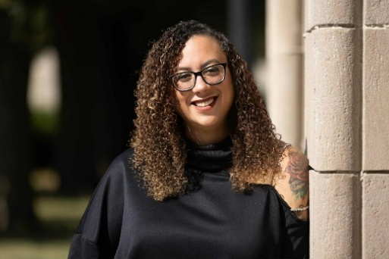
Hello everyone,
As this issue comes together, one theme stands out clearly: Connection in action. With the updates and initiatives shared above and the everyday work happening across our campus, it is evident that progress here is never a solo effort. It is built through collaboration, shared purpose and a willingness to show up for one another.
In my continued transition into this role, I have been especially struck by how deeply committed our civil service community is — not only to the work itself, but to each other. The stories, updates and efforts highlighted in this newsletter reflect that commitment. They remind us that even small moments of engagement can create meaningful impact when we are moving forward together.
As we keep that momentum going, I encourage you to stay connected, whether that means sharing feedback, celebrating a colleague or simply reaching out with an idea. This space is strongest when it reflects the voices and experiences of those it represents.
Thank you again for being part of this ongoing journey. I look forward to continuing to share, learn and grow alongside all of you and, of course, to finding those moments that make us pause, smile and appreciate the community we are building together.
Sincerely,
Jessie Alex

Volunteers Needed for Commencement
We look forward to celebrating our graduates during commencement ceremonies:
- Friday, May 8, 2026.
- Saturday, May 9, 2026.
- Location: Convocation Center.
Please consider volunteering your time to help make these events successful for our graduates, families and guests.
If you are able to help and are not already participating through your academic college or the Graduate School, please visit the commencement volunteer website and complete the form.

Workplace Guidance Committee is Here to Help You
The Workplace Guidance Committee is here as a resource, not just for formal grievances, if needed.
If you have questions, concerns or even positive feedback about your work environment, we are available to listen, help or navigate options if needed.
You can reach the chair directly at rmeyer@niu.edu or contact the committee through OSC@niu.edu with WGC in the subject line.

Employment Changes

January 2026

Welcome New Employees
- Meghan Collins, Admissions and Records Representative – Registration and Records
- Nicholas Craun, Program Assistant – Disability Resource Center
- Sharon Da Silva, Accounting Officer – Allied Health and Communicative Disorders
- Blaine Hash, Building Service Worker – Building Services
- Ian Hubik, Equipment Service Supervisor – Residential Dining Service
- Cynthia Lund, Culinary Worker I – Residential Dining Service
- Charles Lundsberg, Program Coordinator – Center for P-20 Engagement
- Christian Mauer, Program Coordinator – Research Compliance, Integrity and Safety
- Valena McGinnis, Office Administrator – Philosophy
- Steve Schultz, Agricultural Gardener – President’s Office
- Aquila Tribblet, Food Court/Snack Bar Supervisor – Campus Dining Service
- Michael Vasquez, Police Officer – Public Safety
- Linda Watson, Marketing Associate – Conference and Event Services
- Leneal Whitehead II, Assistant Food Service Manager – Residential Dining Service
- Patricia Wielert, Office Administrator – Allied Health and Communicative Disorders
- Sean Word, Program Coordinator – Family and Consumer Sciences

Retirements
- Cheryl Alliston, Administrative Assistant – Associate Vice President Finance
- Chiemi Bentley, Senior Library Specialist – University Libraries
- Denotra Davis, IT Technical Associate – Integrated Media Technologies
- Patricia Erickson, Administrative Assistant – University Council
- Nancy Grych, Program Assistant – Continuing Professional Education
- Diane Hart, Program Coordinator – Career Services
- Caroline Kosmel, Program Assistant – Career Services
- Joan Laurino, Program Coordinator – Vice President Marketing and Communications
- Julie Lorang, Office Administrator – School of Interdisciplinary Health Professions
- Jennifer Ridge, Program Assistant – School of Interdisciplinary Health Professions

Separations
- Jason French, Culinary Worker III – Residential Dining Service
- Sarah Garcia, Senior Events Coordinator – Conference and Event Services
- Mark Hazelton, Building Service Worker – Building Services
- Zachary Kocher, Food Court/Snack Bar Supervisor – Campus Dining Service
- Joseph Lathrop, Steam and Power Plant I – Heating Plant
- Robert Miller, Building Service Worker – Building Services
- Mark Schabacker, Building Service Worker – Building Services

Death
- Lori Henshold, Program Director – Center for P-20 Engagement

February 2026

Welcome New Employees
- Adnan Ajaz Pasha, Institutional Research Data Coordinator – Division of Research and Innovation Partnerships
- Hannah Anderson, Facilities Operations Specialist – Regional Center Operations
- Faizan Baksh, Internal Auditor – Internal Audit
- Ariana Brannon, Food Court/Snack Bar Supervisor – Campus Dining Service
- Charlotte Estes, Office Support Specialist – Center for P-20 Engagement
- Alexandria Halverson, Customer Service Assistant – Office of the Bursar
- Doug Herrington, Library Assistant – Northern Public Radio
- William Perkins, Automotive Technician – Transportation
- Erica Schermerhorn, Office Administrator – Transportation
- Michael Stern, Sheetmetal worker – Physical Plant

Retirement
- Linda Carlson, Office Support Specialist – Sponsored Programs Administration

Separations
- Alexandria Halverson, Customer Service Assistant – Office of the Bursar
- Emily Miller, Building Service Worker – Building Services
- Patrick Murphy, Manager of Sports Facilities – Intercollegiate Athletics
- Denise Sherden, Administrative Aide – College of Liberal Arts and Sciences
- Leneal Whitehead II, Assistant Food Service Manager – Residential Dining

Death
- William Hertzner, Facility Operations Specialist – University Libraries

Service Awards

January 2026

10 Years
- Carmin Berchiolly, Curator of Art III – Center for Burma Studies
- Brock Bjelk, Culinary Worker I – Residential Dining Service
- Keith Cochrane, Senior Library Specialist – University Libraries
- Lynette Fischer, Office Administrator – Computer Science
- Jie Huang, Statistician Specialist – Center for Governmental Studies
- Vimolrat Mounivong, Building Service Worker – Building Services

15 Years
- Jennifer Ellis, Program Director – Accountancy
- Laura Gutierrez, Program Coordinator – Psychology
- Andrea Nabors, Program Services Specialist – Center for Child Welfare and Education
- Anthony Sosin, IT Support Associate – Infrastructure Services

20 Years
- Anthony Del Fiacco, Chief Broadcasting Engineer – Integrated Media Technologies
- Sharon Farley, Office Support Specialist – Biological Sciences
- Christine Gould, IT Support Associate – Operation Services
- Theresa LaRocco, Admissions and Records Associate – Graduate School
- Brian Pringnitz, Food Service Manager – Residential Dining Service

25 Years
- Bridgett Davis, Benefits Counselor – Human Resource Services
- Kathleen Faber, Office Manager – Health Studies
- Timothy Gray, Building Service Worker – Building Services
- Jennifer Gregory, Office Administrator – Political Science

February 2026

5 Years
- Jane Donahue, Marketing Associate – College of Health and Human Sciences
- Shakaria Smith, Program/Student Advisor – Huskie Academic Support Center
- Matthew Todd, Program Coordinator – Music

10 Years
- Nadine Cruz Saubert, Child Development Supervisor – Child Development and Family Center
- Bethany Geiseman, Program/Student Advisor – College of Education
- Doreen Mace, Program Assistant – Orientation and Family Connections
- Jeannie Peterson, Office Support Specialist – Sponsored Programs Administration
- Darius Sias, Human Resource Assistant Manager – Human Resource Services

25 Years
- Jeremy Reid, Athletic Communication Associate – Intercollegiate
- Michael Albert, IT Technical Associate – Infrastructure Services
- Angie Flannery, Program/Student Advisor – College of Education
- Cynthia McCord, Administrative Aide – Vice President Marketing and Communications
- Mary Schlagel, Safety/Environmental Compliance Specialist – Environmental Health and Safety

30 Years
- Samuel Baker, Program/Student Advisor – Academic Advising Center

Northern Staff News is published by the Operating Staff Council of Northern Illinois University.
Editor: Jessie Alex.
Contributors: Tamara Boston, Grace Hook, Rave Meyer, Jay Monteiro, Mark Pietrowski, Jim Slagstad, Karen Smith.
Graphic Design: Holly Nicholson.
Northern Illinois University is an equal opportunity/ affirmative action institution. Printed by authority of the state of Illinois.
niu.edu 4/26.

