

Northern Staff News

December 2025
niu.edu/operating-staff-council | osc@niu.edu

Table of Contents
President’s Corner………………………………….1
Do You Know If You Are in a Union at NIU?..…....2
Confessions of a New Editor……………………....2
Operating Staff Dependent Endowed Scholarship…3
Give and You Shall Receive...…………….……….3
Employment Changes……………………………...4
Service Awards……………………………….…....5
Resource Access Feedback Request…….…….......6

OSC Meetings and Minutes can be found on our OSC website.

If you have any suggestions for future articles, please send an email to jessie.alex@niu.edu.

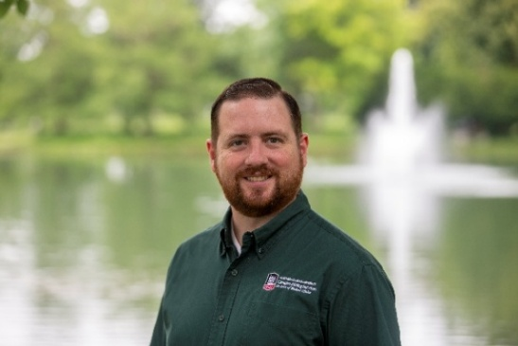
President’s Corner
Greetings Operating Staff.
Change is woven into the fabric of NIU. In our commitment to student success, innovation and community impact, we regularly evolve to meet new challenges and opportunities. Whether those changes are technological, structural, procedural or cultural, one truth remains: Change affects people. How we navigate that change as individuals and as a community defines our strength.
In higher education, we often talk about embracing change as if it is a simple matter of mindset. The reality is more complex. Change, even positive change, can bring uncertainty, increased workloads, shifting expectations and emotional strain. It can disrupt routines, challenge long-held beliefs and create moments of discomfort. Many of us learn to push through these feelings quietly, telling ourselves that being overwhelmed is simply part of the job. We normalize the pressure, we keep going and, too often, we suffer in silence.
But silence is not strength. Your well-being, your voice and your experience matter. Embracing change means more than accepting new processes or policies. It means recognizing that we are not alone in navigating transitions and that leaning on each other is not a sign of weakness but a cornerstone of a healthy and resilient workplace.
Shared governance and shared leadership are core values at NIU, but they flourish only when each of us feels safe and supported in speaking up. If something is not working, if a new process is unclear or if a transition feels overwhelming, your perspective matters and you do not have to navigate those moments alone.
There are many ways to share concerns or ideas. You can speak with a supervisor, a trusted colleague, a personnel advisor or one of the governance bodies such as OSC, SPS Council or Faculty Senate. These groups exist because your voice matters, and meaningful change requires participation from the people who live the work
every day.
If you have a question, an idea or a concern and do not know where to begin, you are always welcome to reach out to me or any member of OSC. We are here to help support and connect with you.
None of us can do this work in isolation. The healthiest path forward through change, uncertainty and opportunity is one we walk together with openness, compassion and a shared commitment to supporting one another.
Take good care,
Jim Slagstad, President
Operating Staff Council 2025-2027
jslagstad@niu.edu | osc@niu.edu

Do You Know If You Are in a Union at NIU?
Many employees are surprised to learn they may already be part of a union at NIU. You do not sign up for union membership. It is based on your job classification. That means you could be covered by a collective bargaining agreement without realizing it.
If you are new to NIU or hired into a new classification, your offer letter will indicate whether the position is represented by a union and which one. Job postings also show if a position is covered and name the union.
NIU has several unions across campus, and different groups fall under different types of contracts. Some employees are under negotiated wage agreements, while others are under prevailing wage contracts. Your rights, pay structure and working conditions come from the agreement tied to your classification, not your title.
The simplest way to know your union status is to check NIU’s Human Resource Services website under “Unions.” The page lists each bargaining unit and the employee groups they represent.
This page also links to the agreements, which outline pay, evaluations, schedules, leave time, overtime, discipline and grievance procedures. Even if you never need to use these procedures, reading your agreement provides clarity.
If you do not know who your union representative is, contact Academic or Civil Service labor relations staff listed on the union webpage.
Understanding your agreement helps ensure you know your rights and the structure supporting your work.

Confessions of a New Editor
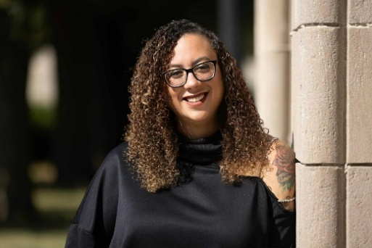
Hello everyone,
I am excited to step into this new role and truly grateful for the opportunity to help share the stories, updates and moments that shape our civil service community at Northern Illinois University. I am also aware that I am stepping into some impressively large shoes. Tawanda did not just set the bar, she decorated it and organized it.
As I get settled, I would love to hear your ideas. If there is something you would like to see featured, expanded, spotlighted or completely reinvented, please reach out. You can email me at jessie.alex@niu.edu, and yes, I genuinely want to hear from you.
Thank you for the warm welcome as I begin this adventure. I look forward to bringing helpful information, engaging stories and hopefully a smile or two in every issue. A full laugh will be considered a professional milestone.
Sincerely,
Jessie Alex

Operating Staff Dependent Endowed Scholarship
MyScholarships makes applying for the Operating Staff Dependent Scholarship easy. Students need to complete and submit the general application and answer one additional question.
The system will be open through Jan. 31, 2026.
For more information, visit the OSC website.
To apply, dependent students should visit the Scholarship Office website.

Give and You Shall Receive
As we approach the holidays, please consider giving back to our NIU community:
- Donate to the Civil Service Emergency Fund.
- Donate to the Huskie Food Pantry.
- Donate to the Operating Staff Dependent Endowed Scholarship Fund.

Employment Changes

September 2025

Welcome New Employees
- Amy Bain, Office Administrator – Special and Early Education
- Sandra Brown, Culinary Worker I – Residential Dining Service
- Christopher Canaday, Culinary Worker III – Residential Dining Service
- Adrianna Davenport, Admissions and Records Representative – Registration and Records
- Jason French, Culinary Worker III – Residential Dining Service
- Alexzander Groce, Culinary Worker I – Residential Dining Service
- Cameron Hampton, Food Court/Snack Bar Attendant – Campus Dining Service
- Ann Kremer, Program Director – Special and early Education
- Cynthia Meisner, Program Coordinator – P-20 Center
- Anthony Ramos, Dietitian Nutritionist – Intercollegiate Athletics
- Douglas Remec, Assistant Food Service Manager – Retail Dining Service
- Emily Ropars, Program Coordinator – Special and Early Education
- Talin Tokat, Program Coordinator – Special and Early Education
- Nneka Williams, Child Development Supervisor – Child Development and Family Center
- Sharetta Young, Collection Specialist – Bursar

Retirements
- Jean Baxter, Program Coordinator – Student Involvement and Leadership Development
- Josephine Burke, Program Director – Art Museum
- Katharine Dempsey, Image Processing Technician II – Integrated Media Technologies
- Michael Fleming, Image Processing Technician II – Integrated Media Technologies
- Rosemarie Henton, Program Director – Chief Diversity Officer
- Julie Miller, IT Technical Associate – Vice President Research and Innovation Partnerships
- Peter Olson, Curator of Art II – Art Museum
- Nancy Robinson, Building Service Worker – Building Services

Separations
- Adrianna Davenport, Admissions and Records Representative – Registration and Records
- Deborah Gomez, Administrative Assistant – Facilities Management
- Taylor Greenburg, Sports Equipment Supervisor – Intercollegiate Athletics
- Cameron Hampton, Food Court/Snack Bar Attendant – Campus Dining Service
- Shawanda Harris, Building Service Worker – Building Services
- Antonio Holloway, Marketing Associate – Intercollegiate Athletics
- Selina Holman, Customer Service Assistant – Bursar
- Alazae Jaros, Human Resource Officer – Human Resource Services
- Karla Ortega, Events Coordinator – Holmes Student Center

October 2025

Welcome New Employees
- Daniell Albert, Office Manager – Campus Dining Service
- Alison Gordon, Program Coordinator – P-20 Center
- Jonathan King, IT Support Associate – Regional Center Operations
- Patti Noyes, Building Service Worker – Building Services
- Sabiha Shaik, IT Technical Associate – Report Cards
- Sharon Sheehan, Program Coordinator – P-20 Center
- Darrin Thompson, Food Court/Snack Bar Attendant

Death
- Thomas Hapeman, IT Support Associate – Infrastructure

Retirements
- Eric Biletzky, Information Technology Manager – College of Health and Human Sciences
- Karen Brint, Library Operations Associate – Libraries
- Devon Buckle, Police Officer – Public Safety
- Daniel Shipman, Building Service Worker – Building Services
- Bradford Smith, Automotive Technician – Transportation
- Mildred Tyne, Accounting Officer – Allied Health and Communicative Disorders

Separations
- Junelle Bennett, Program Director – Chief Diversity Officer
- Peter Challand, Office Support Specialist – English
- Richard Echevarria, Program Coordinator – Family and Consumer Sciences
- Ryan Hanback, IT Support Associate – Regional Center Operations
- Amanda Kraaatz, Financial Aid Coordinator – Financial Aid and Scholarship Office
- Matthew McCue, Human Resource Assistant Manager – Human Resource Services
- Jenna Villani, Office Administrator – English

Service Awards

September 2025

10 Years
- Jacklyn Egolf, Senior Library Specialist, Libraries
- Elizabeth Harrison, Senior Business Manager, Intercollegiate Athletics
- Jennifer Kopecky, Program Assistant, Continuing Professional Education
- Susan Mizgalski, Marketing Associate, College of Education
- Jenna Pracht, Program Director, Orientation and Family Connections
- Skyler Robinson, Storekeeper II, Materials Management

15 Years
- Andrea Allen, Program Director, Student Financial Advising Services
- Sofia Komitas, Culinary Worker II, Residential Dining Service
- Dawn Montgomery, Facility Operations Coordinator, Holmes Student Center

20 Years
- Lucas Bailey, IT Technical Associate, Application Services

30 Years
- Karen Baker, Business and Administrative Associate, Procurement Services and Contract Management

35 Years
- Lisa King, Program Coordinator, CHANCE Program

October 2025

5 Years
- Cathy Davis, Financial Aid Manager, Financial Aid and Scholarship Office
- Ashley Rauen, Administrative Aide, College of Health and Human Sciences
- John Vain II, Procurement Officer, Materials Management

10 Years
- Samantha Bonnell, Storekeeper II – Materials Management

15 Years
- Angela Collin, Culinary Worker II – Residential Dining Service
- Crystal Doyle, Administrative Assistant – President’s Office
- Angela Gray, Program/Student Advisor – Accountancy
- Christine Lagattolla, Program Coordinator – Vice Provost
- Sara Richter, Library Specialist – Libraries
- Eric Schetley, IT Support Associate – College of Health and Human Sciences

20 Years
- Elizabeth Wright, Executive Assistant – President’s Office
- Jason Wright, Police Sergeant – Public Safety

25 Years
- Kellie Fuss, Child Development Supervisor – Child Development and Family Center
- Diane Mathison, Child Development Supervisor – Child Development and Family Center
- Brian McCarthy, Food Service Sanitation Laborer – Residential Dining Services

30 Years
- Amy Deegan, Office Administrator – Cener for Innovative Teaching and Learning
- Jonathon Ostenburg, IT Technical Associate – Application Services
- Robert Spangler, Heavy Driver – Materials Management
- Jessica Webb, IT Technical Associate – University Marketing

Resource Access Feedback Request
We are collecting a list of policies, procedures and tools that are difficult to locate or have moved. If you have trouble finding a resource, or frequently help others locate one, please email osc@niu.edu. Your feedback helps improve access across campus.
Northern Staff News is published by the Operating Staff Council of Northern Illinois University.
Editor: Jessie Alex.
Contributors: John Acardo, Grace Hook, Rave Meyer, Jay Monteiro, Jim Slagstad.
Graphic Design: Holly Nicholson.
Northern Illinois University is an equal opportunity/ affirmative action institution. Printed by authority of the state of Illinois.
niu.edu 12/25.

