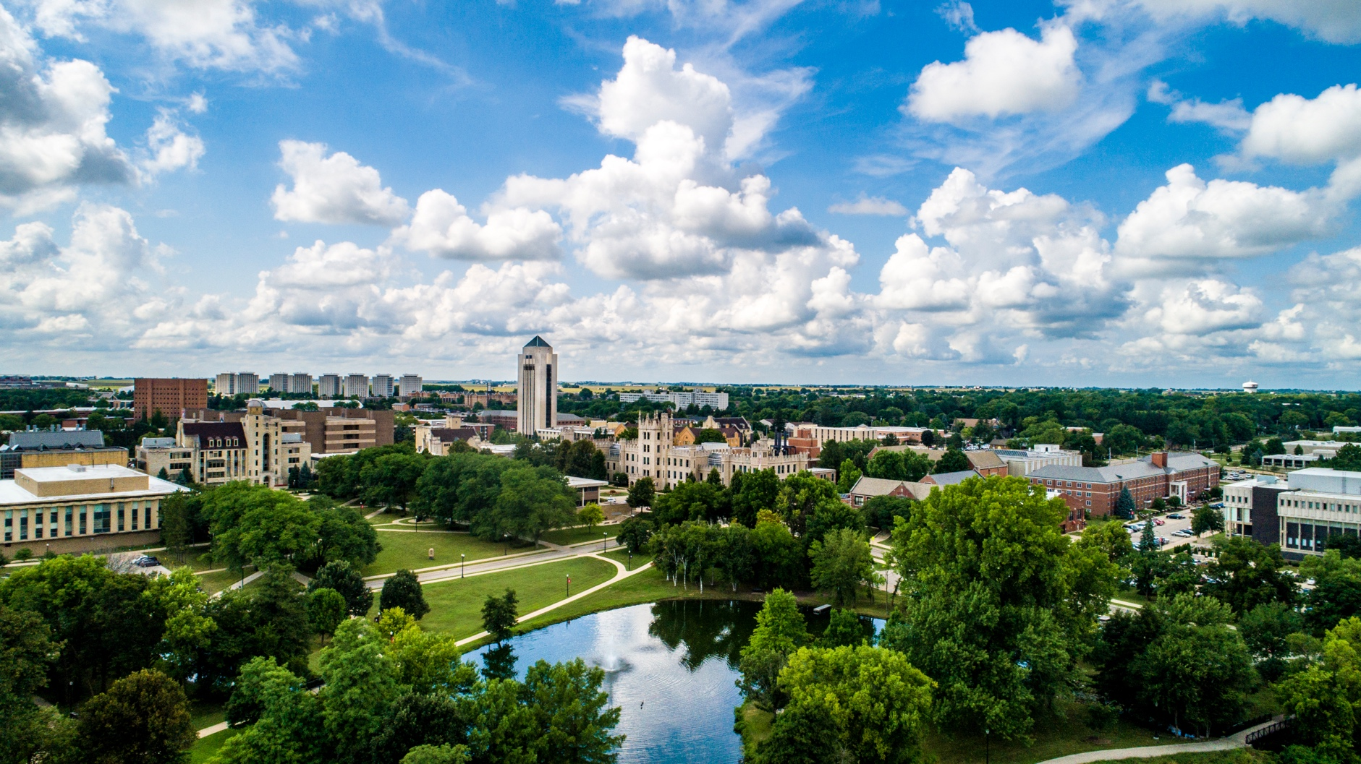

Northern Illinois University

# Northern Staff News

# January 2024

niu.edu/operating-staff-council | osc@niu.edu

Contents

President’s Corner 1

Jan. 31 Deadline for the Operating Staff Dependent Endowed Scholarship 1

Confessions of a Seasoned Huskie 2

Presidential Award for Staff Excellence 3

We’re Almost There! 3

Crucial Conversations 3

Employment Changes 4

November 2023 4

December 2023 4

Service Awards 5

November 2023 5

December 2023 6

**OSC Meetings and Minutes** can be found on our [OSC website](https://www.niu.edu/operating-staff-council/meetings/index.shtml).

## President’s Corner

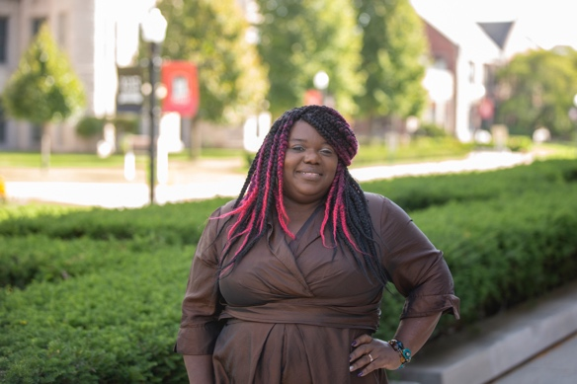Greetings Operating Staff,

Happy New Year! I hope you all were able to enjoy the holidays and a well-deserved break. Hello 2024! As we begin the journey of a new year, let us look at all the opportunities this year will bring. Let’s continue to keep our students at the forefront of all that we do.

With many of our employees working from home, the weather should not be an issue, but for those of us who are working on campus, if you must go out in this weather be sure to bundle up and consider keeping [emergency supplies](https://www.almanac.com/content/winter-car-emergency-kit) in your car.

I encourage you to attend our [upcoming OSC meetings](https://www.niu.edu/operating-staff-council/index.shtml) March 7 and April 4. Our meetings are on the first Thursday of every month and start at 9 a.m. Our presenters will be CFO George Middlemist and President Lisa Freeman. This is a perfect time to ask any questions that you may have. All the meetings are currently hybrid, so it makes it easier than ever to listen in. I am looking forward to all the new year has to offer. Here’s to a great start for the semester.

**Natasha Johnson**  
President, Operating Staff Council 2023-2025

[njohnson11@niu.edu](mailto:njohnson11@niu.edu) | osc@niu.edu

## Jan. 31 Deadline for the Operating Staff Dependent Endowed Scholarship

This is a reminder that our annual [MyScholarships](https://www.niu.edu/financial-aid/scholarships/my-scholarships/index.shtml) application is closing soon. This single, general application is used for multiple 2024-2025 NIU-offered scholarships, including our [Operating Staff Dependent Endowed Scholarship](https://www.niu.edu/operating-staff-council/scholarship/apply.shtml)**.** The deadline to apply for this and many other of these NIU scholarships is Jan. 31. Our [Operating Staff Dependent Endowed Scholarship](https://www.niu.edu/operating-staff-council/scholarship/apply.shtml) is a scholarship opportunity for NIU students who are the children of NIU operating staff (civil service) employees. This scholarship is made possible by the fundraising activities of civil service employees. Eligible students should complete and submit the general application, search for “Operating Staff Dependent Endowed Scholarship,” and then answer one additional question to be considered for this award for the 2024-2025 academic year. Please share this information with your students. If you would like more information, visit our [Operating Staff Council Dependent Scholarship](https://www.niu.edu/operating-staff-council/scholarship/index.shtml) webpage.

For additional assistance with the MyScholarships application system, students can contact our [Scholarship Office](https://www.niu.edu/financial-aid/scholarships/index.shtml) via email at [scholarships@niu.edu](mailto:scholarships@niu.edu).

If students have questions about how to maximize their financial resources or how to create a financial plan for the upcoming academic year, encourage them to schedule a virtual, phone or in-person appointment with our [Student Financial Advising Services](https://www.niu.edu/financial-advising/index.shtml) team or email [financial-advising@niu.edu](mailto:financial-advising@niu.edu).

## Confessions of a Seasoned Huskie

**Employee Seasoned Huskie:** Patricia Wallace **Department:** Research and Innovative Partnerships **Title:** Assistant Director for Research Compliance, Integrity and Safety **Hire Date:** August 2003  
  
We are honored today to welcome Patricia Wallace who has over 20 years of experience working at NIU. Her most recent role supports our faculty’s research, which is a major function of our university. So, let’s get started.

So, Patricia…

*Hi, Tawanda. No need for formalities. Please call me Patty.*

Great, Patty, what’s the biggest misconception people have about your current position at NIU?

*People think my job is monotonous and boring, but really, I solve new problems every day. There’s a lot of day-to-day activity that is very similar, but I get to know people all across campus and learn about all the new research ideas taking place here at NIU and elsewhere.*

That does sound exciting. When you think of all the departments you’ve worked in, what made the best department you’ve worked in the best?

*People can make or break any work environment. My favorite departments/places have always been the ones where I enjoyed the people. For me, the most positive energy comes from groups who work hard but find time to laugh together.*

I can feel you on that one. What’s the best advice you’ve ever heard or received?

*“Be the reed.” This was said to me in reference to an issue with a student in a class I was teaching many years ago. The man who said it was (and still is) a rather intimidating, well-respected neuroscientist who didn’t have a lot in common with a   
five-foot, one-inch woman who was fairly new to the academic field. I used to think I had to always push against any resistance from others in order to prove myself, but at that moment when he told me to “be the reed,” I realized that I could bend a little while still maintaining my beliefs and standards.*

That’s really something to think about. What other tips can you share that helped you make it at NIU for all your years here?

*Get involved in the things you enjoy! I’ve had a lot of good opportunities that came my way through NIU that weren’t tied to my work. I’ve been a part of FMLA policy changes that benefitted all employees, but I’ve also learned to play guitar through the Community School of the Arts, and I participated in Science Riot where I taught people about the joys of researching human behavior through a stand-up comedy routine.*

Wow! Those sound like really fun experiences. What’s the coolest thing you’re working on right now?

*I’m co-authoring a book on sexual consent/assault based on a few research projects I did here at NIU. After a few papers were published on our work, a book publisher reached out to us asking for a book proposal (if we were interested) that they later accepted. I never would have thought of myself as a book author, but apparently that’s exactly what’s about to happen.*

Insane! Sounds to me like you must get bored easily with such a variety of activities you’re involved with. Tell me something else wonderful that’s happened to you.

*Last spring, I was in the middle of a bedroom makeover when I had to go to Ohio to help my extended family with some things. When I got back to Illinois, my daughters surprised me by finishing up my bedroom (wallpaper down, walls smoothed, fresh coat of paint). To top it off, they got me a lovely golden monkey lamp that I call “Scabbers.” He watches over me while I sleep.*

Aww, how sweet! Do they do windows? Changing gears, what is your most irrational fear?

*I suppose it’s centipedes, but I’m not sure that it’s an irrational fear. Have you spent any time with one?*

We have the **same** fear. I think they are very creepy, so also not sure if the fear is irrational. Let’s move on to a more popular topic. Now that we are in the winter months, many of us like to spend time enjoying our favorite foods. Which recipe are you known for?

*Sticky toffee pudding. I know it sounds unpleasant, but it’s so yummy. I think this was made during the holidays when I was growing up. I remember there being this messed up looking cake in a pan with some sauce nearby. I never ate it. Fast-forward several decades, and I tried a store-bought sticky toffee pudding at my in-laws. It was so good that it motivated me to look for it in my cookbooks. I found one in “The Joy of Cooking.” I took a chance and made it one year, and now it’s a crowd favorite. If you make it, be sure to use the butterscotch sauce recipe in the same book.*

I’ll definitely have to try that one. One more question for the road. Let’s end it on a positive note. What’s something that recently made you smile?

*I went to the winter graduation. I love to see all the excitement on their faces. It’s hard not to smile!*

I totally agree. It just reminds us that we do work for a university and the students are what it’s all about. Thanks so much for sharing your thoughts and experiences with us on this cold wintery day. It goes to show that there is more to our staff than meets the eye 😊.

If you would like to volunteer to be featured as our next seasoned Huskie or rookie, please send an email to me at [tgipson1@niu.edu](mailto:tgipson1@niu.edu).

## Presidential Award for Staff Excellence

The Presidential Award for Staff Excellence recognizes up to six staff members per year who have gone above and beyond the specific duties assigned to them and have demonstrated excellence in their work. These individuals positively influence the work environment, foster cooperation, achieve goals and/or overcome obstacles/challenges while fulfilling employment responsibilities.

Criteria:

* Be a regular staff member working at least 51% time with at least six years of service to NIU, or a full-time temporary staff member with at least six years of service to NIU.
* Have demonstrated a record of excellent service at NIU that goes above and beyond basic requirements of position/role.
* Have demonstrated how they positively influence their work environment, the campus and/or the community through their efforts.
* Have not received an SPS Presidential Award for Excellence or Operating Staff Outstanding Service Award in the past.
* Nominations are encouraged in all staff classifications where eligible staff members have demonstrated excellence in their efforts on the job.

Presidential Award for Staff Excellence recipients will receive a stipend of $2,500 each and recognition at our annual staff awards event. The deadline for [submissions of nominations and references](https://niu.az1.qualtrics.com/jfe/form/SV_1AqQZcLGWm2WVCe) is Monday, Feb. 12.

## We’re Almost There!

Please donate to our [Operating Staff Emergency Fund](https://www.niu.edu/operating-staff-council/emergency-fund/index.shtml). We’ve had several requests for assistance but haven’t enough to distribute yet. We’re almost there — please consider donating. A little goes a long way. You may donate by payroll deductions or a one-time donation.

## Crucial Conversations

“[Crucial Conversations](https://hrs.news.niu.edu/2023/12/07/spring-crucial-conversations/)” is a two-day, in-person training course led by John Acardo, senior associate vice president and chief human resource officer. This course focuses on fostering effective communication and mastering dialogues that are crucial to an organization’s health and effective performance. If you have an interest in considering advanced skills for engagement, efficiency and equity in your work, we encourage you to join us for “Crucial Conversations.” (The presenter is not paid for this activity).

## Employment Changes

### November 2023

#### Welcome New Employees:

#### Matthew Boerema, Building Service Worker – Building Services

#### Alaina Eubanks, Culinary Worker II – Residential Dining Service

#### Stephanie Fasso, Food Court/Snack Bar Supervisor – Residential Dining Service

#### JaNiaya Flowers, Security Guard – Public Safety

#### Vitaliy Koen, Graphic Designer – University Marketing

#### Deanna Mershon, Program Coordinator – Regional Development Institute

#### Lindsey Mueller, Program Coordinator – Continuing Professional Education

#### Mackenzie Myers-Riggs, Police Telecommunicator – Public Safety

#### Juan Navarro Jr., Program/Student Advisor – Student Athlete Academic Support Services

#### Kelly Newlin, Human Resource Officer – Human Resource Services

#### Melissa Robinson, Office Manager – Visual and Performing Arts External Programming

#### April Startzel, Program Coordinator – P-20 Center

#### Hudsondra Townsend, Residence Hall Attendant – Housing and Residential Services

#### Kristion Washington, Residence Hall Attendant – Housing and Residential Services

#### Death

#### Joseph Essex, Food Sanitation Laborer – Residential Dining Service

#### Retirements:

#### David Finlay, Construction Project Coordinator II – Architectural/Engineering Services

#### Delyce Turner, Building Service Worker – Building Services

#### Separations:

#### Eric Armstrong, Program Director – Military Student Services

#### Keith Chartrand, Marketing Associate – Intercollegiate Athletics

#### Gaylen Rivers, Program Assistant – Center for Black Studies

#### Stephen Samuels, Program Coordinator – College of Engineering and Engineering Technology

#### Jeremy Stewart, Carpenter – Physical Plant

#### Hudsondra Townsend, Residence Hall Attendant – Housing and Residential Services

#### Noah Wilson, Office Manager – Physics

### December 2023

#### Welcome New Employees:

* Robert Barton, IT Manger/Administrative Coordinator – DoIT-Admin-Business-Finance
* Evan Castaneda, Building Service Worker – Building Services
* Nicole DeRango, Administrative Assistant – Intercollegiate Athletics
* Michelle Fleming, Building Service Worker – Building Services
* Elsye Jones, Athletic Communications Associate
* Jaleeza Kinney, Building Service Worker – Building Services
* Hailey Manzano, Child Development Supervisor – Child Development and Family Center
* Shannon Meier, Office Support Specialist – Lorado Taft Operations
* Kelli Sinclair, Admissions and Records Associate – Registration and Records
* Tyrrell Tomlin, Senior Events Coordinator – Conferences Event Management
* Allison von Ende, Program Coordinator – Huskie Academic Support Center

#### Separations:

* Carrie Aldrich, Program Coordinator – Disability Resource Center
* Kendall Brenneman, Program Assistant – Orientation and Family Connections
* Fern Evins, Snack Bar Attendant – Residential Dining Service
* Michelle Fleming, Building Service Worker – Building Services
* Kelly Gustafson, Accounting Officer – Accounts Payable and Travel
* Jensen Heldt, Human Resource Representative – Human Resource Services
* Jay Jarvis, Program Assistant – Orientation and Family Connections
* Erica McFarland, Program/Student Advisor – College of Engineering and Engineering Technology
* Ariel Owens, Program Director – Diversity and Equity
* Melissa Robles, Business/Administrative Associate – Center for Governmental Studies

## Service Awards

### November 2023

#### 5 Years:

#### Zachary Birch – Housing and Residential Services

#### Maya Croslow – Holmes Student Center

#### Naina Richards – Disability Resource Center

#### Clinton Rosebourgh Jr. - Center for Child Welfare and Education

#### Stephen Swed – Chemistry and Biochemist

#### Jingzhi Zhang – Office of Information Security

#### 10 Years:

#### Andria Maxwell – Psychology

#### 15 Years:

#### Dean Coyle – Infrastructure Services

#### Gayle Ewald – Financial Aid and Scholarship Office

#### Craig Fritz – Application Services

#### Katie Juraska – Building Services

#### Mark Whitely – Operation Services

#### 20 Years:

#### Diana Caldwell – Admissions Tours and Events

#### Derek Carter – Building Services

#### Alexander McConachie Jr. – Enrollment Management

#### Lesly Schoo – College of Law

#### 25 Years:

#### Eric Biletzky – Vice President Research and Innovation Partnerships

#### Cara Carlson – Vice President Research and Innovation Partnerships

#### Rebecca Ferrante – Development Operations

#### Patrick McCarthy – Biological Sciences

#### 50 Years:

#### Connie Weaver – College of Business

### December 2023

#### 5 Years:

#### Alexandria Blake – College of Health and Human Sciences

#### Courtney Cochrane – Conferences Event Management

#### 10 Years:

#### Jason Stiegman – Grounds

#### Tracy Wescott – Holmes Student Center

#### 15 Years:

#### Johnathon Foster – Heating Plant

#### Paul Wrezinski – Housing and Residential Services

#### 25 Years

#### Varsie Geisler – Health Studies

#### 30 Years:

#### Peter Olson – Art Museum

Northern Staff News is published by the Operating Staff Council of Northern Illinois University.

Editor: Tawanda Paul.

Contributors: Natasha Johnson, Jay Monteiro, Angie Gutiérrez-Vargas, Jason Reed, Karen Smith, Philip Terry.

Graphic Design: Holly Nicholson.

Northern Illinois University is an equal opportunity/ affirmative action institution. Printed by authority of the state of Illinois.

niu.edu 1/24.