SOCIAL PSYCHOLOGY - PSYCHOLOGY 372
Section 3, Reference #4538
Spring, 2015
© Copyright, John J. Skowronski, 2015
T, TH............. 9:30AM – 10:45AM............... 3 Credits .............. PM 110
SAVE THIS SYLLABUS FOR FUTURE REFERENCE!
Information in this syllabus is subject to changes and additions announced in class!
There WILL likely be some changes, so come to class!
Warning!!!!! The concepts, ideas, and words used in this class may challenge your sense of ethics and morals and your way of thinking about the world. If you are easily offended or cannot handle such disquieting information, think about looking elsewhere for your social psychology.
Rating: NC - 17 (rated for occasionally foul language and both sexual and violent content -- and I mean it!)

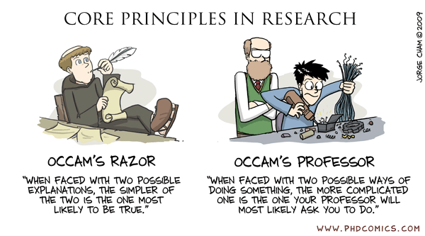

COURSE DESCRIPTION FROM THE NIU BULLETIN
Behavior in the context of social interaction, with emphasis on experimental findings. Study of such topics as interpersonal judgment and perception, social attraction, aggression, prejudice and social influence, including attitude formation and persuasion, conformity and social modeling. (Yawn!)

THE REAL SCOOP: DR. JOHN'S DESCRIPTION
The stuff in this course deals with some of the most interesting questions in psychology! Why do some people have such weird ideas about other people? Why can't different groups get along? Why do advertisers run those boring ads millions of times on TV? What does it mean to fall in (and out) of love with someone else? Is there a difference between love and lust? Can people really be brainwashed? I get juiced just thinking about all this stuff! I hope that you get as EXCITED about social psychology as I am!!!
In addition to exposing you to the fascinating world of Social Psychology, I have a few other goals. I want to expose you to how psychologists think, how they do research, and what the results of the research mean (note: they might not mean what you think they mean). I hope to make you immune to some of the BULL MANURE that passes for psychology these days, especially in the popular media. It is easy to philosophize (e.g., spread bull patties) about psychology, but philosophical speculation is not fact. Truth lies in REPLICATED DATA: In evaluating claims, I want you to always focus on the REPLICATED DATA.
I also hope to use this class to help you learn more about your favorite topic: YOURSELF.
Finally, I hope to use this class to help sharpen up some of those skills that you will need in the real world: how to prepare, how to read, how to write, and how to critically analyze real-world situations in terms of social psychological ideas and principles. Let's roll!

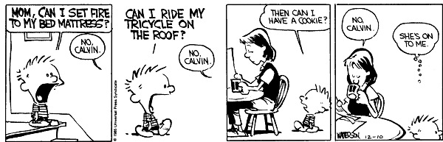

EXECUTIVE SYLLABUS SUMMARY

Textbook:

Kendrick, D.T., Neuberg, S.L., & Cialdini, R.B. (2015). Social Psychology: Goals in Interaction (6th Edition). Boston: Pearson Publishing. ISBN13: 987-0-13-381018-9

Social Psychojeopardy and Exams:

Social Psychojeopardy will test your knowledge about the book every day: You can earn extra credit by answering the Social Psychojeopardy questions.
Four exams are scheduled - see syllabus outline for chapters assigned for each.
For exams, bring some #2 pencils and a nice eraser.
Exams are multiple choice, 60 items, 1 point per item.
Exam questions will cover material from both class and textbook.
Exams are non-comprehensive, so there is no comprehensive final exam.
See course outline for material covered & exam dates, date change is very unlikely.
All make-up exams administered during university-assigned final exam period:
Thurs. May 7, 10:00a.m. - 11:50 a.m.

Papers:

Six one-page thought papers are required.
Satisfactory, on time completion of six papers will earn 30 points.
Two additional papers can be done for extra credit (3 points each, 6 points max.).
Additional extra credit can be obtained by using the writing center as a part of your revising process (1 point per documented visit; 8 points max.).
For each paper, take a concept from the assigned chapter that is unfamiliar to you and relate it to an event in your life (see examples at end of syllabus).
Papers are due at the beginning of class on the dates listed in the syllabus.
Late papers will not be accepted.
These are practice job/graduate program applications: Papers need to be well-written with few errors, or your application gets tossed in the trash (metaphorically, of course).

Grading:

Grades are determined by simply adding up the points obtained from the various class assignments and comparing the total points obtained to the grade scale described on page 20 of this syllabus.
Your professor does not mess with the grading system, so it is highly unlikely that the grading scale will change or that you will be capriciously allocated extra points (even if you say pleeeeeeeeeeeeeeeeze!).
In the event that additional extra credit is available, it will be available to all students and will also serve to meet the needs of graduate student research projects. Such opportunities will be announced in class or via e-mail.

Cheating:

You cheat, you get caught, you fail the course. No appeals.
ABOUT YOUR PROFESSOR



Name: John J. Skowronski Aliases: Dr. Skowronski, Dr. John, Dr. J.
Feel free to call me whatever you like -- just be careful what you call me to my face!
NIU Rank: Full Professor (and people generally think that I'm full of it!)

Birthplace: Chicago (South Side, inner-city….so don't even THINK of messing with me…)

Degrees: M.A., Ph.D., University of Iowa, B.A., Augustana College (Il.)
Go Harwks! Go Vikings!
Yes, as much as it amazes you, I am a Ph.D. --- that means I can, indeed, Pile it Higher and Deeper.
A FEW OF DR. SKOWRONSKI’S PROFESSIONAL HIGHLIGHTS
Co-author of the book Autobiographical Memory (Lawrence Erlbaum Publishers)
Co-editor of the book First Impressions (Guilford Press)
Author or co-author of over 125 professional journal articles and book chapters.
Former Associate Editor, Social Cognition and Journal of Experimental Social Psychology
Recipient, {Go Buckeyes!} Ohio State University Alumni Award for Distinguished Teaching (back in my former job, they were under the mistaken impression that I could actually teach.....).

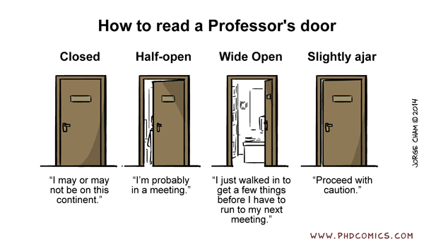

CONTACTING DR. SKOWRONSKI

PM Office: 418 PM Office Phone: 753-7073 E-mail: jskowron@niu.edu

FVC Office: 115a FVC Office Phone: 753-0529
As pro golfer Fred Couples once said, the problem with answering the phone is that there might be someone on the other end. As this suggests, chances are that if you call me, you'll have to leave a message on my voice mail. Checking phone messages is generally low priority on my list of things to do. Because I sometimes neglect to check voice mail, E-mail is probably a better place to leave messages. At least I check e-mail occasionally - usually daily.
Office Hours: W 8-11 am and by appointment
Feel free to make appointments to see me -- whatever reason is good enough for you is good enough for me! You can even take a chance and just drop by if you are feeling lucky. However, I am often heavily scheduled for appointments during office hours, so appointments are safer. Bring along pizza and root beer, just to make sure I'll let you in to my office.
I'm yours to use in this course (use me....ohhhh, please use me!). Ask me for help in the course, and I'll do my best! I'm here to help you learn about social psychology in whatever reasonable way that I can.

COURSE TEXTBOOK

This book is available in the University bookstore and may be available in VCB or at on-line sources (e.g., Amazon.com).

Please buy your book quickly -- you will need to start reading it today. Make sure that you buy only this textbook, not the books possibly used in other sections of this course on this campus, or other courses elsewhere.

Do NOT buy last semester’s book (which was the 5th edition). Yes….the current book (6th edition) is different.

I happen to believe that this is the best Social Psychology book out there. Of course, I also believe that Elvis is alive and was abducted by wild alien women from the planet Amazonia....

You MAY choose to use the equivalent e-version of this book. However, if you do so, you are on your own. I offer NO tech support.
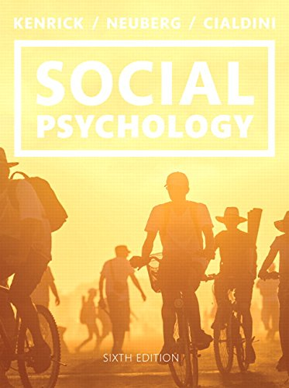

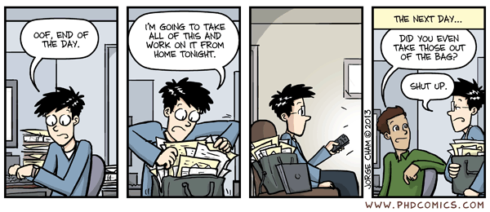
COURSE PHILOSOPHIES AND ASSIGNMENTS
My main goal in this course is to MAXIMIZE the extent to which you LEARN about and UNDERSTAND Social Psychology. After all, when it comes down to the nitty-gritty, it is not about your grade, or your attendance, or your ability to suck up to the course professor. It’s about your ability to KNOW about social psychology, to UNDERSTAND social psychology, and to see how social psychology APPLIES to your world.
Thus, in this class I try to do stuff, and to have you do stuff, that promotes: (1) knowledge, (2) understanding, and (3) your ability to apply social psychology. We don’t have time to waste on crud that does not work toward these goals. Here are some of the behaviors and tasks that will promote long-term learning and understanding:

(1) Read the Textbook – HARD! (This does NOT mean hardly read…)
One principle that guides this class is "READ EARLY AND READ OFTEN!" It is amazing how little value some students place in preparing early and often. Why am I emphasizing this? Simple – it’s SCIENCE! The data from the expert researchers in learning indicates that maximum learning occurs when you read early, when you read often, when you re-read material several times, and when you think about and apply what you read as you read it. Thus, because the goal in this course is to maximize learning, I expect you to be doing these things for this course.
We both know that some students think that they can adequately learn via the "power-cram-take-no-doze-read-the-chapters-once-the-night-before-the-test" method of study. If this is the way that you going to try to learn social psychology in this course, save us both a lot of pain and get the heck out now. If you stay in this course and try to get by with this method of study, you’ll get pissed off and blame me when this power cram method fails (as reflected in the grades that you will earn on exams), and I’ll get pissed off because I will perceive you to be wasting your opportunity and not trying very hard to learn (as an inner-city kid, I take opportunity very seriously). Why should we both get pissed off at each other? If you do not plan to put in the time and hard effort needed to learn social psychology, then why the heck are you even here?
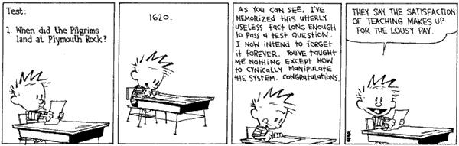

(2) Social Psycho Jeopardy!

To encourage you to read early and often, at the beginning of most class periods we will play a social psychological version of Jeopardy in which I give you an answer and you must provide the correct question to the answer.

In my role as the evil quizmaster Alex Trebek, I will present the answers and will decide if your questions are correct -- and all decisions of the judge are final (Sheesh! This is worse than Judge Judy!).

Your odds of being called on during these Psycho Jeopardy sessions are high, so you need to come to class prepared unless you want to look like an ignorant doofus (Who knows? Maybe ignorant doofushood is fashionable these days). To be prepared, you need to read the textbook chapters in advance….HARD! The textbook chapters that will be the source of the Social Psycho Jeopardy questions for each class period are listed in the course outline.

In addition to helping you to learn the material better so that you will do well on the exams, each correct question will get you 1 BONUS POINT toward your final grade. This is one of the few sources of EXTRA CREDIT POINTS in the course, so if you want extra credit, START READING THE BOOK NOW, KEEP READING and READ EARLY AND OFTEN (a good thing to do in all your classes, not just in this class).

(3) Practice Job/Grad School Application Papers
I will give you the opportunity to write one short paper for each chapter from chapters 2 through 13. The point of each paper will be to relate a social psychological concept, theory or research finding that you learned about to a personal experience that you have had in your lives. Examples of such papers are presented at the end of this syllabus.
Why are you doing this? The task has two goals.
Skill assessment/improvement. Well, many of you will be applying for jobs/graduate school soon! As a part of the application process, people ask you to write stuff! Is YOUR writing ready to be put to the test? Write a lousy paper or one with too many errors and your application will be tossed into the circular file so that your prospects will be reduced to careers in which the only critical phrases you need to know are things like “you want fries with that?”
Imagine that you are applying for a job at Amalgamated Widgets Corp., or that you are applying for a graduate school Ph.D. program at Humungous University. Also imagine that as a part of the application process, you are asked to write a one-page paper describing a psychologically important event in your life. This is more than just a simulation: During the application process, some places actually do this.
Can you write a document that passes muster for the job/grad school application process? If, not, how can it be better? That’s what this task is about…to HELP YOU GET BETTER.

You want these papers to be accurate in content and to be written well! This is a formal application – you must use standard English: Make no punctuation errors; write complete sentences; present an organized paper. Each paper will be scrutinized carefully by the HR Department/Admissions Committee – which is ME. As are many HR Departments/ Admissions Committees, I’m a tough f&*%&*$&!! bastard who will be looking for any flaw. After all, I have applications from hundreds of people for each position I have, so I’m looking for any excuse to toss your application into the circular file. Can you make these personal experience papers good enough to avoid the circular file?
I’ll give you an assessment of how well you did on these papers (did you pass through triage?) and will try to provide feedback on writing details. If you pay attention to the feedback, you can improve your writing.
Learning goal. In addition to skills assessment, these papers also have another point: learning. The data from my colleagues who study learning suggest that one very effective way to promote long-term learning is to relate the material to be learned to the self. That’s exactly what each paper asks you to do.
To do each paper, for each chapter that you work from select a principle, idea, or theory. It can be any principle or theory discussed in the chapter – affordances, self-perception theory, pluralistic ignorance, basking in reflected glory, using downward social comparisons to make you feel better about yourself – just make sure that the concept is contained in the assigned textbook chapter for a given week.
Then, describe an episode or incident from your own life that you can now see is relevant to the selected principle or theory (see examples at the end of the syllabus).
For example, one of my summer jobs when I was in college was to work as a stock clerk in a department store named Goldblatt’s. I was a summer employee who was just there for a couple of months, but there were other clerks that were “lifers” who were not aware that I was just there for a short time. Because I tend to work hard at whatever I do, the “lifers” perceived that I was trying to get a promotion. As a result, I was treated negatively by that group (e.g., was socially rejected and was subjected to hazing).
Thus, if I were doing the class writing assignment, I could relate this incident to the notion that group members “reject the deviate”, and often use negative treatment, power, and persuasion to enforce those norms so that group members “toe the line”. Those who don’t “toe the line” can be rejected, hazed (e.g., being fire-extinguished in a freight elevator), or worse.
Thankfully, the hazing stopped after people realized that I was just a summer employee, so I was not a threat to their jobs. Of course, it also stopped after they made me so angry that I threw a box springs unit at them….but that’s an incident that may be best described in the chapter that discusses causes of aggressive behavior …..
A few rules for these papers:
(1) These papers MUST be word-processed, and SHOULD be NO MORE THAN two pages in length. ONE PAGE IS PREFERABLE as long as you meet the assignment requirements;
(2) Make TWO copies of each paper, and keep one for yourself. You may need to produce this copy if my records get screwed up (and they will);
(3) Use ONLY your alias (more about that in class) as your identifier on your paper - no real names please! Again, this will help prevent you from embarrassment when I post your paper in the hallway and publicly identify it as a good/bad paper.
(4) Bring your papers to class. The deadline for submission is the beginning of class on the due date; the end of the daily psychojeopardy session is the time at which the submission window is closed (and this will be reflected by the ceremonial closing of the paper-carrying briefcase). No, I will not accept papers submitted via e-mail, or that are put in my mailbox, under my car’s windshield wipers, slipped under my office door, etc. If you want to turn a paper in early, give it to me in class on a day before the due date.
(5) The papers will receive one of two grades: either a 1 (Satisfactory) or a 0 (Unsatisfactory - a waste of my time). A paper will be graded as unsatisfactory either if it does not satisfy the assignment OR if has so many technical errors that I get royally ticked off at your lousy writing. You will not have the opportunity to rewrite these papers after turning them in, so do your rewriting before you turn them in. Do the best job that you can on every one of them.
(6) Finally, no papers will be accepted after the deadline. I repeat … no papers will be accepted after the deadline. I repeat … no papers will be accepted after the deadline. Got it? I hope so, because no papers will be accepted after the deadline.

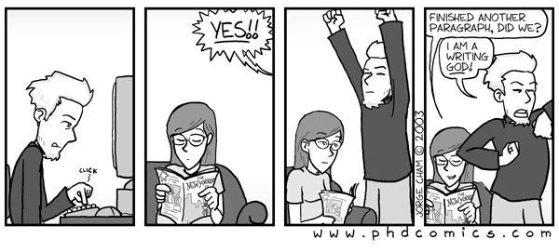
It is important for you to remember that these papers are about YOU. Think Oprah here -- I want self disclosures ... but self disclosures that are related back to NEW social psychology that you have learned by reading the book or by attending class.
Here are a few examples to help you to get started: (1) We will be talking about cognitive dissonance in class - have you ever experienced cognitive dissonance? When did you experience this? Why? How did you feel? What happened? (2) We will be talking about the power of ambiguity in person perception. Can you think of an event in your life in which ambiguity had a powerful effect on how you might have thought about another person – or how they might have thought about you? (3) The text will describe how salespeople use compliance techniques such as the “low-ball” technique. Describe a time when you were low-balled. How did you feel? Did you give in?
Because one purpose of this task is to promote learning, it would be best if you dug deep here and to relate stuff in your life to social psychology that is NEW TO YOU IN THIS COURSE, not to social psychology that you basically already understand (e.g., basic concepts such as prejudice). However, because I cannot judge what’s new to you, I’ll take whatever you give me – as long as you use the principle or theory correctly, and as long as the paper is done well.
In addition to promoting learning, I want to use these papers to help you to understand others. The social psychological data suggest that social interactions benefit when people can see others' perspectives and can develop empathy for others. Hence, I intend to share some of these papers with others both inside and outside the class. PLEASE BE AWARE IN ADVANCE THAT THESE PAPERS WILL BE IN THE PUBLIC DOMAIN!!!!! I often post them in the hallway outside of class, sometimes with commentary, or I may read them in class or post them on the Web. Hence, do not put stuff in these papers that you don't want the world to know about you, and always use YOUR ALIAS to help maintain your anonymity.
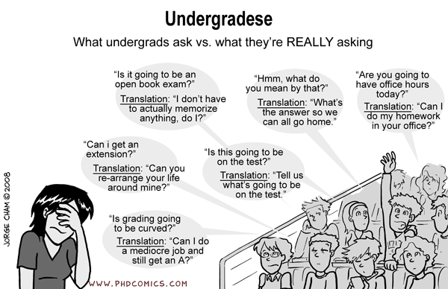_
There is no need to “pad” these papers! One page is fine. Thus, don't spend a lot of time defining or explaining the principle; just mention it at the start of the paper so that I know what you are trying to talk about.
Finally, remember that you have 12 opportunities to complete 6 satisfactory required papers. However, it would be a mistake to think that completion of any of the papers is optional. The first 6 papers are REQUIRED. The last 6 papers are there JICYFU or JICLFYO (your instructor can clarify the meaning of these acronyms in private conversation) This procedure reflects the fact that the course builds in “second chances” – those last 6 papers are your “make up” papers in case stuff goes wrong on one or more of the first 6 papers.
Remember that I make no decisions in this class: they are all pre-made. One pre-made decision is that if you fail to complete 6 satisfactory papers, you get 0 points. Don’t do that to yourself. Don’t fall into the trap of procrastination, waiting until the last minute to complete all the papers. There always seems to be a student or two who makes that mistake and thinks that they will somehow be given the chance to make up the work. The last 6 papers ARE your chance to make up work if you don’t turn in any of the first 6 papers. You get no more chances after those are gone.

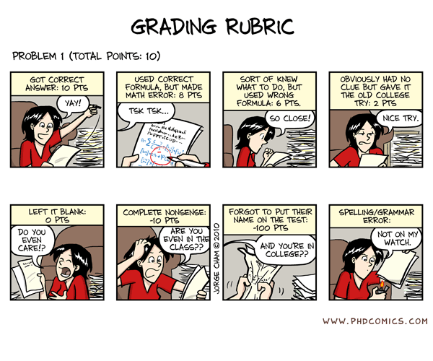

Maybe it’s because I was raised by a mother whose first language was Polish, but for me, as for many others, writing is never easy. My first drafts are almost always flawed – badly. However, I tend to be able to get things into better shape as I make revisions through multiple drafts. Thus, my experience as a writer (a book, and edited book, and piles of chapters and journal articles) has led me to believe that good writing relies on good self-editing. Moreover, I like to “put a paper away” for a while, and then come back to it later with “fresh eyes”. It is often amazing to me how easy it is to spot flaws after one takes a respite from a paper. Try this technique yourselves. That is, try starting these papers early, then shaping them through multiple revisions.
Getting Writing Help at the Writing Center
This revision process can be helped by consulting writing experts before you submit a paper. The university has a writing center (http://www.niu.edu/uwc/, 815-753-6636) and writing coaches who can help you to revise your papers.
If you choose to use the center:
- set up an appointment - you will need to set up an appointment well in advance of the assignment due dates (especially the later assignments – appointment slots quickly fill up toward the end of a semester).
- Take TWO copies of your paper to the writing center.
- After your session, make revisions to your paper.
- Submit to me three things: Your original paper, a writing center-stamped copy of the feedback form, and a revised paper.
Summary of Course Writing Component
You need only complete 6 satisfactory papers to fulfill the assignment for 30 points. Papers will be judged to be unsatisfactory if they misuse the psychological principle OR if they are badly written OR if they contain too many technical errors. Remember, you need to turn 6 ACCEPTABLE ON-TIME papers to complete this assignment!
YOU CAN EARN 6 POINTS OF EXTRA CREDIT FOR EACH ADDITIONAL SATISFACTORY PAPER THAT YOU COMPLETE, UP TO TWO PAPERS (6 points) MAXIMUM.
YOU CAN ALSO EARN AN ADDITIONAL 8 EXTRA CREDIT POINTS (1 per paper) if you use the NIU Writing Center and you submit the three required documents.
Finally, in this class,
NO (THAT'S NO, NONE, NULL, NADA, NYET, NEIN) LATE PAPERS WILL BE ACCEPTED. Late papers are never accepted. LATE PAPERS ARE NOT ACCEPTED.

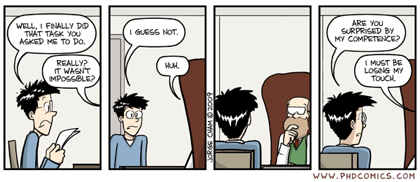
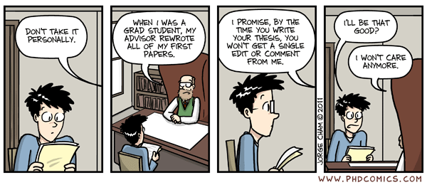
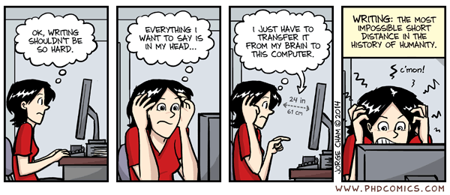
Paper Deadlines
All Papers Are Due in Hardcopy AT THE START of CLASS at 9:30 AM on the Due Date.
Because the NIU computer labs only open at 8AM, it would be safest if you printed the papers off before the day on which the papers are due.

Paper # | Chapter # | Due Date
A | 2 | T (1/20)
B | 3 | T (1/27)
C | 4 | T (2/10)
D | 5 | T (2/17)
E | 6 | T (2/24)
F | 7 | T (3/3)
G | 8 | T (3/10)
H | 9 | T (3/24)
I | 10 | T (3/31)
J | 11 | T (4/7)
K | 12 | T(4/14)
L | 13 | T(4/21)

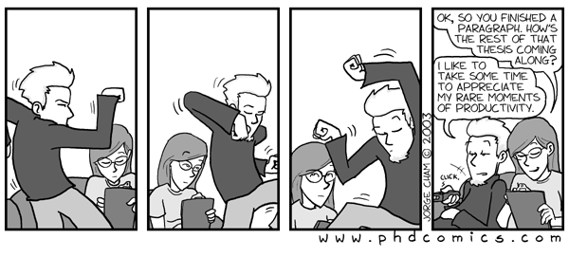
(3) In-class examinations
Why do professors often ask students to take exams? Simple – the data from numerous studies suggests that students LEARN MORE when they have to take exams over course material. Hence, because this course wants to promote learning, students in this course will be asked to take examinations – FOUR of them.
Exam structure and format. Each exam will be a unit exam covering about 1/4 of the course. There will not be a comprehensive final. Each exam will consist of 60 multiple choice questions (with an occasional bonus question or two, at my discretion). Each question is worth 1 point.
Anything in the text or in class (including responses to student questions) is fair game on the test. However, my exam questions generally focus on important THEORIES, PRINCIPLES, RESEARCH FINDINGS and APPLICATIONS. I rarely ask about the names of researchers or the dates on which their findings were published except when it is relevant, as in the historical overview of social psychology. To do well on the tests you need to READ EARLY AND OFTEN and THINK ABOUT WHAT YOU READ. Perfect memory for class material will go a long way toward good performance on the tests, but I expect that you should also be able to APPLY WHAT YOU HAVE LEARNED.
The tests are constructed with the following goals in mind: 25 questions on each exam can be answered either from reading the text or from class notes; 20 questions can be answered only by reading the text; and 15 questions can be answered only from class notes. Please bring some #2 pencils and a good eraser – answers will be made on a Scantron answer sheet, so make those marks dark and those erasures complete.
Post-exam reviews. There will not be in-class exam reviews. However, you can come up and review an exam when we both have time. Set up an appointment to do so.
Question dispute policy. Students may disagree with an answer that I consider to be correct. When this happens to you, please submit your dispute in writing, citing supporting documentation (page numbers, dictionary definitions, citations, etc.). This may seem like a hassle, but trust me, it's for the best – my experience is that it tends to work in favor of students.
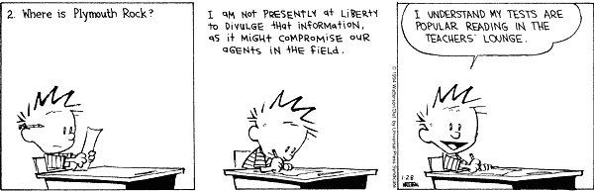

Late exam arrivals. Time is a precious commodity on exams - arrive on time (or even early) on exam days so the exam can start promptly. The exam room will be closed 15 minutes after the scheduled start of the exam. The reason? Many people need at least an hour to complete the exam, so if you are 15 minutes late (or more) there is insufficient time to complete the exam. Moreover, late arrivals will NOT be given extra time to complete the exam. The exam room will be cleared out at 10:50 so that other classes can use the classroom. Thus, do your best to get to the exam early (hard for a 9:30 AM class, I know).
Make-up exams. If you miss ONE regularly scheduled exam for any reason (6 feet of snowfall, excessive partying, sickness, your own death, the death of a family member or pet, car breakdowns, traumatic breakups with your significant other, screwed up alarm clocks, aliens landing on earth, the apocalypse, spontaneous collapse of this universe, the return of the black death, depression induced by the latest Britney Spears CD, etc.) you are AUTOMATICALLY GUARANTEED A MAKE-UP EXAM. It is not necessary to call me in advance, and no excuse or note is necessary. However, all (and I do mean all) make-up exams will be administered during our university-assigned final exam time (Thurs. May 7, 10:00a.m. - 11:50 a.m. ).

The fact that a makeup is guaranteed if you miss ONE exam should encourage you to use good sense if you have to drive any distance to campus. No exam is worth your life. If the roads are bad, stay home and know that your makeup is guaranteed and already scheduled.
Experience has shown that it is difficult to make up two or more exams. In the past, students who have done so have failed the class a very high proportion of the time. Hence, if you miss two or more exams it might be better if you spend your time during finals week on those courses where your prospects are better. Nonetheless, I will allow completion of up to two make-ups during the make-up session, but no more. If two make-ups are taken, both must be completed during the time allotted for the final exam.
The make-up guarantee does NOT apply to make up exams. If you miss make up test, or arrive after the 15-minute grace period has expired, you'd better pucker up and kiss your kiester goodbye!

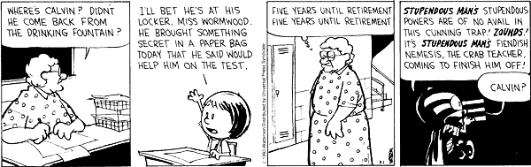

CHEATING: YOU CHEAT, YOU FAIL!!!!
Cheating is wrong. Don't do it. Cheating extends to any work that you turn in for this course, including papers and exams. Don't do it. I hate dealing with cheating, and because I hate it, I get very, very cranky. Don't do it. I even hate thinking about it. Don't do it. Cheating includes copying from others' exams, plagiarizing others' papers, turning in work that is not your own, and anything else even vaguely nefarious or dishonest. Don't do it. I have had to deal with far too much cheating in my academic lifetime. Don't do it. When I catch cheaters, I fail them - for the whole course. Don't do it. I also refer them to their department and to the university for further disciplinary action, recommending that they get kicked out of school and that a reprimand letter for cheating get included in their permanent record. Don't do it. There are no exceptions to this policy. Don't do it. So, write your own papers. Keep those eyes riveted to your own paper during exams, and do not use shoes, arms, pencils, the bills of your caps, other people, or any other such artificial "performance aids" during exams. Don't do it. Just keep this simple rule in mind: you cheat, YOU FAIL!!! I'll sic O.J. Simpson, Charles Manson, Freddy Krueger, Jason, and Britney Spears on you...simultaneously. Don't do it. I really, really, really, really mean it. Don’t do it.

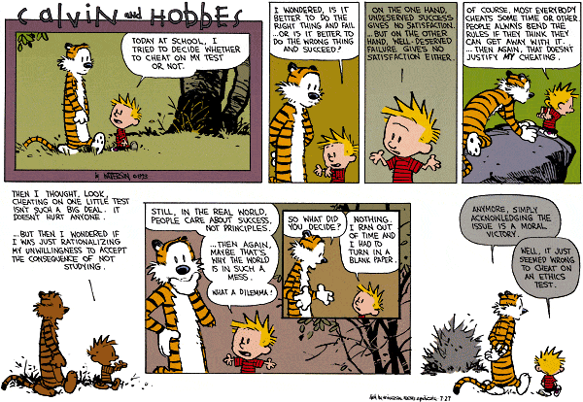
CLASS ATTENDANCE AND COMPORTMENT
Class attendance is not required, but it is expected. Lectures, class discussions, demonstrations -- and most importantly, your mental involvement -- are all valuable potential contributors to your learning. Class attendance is a serious and essential responsibility for all students. Attendance allows you the opportunity to maximize your learning potential; missing class often puts you at a disadvantage (for example, much of what I will discuss in lecture is on the exam and is not included in the text). If you know you are going to be late to (or leave early from) class, please come anyway. I would rather have you present for part of class than to have you miss it completely. However, try not to make these comings and goings a habit - they do tend to be disruptive to others. Make sure to bring me some tea if you are very late in arriving to class: I take mine with artificial sweetener.
I NEVER make my Powerpoint presentations available to students outside of class. If you can’t keep up with me, don’t want to take notes, or can’t take notes due to a disability, bring a video recorder or a camera and record the lecture as it is presented.
As a student, TAKE CONTROL OF YOUR OWN LEARNING. For example, sometimes as I lecture things might go by too quickly for you to take good notes. If this happens, ask me to stop and go over something again, or to provide examples.
Second, I ask you to be a good community member and PLEASE CONSIDER THE NEEDS OF OTHERS. This means a lot of stuff: for example, if others need help (e.g., they ask to see your notes), then help them. Don't be disruptive in class (e.g., via excessive talking); other people might actually want to pay attention. Don't monopolize discussions or question-and-answer sessions; allow everyone to participate.
Third, please SHOW RESPECT FOR OTHERS' IDEAS AND OPINIONS. In this class we will be discussing personal and sensitive issues that sometimes provoke strong feelings. Please be sensitive to the feelings of others in discussing these issues. Also remember that GOOD PEOPLE CAN HAVE DIFFERING OPINIONS ON ISSUES, and that part of the purpose of the class is to increase your familiarity with how others might think and feel about various issues related to social psychology and social life. Please keep personal criticisms to a minimum, and instead try to listen, learn from, and think about the various perspectives that people bring to our class discussions. Please do not criticize or belittle people simply because they happen to have different values and priorities than your own.
Finally, feel free to use recording devices, computers, or cell phone cameras to take notes, record lectures, or to take photos of the class Powerpoint slides. However, please do not use these devices for other purposes (e.g., send text messages; surf the web). The reason is that doing so distracts me and causes me to do a poor job on my lectures. I get distracted in class by people who misuse their electronic devices. I desperately want to do a good job for you, so please respect my wishes in this matter and do use your electronic devices during class for non-class purposes. Otherwise, those devices might face the wrath of the 14-pound sledgehammer that I still have from my steel mill days.

SOURCES OF POINTS IN THE COURSE & COURSE GRADING
Points in the course will be accumulated from either "regular" sources or from "extra credit" sources and will almost always totally determine your final grade in the course. These may be the only sources of points in the course. However, if a graduate student needs help with a research project, an additional extra credit project might be offered. But don't count on that. There will NOT be any other sources of extra credit available, so don’t even ask….
Regular Point Sources

Exam 1: 60 pts.
Exam 2: 60 pts
Exam 3: 60 pts
Exam 4: 60 pts
On-Time & Satisfactory Completion of ALL 6 Required Papers: 30 pts
___________________________________________________________________
Total Possible "Regular" Points: 270 pts.

Extra Credit Points/Point Adjustments

Extra Job Application Papers (2 max.) 3 Points Each, 6 Points Maximum
Documented Revision Visits to the Writing Center 1 Point Each, 8 Points Maximum
Occasional Bonus Questions on Exams Just a Few
Psycho Jeopardy Points Whatever You Can Earn
Research-related Extra Credit As Needed/As Opportunities Arise

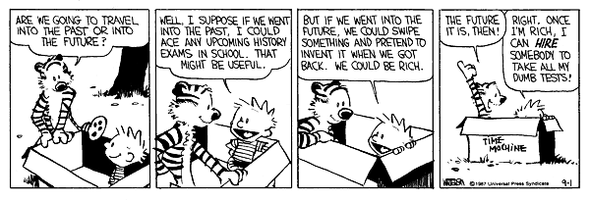

Grades and Points
A = 243 & up A- = 238-242 B+ = 232-237 B = 216-231 B- = 211-216
C+ = 205-210 C = 189-204 D = 162-188 F = 161 & Below
These are the cutoffs. They will not be changed. These are the cutoffs. They will not be changed. These are the cutoffs. They will not be changed. These are the cutoffs. They will not be changed.
Please note that your esteemed and worthy professor (Hey! That's me!) reserves the right to add or subtract points from a student's point total. It’s important for you to know that I have NEVER USED THIS OPTION. However, I keep it available because I can imagine circumstances in which I might need to use it (you being one point below a cut point isn't one of them).
The bottom line, then, is that your grade depends ENTIRELY on YOUR PERFORMANCE: don't look to me to bail you out if you don't learn anything and your exam performance reflects that lack of learning. Don't look to me to bail you out if you are one point below a grade cutoff. If you want more points, EARN as many as you can – read early and often and frequently review your notes to learn a lot so that you can do well on the exams. In addition, do all the required papers and do the extra credit papers. Do well on Psycho Jeopardy.
Course grades on exams and papers should be available through the university’s Blackboard application. In case you lose the one that I sent to you, the course syllabus will also be posted on Blackboard. It is also available on my personal NIU webpage: (http://www.niu.edu/jskowronski/).

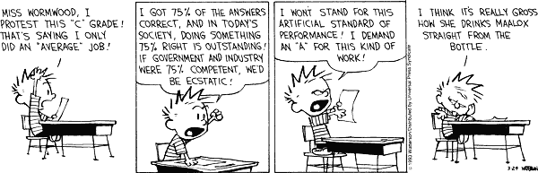
COURSE SCHEDULE

Unit 1: Read Chapters 1, 2, 3
Date/Day | Class Topics | Psycho Jeopardy
1/13(T) | Introduction and Overview  Welcome back my friends to the show that never ends ...
1/15 (TH) | An Empirical Introduction: The Breadth and Importance of Social Psychology Research  Do it to me one more time…. | Ch. 1
1/20 (T) | How to Think About and Evaluate Theories and Research in Social Psychology : The Good, the Bad., and the Ugly  Run any kind of test from a to z …but you still know nothin ‘bout me? | Ch. 2
1/22 (TH) | The Science of Social Psychology  Do it ‘Till You Are Satisfied | Ch. 2
1/27(T) | Thinking about and perceiving other people  What are you - some kinda nut? | Ch. 3
1/29(TH) | More on perceiving and judging others  You’re so vain, you probably think this song is about you… | Ch. 3
2/3(T) | EXAM 1 - CHS 1, 2, & 3

Unit 2: Read Chapters 4, 5, 6

Date/Day | Class Topics | Psycho Jeopardy
2/5(TH) | On The Social Sources of Self Knowledge  I wanna be like Mike!! | Ch. 4
2/10(T) | The Self in the Social World: Feeling and Acting  We do not deal much in facts when we are contemplating ourselves… | Ch. 4
2/12(TH) | Behavior Leads to Attitudes: Practical and Theoretical Considerations  I’ll probably regret this when I get up tomorrow morning … | Ch. 5
2/17(T) | Attitude Change: Direct Persuasion or Sneaky Alteration?  The object of oratory is not truth, but persuasion.... | Ch. 5
2/19(TH) | Social Influence and Its Control Over Behavior: the Case of Obedience  Number one … make it so! | Ch. 6
2/24(T) | Social Influence and Its Control Over Behavior: the Cases of Conformity and Compliance  Mom, can I have a Ferrari? No? Then how about a Ford? | Ch. 6
2/26(TH) | EXAM 2 – CHS 4, 5, & 6

Unit 3: Read Chapters 7, 8, 9, 10

Date/Day | Class Topics | Psycho Jeopardy
3/3(T) | Friends: Why Do People Come To Like Each Other?  I considered her my blood and it don't come no thicker… | Ch. 7
3/5(TH) | Friendship: What’s It Good For?  I'll lean on you and you lean on me and we'll be okay… | Ch. 7
3/10(T) | Loving/Romantic Relationships: Social and Biological Views  I kissed a girl and I liked it…the taste of her cherry Chap Stick … | Ch. 8
3/12(TH) | Loving/Romantic Relationships: Hooking Up, Staying Together, Getting Out  If you love somebody, set them free…. | Ch. 8
3/17 (T)  3/19 (TH) | Spring Break!  Wastin’ away again in Margaritaville ….
3/24(T) | Prosocial Behavior & Aggression: Some Common Theoretical Themes  Born to be wild or born to be mild???? | Ch. 9
3/26(TH) | Aggression: Some Contributory Factors  I ain't start your life but, I'm ma bring it to an end… | Ch.9, 10
3/31(T) | Aggression: Models, Video Games, and Aggression…The TRUTH  Ya feel lucky today, punk? | Ch. 10
4/2 (TH) | EXAM 3 – CHS 7, 8, 9, & 10

Unit 4: Read Chapters 11, 12, 13, and 14

Date/Day | Class Topics | Psycho Jeopardy
4/7(T) | Perceiving and Judging Groups: Stereotypes and Prejudices  Y'all don't know what it's like…being male, middle class and white… | Ch. 11
4/9(TH) | Prejudice and Discrimination  Shame of all nations - What seeds do we plant in an infant's mind?  Seeds of destruction…And don't you trust their kind? | Ch. 11
4/14(T) | Performance in Groups and Under Pressure  He really threw up all over himself on that putt, Jim … | Ch. 12
4/16(TH) | Group Processes and Group Performance  That team just never seems to be able to win the big one… | Ch. 12
4/21(T) | Social Dilemmas: Me or We?  I saw these crazy dudes …. And they went out on the street  They were cleanin' out the empty lot … And makin' it neat  I said, "Man is this cool ….What you tryin' to do?"  They said, "Makin' a garden … For me and for you." | Ch. 13
4/23(TH) | NO CLASS!!!!! Going to meet Elvis in Missouri….
4/28(T) | Looking Back to Look Forward: Social Psychology In The Rear View Mirror | Ch. 14
4/30(TH) | EXAM 4 – CHS 11, 12, 13, & 14

MAKE UP EXAMS
Thurs. May 7, 10:00a.m. - 11:50 a.m.
Please know the NUMBER of the Exam (1, 2, 3 or 4) for which you need the make-up.
**** SPECIAL NEEDS STUDENT INFORMATION ****
Northern Illinois University is committed to providing an accessible educational environment. So am I.
If you need class accommodations or exam accommodations (quiet exam room; extra exam time; class note-taker; etc.), contact the Disability Resource Center (DRC) immediately to make arrangements. This requirement applies to ALL students and applies to ALL accommodations.
I will be happy to work with you on these matters, but all such arrangements MUST be made in coordination with the DRC. Consult with me early in the semester about these matters.
The DRC is located on the 4th floor of the Health Services Building, and can be reached at 815-753-1303 or drc@niu.edu.

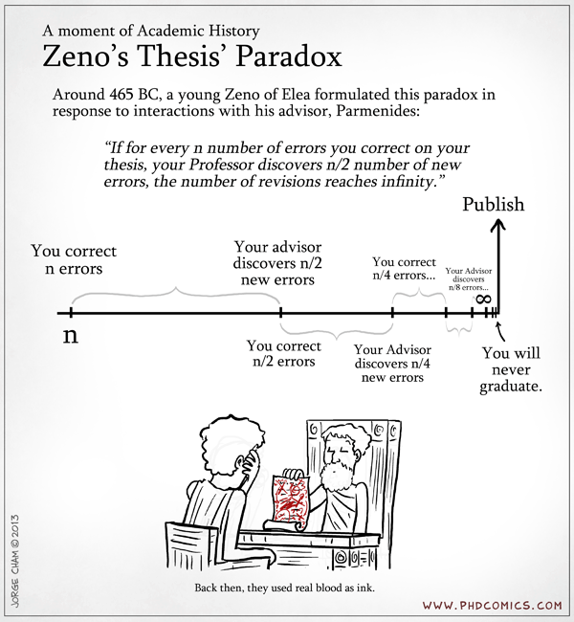

Sample Job/Grad School Application Assignment

Scum of the Earth
PSYC 372
Paper G

Avoidant Attachment

Anxious/ambivalent attachment is one of three attachment styles. It is characterized by fear of abandonment and feeling that one’s needs are not being met. My roommate displays this attachment style in her relationship with her boyfriend. They have been dating for around 3 years and on the surface their relationship appears functional. Despite this, there are some distinct features of their relationship that are characteristic of anxious/ambivalent attachment. For instance, she frequently experiences highs and lows in her relationship with him. It seems like almost every week she is upset about something new he did, and by the next day they have resolved everything. She often describes him as unsupportive or unresponsive to her concerns. The most obvious signs of her anxious/ambivalent attachment are the demands she places on him. Not only does she expect him to marry her, she has dictated the time frame he has and how many kids they are going to have (one, hopefully a boy). She has planned out where they are going to move when they are married and who is going to stay home with their child. She texts him constantly throughout the day and becomes annoyed with him for spending time with his friends instead of with her. Before meeting her current boyfriend, she had many past relationships that mostly lasted for a few weeks, at best. Despite this, they have been together for over 3 years and were even able to maintain their relationship when he moved out of state to go to college over a year ago. It appears as though they are still able to function as a couple despite, her anxious attachment. He makes her very happy, so I hope that they do last.
Sample Job/Grad School Application Assignment
Scum of the Earth
PSYC 372
Paper E

Norm of Reciprocity

The norm of reciprocity is a social norm stating that we must repay others for a behavior with a similar behavior. I frequently use the norm of reciprocity against my unknowing roommate. I prefer to have things done a certain way – I like a clean apartment, I organize the dishwasher, and I require all guests to use a coaster when they put drinks on my furniture. My roommate is not always cognizant of my preferences, and like most people she does not respond well to an obvious demand. If I tell her “you need to do it this way” or even “can you do it that way” she will likely make up an excuse to not do as I have requested. I soon learned that it is much more effective to use the norm of reciprocity to get her to do what I want. Instead of saying “do it this way”, I now say something like, “The kitchen looks really dirty, so I’m going to mop the floor tonight. Would you mind cleaning the counters?” Not only has she always said yes when I have asked her in this manner, she has also always followed through. Sometimes I can even trick her into doing a chore we both hate by agreeing to do something that isn’t nearly as bad. For example, I’ll vacuum the family room floor (which takes an average of 5 seconds) if she takes out all the garbage in the apartment. Despite the fact that I’m obviously doing less work than her, she still agrees to do what I ask her. This is an example of the norm of reciprocity because when I ask her to do something, I pair the request with an agreement to do something else to reciprocate the favor. If she believes that I am doing something for her benefit, she is much more likely to agree to do something for my benefit.

