SOCIAL COGNITION - PSYCHOLOGY 625
Section 1, Spring 2015
Reference # 7306
3 Credits
T, TH............. 11:00AM – 12:15PM ...............PM136
Prerequisite: PSYC 620 and graduate standing in psychology or consent of department
SAVE THIS SYLLABUS FOR FUTURE REFERENCE!
Information in this syllabus is subject to changes and additions announced in class!
There WILL likely be some changes, so come to class!
Rating: NC - 17 (not for the faint of heart, but definitely for inquiring minds!)

The approach that this class will take is CONTEMPORARY and EMPIRICAL and it emphasizes THEORY EVALUATION AND TESTING. That is, much time will be spent describing how recent research has been generated to test theories about mental representation and mental process and how these apply to stuff that is of interest to social psychologists. We will be covering a lot of ground in this course - please dedicate yourself NOW to keeping up with the course’s rapid pace and heavy reading load. If you are not dedicated to reading a lot and in an on-time fashion, you might think about opting out of the class.

This class is focused on the training of future academic psychologists, and is unapologetic about that fact. Note that if you are a non-psychologist, or if you have an applied focus, you will simply need to accept this academic focus if you wish to succeed in the class. If you can’t accept this focus, seek the class exit door.

If you are from another sub area of psychology or from another discipline (communications, anthropology, sociology), welcome! As you will see, I embrace perspectives that can inform social cognitive theory and research and invite you to educate me about such perspectives.
------------------------------------------------------------------------------------------------------------------

CONTACTING YOUR PROFESSOR

Office: PM 418 Office Phone: 815-753-7073 E-mail: jskowron@niu.edu
As pro golfer Fred Couples once said, the problem with answering the phone is that there might be someone on the other end. So chances are that if you call me, you’ll have to leave a message on my voice mail. E-mail is another place to leave me messages that I can ignore - but am less likely to do so than phone messages.

Office Hours: W, 8-11; or by appointment
I often hide to avoid the riff-raff that interferes with productivity. That’s NOT you. Feel free to make appointments to see me -- whatever reason is good enough for you is good enough for me! My weekly office hours are usually filled, so if you need to meet it would be best to make an appointment. Bring along pizza and root beer, just to make sure I’ll let you into my office. You can even take a chance and just drop by if you are feeling lucky, but I am often about on other university business or have standing appointments and meetings, so appointments are safer.
------------------------------------------------------------------------------------------------------------------
-------------------------------------------------------------------------------------------------------------------

COURSE DESCRIPTION FROM THE NIU BULLETIN
Topics at the interface between social psychology and cognitive psychology, addressing how cognitive processes, structures, and theories are related to and influence people's understanding of themselves, others, and the social world. Discussion of these processes, structures, and theories in the context of classic topics in social psychology, including impression formation, attribution, person memory, stereotyping, prejudice, self-perception, and autobiographical memory. PRQ: PSYC 620 and graduate standing in psychology, or consent of department.

A BIT MORE DETAIL FROM DR. JOHN

The social cognition approach to social psychology is especially concerned with mental structures and mental processes and how they contribute to our understanding of how people think about others and about themselves. This course reflects these foci.

In doing so, the course goes beyond descriptions of what happens to focus on assessing and manipulating the mental processes and mental structures that might contribute to commonly observed effects in social psychology. For example, consider the observation that stereotypes bias judgments. Someone in social cognition might ask about, assess, and manipulate the cognitive processes and cognitive structures that contribute to, and are responsible for, these biasing effects. A second example comes from the finding that priming works to influence judgments. A social cognition researcher would ask about, and would attempt to measure and/or manipulate, the structures and processes that are activated by a prime and how they might contribute to subsequent judgments. A third example comes from the observation that people will sometimes misremember things about others. A researcher operating from a social cognition perspective would ask about, and would attempt to try to measure and/or manipulate, the mental structures that are involved when memories are constructed, the mental processes that contribute to those constructions, and the processes that might operate on those structures during retrieval to understand the various sources of distortion in memory.

So here’s your first pop quiz: What constructs are the focus of social cognition research? If you said cognitive processes and cognitive structures, then you would be correct!

For social cognition researchers, it’s always about understanding the cognitive structures and cognitive processes that contribute to how people think about others and how they think about themselves. It’s not just about what happens, it’s about measuring and manipulating the processes and structures that make things happen! In this course, think process and structure! Think process and structure!
------------------------------------------------------------------------------------------------------------------
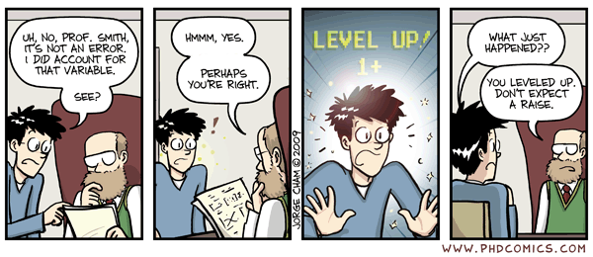

---------------------------------------------------------------------------------------------------

ABOUT YOUR PROFESSOR

Name: John J. Skowronski, Ph.D. Aliases: Dr. Skowronski, Dr. John, Dr. J., JJS
Feel free to call me whatever you like; just be careful what you call me to my face!
NIU Rank: Full Professor (and people generally think that I’m full of it!)
Birthplace: Chicago (Inner City/South Side - so don’t even THINK of messing with me)
Degrees: M.A., Ph.D., University of Iowa, B.A., Augustana College (Il.)
Go Hawks! Go Vikings!
Yes, as much as it amazes you I am a Ph.D.; that means I can, indeed, Pile it Higher and Deeper.

A Few Professional Factoids:

Recipient: - NIU Presidential Research Professor Award
- Ohio State University Alumni Award for Distinguished Teaching
(back in my former job {Go Buckeyes!}, they were under the
mistaken impression that I could actually teach.....)
- Thomas J. Evans Teaching Excellence Award (OSU at Newark)

Associate Editorships: - Social Cognition (8 years, ended 2007)
- Journal of Experimental Social Psychology (4.5 years, ended
2011)

Editorial Board Member: - Journal of Personality and Social Psychology

- Social Cognition
- Journal of Experimental Social Psychology
-Perspectives on Psychological Science

Past Editorial Boards: - European Journal of Social Psychology
- National Science Foundation Social and Developmental Grant
Panel
-Personality and Social Psychology Review

Co-author of: - Autobiographical Memory (Lawrence Erlbaum Publishers)

Co-editor of: - First Impressions (Guilford Publishers)

Author or co-author - Over 125 professional journal articles and book chapters (and
counting)

Other Career Highlights: - 2 Holes in One (Lifetime)
----------------------------------------------------------------------------------------
----------------------------------------------------------------------------------------

MORE ABOUT THE COURSE: THE APPRENTICESHIP MODEL

If you are a graduate student in psychology, I want you to STOP thinking of yourselves as graduate students and START thinking of yourselves as APPRENTICE PSYCHOLOGISTS. In my warped view of the world, there are crucial differences in how students and apprentices think about themselves and how they react to the world. For example:
Students try to avoid work whenever possible; apprentices seek out opportunities to work whenever they can so that they can function well when they leave the apprenticeship.
Students are primarily concerned with the grade they get in a course; apprentices are primarily concerned with how much they’ve learned in a course.
Students want to avoid corrective feedback; apprentices want corrective feedback because they want to get better in their chosen line of work.
Certainly, in your interactions with me you should be aware that I am assuming that you have apprentice-like motives, not student-like motives. My assumption is that you WANT TO GET BETTER at being a psychologist; I have tried to structure the course to HELP YOU DO SO.
How? I will try to give you the opportunity to do some of the same tasks that you will do in your future academic jobs (again, this course is unashamedly geared toward those who are on an academic job path). I also will try to provide some insight and corrective feedback along the way, and ultimately hope to move toward the stage when corrective feedback from folks like me becomes unnecessary.

After all, part of the training of a bricklayer is to teach her/him recognize when a crooked wall has been put up and to know when to tear it down and start over - and maybe to eventually avoid putting up those crooked walls. I want you to be able to do the same thing for the kinds of tasks that confront academic psychologists.
In this regard, it is important to know that I don’t expect you to be perfect at these skills now, so don’t be terribly surprised when I give you (sometimes extensive) corrective feedback. The fact that you are still apprentices means that you have imperfect knowledge and skills and require training (as do we all, throughout our careers)! Hence, don’t expect your work to be perfect, and look hard at the feedback that you get because it will help you to GET BETTER!

The fact that you receive corrective feedback does not mean you are doing poorly! It is simply an expected part of the training process. So don’t get upset when I critique your writing or analysis - that’s why we’re both here! I’m here to HELP; you’re here to LEARN! Fear no errors! Try to have a promotion focus (and you will learn what that term means in the course). Go for the gusto! Do your best now, incorporate the feedback that you get, and you will get better the more you try! Do it! Do it! Do it!
----------------------------------------------------------------------------------------

----------------------------------------------------------------------------------------
The Five Skills That I Expect You To Sharpen In This Course
There are five specific skills that I am going to give you the opportunity to sharpen in this course.

#1 -The first of these skills is KNOWLEDGE.

Knowledge often gets a bum rap. People sometime deride a focus on learning facts and instead suggest that people should be taught “how to think.”

Well, guess what? A lot of very good research examining expert/novice differences in thinking strongly suggests that your thinking ability is partially tied to how much you know and how much experience you have in a given area. Hence, KNOWLEDGE MATTERS - A LOT.

Accordingly, I will give you the opportunity to develop EXPERTISE about Social Cognition - both the research that is done in the area and the theory that drives the research. Development of this capacity will come from the assorted stuff that I assign you to read, my lectures, and our class discussions. We will be covering an awful lot of intellectual territory, and I know that it might sometimes be hard to organize and integrate the knowledge that you are acquiring. To help you in this regard, I have provided a set of questions for you. Writing out or outlining the answers to these questions may help you to thematically crystallize your knowledge of Social Cognition and may help you to see how the various elements of the course might fit together. If you are taking the Social/I/O area comprehensive exams, this activity will provide an additional benefit - one or more of these questions will likely appear on your comprehensive exam (HUGE HINT!!!!).

It is also important to know details. These will be probed during the social cognition psychojeopardy portion of the course. This task will occur at the start of most class periods. I’ll give you an answer and you will respond in the form of a question. You can self-assess the effectiveness of your reading by attending to the extent to which you know the correct questions to the answers that I provide. If you find yourself clueless too often, you need to alter your reading regime to do a better job of acquiring knowledge from what you read.

As you will tell from the course schedule, many class sessions are “to be determined.” This means that the progress of the class will try to be responsive to what YOU want to know about.

#2 - The second of the skills emphasized by the class is CRITICAL ANALYSIS.

In our field, we are constantly posed with the problem of knowing if a piece of research is good. Goodness can be evaluated on several dimensions. Typical questions are: Is the research novel? Is the research interesting? Is the research internally valid? Does the research have theoretical implications? Are there alternative theoretical interpretations that make the paper less interesting than it might be? Is the result interesting enough to publish even though it might not be theoretically relevant?

I want to help you to sharpen your evaluation skills, and will do so via a class assignment that involves role playing. I want you to imagine that you are a big-time academic professor who is regularly sent manuscripts to review by a leading journal in the area. The journal that you are reviewing for and on which you are an associate editor is Social Cognition at NIU.

Over the course of the semester, you will be given four manuscripts to review. In these reviews your task will be to critically analyze the research, along all dimensions - theory, method, analysis, and exposition. When writing each review, you will make a recommendation about the publishability of the research to the editor who sent you the review, outlining the reasons for your recommendation.

In addition, for each of these manuscripts you will also take on the role of a journal associate editor. An associate editor has to read the papers, and read the reviews. The associate editor then must both make a decision about the manuscript and write an action letter conveying the decision. In making your decision, you not only need to do the same things that a reviewer does, but you also need to take into account the opinions of those experts that you have solicited to help you evaluate the manuscript. This often involves critically analyzing the reviews and figuring out which reviews are worth attending to and which are not.

Do the best job of thinking that you can in analyzing the research. If you don’t think that you know enough about an area to do a decent review, you’ll have to do what we real associate editors have to do when placed in the same spot - go do some outside reading!

#3 - The third of the skills to be honed in this course is WRITING.

My experience as a writer suggests to me that becoming a better writer requires much, much, much practice. You will get writing practice in this course by writing four reviews (one for each “live” manuscript) and four editorial action letters (again, one for each manuscript).

These letters and reviews typically are not made public. However, whenever you write in any professional capacity, you should be aware that you are ALWAYS ON STAGE. As a reviewer, your reviews allow prominent people (e.g., journal editors) who are “in the know” to see brief snippets of your work, and they WILL form impressions about you and your abilities based on such work. Those impressions matter to your future academic careers. The manuscript authors (also often prominent people in the area) will similarly forming impressions of you based on your decision letter. More importantly, the manuscript authors will be paying close attention to your letter to decide what to do about the manuscript and how to do it. Nothing is more frustrating to manuscript authors than to get a “revise and resubmit” from an editor and to have absolutely no idea of what needs to be done to make the manuscript suitable for publication. Hence, both the intellectual content and the expository qualities of the letters matter.

Because writing matters, it is important to use the expository tools that you have at your disposal (spell checkers, grammar checkers, repeated reading of your documents by yourself and others) to try to make sure that your document is tersely written, and is correct in grammar and punctuation. You might even use other people (fellow grad students, the people at the writing center) to give your reviews/letters a read before submitting. I will be especially brutal when reacting to errors when they occur frequently, for that high frequency usually reflects lack of effort or lack of attention to detail. I don’t like lack of effort or lack of attention to detail, so I’ll definitely let you know when I see it. Think CRAFTSMANSHIP. Think QUALITY.

#4 - The fourth of the skills to be honed in this course is SPEAKING AND DISCUSSION.

One of the important things that you will be doing in your future jobs as academic psychologists is to talk to other people about psychology. Often, this will be in an informal setting in which ideas are freely exchanged. Such exchanges often involve the presentation of your own thoughts, as well as presenting critiques of the ideas of others. Both kinds of presentations are important. Your time to practice such skills will be during class question-and-answer sessions as well as during class discussions.

It is important to be clear and organized in such communications. It is also important to both be intellectually rigorous in your evaluations of the ideas of others, but to temper that rigor when being critical (e.g., lines such as Dan Aykroyd’s famous “Jane, you ignorant slut” from old-school Saturday Night Live episodes are probably best avoided). This class will provide the opportunity to informally share ideas about social cognition theory and research. I want you to consciously shape your communications in these discussions so that they are SHORT, CLEAR, RIGOROUS, and SENSITIVE.

#5 - The fifth skill that I want you to practice in this course is QUESTION ASKING.

Learning to ask good questions is a crucial skill for psychologists. Certainly, learning to ask good questions is important to research: good questions lead to good answers. However, questioning skills are also important in other ways. For example, if you are dealing with students or clients, asking good questions can help you to understand the perspectives and concerns that they cannot always articulate well. When dealing with a speaker, asking good questions has impression formation value (it makes the audience look good) and it can help the speaker (by sparking new ideas and directions). Finally, learning to ask good questions can also spur productive intellectual discourse. Discourse can be especially interesting when it is tailored to the specific things that YOU want to know.

You can practice this skill in two ways. First, on Tuesdays of most weeks, I will be asking you to submit two questions derived from that week’s assigned readings. THESE QUESTIONS ARE CRUCIAL – THEY WILL DETERMINE THE DIRECTION OF MOST THURSDAY CLASSES!!! Most of the Thursday class sessions will be devoted to answering these questions. Good questions mean good classes.

Secondly, you get to ask questions during class. I explicitly provide an opportunity to do this when I ask “Any questions” at the start of each class period. You can also do this at any time during class. DON’T BE RELUCTANT to ask questions. I WANT you to be that 5-year old who is always asking things like “Why is the sky blue?” Use this class to foster your inquisitiveness and to develop your question-asking skills.
----------------------------------------------------------------------------------------------------
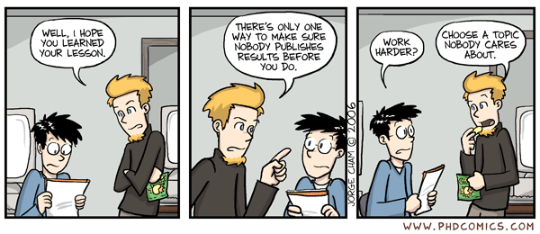

----------------------------------------------------------------------------------------------------

READING STUFF
COURSE TEXTBOOK

Carlston, D.E. (Ed.) (2013). The Oxford handbook of social cognition. New York, NY: Oxford University Press. ISBN – 13: 978-0-19-973001-8

I always worry that I bias students’ views of an area by the text I select. Intentional or not, textbook writers’ biases are reflected in the texts that they write. To try to avoid such issues, I often assign texts reflecting differing perspectives. I have done so in this course. The text is a collection of chapters written by authors who evince a high level of diversity. This diversity will serve you well in that you will be exposed to many different ways of thinking about social cognition, as well as being exposed to many facets of social cognition research and theory.
It is important for you to know that reading the book and learning from the book will largely be YOUR responsibility. The class presentations that I provide will often not overlap with the stuff that you happen to be reading from these books at any given time. I have my own stories to tell about social cognition, and I intend to tell them. My presentations will provide a personal perspective on social cognition. I will focus on stuff: (1) I like; (2) that I am interested in; (3) that I want to better understand (I’m still learning, too); and (4) that the book doesn’t cover and that I think you need to know about. To aid your memory, you ought to take good notes for my class presentations (or record my class presentations).
This class style also has implications for you and your reading. It is IMPORTANT for you to read ahead, to think about what you are reading, and to use our interactions in class to clarify your understanding of reading. That is, in part, what the discussion questions that I am asking you to submit are for. They are designed to give you the opportunity (even force you) to TALK TO ME about what you are reading from the textbooks. However, don’t feel confined to these questions to get my insights into the books. One thing that I will ask before every class sessions is “do you have questions today?” WHEN I ASK THIS QUESTION, I MEAN IT. This is your opportunity to use me to help you. I can’t help you if I don’t know that you need help. So ask!

Also note that I have, as yet, NOT read the entire Carlston tome. This is a trick of the trade: To help keep current in my areas, I often assign stuff in class that I haven’t read so that I keep up with things. Hence, think of me as a fellow traveler – I am learning, too! The fact that I am a fellow student is important! YOUR questions, insights, and perspectives are very valuable to me as I try to understand all this stuff. Hence, I will be paying great attention to your questions, comments, and insights as the course goes on.


NON-TEXT COURSE READINGS
I have accumulated some additional material for you to read. I have assigned three manuscripts (designated as Manuscripts 1 through 3) and have provided the reviews and a decision letter for each. These are “real” manuscripts that were submitted for publication, and the reviews and decision letters are real. These materials are assigned so that you can get a view of the review process prior to writing your own reviews. The “real” reviews and letters will give you some models to use for your own reviewing and decision-making efforts.

I am also assigning a couple of short articles that describe reviewing. These should help you to understand the things on which you should focus as you construct your reviews and decision letters.

Once you’ve seen these things, you get to put what you’ve learned into practice. You will:

- write reviews of Manuscripts 4 through 7;
- use the reviews of others to write an editorial action letter to the manuscript authors for each manuscript; as a part of this process, you get to use the decision letter written by others to help you write your own decision letters;
- assign a grade to the reviews written by others;
- get to see the actual reviews and decision letters so you can do a self-assessment of your own efforts.

As this syllabus is written, my intent is to send all these materials to you. I may also make them available on a computer or memory stick for download, as needed. More information about the readings and their availability will be presented in class.

----------------------------------------------------------------------------------------------------
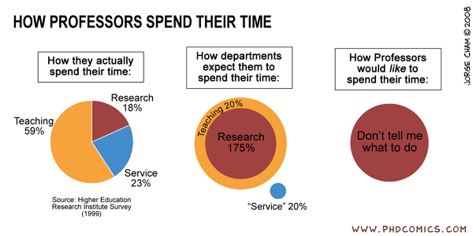
----------------------------------------------------------------------------------------------------
SUMMARY OF CLASS TASKS

WRITE REVIEWS AND ACTION LETTERS
In this course you will write four reviews and four action letters.
Reviews help action editors evaluate a manuscript and to provide feedback to authors that can be used to improve the manuscript. Be tough-minded, but also be constructive in your commentary!

YOU WILL NEED TO BRING FOUR COPIES OF YOUR REVIEWS TO CLASS!!!!! YOU WILL ALSO NEED TO E-MAIL A COPY TO ME (Via attachment – use the Microsoft Word .doc format, please).
Action letters are the letters that editors write to authors. These letters typically summarize the comments of the reviewers (at least, those comments that seem particularly important), include the perspective of the action editor, and convey a decision about the manuscript to the authors. YOU WILL NEED TO GIVE ME ONE HARDCOPY OF THE ACTION LETTER, ACCOMPANIED BY THE REVIEWS THAT YOU USED WITH YOUR REVIEW GRADES.
Use your CLASS ALIAS when submitting these class documents - do not use your real name.

SUBMIT WEEKLY DISCUSSION QUESTIONS
Classroom instruction is a funny business. As instructors, we make judgments about what students SHOULD know, but students are not often asked what they WANT to know. I try to address some of your wants in this part of the course. Submit TWO questions via e-mail on Tuesday of most weeks (see schedule for details). Those questions should be concerned with the readings for that given week. These questions can be about ANYTHNG RELATED TO THE READINGS - requests about whether a research idea that you had might be good, request for clarifications of terms or ideas, connections that you’ve made between bodies of knowledge, etc. Some of these questions will be answered in each Thursday class session. In the past, I have often devoted entire class sessions to answering one or more of these questions, so I will be taking them quite seriously. Remember – these questions are helping ME to learn. Moreover, good questions from you mean good class sessions for all.

ANSWER PSYCHOJEOPARDY QUESTIONS
To help you keep up with the reading, each class period will begin with a session of Social Cognition Psychojeopardy. I will give you answers to questions and you will try to provide the questions. You get a point for each question you correctly provide. You will be called on arbitrarily in the class, so you need to read to be ready - unless you want to look like a doofus to the rest of the class. The syllabus class schedule describes the reading material that will be the focus of each jeopardy session.
ANSWER OVERVIEW QUESTIONS
There is a set of overview questions provided in this syllabus. As you read, you will find it useful to outline or write out answers to these questions. Such mental activity promotes learning. Though you do NOT need to submit your answers to these questions to me, for those of you in Social/I-O psychology, these reviews will also be useful in another way - they will help you to prepare for the area comprehensive exam. Each of the questions on this syllabus is a question that might appear on the exam.

INTERACT IN CLASS
Students get in the habit of expecting to be force fed by professors - almost as if the Profs should jam a funnel in a student’s ear and stuff the knowledge in. Not here. You are responsible for educating yourselves. I’m here to guide and help you. If you get lost in your reading and thinking, ask me for help and maybe I can do so. You also are here to stimulate me - I’m a student too. It has often happened that student questions and perspectives have caused me to reconsider an area of research or theory. If you can do that in this course, it helps to make the course useful to me - and that makes me especially happy to teach.
----------------------------------------------------------------------------------------------------

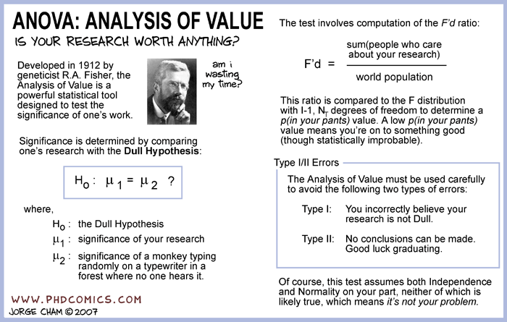
----------------------------------------------------------------------------------------------------

COURSE GRADING

The Grading Scale
Think of the response scale for all intellectual products of this course as ranging from 3 (Delightfully Wonderful) to 0 (A Total Waste of Time). On this scale, a value of 2 represents “standard” A-level graduate student work. Values above 2 are used to indicate those whose work is better then that expected for the typical advanced graduate student. Values that approach 2.5 reflect the level or work expected from a practicing academic psychologist; values that approach 3 are reserved for the gods (e.g., Tory Higgins; John Bargh). Values below 2 are used to indicate work that is less-than-expected for a Ph.D. - track graduate student. In the past most grades on most assignments have fallen between 1.5 and 2.
The Sources of Your Grade and How They Are Combined
Your grades will be entirely determined from the following sources: (1) 4 manuscript reviews (10% each), (2) 4 editorial action letters (10% each), (3) discussion question submissions (10%), (4) psychojeopardy performance (5%) and (5) class participation (5%). To derive a course grade, a numerical value (0 to 3) for each category will be generated and these values will be multiplied by the category weight. These weighted averages will then be translated into a course grade. The general rule translating weighted averages to grades used in past courses has been:

2.0 and above = A 1.70-1.99 = B 1.30-1.69 = C 1.00-1.29 = D .99 and below = F
I do not expect this rule to change, but I reserve the right to do so. In the context of this system, I will use the university’s +/- grade options as I deem necessary.

Where The Evaluations Come From
I am solely responsible for grading.

- However, the “associate editors” who had to use your reviews to write their decision letters will also grade your reviews. These grades are only advisory. The grade that I assign to a review will be the one that counts. My evaluation will be based on a review’s quality.

-My evaluation of your editorial letters will be based on my judgment of their quality.

-Your discussion question grade will be based on the frequency with which you submit discussion/clarification questions and on my evaluation of the quality of your questions.

-My evaluation of your class participation will be based on my own judgments and observations, as well as on the input solicited from your classmates.

-Your psychojeopardy grade will be derived from the number of psychojeopardy items that you get correct throughout the semester.

As in the Olympics, my quality judgments will use both my evaluation of content and my evaluation of the technical elements of writing (just think of me as the judge from Skowronsonia). I expect editors’ grades (e.g., of the manuscript reviews that you use to generate an action letter) to do the same. When I ask you to grade others’ work, remember the scale anchors: (3 = Delightfully Wonderful, 2 = Quality of Work is About That Expected From a Really Good Graduate Student, 1 = Work Quality Substantially Below the Level Expected From an Advanced Graduate Student, 0 = A Total Waste of Time). Use these scale anchors when making your judgments. Take these anchors seriously, please.

Deadline Rules
Reviews and Letters. Reviews are due in my electronic mailbox before the START of class (11:00 AM) and hardcopies AT the start of class (11:00 AM) on the assigned due date. Your e-mails are time and date stamped; for purposes of this class, that stamp is the OFFICIAL time. Remember that there is a delay between when you send an e-mail and when it arrives - IT IS THE ARRIVAL TIME THAT COUNTS. Remember that the due date and time is the LAST POSSIBLE MOMENT to submit before penalties accrue. Given that you usually have ample time to complete the assignment, I will be unsympathetic to even valid excuses for late submissions (e.g., illness, balky electricity, bottled-up server, a dragon ate my computer).
I also recognize that life happens. Hence, I will accept late reviews and letters. There will always be a cost to late submissions, but the cost will depend on context. Generally, the first late submission will not cost much; habitual late submissions will be much more costly. Hence, the sensible student response to this policy should be early submission. Be a chronic “deadline walker” at your peril.
Discussion questions. Discussion questions CANNOT be turned in late. Misses influence your grade in a nonlinear fashion: one missed question set will not hurt your grade much, but the more you miss, the more your grade in this area is affected via a positively accelerating penalty curve (e.g., the penalty grows in an exponential fashion). I will also assess the quality of those questions and use them when determining a discussion question grade.
----------------------------------------------------------------------------------------------------

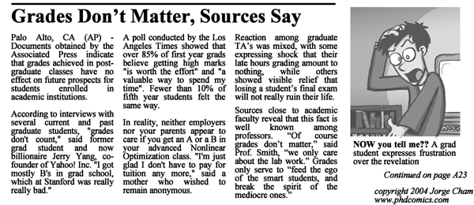

_____________________________________________________________________________________________

COURSE OVERVIEW, ASSIGNMENTS, & DEADLINES
_____________________________________________________________________________________________

1/13 (T) Course Overview (Those who trust enter the worship circle)

Textbook/Readings to be Read by Today/Psychojeopardy Target: None

Give Me: An ALIAS that you will use when turning in assignments.
_____________________________________________________________________________________________

1/15 (TH) Introduction to Manuscript Reviews, Reviewing, and Editorial Decisions
Introduction to Social Cognition: A Historical Perspective (When dinosaurs roamed )

Textbook/Readings to be Read by Today/Psychojeopardy Target: None

Relevant Non-Text Readings For Today:

Manuscripts 1-3
Letters and comments 1-3
JCP reviewer Instructions
Reviewer Guidelines 2009

GIVE ME: Nothing but your undying allegiance ….

FOR NEXT WEEK: Chapters 1 – 4

FOR THE FUTURE: Start Working on Manuscript 4
_____________________________________________________________________________________________

1/20 (T) Introduction to Social Cognition: A Methodological Perspective (Run every kind of
test from A to Z, but you’ll still know nothing about me)

Textbook Psychojeopardy Targets: Chapters 1 & 2

GIVE ME: Questions about Chapters 1-4
___________________________________________________________________________________________

1/22 (TH) Your Questions Answered

Textbook Psychojeopardy Targets: Chapters 3 & 4

FOR NEXT WEEK: Chapters 5 - 7
_____________________________________________________________________________________________

1/27 (T) Class Session: To Be Determined

Textbook Psychojeopardy Targets: Chapters 5 & 6

GIVE ME: Questions about Chapters 5 – 7
_____________________________________________________________________________________________

_____________________________________________________________________________________________

1/29 (TH): Your Questions Answered

Textbook Psychojeopardy Targets: Chapter 7

FOR NEXT WEEK: Chapters 8 - 10

MANUSCRIPT 4 REVIEWS DUE!!!
_____________________________________________________________________________________________

2/3 (T) To Be Determined

Textbook Psychojeopardy Targets: Chapters 8 & 9

GIVE ME: Questions about Chapters 8 - 10

A HEADS UP: Manuscript 4 Decision Letters Due in 1 Week
_____________________________________________________________________________________________

2/5 (TH) Your Questions Answered

Textbook Psychojeopardy Targets: Chapter 10

FOR NEXT WEEK: Chapters 11 - 13
_____________________________________________________________________________________________

2/10 (T) To Be Determined

Textbook Psychojeopardy Targets: Chapters 11 & 12

GIVE ME: Questions about Chapters 11 - 13

MANUSCRIPT 4 DECISION LETTERS & REVIEW GRADES DUE!!!!
_____________________________________________________________________________________________

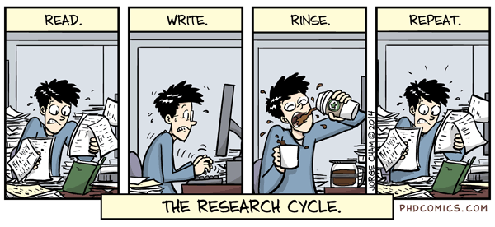
_____________________________________________________________________________________________

2/12 (TH) Your Questions Answered

Textbook Psychojeopardy Targets: Chapter 13

FOR NEXT WEEK: Chapters 14 – 17

_____________________________________________________________________________________________

2/17 (T) To Be Determined

Textbook Psychojeopardy Targets: Chapters 14 & 15

GIVE ME: Questions about Chapters 14 – 17

A HEADS UP: Manuscript 5 Decision Letters Due in 1 Week
_____________________________________________________________________________________________

2/19 (TH) Your Questions Answered

Textbook Psychojeopardy Targets: Chapter 16 & 17

FOR NEXT WEEK: Chapters 18 - 20 _____________________________________________________________________________________________

2/24 (T) To Be Determined

Textbook Psychojeopardy Targets: Chapters 18 & 19

GIVE ME: Questions about Chapters 18 - 20

MANUSCRIPT 5 REVIEWS DUE!!
_____________________________________________________________________________________________

2/26 (TH) Your Questions Answered

Textbook Psychojeopardy Targets: Chapter 20

FOR NEXT WEEK: Chapters 21 – 23

A HEADS UP: Manuscript 5 Decision Letters Due in 1 Week
_____________________________________________________________________________________________

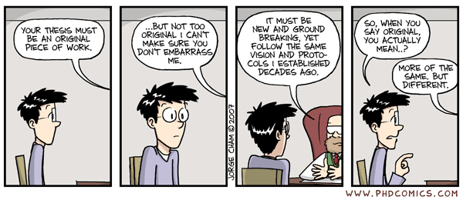
_____________________________________________________________________________________________

3/3 (T) To Be Determined

Textbook Psychojeopardy Targets: Chapters 21 & 22

GIVE ME: Questions about Chapters 21 - 23
_____________________________________________________________________________________________

3/5 (TH) Your Questions Answered

Textbook Psychojeopardy Targets: Chapter 23

FOR AFTER BREAK: Chapters 24 - 26

MANUSCRIPT 5 DECISION LETTERS & REVIEW GRADES DUE
_____________________________________________________________________________________________

3/10 – 3/12 SPRING BREAK!!!!!! (Let’s be careful out there …)
_____________________________________________________________________________________________

3/17 (T) To Be Determined

Social Judgment Processes and Shortcuts: If it looks like a duck and walks like a duck …

Textbook Psychojeopardy Targets: Chapters 24 & 25

GIVE ME: Questions about Chapters 24 - 26
_____________________________________________________________________________________________
3/19 (TH) Your Questions Answered

Textbook Psychojeopardy Targets: Chapter 26

FOR NEXT WEEK: Chapters 27 - 30
_____________________________________________________________________________________________

3/24 (T) To Be Determined

Textbook Psychojeopardy Targets: Chapters 27 & 28

GIVE ME: Questions about Chapters 27-30
_____________________________________________________________________________________________
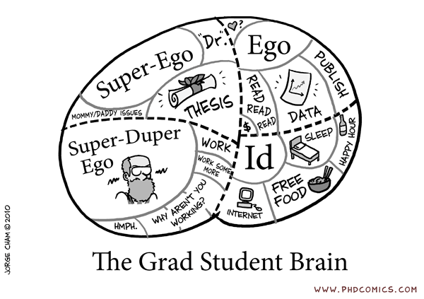
_____________________________________________________________________________________________

3/26 (TH) Your Questions Answered

Textbook Psychojeopardy Targets: Chapters 29 & 30

FOR NEXT WEEK: Chapters 31, 32, & 34

A HEADS UP: Manuscript 6 Reviews Due in 1 Week
__________________________________________________________________________________________

3/31 (T) To Be Determined

Textbook Psychojeopardy Targets: Chapters 31 & 32

GIVE ME: Questions about Chapters 31, 32, & 34
_____________________________________________________________________________________________

4/2 (TH) Your Questions Answered

Textbook Psychojeopardy Targets: Chapter 34

FOR NEXT WEEK: Chapters 33, 35, & 36

MANUSCRIPT 6 REVIEWS DUE

A HEADS UP: Manuscript 6 Decision Letters & Review Grades Due in 1 Week
_____________________________________________________________________________________________

4/7 (T) To Be Determined

Textbook Psychojeopardy Targets: Chapters 33 & 35

GIVE ME: Questions about Chapters 33, 35, & 36
__________________________________________________________________________________________

4/9 (TH) Your Questions Answered
Textbook Psychojeopardy Targets: Chapter 36

FOR NEXT WEEK: Chapters 37 - 39

MANUSCRIPT 6 DECISION LETTERS & REVIEW GRADES DUE
_________________________________________________________________________________________

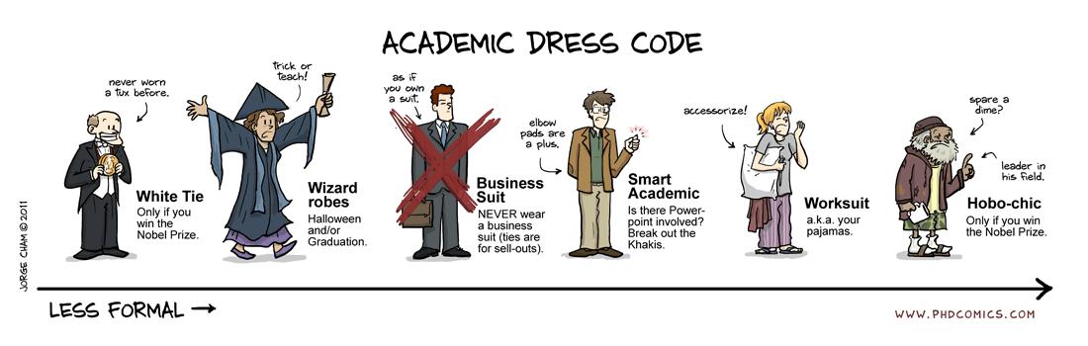
_________________________________________________________________________________________

4/14 (T) To Be Determined

Textbook Psychojeopardy Targets: Chapters 37 & 38

GIVE ME: Questions about Chapters 37 – 39

A HEADS UP: Manuscript 7 Reviews Due in 1 Week
_____________________________________________________________________________________________

4/16 (TH) Your Questions Answered

Textbook Psychojeopardy Targets: Chapter 39

FOR NEXT WEEK: Chapters 40 – 43
_____________________________________________________________________________________________

4/21 (T) To Be Determined

(T) Social Cognition and Action … Ok, I need to think about this before I go ahead and do it….

Textbook Psychojeopardy Targets: Chapters 40 & 41

GIVE ME: Questions about Chapters 40 – 43 (at least one must be from 42 or 43)

MANUSCRIPT 7 REVIEWS DUE
_____________________________________________________________________________________________

4/25 (TH) ROAD TRIP! No class
_____________________________________________________________________________________________

4/28 (T) Your Questions Answered
My Questions Answered

Textbook Psychojeopardy Targets: Chapters 42 & 43

GIVE ME: Your Undying allegiance

A HEADS UP: Manuscript 7 Decision Letters and Review Grades Due in 1 Week
_____________________________________________________________________________________________

4/30 (TH) MPA assignment!! ROAD TRIP!!!!!!!

Get your kiester into Chicago for MPA.

There is some GREAT social cognition happening there this year.

There are also TONS of other speakers with semi featured time slots, as well as a million posters and presentations.

You are ASSIGNED to get in there for at least one day; and I know that you can because Friday is Reading Day, so you have it open (grin).

I’ll be watching for you!
_____________________________________________________________________________________________

5/5 (T) MANUSCRIPT 7 DECISION LETTER + REVIEW GRADES DUE BY NOON
_____________________________________________________________________________________________
10 Focus/Comps Questions

What is Social Cognition? What is its history? What are some of the important themes and ideas that underlie the area? Be as specific as you can in describing relevant theories and research findings.

Provide an overview of the cognitive processes that are involved in thinking about others as information enters the cognitive system and flows through the system. (e.g., information processing). Give examples of the impact of these different processes on thought and/or behavior. Be as specific as you can in citing relevant research paradigms and results.

One of the main themes in social cognition concerns mental representation. Describe important ideas and experiments in social cognition that relate to mental representation and that illustrate its importance. Be as specific as you can in describing relevant theories and research findings.

How have the ideas derived from social cognition influenced researchers in other areas of social psychology? Be as specific as you can in describing relevant theories and research findings.

How have the ideas derived from social cognition influenced researchers in other areas of psychology and social science? Be as specific as you can in describing relevant theories and research findings.

One of the themes in social cognition revolves around “effortful” mental processing. Describe some theoretical ideas that involve such effortful processing and illustrate the operation of such processing in various research domains. Be as specific as you can in describing relevant theories and research findings.

One of the themes in social cognition revolves around how cognition can be influenced without an individual’s awareness of the influence. Describe some theoretical ideas that involve such non-conscious processing and illustrate the operation of such processing in various research domains. Be as specific as you can in describing relevant theories and research findings.

Social cognition can be motivated. Describe some theoretical ideas that involve such motivated processing and illustrate the operation of such processing in various research domains. Be as specific as you can in describing relevant theories and research findings.

Social cognition is important to, and is influenced by, interpersonal contexts. Describe some theoretical ideas that involve such context and illustrate the operation of such contexts in various research domains. Be as specific as you can in describing relevant theories and research findings.

Social cognition is relevant to how people think about themselves. Describe how and why. Describe some theoretical ideas that involve the self and social cognition and illustrate the operation of such ideas in various self-relevant research domains. Be as specific as you can in describing relevant theories and research findings.

