Studying the Self Through The Lens of a Social Psychologist
PSYCHOLOGY 671 - 00J1 (#10204)
Studies in General Psychology: Social Behavior
Spring 2014

T, TH............. 9:30 AM – 10:45 AM ............... 3 Credits .............. PM 136

SAVE THIS SYLLABUS FOR FUTURE REFERENCE!

Information in this syllabus is subject to changes and additions announced in class!
And there WILL likely be some changes, so come to class!
------------------------------------------------------------------------------------------------------------

UNINFORMATIVE DESCRIPTION FROM THE NIU BULLETIN

Specific topics in the area of general psychology offered under the appropriate heading. May include lecture, laboratory, seminar, or a combination of these methods. Topics and semester hours of credit vary. May be repeated to a maximum of 18 semester hours. (Yawn!).

THE REAL SCOOP: DR. JOHN'S DESCRIPTION
Course Format. Some classes will follow a lecture format. However, many (even most) class sessions will be in seminar format.
To clarify this for you, the concept of a seminar is generally considered to be a form of academic instruction offered at an academic institution or offered by a commercial or professional organization. It has the function of bringing together small groups for recurring meetings, focusing each time on some particular subject, in which everyone present is requested to actively participate. This is often accomplished through an ongoing Socratic dialogue with a seminar leader or instructor, or through a more formal presentation of research. Normally, participants must not be beginners in the field under discussion (at US universities, seminar classes are generally reserved for upper-class students, although at UK and Australian universities seminars are often used for all years). The idea behind the seminar system is to familiarize students extensively with the methodology of their chosen subject and also to allow them to interact with examples of the practical problems that always occur during research work. It is essentially a place where assigned readings are discussed, questions can be raised and debates can be conducted. It is relatively informal, at least compared to the lecture system of academic instruction.
In some European universities, a seminar may be a large lecture course, especially when conducted by a renowned thinker (regardless of the size of the audience or the scope of student participation in discussion). Some non-English speaking countries in Europe use the word seminar (e.g., German Seminar, Slovenian seminar, etc.) to refer to a university class that includes a term paper or project, as opposed to a lecture class (i.e., German Vorlesung, Slovenian predavanje, etc.). This does not correspond to English use of the term.

Course Content. The content of this course is shaped by two things: (1) my perceptions of research areas that exist at the interface between social psychology and the broader the area of "the self" (which is huge), and (2) my own personal interests.

Let me clarify point 1. Almost every introductory level textbook in social psychology includes a chapter that discusses 'the self'. When I was a young student, I always asked myself why that was the case. I did not care much for the topic because it seemed to take me away from the things that caused me to be interested in social psychology in the first place. It also seemed to take me closer to things that clinical psychologists did (and that was definitely not a domain of interest for me).

It took me a while to realize that there were several reasons for social psychologists to be interested in the self. Among them are: (1) it is possible that the self is shaped by the social context via social feedback mechanisms (reflected appraisal - exactly how much this happens is a topic of considerable debate); (2) comparisons of the self to others can occur, yielding both emotional consequences and cognitive consequences; (3) the way in which we think about OTHER people, the dimensions on which we judge them, and the weight that is placed on various factors that enter into those judgments, can be influenced by our own self-perceptions; and (4) elements of the self and the self-concept influence how a person acts in the social world, including the manner in which they try to present themselves to others. You will see exactly these topics represented in this course syllabus.

Now to point #2. Much of this course is about me (grin). Some topics that are addressed in this syllabus reflect many of my own personal interests (the course subtitle is "Studying the Self Through the Lens of a Social Psychologist" - that social psychologist would be ME - grin). Among these topics are things that have to do with the storage, structure, and processing of self-relevant information - interests that obviously derive from my general interests in social cognition. In addition, I have a research interest in aspects of autobiographical memory, a topic that many now argue has crucial relevance to the self-concept (and we'll be reviewing some of these arguments). I also have an interest in self-judgments and self-judgment processes. I hope that you enjoy learning about these kinds of topics. I know that I will enjoy thinking about them and exploring your ideas about them.

CONTACTING YOUR PROFESSOR

PM Office: 418 PM Office Phone: 753-7073 E-mail: jskowron@niu.edu
FVC Office: 115a FVC Office Phone: 753-0529

As pro golfer Fred Couples once said, the problem with answering the phone is that there might be someone on the other end. So chances are that if you call me, you'll have to leave a message on my voice mail. E-mail is another place to leave me messages that I can ignore – but at least I check that regularly. I’ve been known to ignore my phone for months.

Office Hours: T at 10:50 AM -12:15 AM, TH at 10:50AM – 12:25PM. I am also available by appointment (in my PSYC office) at least once/semester.

I am often about on other university business and lots of people try to use my office hours, so appointments are safer. Bring along pizza and root beer, just to make sure I'll let you in to my office.
COURSE OVERVIEW: YOU AND THIS CLASS

Are You Ready To Be In This Course? Even though there is no prerequisite, the course assumes that you have advanced knowledge of social psychology (e.g., you've taken at least one graduate-level course on the topic). This course is not for beginners.

Reading Level and Sophistication Level. The course also assumes that you are motivated enough to read a lot (pay special attention to the words "a lot") of professional-level material, to be able to discuss that material in sophisticated and theoretically-relevant ways, and to be able to discuss the material in empirically testable ways.

Class Sessions. The class is organized topically. The syllabus contains a question that frames some issues for both sessions. Day 1 on each topic will be spent reviewing some of the basic and overview material about the topic. This material will be stimulated by the assigned chapters or review articles. Note that I do not plan to lecture on these days. I want to talk, not lecture. I plan to come in with some ideas and questions, and you should do the same.

The second class day devoted to a topic will be a “skull session.” Each week assigns several articles that describe some empirical approaches and results that are related to the week’s topic. We will spend much of the skull session class periods (and maybe more) talking about how research might be framed to address the topic. Your input will be crucial – both conceptually and methodologically. My goal for each topic is to have designed at least one set of studies derived from at least one of the articles. I don’t know if any specific research will come from these sessions, but I’m hoping that some executable research might be generated and that you might get excited enough about the research to actually conduct a study or 6. This is a crucial part of the course – the quality and quantity of your class participation will be evaluated both by me and by other class members, and will contribute substantially to your final grade.

The Grant Proposal Assignment. One task that you may face you in the world of academia is to dig for dollars via grants. If you get one, you’re university will love you, and you’ll be able to buy that new Ferrari you’ve always wanted. How do you get grants? There are a lot of different ways, and there are a lot of different places to apply. One place is the federal government – grants from that source are looked at especially fondly by departments.

For your class assignment you will write a multi-study grant proposal detailing a research program that explores one of topics discussed in the class. Try to write one that you can even use for NSF’s SBE Doctoral Dissertation Research Improvement Grant program! Construct your proposal as if you were going to submit a grant to funding mechanism – that is, treat this as a ‘live” assignment. Who knows, maybe you will submit! I will be asking you for as many bells and whistles as you can provide – budgets, equipment lists, rationales, the whole nine yards. The point here is that I want you to see what it’s like to prepare a grant proposal so you know how to do one when you need to.

For preliminary information about this grant program, see http://www.nsf.gov/funding/pgm_summ.jsp?pims_id=13453. Kellie Dyslin is the excellent grants person for the Psych. Dept. – she’ll be coming into our second class session to give you some ideas, pointers, forms, etc. Still, you may feel a little lost at the start. That’s OK. We all have had that feeling when doing grants. I think that it’s better for you to have it for this assignment than when you are doing one “for real” (assuming this one is not “for real” – but remember that if it’s good, it could be ….). Start early on the needed paperwork, forms, etc – this is not an assignment to leave for the last minute!

Topics and Dates

Jan | 14 | Introductory Themes and Issues | Jan | 16 | Kellie Dyson Talks Grants
Jan | 21 | Reflected Appraisal/Symbolic Interaction | Jan | 23 | Research Skull Session
Jan | 28 | Self-Esteem and the Sociometer Hypothesis | Jan | 30 | Research Skull Session
Feb | 4 | Projected Appraisal | Feb | 6 | Research Skull Session
Feb | 11 | Social Comparison and the Self | Feb | 13 | Research Skull Session
Feb | 18 | The Self in Social, Cultural, and Group Context | Feb | 20 | Research Skull Session
Feb | 25 | Self-knowledge: Content and Complexity | Feb | 27 | Research Skull Session
Mar | 4 | Self Presentation and Impression Management | Mar | 6 | Research Skull Session
Mar | 11 | Spring Break | Mar | 13 | Spring Break
Mar | 18 | The Self and Social Information Processing | Mar | 20 | Research Skull Session
Mar | 25 | The Motives of Self-Enhancement and Self-Protection | Mar | 27 | Research Skull Session
Apr | 1 | The Motive of Self-Verification | Apr | 3 | Research Skull Session
Apr | 8 | Mnemic Neglect | Apr | 10 | Research Skull Session
Apr | 15 | The Interplay Between Autobiographical Memory and the Self | Apr | 17 | Research Skull Session
Apr | 22 | The Self and Emotional Reactions to Memories: The Fading Affect Bias | Apr | 24 | Research Skull Session
Apr | 29 | Class Recapitulation and Windup | May | 1 | No Class – MPA (and You ARE going!)
May | 8 | Grant Proposal Due (11:59AM)
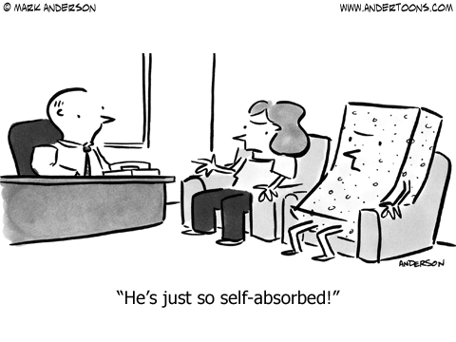

Grading

Your grant proposal will account for 50% of your grade. Both the quality of the ideas in the grant, as well as technical matters related to the construction of the grant (correct form completion, language use, etc.) will enter into the grading process. These judgments will be made solely by your professor. His judgment is final. The submission deadline is Thurs. May 8, 11:59 a.m. (the end of our assigned final exam session). Exams can be submitted early. It is preferred that exams be given directly to me, but you can give them to the PM 400 staff and have them stuffed in my mailbox. Keep a copy of your grant proposal for your records.

Your contribution to class discussions will account for 50% of your grade. This judgment will be made by your professor, probably after consultation with class members. However, your professor’s judgment is final.

ABOUT YOUR PROFESSOR

Name: John J. Skowronski, Ph.D. Aliases: Dr. Skowronski, Dr. John, Dr. J.
Feel free to call me whatever you like -- just be careful what you call me to my face!

NIU Rank: Full Professor (and people generally think that I'm full of it!)

Birthplace: Chicago (so don't even THINK of messing with me!)

Degrees: M.A., Ph.D., University of Iowa, B.A., Augustana College (Il.)
Go Hawks! Go Vikings!

Yes, as much as it amazes you I am a Ph.D. --- that means I can, indeed, Pile it Higher and Deeper.

A Few Professional Highlights:

Co-author of the book Autobiographical Memory (Lawrence Erlbaum Publishers)
Co-Editor of the book First Impressions (Guilford Publishers).
Author or co-author of over 110 professional journal articles and book chapters.
Former Associate Editor, Social Cognition & Journal of Experimental Social Psychology (professional journals)
Recipient, Ohio State University Alumni Award for Distinguished Teaching (back in my former job {Go Buckeyes!}, they were under the mistaken impression that I could actually teach.....)

Previous Employers (e.g., folks who have finally gotten rid of me):

Augustana College (Instructor)
The University of Iowa (Instructor)
Kansas State University (Visiting Assistant Professor)
Purdue University (Visiting Assistant Professor)
Southampton University, England (Distinguished Visiting Professor)
The Ohio State University (Assistant, Associate, and Full Professor)
COURSE READINGS: READ ‘EM AND WEEP

The readings are all located on a computer in a room to be announced. They are in a file labeled 671J, and are organized by subfolders. Take a memory stick and harvest them at your earliest convenience. Make sure to COPY them to your memory stick – not move them!

Week 1 (Jan 14-Jan 16) Establishing the “Lay of the Land” - Reviews of the “Self” and views of the “Self”

Morf, C. C. & Koole, S.L. (2012). The self. In M. Hewstone, W. Stroebe, & K. Jonas (Eds.), Introduction to Social Psychology: A European perspective (5th ed.; pp. 121-169). Oxford: Blackwell.

Swann, W.B., Jr. & Bosson, J. (2010). Self and identity. In S.T. Fiske, D.T. Gilbert, & G. Lindzey (Eds.), Handbook of social psychology (5th ed., pp. 589-628), New York: McGraw-Hill.

Oyserman, D., Elmore, K., & Smith G. (2012). Self, self-concept, and identity. In M. Leary & J. Tangney (Eds). Handbook of self and Identity (2nd ed., pp. 69-104). New York, NY: Guilford Press.

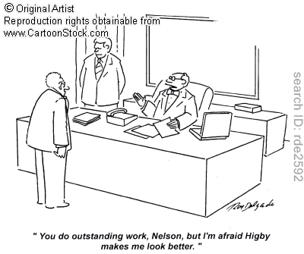

Week 2 (Jan 21 – Jan 23) - Tell me again how great you think I am….. Seeing us how others see us (Reflected Appraisal/Symbolic Interactionism)

The reflected appraisal idea suggests that we in part come to know ourselves by the reactions that others have to us and from the feedback that we get from others (there is a whole area/journal in sociology devoted to this idea, which also goes by the name of symbolic interactionism). However, some psychologists (e.g., those who look at contingencies of self-worth) suggest that the emphasis on the social view of the self may be overemphasized. Here are some relevant readings that tap into this controversy.

Serpe, R.T., & Stryker, S. (2011). The symbolic interactionist perspective and identity theory. In S.J. Schwartz, K. Luyckx, & V. L. Vignoles (Eds.), Handbook of identity theory and research (Vol. 1, pp. 225-248). New York, NY, US: Springer Science + Business Media; US.

Wallace, H.M., & Tice, D.M. (2012). Reflected appraisal through a 21st-century looking glass. In M.R. Leary & J.P. Tangney (Eds.), Handbook of self and identity (2nd ed., pp. 124-140). New York, NY, US: Guilford Press; US.

Nurra, C., & Pansu, P. (2009). The impact of significant others' actual appraisals on children's self-perceptions: What about Cooley's assumption for children? European Journal of Psychology of Education, 24, 247-262.

Horberg, E. J., & Chen, S. (2010). Significant others and contingencies of self-worth: Activation and consequences of relationship-specific contingencies of self-worth. Journal of Personality and Social Psychology, 98, 77-91.

Overstreet, N. M., & Quinn, D.M. (2012). Contingencies of self-worth and appearance concerns: Do domains of self-worth matter? Psychology of Women Quarterly, 36, 314-325.

Greenwood, D. N. & Dal Cin, S. (2012). Ethnicity and body image: Black and White American women's negotiation of media ideals and others' approval. Psychology of Popular Media Culture. 1, 220-235.

Plaut, V. C., Markus, H. R., Treadway, J. R., & Fu, A. S. (2012). The cultural construction of self and well-being: A tale of two cities. Personality and Social Psychology Bulletin, 38, 1644-1658.

Overall, N. C., & Fletcher, G. J. O. (2010). Perceiving regulation from intimate partners: Reflected appraisal processes in close relationships. Personal Relationships, 17, 433-456.

Richard, A. J., Trevino, R. A., Baker, M., & Valdez, J. (2010). Negative reflected appraisal, negative self-perception, and drug use intentions in a sample of suburban high school students. Journal of Child & Adolescent Substance Abuse, 19, 193-209.

Litrico, J-B., & Choi, J. N. (2013). A look in the mirror: Reflected efficacy beliefs in groups. Small Group Research, 44, 658-679.
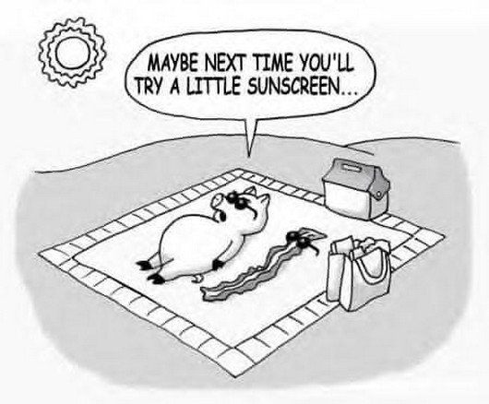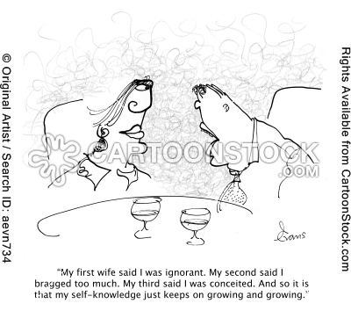
Week 3 (Jan 28 – Jan 30) – If you feel good about me that must mean that I feel good about me, too! Self-esteem and the Sociometer hypothesis.

The sociometer hypothesis is the notion, grounded in evolution, that self esteem really is a signal designed by nature to track the quality and quantity of your social interactions. Lots of research supports the sociometer idea – how can it be attacked? Try to think of methods that can be used to test your ideas and come prepared to talk about them.

Leary, M. R. (2005). Sociometer theory and the pursuit of relational value: Getting to the root of self-esteem. European Review of Social Psychology, 16 , 75-111.

Denissen, J. A, Penke, L., Schmitt, D.P., & van Aken, M.A.G. (2008). Self-esteem reactions to social interactions: Evidence for sociometer mechanisms across days, people, and nations. Journal of Personality and Social Psychology, 95, 181-196.

Anthony, D.B., Holmes, J.G., & Wood, J.V. (2007). Social acceptance and self-esteem: Tuning the sociometer to interpersonal value. Journal of Personality and Social Psychology, 92, 1024-1039.

Srivastava, S., & Beer, J.S. (2005). How self-evaluations relate to being liked by others: Integrating sociometer and attachment perspectives. Journal of Personality and Social Psychology, 89, 966-977.

Lemay, E.P. Jr.,& Ashmore, R.D. (2006). The relationship of social approval contingency to trait self-esteem: Cause, consequence, or moderator? Journal of Research in Personality, 40, 121-139.

MacDonald, G., Saltzman, J.L., & Leary, M. R. (2003). Social approval and trait self-esteem. Journal of Research in Personality, 37, 23-40.

Kavanagh, P.S., Robins, S.C., & Ellis, B.J. (2010). The mating sociometer: A regulatory mechanism for mating aspirations. Journal of Personality and Social Psychology, 99, 120-132.

Stinson, D.A., Logel, C., Holmes, J.G., Wood, J.V., Forest, A.L., Gaucher, D., Fitzsimons, G.M., & Kath, J. (2010). The regulatory function of self-esteem: Testing the epistemic and acceptance signaling systems. Journal of Personality and Social Psychology, 99, 993-1013.

Bernstein, M. J., Claypool, H. M., Young, S. G., Tuscherer, T., Sacco, D. F., & Brown, C. M. (2013). Never let them see you cry: Self-presentation as a moderator of the relationship between exclusion and self-esteem. Personality and Social Psychology Bulletin, 39, 1293-1305.

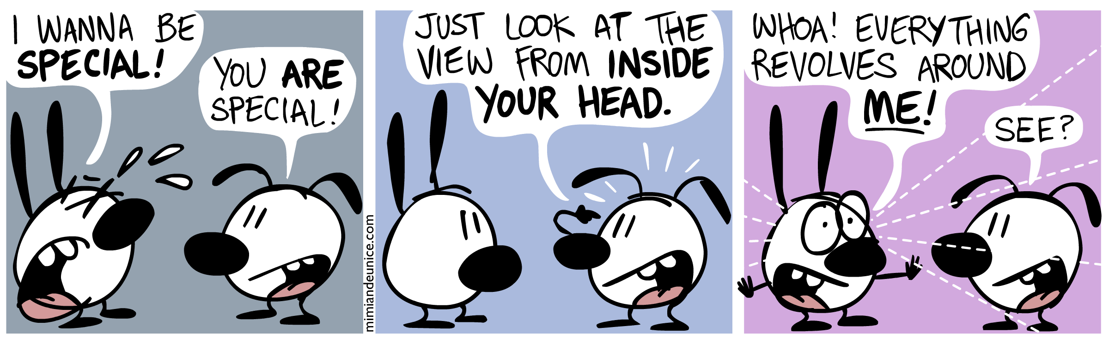

Week 4 (Feb 4 – Feb 6) – How we think others see us (Projected Appraisal)
Pick your favorite subtitle:
(a) She’s just not that into me
(b) Alecia Santuzzi paid me $100 to talk about this stuff in this class

One other potential flaw with the notion of reflected appraisal is that we actually know what others think about us. There are lots of reasons (projection, communicative ambiguity, self-protection, cognitive distortion) why this may not happen. On the other hand, can people really be that dense as to be oblivious about what others think about them? It’s a hot issue, and here’s what some of the current thinking and research (with one of my favorite classics thrown in) says:

Carlson, E. N., & Kenny, D. A. (2012). Meta-accuracy: Do we know how others see us? In S. Vazire & T. D. Wilson (Eds.), Handbook of self-knowledge (pp. 242–257). New York, NY: Guilford Press.

Carlson, E. N., & Furr, R. M. (2013). Resolution for meta-accuracy: Should people trust their beliefs about how others see them? Social Psychological and Personality Science, 4, 419-426.

Kenny, D. A., & DePaulo, B. M. (1993). Do people know how others view them? An empirical and theoretical account. Psychological Bulletin, 114, 145-161.

Carlson, E. N., Vazire, S., & Oltmanns, T. F. (2011a). You probably think this paper's about you: Narcissists' perceptions of their personality and reputation. Journal of Personality and Social Psychology, 101, 185-201.

Carlson, E. N., Vazire, S., & Furr, R. M. (2011b). Meta-insight: Do people really know how others see them? Journal of Personality and Social Psychology, 101, 831–846.

Carlson, E. N., Furr, R. M., & Vazire, S. (2010). Do we know the first impressions we make? Evidence for idiographic meta-accuracy and calibration of first impressions. Social Psychological and Personality Science, 1, 94-98.

Kaplan, S.A., Santuzzi, A.M. & Ruscher, J.B. (2009). Elaborative metaperceptions in outcome-dependent situations: The diluted relationship between default self-perceptions and metaperceptions. Social Cognition, 27, 601-614.

Elfenbein, H.A., Eisenkraft, N, & Ding, W.W. (2009). Do we know who values us? Dyadic meta-accuracy in the perception of professional relationships. Psychological Science, 20, 1081-1083.

Santuzzi, A.M. (2007). Perceptions and metaperceptions of negative evaluation: Group composition and meta-accuracy in a social relations model. Group Processes & Intergroup Relations, 10, 383-398.

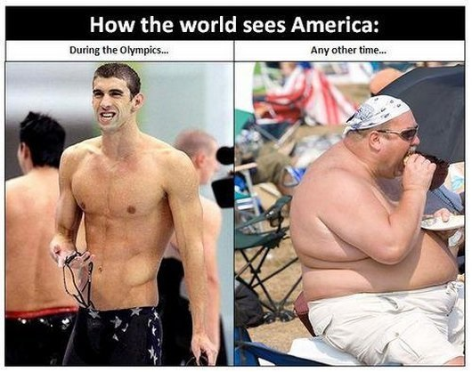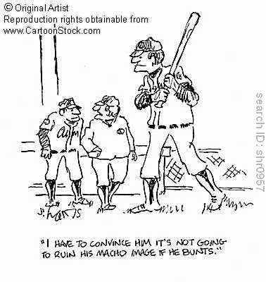
Week 5 (Feb 11 – Feb 13) – Hey – your grade was better than mine! No fair! .... Issues in Social Comparison and Implications for the Self

Understanding Social Comparison used to be so easy – you want to feel better about yourself? Compare downward. You want to feel worse about yourself? Compare upward. Then, social cognition types got involved in the area and things got a whole lot more complex. Following the lead of the readings, consider the mental processes and structures invoked during social comparisons and try to think of more how they might serve to moderate the social comparison process. Try to think of methods that can be used to test your ideas and come prepared to talk about them.

Alicke, M.D., Guenther, C.L., & Zell, E (2012). Social self-analysis: Constructing and maintaining personal identity. In M.R. Leary & J.P. Tangney (Eds.), Handbook of self and identity (2nd ed., pp. 291-308). New York, NY, US: Guilford Press; US.

Corcoran, K., Crusius, J., & Mussweiler, T. (2011). Social comparison: Motives, standards, and mechanisms. In Chadee, D. (Ed.), Theories in social psychology (pp. 119-139). West Sussex, UK: Wiley-Blackwell.

Normand, A., & Croizet, J-C. (2013). Upward social comparison generates attentional focusing when the dimension of comparison is self-threatening. Social Cognition, 31, 336-348.

Visconti, K.J., Kochenderfer-Ladd, B., & ;Clifford, C.A. (2013). Children's attributions for peer victimization: A social comparison approach. Journal of Applied Developmental Psychology. No Pagination Specified.

Steinbeis, N. & Singer, T. (2013). The effects of social comparison on social emotions and behavior during childhood: The ontogeny of envy and Schadenfreude predicts developmental changes in equity-related decisions. Journal of Experimental Child Psychology, 115, 198-209.

Bounoua, L., Cury, F., Regner, I., Huguet, P., Barron, K.E., & Elliot, A.J. (2012). Motivated use of information about others: Linking the 2 x 2 achievement goal model to social comparison propensities and processes. British Journal of Social Psychology, 51, 626-641.

Soibel, A., Fong, K., Mullin, J.B., Jenkins, G., & Mar, R.A. (2012). Is self-monitoring related to social comparison? It depends how you ask. Individual Differences Research, 10, 193-201.

Datta, N., & Kulik, J.A. (2012). Women's approach and avoidance of social comparison opportunities when exercising. Basic and Applied Social Psychology, 34, 467-473.

Steinmetz, J., & Mussweiler, T. (2011). Breaking the ice: How physical warmth shapes social comparison consequences. Journal of Experimental Social Psychology, 47, 1025-1028.

Hill, S.E., DelPriore, D.J., & Vaughan, P.W. (2011). The cognitive consequences of envy: Attention, memory, and self-regulatory depletion. Journal of Personality and Social Psychology, 101, 653-666.

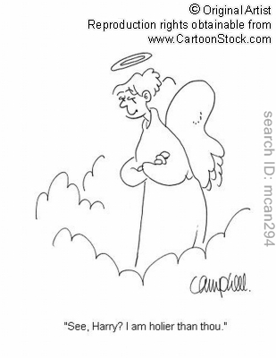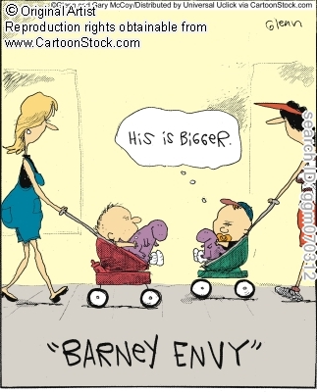

Week 6 (Feb 18 – Feb 20) – Cub fans say: “We is me and woe is us” - The self in relational, group, and cultural context

The self is influenced by the relationships and groups to which an individual belongs. How does this happen? Why? For whom? We belong to a lot of groups. Why and when might a group membership affect how we think about ourselves, and when might it not? Interesting questions all, and these questions help to explain why social psychologists hotly pursue knowledge about the self.

Aron, A., Lewandowski, G.W., Mashek, D., & Aron, E.N. (2013). The self expansion model of cognition and motivation in close relationships. No pagination specified.

Cross, S.E., & Gore, J.S. (2012). Cultural models of the self. In M.R. Leary & J.P. Tangney (Eds.), Handbook of self and identity (2nd ed., pp. 587-614). New York, NY, US: Guilford Press; US.

Aron, A. & Nardone, N. (2012). The self and close relationships. In M. R. Leary & J. P. Tangney (Eds.), Handbook of self and identity (2nd ed., pp. 520-541). New York: Guilford.

Burris, C.T., & Rempel, J.K. (2008). Me, myself, and us: Salient self-threats and relational connections. Journal of Personality and Social Psychology, 95, 944-961.

Kang, S.K., Hirsh, J.B., & Chasteen, A.L. (2010). Your mistakes are mine: Self-other overlap predicts neural response to observed errors. Journal of Experimental Social Psychology, 46, 229-232.

Slotter, E.B., Gardner, W.L., & Finkel, E.J. (2010). Who am I without you? The influence of romantic breakup on the self-concept. Personality and Social Psychology Bulletin, 36,147-160.

Slatcher, R.B., Vazire, S., & Pennebaker, J.W. (2008). Am "I" more important than "We"? Couples' word use in instant messages. Personal Relationships, 15, 407-424.

Leach, C.W., van Zomeren, M., Zebel, S., Vliek, M.L.W., Pennekamp, S.F., Doosje, B., Ouwerkerk, J.W., & Spears, R.. (2008). Group-level self-definition and self-investment: A hierarchical (multicomponent) model of in-group identification. Journal of Personality and Social Psychology, 95, 144-165.

Kimel, S.Y., Grossmann, I., & Kitayama, S. (2012). When gift-giving produces dissonance: Effects of subliminal affiliation priming on choices for one's self versus close others. Journal of Experimental Social Psychology, 48, 1221-1224.

Park, B.K., Choi, J.A, Koo, M., Sul, S, & Choi, I. (2013). Culture, self, and preference structure: Transitivity and context independence are violated more by interdependent people. Social Cognition, 31, 106-118.

English, T. & Chen, S. (2011). Self-concept consistency and culture: The differential impact of two forms of consistency. Personality and Social Psychology Bulletin, 37, 838-849.

Gore, J.S. (2013). Individual differences that moderate the effectiveness of relational reasons for self-improvement. Motivation and Emotion. No Pagination Specified.



Week 7 (Feb 25 – Feb 27) - I’m SUCH a deep and complex person! Self knowledge: content & complexity

When I think of myself, what do I think of? One can access traits, behaviors, group memberships, social roles, etc. What determines which of these facets gets accessed at any given time? Are any of these more critical to “selfness” than others? Can you distinguish between your “true self” and the different faces that you present to people in different circumstances? There are lots of interesting theoretical questions to be pursued, here. Some of those ideas are reflected in the article list. Try to think of methods that can be used to test your ideas and come prepared to talk about them.

Back, M.D., & Vazire, S. (2012). Knowing our personality. In S. Vazire & T.D. Wilson (Eds.), Handbook of self-knowledge, (pp. 131-156). New York, NY, US: Guilford Press; US.

Showers, C.J., & Zeigler-Hill, V. (2012). Organization of self-knowledge: Features, functions, and flexibility. In M.R. Leary & J.P. Tangney (Eds.), Handbook of self and identity (2nd ed., pp. 105-123). New York, NY, US: Guilford Press; US.

Klein, S.B., & Lax, M.L. (2010). The unanticipated resilience of trait self-knowledge in the face of neural damage. Memory, 18, 918-948.

Carlson, E.N. (2013). Overcoming the barriers to self-knowledge: Mindfulness as a path to seeing yourself as you really are. Perspectives on Psychological Science, 8, 173-186.

McConnell, A.R., Shoda, T.M., & Skulborstad, H.M. (2012). The self as a collection of multiple self-aspects: Structure, development, operation, and implications. Social Cognition, 30, 380-395.

Libby, L.K., Valenti, G, Hines, K.A., & Eibach, R.P. (2013). Using imagery perspective to access two distinct forms of self-knowledge: Associative evaluations versus propositional self-beliefs. Journal of Experimental Psychology: General. No pagination specified.

Schlegel, R.J., Hicks, J.A., Davis, W.E., Hirsch, K.A., & Smith, C.M. (2013). The dynamic interplay between perceived true self-knowledge and decision satisfaction. Journal of Personality and Social Psychology, 104, 542-558.

Haslam, C., Jetten, J., Haslam, S. A., Pugliese, C., & Tonks, J. (2011). 'I remember therefore I am, and I am therefore I remember': Exploring the contributions of episodic and semantic self-knowledge to strength of identity. British Journal of Psychology, 102, 184-203.

Klein, S.B., Gangi, C.E., & Lax, M.L. (2011). Memory and self-knowledge in young adults with ADHD. Self and Identity, 10, 213-230.

Bar-Anan, Y., Wilson, T.D., & Hassin, R.R. (2010). Inaccurate self-knowledge formation as a result of automatic behavior. Journal of Experimental Social Psychology, 46, 884-894.

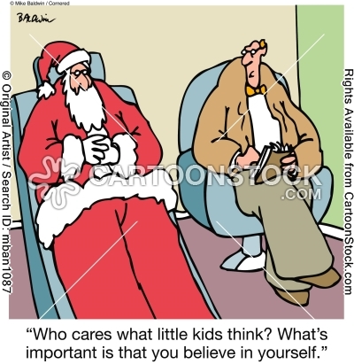

Week 8 (Mar 4 – Mar 6) - Zelig Lives! Self-presentation and impression management

Ok, so everyone knows that people try to manage the impressions that they make on others? But do they try to present themselves accurately, or as they want themselves to be seen? Do they sometimes do one and sometimes do the other? What kinds of self-presentations and excuses seem to work, which don’t, and why? What are the mental consequences of having to manage impressions, especially when one is trying to manage several at once? Read on, my children, for insight into such issues, and more….

Schlenker, B.R. Self-presentation. In M.R. Leary & J.P. Tangney (Eds.), Handbook of self and identity (2nd ed., pp.542-570). New York, NY, US: Guilford Press; US.

Tenney, E.R., & Spellman, B.A. (2011). Complex social consequences of self-knowledge. Social Psychological and Personality Science, 2, 343-350.

Tyler, J. M. (2012). Triggering self-presentation efforts outside of people’s conscious awareness. Personality and Social Psychology Bulletin, 38, 619-627.

Tyler, J. M., Connaughton S. L., Desrayaud, N., & Fedesco, H. N. (2012). Organizational Impression Management: Utilizing Anticipatory Tactics. Basic and Applied Social Psychology, 34, 336-348.

Tal-Or, N. (2010). Indirect ingratiation: Pleasing people by associating them with successful others and by praising their associates. Human Communication Research, 36, 163-189.

Jenkins, J.S., & Skowronski, J.J. (2014). The impression management consequences of invoking negative stereotype excuses. Manuscript under review.

Blair, A., & Roese, N. J. (2013). Balancing the basket: The role of shopping basket composition in embarrassment. Journal of Consumer Research, 40, 676-691.

Schrick, B.H., Sharp, E.A., Zvonkovic, A., & Reifman, A. (2012). Never let them see you sweat: Silencing and striving to appear perfect among U.S. college women. Sex Roles, 67, 591-604.

Huang, G-h., Zhao, H.H., Niu, X-y., Ashford, S.J., & Lee, C. (2013). Reducing job insecurity and increasing performance ratings: Does impression management matter? Journal of Applied Psychology, 98, 852-862.

Holoien, D.S., & Fiske, S.T. (2013). Downplaying positive impressions: Compensation between warmth and competence in impression management. Journal of Experimental Social Psychology, 49, 33-41.

Leary, M.R., & Allen, A.B. (2011). Self-presentational persona: Simultaneous management of multiple impressions. Journal of Personality and Social Psychology, 101, 1033-1049.

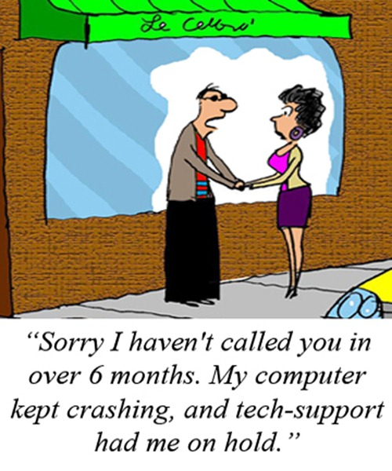

Week 9 (Mar 18 – Mar 20) – Why do you waste your time on unimportant crud like that? The self and social information processing.

To some extent, if you want to understand how people perceive others, you have to understand how people perceive themselves. For example, when thinking about others’ opinions, people often project their own views onto others. A second example is the extent to which peoples’ own beliefs and views of the world affect how they evaluate others, such as the dimensions on which they choose to evaluate them or the extent to which judgment biases emerge. I’m interested in these phenomena from a moderation perspective and from a process perspective. When will the self be important to the judgments that we make about others, and when not? I want to talk about ways in which this problem can be further researched. Try to think of methods that can be used to test your ideas and come prepared to talk about them.

Dunning, D. (2012). The relation of self to social perception. In M.R. Leary & J.P. Tangney (Eds.), Handbook of self and identity (2nd ed., pp. 481-501). New York, NY, US: Guilford Press; US.

Saribay, S. A., Rim, S.Y., & Uleman, J.S. (2012). Primed self-construal, culture, and stages of impression formation. Social Psychology, 43, 196-204.

Ma-Kellams, C., & Blascovich, J (2012). Inferring the emotions of friends versus strangers: The role of culture and self-construal. Personality and Social Psychology Bulletin, 38, 933-945.

Shoda, T.M., & McConnell, A. R. (2013). Interpersonal sensitivity and self-knowledge: Those chronic for trustworthiness are more accurate at detecting it in others. Journal of Experimental Social Psychology, 49, 440-443.

Ditzfeld, C.P., & Showers, C.J. (2013). Self-structure and emotional response categorization: Who judges a face by its emotional cover? Journal of Research in Personality, 47, 145-152.

Van Bavel, J.J. & Cunningham, W.A. (2009). Self-categorization with a novel mixed-race group moderates automatic social and racial biases. Personality and Social Psychology Bulletin, 35, 321-335.

Critcher, C.R., & Dunning, D. (2009). Egocentric pattern projection: How implicit personality theories recapitulate the geography of the self. Journal of Personality and Social Psychology, 97, 1-16.

Kilianski, S.E. (2008). Who do you think I think I am? Accuracy in perceptions of others' self-esteem. Journal of Research in Personality, 42, 386-398.

Sedikides, C., & Skowronski, J. J. (1993). The self in impression formation: Trait centrality and social perception. Journal of Experimental Social Psychology, 29, 347-357.

Milyavskaya, M., Reoch, J., Koestner, R.F., & Losier, G. F. Seeking social connectedness: Interdependent self-construal and impression formation using photographic cues of social connectedness. The Journal of Social Psychology, 150, 689-702.

Barkan, R., Ayal, S., Gino, F., & Ariely, D. The pot calling the kettle black: Distancing response to ethical dissonance. Journal of Experimental Psychology: General, 141, 757-773.

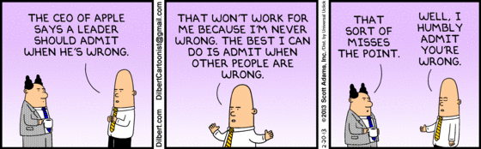

Week 10 (Mar 20 – May 27) - I am looking goooooooood! = Self-enhancement…. and My grade wasn’t that bad and I could have done better and it was your fault because the test was too hard!= Self-protection

I have lots of interests here – one of them is how these self-motives might affect or relate to memory. One line of research that has pursued this is in the laboratory – it is work on mnemic neglect. Basically, this work shows that people have relatively poor memory for personality feedback that is especially self-threatening. However, there are a lot of questions about this effect. Can one localize the mental processes that are responsible for it (attention, encoding, storage, retrieval)? What are some of the other personality or motivational moderators that might yield insight into the potential reasons why the effect occurs? Try to think of methods that can be used to test your ideas and come prepared to talk about them.

Alicke, M., & Sedikides, C. (2009). Self-enhancement and self-protection: What they are and what they do. European Review of Social Psychology 20, 1-48.

Sedikides, C. (2012). Self-protection. In M.R. Leary & J.P. Tangney (Eds.), Handbook of self and identity (2nd ed., pp. 327-353). New York, NY, US: Guilford Press; US.

Preuss, G.S., & Alicke, M.D. (2009). Everybody loves me: Self-evaluations and metaperceptions of dating popularity. Personality and Social Psychology Bulletin, 35, 937-950.

Pulfrey, C., & Butera, F. (2013). Why neoliberal values of self-enhancement lead to cheating in higher education: A motivational account. Psychological Science, 24, 2153-2162.

Chatterjee, P., Irmak, C., & Rose, R.L. (2013). The endowment effect as self-enhancement in response to threat. Journal of Consumer Research, 40, 460-476.

Liu, J., Lee, C., Hui, C, Kwan, H.K., & Wu, L-Z. (2013). Idiosyncratic deals and employee outcomes: The mediating roles of social exchange and self-enhancement and the moderating role of individualism. Journal of Applied Psychology, 98, 832-840.

Beer, J.S., Chester, D.S. & Hughes, B.L. (2013). Social threat and cognitive load magnify self-enhancement and attenuate self-deprecation. Journal of Experimental Social Psychology, 49, 706-711.

Hepper, E.G., Sedikides, C., & Cai, H. (2013). Self-enhancement and self-protection strategies in China: Cultural expressions of a fundamental human motive. Journal of Cross-Cultural Psychology, 44, 5-23.

Kim, Y-H, & Chiu, C-Y. (2011). Emotional costs of inaccurate self-assessments: Both self-effacement and self-enhancement can lead to dejection. Emotion, 11, 1096-1104.

Schmeichel, B.J., & Demaree, H.A. (2010). Working memory capacity and spontaneous emotion regulation: High capacity predicts self-enhancement in response to negative feedback. Emotion, 10, 739-744.

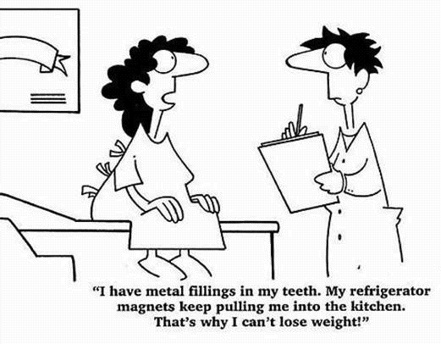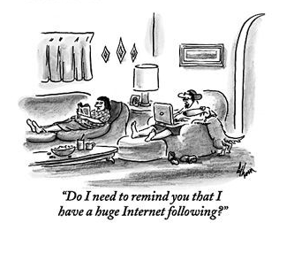
Week 11 (Apr 1 – Apr 3) - Ohh, baby, why don’t you tell me what I want to hear? Self verification.

One of the others self-motives is self-verification: the desire to have ideas about the self confirmed. When might this desire be especially strong? What happens when it is in conflict with the motives to self-enhance or self-protect? Do people like it when negative feedback that confirms self-images is received? Do people seek feedback that confirms their self-views, even when the feedback is threatening? Does the motive to self-verify affect how people recall their own behavior? There is lots of good stuff here. Read about some of it.

Swann, W. B., Jr. (2012). Self-verification theory. In P. Van Lang, A. Kruglanski, & E.T. Higgins (Eds.), Handbook of Theories of Social Psychology (pp. 23-42). Sage: London.

Swann, W.B., & Buhrmeister, M.D. (2012). Self-enhancement: The search for coherence. In M.R. Leary & J.P. Tangney (Eds.), Handbook of self and identity (2nd ed., pp. 405-424). New York, NY, US: Guilford Press; US

Libby, L.K., & Eibach, R.P. (2011). Self-enhancement or self-coherence? Why people shift visual perspective in mental images of the personal past and future. Personality and Social Psychology Bulletin, 37, 714-726.

Valentiner, D.P., Skowronski, J.J., McGrath, P.B., Smith, S.A., & Renner, K.A. (2011). Self-verification and social anxiety: Preference for negative social feedback and low social self-esteem. Behavioural and Cognitive Psychotherapy, 39, 601-617. doi: http://dx.doi.org/10.1017/S1352465811000300

Bilewicz, M., & Kofta, M. (2011). Less biased under threat? Self-verificatory reactions to social identity threat among groups with negative self-stereotypes. Journal of Applied Social Psychology, 41, 2249-2267.

Seih, Y-T., Buhrmester, M.D., Lin, Y-C., Huang, C-L., & Swann, W.B. Jr. (2011). Do people want to be flattered or understood? The cross-cultural universality of self-verification. Journal of Experimental Social Psychology, 49, 169-172.

Cable, D.M., & Kay, V.S. (2012) Striving for self-verification during organizational entry. Academy of Management Journal, 55, 360-380.

Gregg, A.P., Hepper, E.G., & Sedikides, C. (2011). Quantifying self-motives: Functional links between dispositional desires. European Journal of Social Psychology, 41, 840-852.

Brooks, M.L., Swann, W.B. Jr., & Mehta, P.H. (2011). Reasserting the self: Blocking self-verifying behavior triggers compensatory self-verification. Self and Identity, 10, 77-84.

Scherr, K.C., Madon, S., Guyll, M., Willard, J., & Spoth, R. (2011). Self-verification as a mediator of mothers' self-fulfilling effects on adolescents' educational attainment. Personality and Social Psychology Bulletin, 37, 587-600.
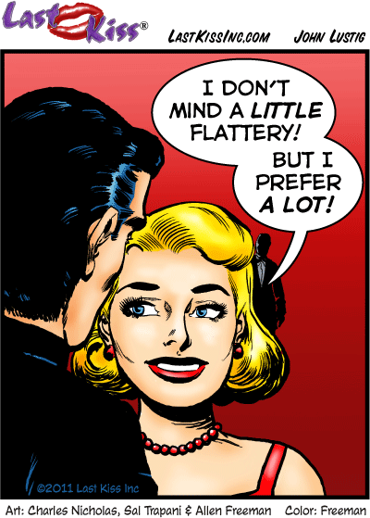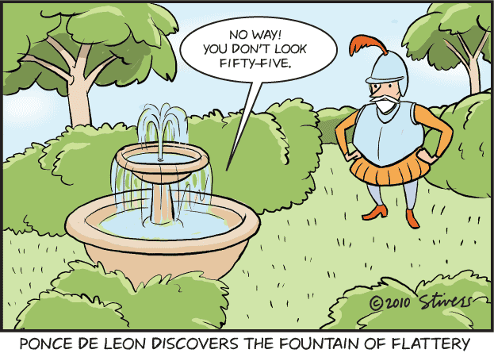
Week 12 (Apr 8 – Apr 10) – I don’t remember reading that part of the report where you told me I was going to die old and lonely: Mnemic neglect

Wells, B.M. (2013). The waxing and waning of self-threatening memories: Testing the cognitive mechanisms of the mnemic neglect model. Doctoral dissertation, Northern Illinois University.

Pinter, B., Green, J.D., Sedikides, C., & Gregg, A.P. (2011). Self-protective memory: Separation/integration as a mechanism for mnemic neglect. Social Cognition, 29, 612-624.

Green, J.D., Sedikides, C., Pinter, B., & Van Tongeren, D.R. (2009). Two sides to self-protection: Self-improvement strivings and feedback from close relationships eliminate mnemic neglect. Self and Identity, 8, 233-250.

Green, J.D., Sedikides, C., & Gregg, A.P. (2008). Forgotten but not gone: The recall and recognition of self-threatening memories. Journal of Experimental Social Psychology, 44, 547-561.

Newman, L.S. Nibert, J.A., & Winer, E. S. (2009). Mnemic neglect is not an artifact of expectancy: The moderating role of defensive pessimism. European Journal of Social Psychology, 39, 477-486.

Newman, L.S., Sapolsky, M.S., Tang, Y., & Bakina, D.A. (2013). What's recalled depends on the nature of the recall procedure: The case of mnemic neglect. Social Psychology.

Zengel, B., Skowronski, J.J., Valentiner, D.P., & Sedikides, C. (2014). Loss of mnemic neglect among socially anxious individuals. Manuscript in preparation.

Saunders, J. (2013). Selective memory bias for self-threatening memories in trait anxiety. Cognition and Emotion, 27, 21-36.

Saunders, J. (2011). Reversed mnemic neglect of self-threatening memories in dysphoria. Cognition and Emotion, 25, 854-867.

Jenkins, J. S., Zengel, B., & Skowronski, J. J. (2014). I've never thought about that: The effects of descriptive and explanatory introspection on mnemic neglect. Manuscript in preparation.

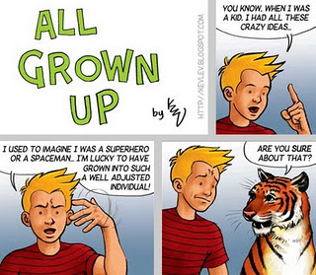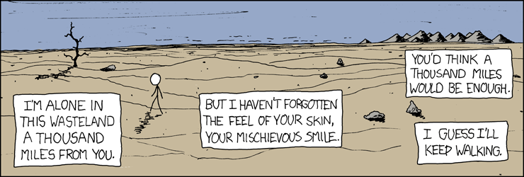
Week 13 (Apr 15 – Apr 17) – Boy, when I started grad school I was dumber than a turnip – look where I am now! The interplay between autobiographical memory and the self.

This section reflects my specific interest in the self and autobiographical memory. How might autobiographical memory shape the self? How might this shaping change over time? How might the self shape (distort, promote some memories, cause forgetting of other memories) autobiographical memory? Boy, there’s so much stuff here I almost couldn’t restrain myself when deciding on readings. Look at some of them…..

Prebble, S.C. Addis, D.R., & Tippett, L.J. (2013). Autobiographical memory and sense of self. Psychological Bulletin, 139, 815-840.

Skowronski, J.J. (2011). The Positivity Bias and the Fading Affect Bias in Autobiographical Memory: A Self-Motives Perspective. In C. Sedikides & M. Alicke (Eds.), The Handbook of Self-Enhancement and Self-Protection (pp. 211-231). New York: Guilford Press.

Wilson, A.E., Gunn, G.R., & Ross, M. (2009). The role of subjective time in identity regulation. Applied Cognitive Psychology, 23, 1164-1178.

Anderson, M.C., & Levy, B.J. (2009). Suppressing unwanted memories: Current Directions in Psychological Science, 18, 189-194.

Luchies, L.B. Wieselquist, J., Rusbult, C.E. Kumashiro, M., Eastwick, P. W.; Coolsen, M.K., & Finkel, E.J. (2013). Trust and biased memory of transgressions in romantic relationships. Journal of Personality and Social Psychology, 104, 673-694.

Sperduti, M., Martinelli, P. Kalenzaga, S.; Devauchelle, A-D., Lion, S.; Malherbe, C., Gallarda, T.; Amado, I., Krebs, M-O., Oppenheim, C., & Piolino, P. (2013). Don't be too strict with yourself! Rigid negative self-representation in healthy subjects mimics the neurocognitive profile of depression for autobiographical memory. Frontiers in Behavioral Neuroscience, 7, ArtID 41.

Grysman, A., & Hudson, J.A. (2011). The self in autobiographical memory: Effects of self-salience on narrative content and structure. Memory, 19, 501-513.

Rasmussen, A.S. & Habermas, T. (2011). Factor structure of overall autobiographical memory usage: The directive, self and social functions revisited. Memory, 19, 597-605.

Duval, C., Desgranges, B., de La Sayette, V. Belliard, S., Eustache, F., & Piolino, P. (2012). What happens to personal identity when semantic knowledge degrades? A study of the self and autobiographical memory in semantic dementia. Neuropsychologia, 50, 254-265.

Fuentes, A., & Desrocher, M. (2012). Autobiographical memory in emerging adulthood: Relationship with self-concept clarity. Journal of Adult Development, 19, 28-39.

D'Argembeau, A., & Van der Linden, M. (2008). Remembering pride and shame: Self-enhancement and the phenomenology of autobiographical memory. Memory, 16, 538-547.

Wang, Q. (2008). Being American, being Asian: The bicultural self and autobiographical memory in Asian Americans. Cognition, 107, 743-751.

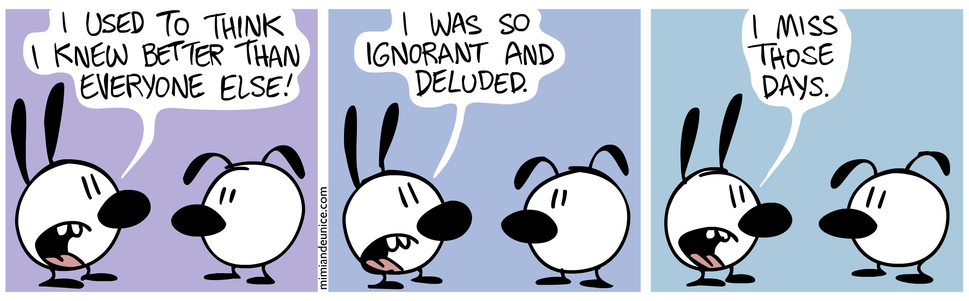
Week 14 (Apr 22 – Apr 24) – Oh man, when I think about that Scottie Pods home run, I get goose bumps all over again! Emotional reactions to autobiographical memories, the self, and the fading affect bias.

People have emotional responses to their memories. There tends to be a valence effect such that positive memories tend to retain their emotional punch more than do negative memories. Might this be effect related to the current state of the self? Might it reflect the tendency of the self to engage in self-regulation over time (e.g., find explanations for negative events to minimize their impact). This is my own personal sandbox – I’ve probably done 90% of the work that has been published in this area. Maybe you can help to keep this rate up by thinking of some great new lines of research. After all, it’s always all about me ….

Skowronski, J.J., Walker, W.R., Henderson, D.X., & Bond, G.D. (2014). The Fading Affect Bias: Its history, its implications, its future. In J.M. Oson & M.P. Zanna (Eds.) Advances in Experimental Social Psychology (Vol. 49, pp. 163-218). San Diego: Academic Press.

Ritchie, T., Sedikides, C., & Skowronski, J. (2014). Emotions experienced at event recall and the self: Implications for the regulation of self-esteem, self-continuity, and meaningfulness. Manuscript in revision.

Ritchie, T., Skowronski, J., Cadogan, S., & Sedikides, C. (2014/in press). Affective responses to self-defining autobiographical events. Self and Identity.

Gibbons, J.A., Lee, S.A., & Walker, W. R. (2011). The fading affect bias begins within 12 hours and persists for 3 months. Applied Cognitive Psychology, 25, 663-672.
Ritchie, T.D., & Skowronski, J.J. (2009). Perceived change in the affect associated with dreams: The fading affect bias and its moderators. Dreaming, 18, 27-43.
Landau, J.D., & Gunter, B.C. (2009). “Don't worry; you really will get over it": Methodological investigations of the fading affect bias. American Journal of Psychology, 122, 209-217.

Ritchie, T., Skowronski, J.J.; Hartnett, J. Wells, B., &Walker, W. R. (2009). The fading affect bias in the context of emotion activation level, mood, and personal theories of emotion change. Memory. 17, 428-444.

Schrauf, R.W., & Hoffman, L. (2007). The effects of revisionism on remembered emotion: The valence of older, voluntary immigrants' pre-migration autobiographical memories. Applied Cognitive Psychology, 21, 895-913.

Ritchie, T.D., Skowronski, J.J., Wood, S.E., Walker, W. R., Vogl, R.J. & Gibbons, J.A. (2006). Event Self-importance, Event Rehearsal, and the Fading Affect Bias in Autobiographical Memory. Self and Identity, 5, 172-195.

Skowronski, J.J., Gibbons, J.A., Vogl, R.J., & Walker, W. R. (2004). The effect of social disclosure on the intensity of affect provoked by autobiographical memories. Self and Identity, 3, 285-309.

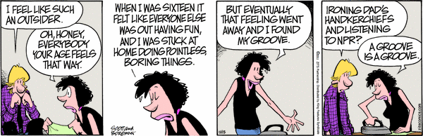
Week 15 (Apr 29 – May 1) – The class in the rearview mirror: Recapitulations, themes, and reviews.

Ok, You’ve made it this far. Congratulations! Just to wrap things up, here are three final readings that provide some overviews and context on the area of the self (and that remind you just how much there is to know and learn). There will not be a skull session this week (MPA – your ARE going…it’s a class assignment!).

Swann, W.B. Jr.; Chang-Schneider, C., & Larsen McClarty, K. (2007) Do people's self-views matter? Self-concept and self-esteem in everyday life. American Psychologist, 62, 84-94.

Morf, C. C. & Mischel, W. (2012). The self as a psycho-social dynamic processing system: Toward a converging science of self-hood. In M. R. Leary & J. P. Tangney (Eds.), Handbook of self and identity (2nd ed.; pp. 21-49), NY: Guilford.

Alicke, M.D., Zell, E., & Guenther, C.L. (2013). Social Self-Analysis: Constructing, Protecting, and Enhancing the Self. In J.M. Olson, and M.P. Zanna (Eds.), Advances in Experimental Social Psychology (Vol. 48, pp. 173-234). San Diego, CA: Academic Press.

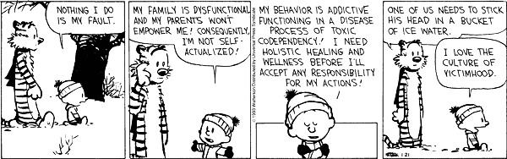

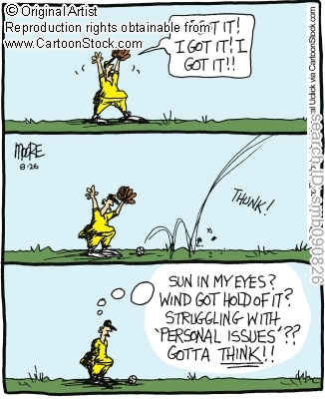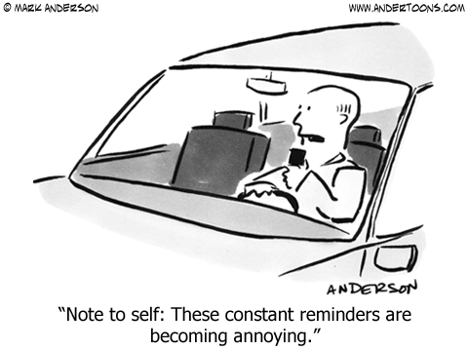

Many colleagues, too many to list by name, received solicitations for the chapters and articles that are assigned in this course. Almost all replied to the requests for materials, and did so with amazing rapidity. Dr. Skowronski and the 671j students offer their grateful thanks to everyone who contributed a reading to this course. You guys are THE BEST!

