EXPERIMENTAL SOCIAL PSYCHOLOGY - PSYCHOLOGY 620
Section 1, Reference # 12561
Autumn, 2014

T, H............. 9:30 am - 10:45 am ............... 3 Credits .............. PM156
Prerequisite: Graduate standing in psychology or consent of instructor

SAVE THIS SYLLABUS FOR FUTURE REFERENCE!

Information in this syllabus is subject to changes and additions announced in class!
And there WILL likely be some changes, so come to class!

Rating: R - 17 (not for the faint of heart, but definitely for inquiring minds!)

--------------------------------------------------------------------------------------------------------------------

UNINFORMATIVE COURSE DESCRIPTION FROM THE NIU BULLETIN WRITTEN BY AN ANONYMOUS GNOME

An in-depth survey of topics of current interest in the study of social interaction. Emphasis on experimental approaches to the study of social behavior of humans, but developments in animal social experimentation will also be utilized. Topics include, but are not necessarily limited to, attitudes and persuasion, conformity, social judgment, aggression, and interpersonal attraction.

THE REAL SCOOP: DR. JOHN’S DESCRIPTION

I have many goals when I teach this course. First, I want to get you EXCITED about social psychology!!! How can you not be excited -- other people are fascinating! Moreover, the stuff in this course deals with some of the most interesting questions in psychology! Why do some people have such weird ideas about other people? Why can’t different groups get along? Why do advertisers run those boring ads millions of times on TV? What does it mean to fall in (and out) of love with someone else? Is there a difference between love and lust? Can people really be brainwashed? I can feel my blood boiling just mentioning some of this stuff!!! In this course, we will examine and review some of the existing research on these kinds of topics.

This course was designed with the young Social graduate student in mind. However, if you are going to be any type of professional psychologist, YOU NEED TO KNOW SOCIAL PSYCHOLOGY! You’re in clinical? A major approach to depression has its roots in social psychology’s attribution theory, and the progress of therapy often depends on the quality of the client-therapist relationship. You’re in neuroscience or cognitive? The study of social cognitive neuroscience (how people think about others and the underlying cognitive and neural mechanisms) is one of THE hot areas in psychology right now. You’re in developmental? One major theory of development (Vygotsky) strongly links the process of child development to a child’s social and cultural context. You’re in school? Social psychologists have been at the forefront of the study of motivation and how it affects performance. Moreover, bullying is, at its heart, a social interaction. Regardless of your specialty area, YOU NEED TO KNOW SOCIAL PSYCHOLOGY!!!
ABOUT YOUR PROFESSOR

Name: John J. Skowronski, Ph.D. Aliases: Dr. Skowronski, Dr. John, Dr. J., John

Feel free to call me whatever you like — just be careful what you call me to my face!

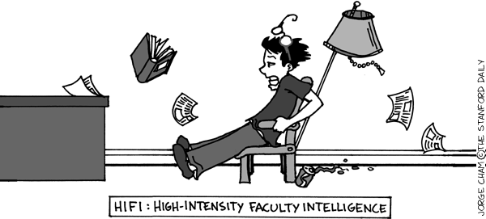

NIU Rank: Full Professor (and people generally think that I’m full of it!)

Birthplace: Inner-City - Chicago’s South Side (so don’t even THINK of messing with me!)

Degrees: M.A., Ph.D., University of Iowa; B.A., Augustana College (Il.)
Go Hawks! Go Vikings!

Yes, as much as it might amaze you, I am a Ph.D. --- that means I can, indeed, Pile it Higher and Deeper.

CONTACTING YOUR PROFESSOR

Office: PM 418 Office Phone: 753-7073 E-mail: jskowron@niu.edu

As pro golfer Fred Couples once said, the problem with answering the phone is that there might be someone on the other end. So chances are that if you call me, you’ll have to leave a message on my voice mail. However, given my aversion to being in my office these days, voice mail is not a good place to leave messages. It might take me months to answer. E-mail is better.

Office Hours: W, 8-11

I’m usually heavily scheduled during office hours, so if you want to see me it would be very wise to make an appointment during that time. You can try to schedule appointments at other times, as well. Bring along coffee, just to make sure I’ll let you into my office. You can try to stop by other times, but university business, the comforts of my home man-cave, and my continuing search for inner peace strongly compete for my attention, so I’m not often in my office these days.

A Few Professional Highlights:

Co-editor of the book First Impressions (Guilford Press)
Co-author of the book Autobiographical Memory (Lawrence Erlbaum Publishers)
Author or co-author of over 120 professional journal articles and book chapters
Former Associate Editor, Journal of Experimental Social Psychology
Former Associate Editor, Social Cognition
Recipient, Ohio State University Alumni Award for Distinguished Teaching (people back in my former job {Go Buckeyes!} were under the mistaken impression that I could actually teach.....)

Previous Employers (e.g., folks who have given thanks because they have gotten rid of me):

Augustana College (Instructor)
The University of Iowa (Instructor)
Kansas State University (Visiting Assistant Professor) {Go Wildcats!}
Purdue University (Visiting Assistant Professor) {Go Boilermakers}
Southampton University, England (Distinguished Visiting Professor)
The Ohio State University, residing at the Newark Campus (Assistant, Associate, and Full Professor)

COURSE GOALS

#1 Learn Stuff About Social Psychology

It is obvious that one of your goals in the course will be to learn about social psychology. This is harder than it may seem. Social psychologists publish research at an alarmingly high rate, so there is a LOT of reading that needs to be done. Hence, part of the course will survey the landscape of social psychology, giving you an overview of the area. However, in the course of that overview, a few things will be emphasized. This class will:

(1) emphasize CONTEMPORARY social psychology;
(2) FOCUS ON THEORETICALLY-DRIVEN RESEARCH; and
(3) emphasize EXPERIMENTAL approaches to social psychology.

That is, we will be focusing on recent research examining the causes of social thought, social emotions, and social behavior, and will tend to focus on experimental approaches to the examination of those causes.

#2 Changing Your Self-Perception: Students You are Not; Apprentices You Are!

In the graduate program here at NIU, you are called students, but to me you are really apprentices. After all, you are now GETTING PAID (e.g., via your assistantships and scholarships) to DO psychology. Hence, you need to engage in a self-perception shift: STOP thinking of yourselves as graduate students and START thinking of yourselves as APPRENTICE PSYCHOLOGISTS. What’s the difference?

Students do as little as possible to get the best grade they can; apprentices try to learn as much as they can and practice whenever possible so that they can function well when they leave the apprenticeship.

Students get upset when they get corrective feedback; apprentices want corrective feedback because they want to get better in their chosen line of work. As Vince Lombardi once said: “... we are going to relentlessly chase perfection, knowing full well we will not catch it, because nothing is perfect. But we are going to relentlessly chase it, because in the process we will catch excellence.”

You will need to practice and improve your skills; this class will give you the opportunity to do so. In doing so, you will make errors. Observers (me, other class members) will try to gently point out your mistakes so that you can come to recognize and fix them yourself. After all, part of the training of a bricklayer is to recognize when a crooked wall has been put up and to know when to tear it down and start over, and maybe to eventually avoid putting up those crooked walls. I want to be able to do the same thing for the kinds of skills that psychologists need to have.



#3 Develop the “Mad Skillz” Needed by Academic Psychologists

There are four skills that I am going to give you the opportunity to sharpen in this course.

The first of these is CRITICAL ANALYSIS. In your career you will need to read and understand primary research articles. In this course we will frequently dissect research articles in social psychology so that you learn how to read journal articles and how to critically evaluate those articles.

The second of these skills is GENERATIVITY. One of the things that you will need to be doing in your career is to generate your own research ideas. I will be asking you to practice this skill by asking you to think about how the research that we will be reading about in this class can serve as a jumping off point for new research. This will be part of many class sessions.

The third of these skills is WRITING. My experience as a writer suggests to me that becoming a better writer requires much practice. Hence, I will be giving you assignments that provide an opportunity to sharpen your writing skills - a skill that is terribly important in the academic world. Importantly, form matters on your papers. Gone are the days when you will receive positive feedback simply because your ideas are good. In my role as a journal editor, I have seen otherwise terrific papers become trivialized by terrible writing. Try to do the best job that you can in making sure that the spelling, punctuation, and grammar that you use in each paper are correct, and that each paper is written in a clear and organized fashion. In an attempt to help you to improve your writing, I will provide corrective feedback (sometimes publicly). The written research proposals will help you to achieve this goal.

The fourth of these skills is PUBLIC DISCOURSE (PUBLIC SPEAKING, DISCUSSION and COMMENTARY). One of the important things that you will be doing in your future psychology-related jobs is to talk to other people about psychology. Sometimes this will be in an informal setting in which ideas are freely exchanged; sometimes this will be in a formal setting (as in a lecture or presentation). This class will be providing you with the opportunity to sharpen your informal setting skills.

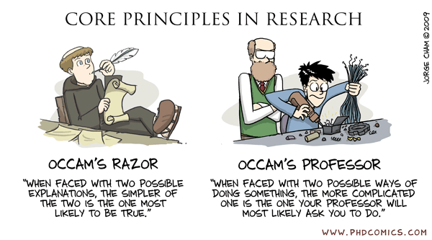
THE TEXTBOOKS

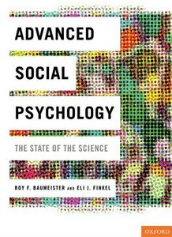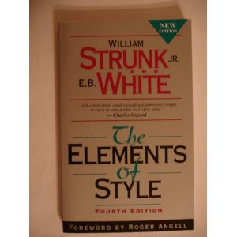

Content Textbook. One of the most difficult tasks that you have ahead of you is bringing yourselves up to speed with respect to social psychology. The required textbook is designed to help this process along by giving you an overview of various areas in social psychology, including important theoretical themes and findings that have emerged in the research. The textbook is:

Baumeister, R.F., & Finkel, E.J. (Eds.) (2010). Advanced social psychology: The state of the science. New York: Oxford University Press.

The course also asks you to read other stuff. The assigned chapters and articles are stored on a computer in a location to be announced in class. Take a flash drive to the computer and harvest the files. Make sure to COPY the files, not MOVE them.

Writing Aids. Two highly recommended textbooks are geared toward improving your writing. The first of these is the newest version of the APA publication guide. This will govern the format of your professional writing from here on out, so you might as well get a copy now. The second book is a brief writing guide to which I will regularly refer as I comment on your writing in the course. Here they are:

American Psychological Association (2009). Publication manual of the American Psychological Association (6th ed). Washington, DC: APA.

Strunk, W.S., & White, E.B. (with a foreword by Angell, R.) (2000). The elements of style (4th ed.). Needham Heights: Pearson Education.

Other Helpful Books. Many books try to help you get through the apprenticeship period, to develop your skills, and to navigate your way through academia. Here are just a few that you might decide to peek at some day:

Rosnow, R. L., & Rosenthal, R. (1997). People studying people: Artifacts and ethics in behavioral research. New York: Freeman.

Darley, J. M., Zanna, M.P., & Roediger, H.M. III (Eds.). (2003). The compleat academic: A career guide (2nd ed.). Washington, DC: APA Books.

American Psychological Association (2009). Mastering APA Style: Student’s Workbook and Training Guide (6th ed.). Washington, DC: APA Books.

Robert J. Sternberg (Ed.) (2006). Career Paths in Psychology: Where Your Degree Can Take You (2nd ed.). Washington, DC: APA Books. Johnson, W.B., & Huwe, J.M. (2002). Getting mentored in graduate Washington, DC: APA Books.

Cone, J.D., & Foster, S.L. (2006). Dissertations and theses from start to finish: Psychology and related fields (2nd ed.). Washington, DC: APA Books.

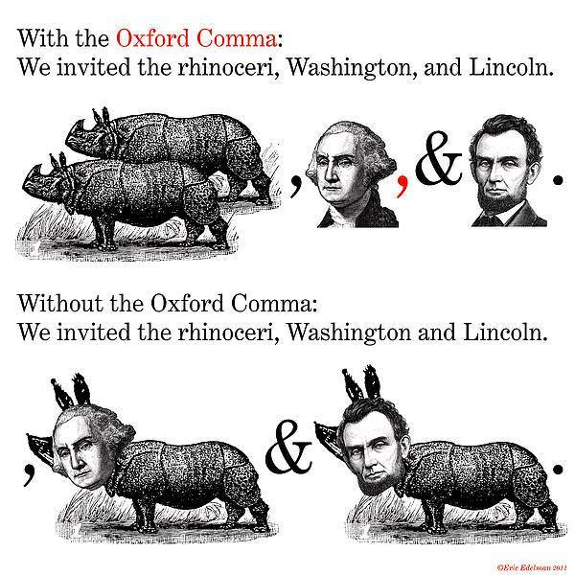

EXAMS: TAKE-HOME AND IN-CLASS

Take-home Exam. To help you to think about and integrate this material, you will be asked to complete a take-home exam. Here are the three exam topics. On the final exam, you must address one of these three topics:

(1) You have signed a contract to write a brief chapter entitled “The Essence of Social Thinking about Others, the Self, and the Situations that they Inhabit - as Explored by Research in Experimental Social Psychology.” The audience for the chapter consists of smart adults who know nothing about social psychology. Use the chapter to convey your view to this audience of the “essence” of the research that explores social thinking in experimental social psychology. This is not a “for dummies” book: Your publisher requests that in your chapter you make sure that you explicitly describe in detail some of the relevant theory and research that is especially important to the study of thinking in social psychology.

(2) You are going to start “The Church of the Greater Prophet” (your motto: my minions do all the work, I get all the profit). Write an action plan for your endeavor. Describe campaigns, strategies, and tactics to recruit people into the church, to keep them in the church, to make them committed to the church, to work for the church’s benefit, and to induce them to donate to the church. Make sure that you explicitly describe the theories and research findings that form the basis for the campaigns, strategies, and tactics that you develop.

(3) Your consulting firm has been asked to present a plan to help an old company, Amalgamated Widgets, survive its current crisis. They want you to write a proposal that they can consider. If they accept it, they’ll pay you buckets o’ money. The company’s productivity and product quality are low, and there are many different groups in the company who seem to be unable to communicate with each other, to cooperate, and indeed, to even get along. Use your knowledge of interpersonal dynamics and group dynamics to write a proposal to help Amalgamated Widgets. The plan should document the campaigns, strategies, and tactics that you might use to both improve the company’s productivity and to improve the social relations among the various factions at the company. Make sure that you explicitly describe the theories and research findings that form the basis for the campaigns, strategies, and tactics that you develop.

How long should your answers be? As long as they need to be. “Good” is more important than “long”. However, these kinds of chapters tend to be 30 to 40 pages long (double-spaced, excluding references), which is roughly 10,000 to 15,000 words. I prefer writing that is simultaneously complete and concise - if you exceed 60 pages, you are probably not being concise enough. If your chapter is 5 pages long, you are probably not being complete enough. Try to be as integrative as you can in your answers – this will be a challenge given the breadth of the questions. Moreover, it would be good to work in stuff from as many chapters of your assigned readings as you can when formulating the answer to each question. The better you do this job, the better your grade.

The exam (hardcopy required) is due on Thursday, Dec. 11, at 10AM. - the start of our university-assigned exam time. It’s best to give the exam to me personally (e.g., at the assigned exam time or during office hours), though you can also ask the staff in PM 400 put it in my mailbox. Sticking the exam under the windshield wiper of my car is not a recommended delivery method.

In-class Exams: Social Psychojeopardy. On each class day there will be a brief quiz covering stuff you were supposed to have read. The format will be a social psychological form of ‘Jeopardy’ - I provide the answers and you provide the questions. You will be called on arbitrarily, so it will be good for you to have read the material in advance. You will earn 1 point for each of the questions that you correctly supply, and I will keep a semester-long tally of your performance. Material covered on each class day is listed in the course schedule beginning on p. 17.

TARGET ARTICLES: PAPERS

The articles. These describe research relevant to the assigned chapters. We will be using these target articles to get you practice in critiquing research and to get you thinking about generating new research in social psychology. Each paper should discuss a new experiment that extends or builds upon a method described in a target article and that, to the extent possible, tests the underlying theoretical model.

Use a replicate-and-extend approach that takes the method used in the target article, includes conditions intended to replicate the results obtained in the original article, and adds a manipulation or condition that you think will be theoretically informative. Your paper should include a detailed rationale for why the study would be theoretically informative, along with detailed predictions about the expected results and potentially informative alternative patterns of results. Dr. Sagarin’s article (Sagarin, Rhodes, & Cialdini, 1998) is an excellent model for this process. It discusses alternative theoretical models and shows how the data would look for the different competing predictions. To be more specific:

I expect these papers to briefly describe the underlying theory and to briefly summarize how that theory was tested and what the results were.

Then, the paper should suggest a follow-up study.

This should include a rationale for:
(1) why the study would be theoretically informative,
(2) detailed predictions about the expected results, and
(3) potentially informative alternative patterns of results.

I expect that the studies will use the “replicate and extend” idea which use the same methodology as in the target article but add a new manipulation.

In all cases, the manipulation should be designed to clarify the underlying theoretical processes that underlie the research performed in the original article.

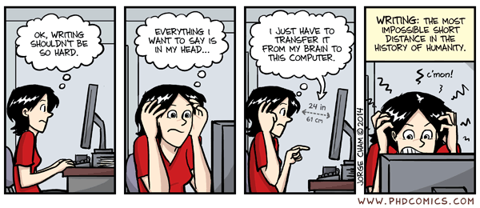

Make two copies and save one for yourself. The papers must be word-processed, and should be no more than two single-sided pages (single spaced is OK). One page or less could sometimes be enough. Remember that you need to write these papers well! No one-draft wonders, please. Good writers extensively edit their own work and go through multiple drafts. I expect you, young apprentices, to do the same. EDIT, REWRITE, EDIT, REWRITE, and EDIT again. From time to time I will provide public feedback on these papers – you don’t want your paper to be the target of one of these public presentations.

Starting SEPT 18, the papers are due on each THURSDAY. The exception is THANKSGIVING WEEK, in which your paper will be due on Tuesday Nov. 25. The papers should each detail a replicate-and-extend study that uses one of the research-focused journal articles assigned for that week as a jumping-off point.

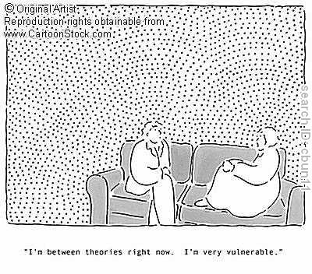
COURSE GRADING

I would really like you to focus on learning new stuff - in my view, grades in this class ought to be secondary to learning. However, the university demands that I assign grades, so here’s how I will do it.

Research proposals. 40% of your grade will be determined by your research proposals. Each paper will be given a grade between 0 and 3. A grade of 3 means that the paper was supremely well conceived and well written, and in my opinion the idea is absolutely worth researching; a grade of 2 means the paper was a solid effort and that there might be a project in there somewhere; a grade of 1 means that, in my opinion, either the idea was not good or the paper was ill-crafted. A grade of 0 means your work was not worth the paper it was written on.

Not every idea is great – most will be OK, and some might stink. You can expect that most good graduate-level papers will be assigned a grade of 2. I tend to reserve grades above 2 for ideas that I think are really good. Moreover, one element of my grading system is that you need not be perfect. I assume that there may be times when it is hard for you to come up with a good idea; one or two of these in the course of the semester will not hurt your grade much. However, if you turn in too many papers that are bad enough to rate a 1 or below, your grade will suffer. The relation here is curvilinear: One or two substandard papers will barely hurt you, but the damage increases with larger numbers of substandard papers. Three substandard papers will begin to detract substantially from your grade.

No late papers will ever be accepted. You need to meet the deadline, which is at the START of class on the assigned day. You can get away with a missed paper, but multiple misses begin to substantially affect your grade. Papers that miss a deadline will be assigned an X - these may revert to a grade of 0 for grading purposes.

To make things clear, to earn an A grade in this portion of the course, you will need to turn in ALMOST ALL of the papers and MOST of what you turn in should be high-quality enough to earn a grade of 2 or better. Doing this will not be easy: I’m trying to help you to become a pro, so I will be using pro-level standards to evaluate these research proposals.

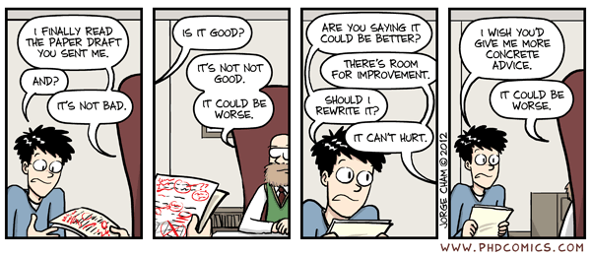
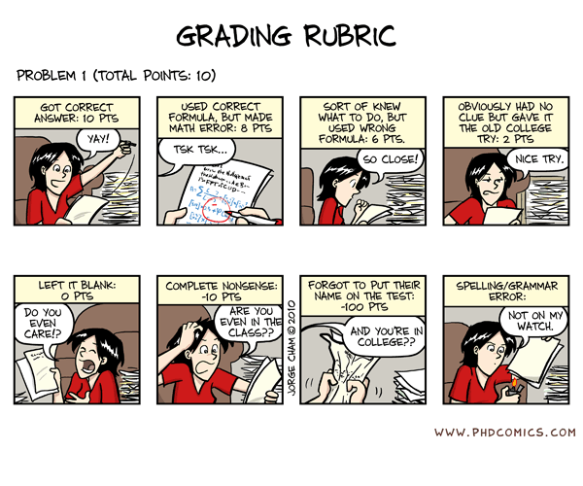

Class Participation. 15% of your grade will be determined by the quality and quantity of your class participation. I will be tracking your in-class comments and questions, as well as your critiques of others’ research proposals. Your grade will suffer if you never say anything, if you say too much (it is not good to monopolize discussions), or if you frequently offer comments that are irrelevant, misdirecting, or overly negative or condescending. A good-quality performance will be assigned a grade of 2, which would translate into a grade of A; grades can range from 0 to 3 (3 = Eliot Smith-type comments (he’s the current editor of one of the sections of JPSP).

My judgment will determine whether your participation is sub-standard or not, but I may supplement my judgment by asking the rest of the class to judge the quality and quantity of a class member’s participation.

Exam Performance. 25% of your grade will be determined by your final exam performance. I will read each of your answers to my take-home questions and will use my judgment to assign it a grade of between 0 and 3 (same scale as described above). You can expect a good, graduate-student quality answer to earn a grade of 2 (which would translate into a grade of A). These exams will be graded in terms of both content and style. That is, you need to answer the question, you need to do so with a writing style that is technically correct (no spelling, punctuation, or grammar errors) and using a writing style that is terse and organized.

Psychojeopardy Performance. 20% of your grade will be determined by your psychojeopardy performance. I will look at the number of questions that you answered correctly over the course of the semester and will assign that performance a grade between 0 and 3. When I see a performance as a good-quality graduate student level performance, I will assign that performance a grade of 2. There is also a prize awarded to the semester’s class psychojeopardy champion.

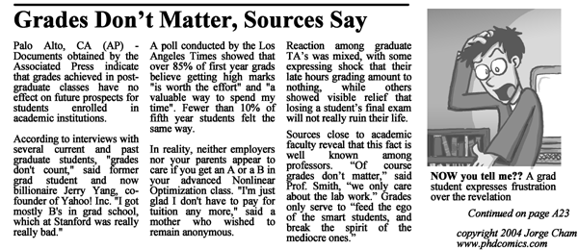

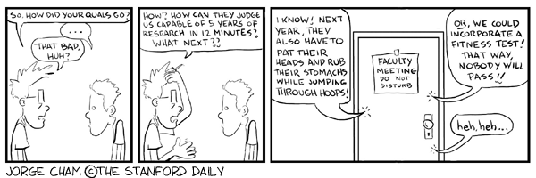

LIVE SOCIAL PSYCHOLOGY: BE HELPFUL AND COOPERATIVE

Please note that your grade will not be at all affected by the performances of others in the class. This means that you are not in competition with others. I have pre-set mental standards about the level of performance that I expect. Therefore, there is no such thing as a curve-breaker in this class!

Hence, feel free to help each other out as much as you can outside of class. It might be especially useful to chat about the material with others in the class before the class starts, or to use each other as sounding boards for questions, research ideas, etc. In my view, the best thing that can happen in this course is for people to be merrily chatting about the chapters and target articles at lunch, in the park, etc. Please do.

COURSE CHEATING POLICY

HOWEVER......Be careful here to respect each other’s intellectual property: after your discussions, don’t “borrow” the ideas that others were intending to use for themselves and include them in your own papers. It is legitimate, however, to use thoughts or ideas offered by others if they are freely given. Sometimes the line is a fine one - if you have any doubt, ASK!!!!!

Cheating is a practice that I frown upon, and you won’t like it at all when I frown. Cheating is wrong. Don’t do it. Cheating ticks me off. Don’t do it. Cheating extends to any work that you turn in for this course. Don’t do it. I hate dealing with cheating, and because I hate it, I get very, very cranky. Don’t do it. I even hate thinking about it. Don’t do it. Cheating includes copying from others’ exams, plagiarizing others’ papers, turning in work that is not your own, and anything else nefarious or dishonest that might apply. Don’t do it. I have had to deal with far too much cheating in my academic lifetime. Don’t do it. When I catch cheaters, I fail them - for the whole course. Don’t do it. I also refer them to their department and to the university for further disciplinary action, recommending that they get kicked out of school and that a reprimand letter for cheating get included in their permanent school file. Don’t do it. There are no exceptions to this policy. Don’t do it. Just keep this simple rule in mind: you cheat, YOU’LL PAY!!! I’ll sic O.J. Simpson, Scott Peterson, Charles Manson, Freddy Kruger, Jason, and Barry Manilow on you...simultaneously. Don’t do it.

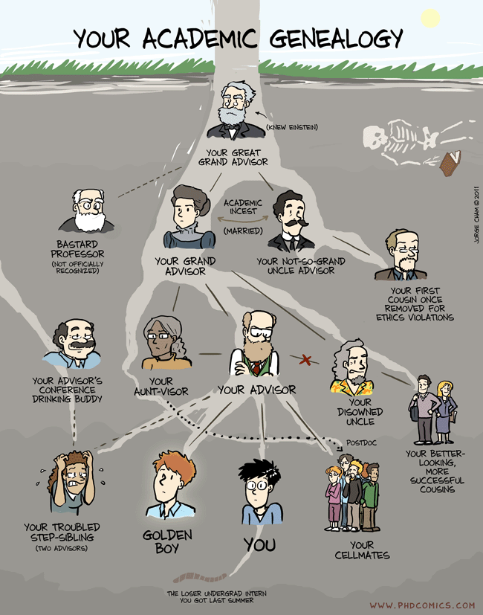
Class Topics and Readings

--------------------------

Aug 26 – Intro to the Course, or, Why you Might Want to Get the Hell Out of Here Right Now

------------------------

Aug 28 – A Research Introduction to Social Psychology: Examples of How We Go About Doing What We Do

CLASS PSYCHOJEOPARDY SESSIONS BEGIN!

Read:

Baumeister & Finkel, Chapter 1 (Baumeister)

------------------------

Sept 2 – Social Psychology: Views from History

Read:

Ross, L., Lepper, M., & Ward, A. (2010). History of social psychology: Insights, challenges, and contributions to theory and application. In S. T. Fiske, D. T. Gilbert, & G. Lindzey (Eds.), The Handbook of Social Psychology (Fifth Edition, Vol. 1, pp. 3‐50). Hoboken, NJ: John Wiley.

------------------------

Sept 4 - Social Psychology: From the Past to the Present

Read:

Baumeister & Finkel, Chapter 2 (Reis)

Yang, Y-J., & Chiu, C-y. (2009). Mapping the structure and dynamics of psychological knowledge: Forty years of APA journal citations (1970-2009). Review of General Psychology, 13, 349-356.

Cacioppo, J. T. (2007). The structure of psychology. Observer, 20, 3 & 50-51. http://www.psychologicalscience.org/observer/getarticle.cfm?id=2259

------------------------
------------------------

Sept 9 – The Pursuit of Research in Social Psychology I

Read:

Wilson, T. D., Aronson, E. & Carlsmith, K. M. (2010). Experimentation in Social Psychology. In D. Gilbert, S. Fiske, and G. Lindzey (Eds.) Handbook of Social Psychology (5th edition, Vol. 1, pp. 51-81). NY: Oxford University Press.

DeCoster, J., Iselin, A-M. R., & Gallucci, M. (2009). A conceptual and empirical examination of justifications for dichotomization. Psychological Methods, 14, 349-366.

------------------------

Sept 11 – Thinking Theoretically-Driven Experimentation

Read:

Sagarin, B.J., Rhoads, K.v.L, & Cialdini, R.B. (1998). Deceiver's distrust: Denigration as a consequence of undiscovered deception. Personality & Social Psychology Bulletin, 24, 1167-1176. (for depiction of mediational paths)

Spencer, S.J., Zanna, M.P, & Fong, G.T. (2005). Establishing a causal chain: Why experiments are often more effective than mediational analyses in examining psychological processes,” Journal of Personality and Social Psychology, 89, 845–51.

Kerr, N.L. (1998). HARKing: Hypothesizing after the results are known. Personality and Social Psychology Review, 2, 196-217.

Sagarin, B.J., Ambler, J.K., & Lee, E. M. (2014). An ethical approach to peeking at data. Perspectives on Psychological Science, 9, 293-304.

------------------------

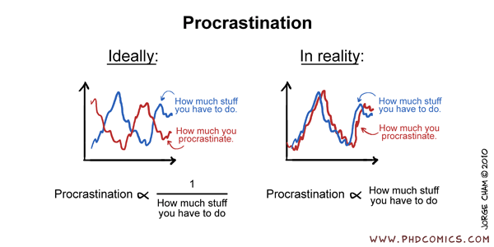

------------------------

Sept 16 - The Pursuit of Research in Social Psychology: Outside the Lab

Read:

Reis, H. T., & Gosling, S. D. (2010). Social psychological methods outside the laboratory. In S.T. Fiske, D.T. Gilbert, & G. Lindzey, (Eds.), Handbook of social psychology (5th ed., Vol. 1, pp. 82-114). New York: Wiley.

Ostrom, E. (2006). The value-added of laboratory experiments for the study of institutions and common-pool resources. Journal of Economic Behavior and Organization, 61, 149-163.

Salovey, P., & Williams-Piehota, P. (2004). Field experiments in social psychology. American Behavioral Scientist, 47, 488-505.

------------------------

Sept 18 – Biology and Social Psychology: Views from Evolution

Read:

Baumeister & Finkel, Chapter 17 (Maner & Kenrick)

Schaller, M., Miller, G.E, Gervais, W.M., Yager, S., &; Chen, E (2010). Mere visual perception of other people's disease symptoms facilitates a more aggressive immune response. Psychological Science, 21, 649-652.

Hodges-Simeon, C.R., Gaulin, S.J.C., & Puts, D.A. (2011). Voice correlates of mating success in men: Examining "contests" versus "mate choice" modes of sexual selection. Archives of Sexual Behavior, 40, 551-557.

Lieberman, D., Oum, R., & Kurzban, R. (2008). The family of fundamental social categories includes kinship: Evidence from the memory confusion paradigm. European Journal of Social Psychology, 38, 998-1012.

Maner, J. K., & Miller, S. L. (2013). Adaptive attentional attunement: Perceptions of danger and attention to outgroup men. Social Cognition, 31, 733-744.

------------------------
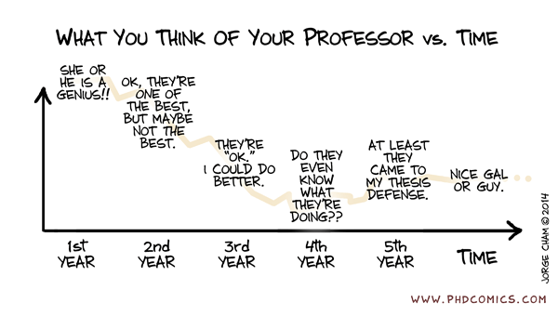

Sept 23 – Biology and Social Psychology: Views from Social Neuroscience

Read:

Baumeister & Finkel, Chapter 16 (Heatherton & Wheatley)

Kim, Y., Seo, J., Song, H., Yoo, D. Lee, H. J.; Lee, J. Lee, Gunyoung; K. E., Kim, J.G., & Chang, Y.. (2011). Neural correlates related to action observation in expert archers. Behavioural Brain Research, 223, 342-347.

Quadflieg, S., Turk, D.J. Waiter, G.D., Mitchell, J.P., Jenkins, A.C., & Macrae, C.N. (2009). Exploring the neural correlates of social stereotyping. Journal of Cognitive Neuroscience, 21, 1560-1570.

Freeman, J.B., Rule, N.O., Adams, R.B. Jr., & Ambady, N. (2010). The neural basis of categorical face perception: Graded representations of face gender in fusiform and orbitofrontal cortices. Cerebral Cortex, 20, 1314-1322.

Van Hoeck, N., Ma, N., Ampe, L., Baetens, K., Vandekerckhove, M., & Van Overwalle, F. (2013). Counterfactual thinking: An fMRI study on changing the past for a better future. Social Cognitive and Affective Neuroscience, 8, 556-564.

------------------------

Sept 25 - Biology and Social Psychology: Views from Psychophysiology and Embodiment

Read:

Blascovich, J., & Mendes, W.B. (2010). Social Psychophysiology and Embodiment. In S.T. Fiske, D.T. Gilbert, & G. Lindzey (eds.). Handbook of Social Psychology (5th Edition, Vol. 1, pp. 194-227): New York: Wiley.

Sagarin, B.J., Cutler, B., Cutler, N.,Lawler-Sagarin, K.A., & Matuszewich, L. (2009). Hormonal changes and couple bonding in consensual sadomasochistic activity. Archives of Sexual Behavior, 38, 186-200.

Slepian, M.L. Weisbuch, M., Rule, N.O., & Ambady, N. (2011). Tough and tender: Embodied categorization of gender. Psychological Science, 22, 26-28.

Van Overwalle, F., Van den Eede, S., Baetens, K., & Vandekerckhove, M. (2009). Trait inferences in goal-directed behavior: ERP timing and localization under spontaneous and intentional processing. Social Cognitive and Affective Neuroscience, 4, 177-190.

Amodio, D.M., & Harmon-Jones, E. (2011). Trait emotions and affective modulation of the startle eyeblink: On the unique relationship of trait anger. Emotion, 11, 47-51.

------------------------

------------------------

Sept 30 – The Cultural Context of Social Life

Read:

Baumeister & Finkel, Chapter 18 (Heine)

Zou, X., Tam, K., Morris, M.W., Lee, S., Lau, I.Y., & Chiu, C. (2009). Culture as common sense: Perceived consensus versus personal beliefs as mechanisms of cultural influence. Journal of Personality and Social Psychology, 97, 579-597.

Gaertner, L., Sedikides, C., & Chang, K. (2008). On pancultural self-enhancement: Well-adjusted Taiwanese self-enhance on personally valued traits. Journal of Cross-Cultural Psychology, 39, 463-477.

Balcetis, E., Dunning, D., & Miller, R.L (2008). Do collectivists know themselves better than individualists? Cross-cultural studies of the holier than thou phenomenon. Journal of Personality and Social Psychology, 95, 1252-1267.

Uskul, A.K., & Over, H. (2014). Responses to social exclusion in cultural context: Evidence from farming and herding communities. Journal of Personality and Social Psychology, 106, 752-771.

------------------------

Oct 2 – Nonverbal Behavior

Read:

Ambady, N. & Weisbuch, M. (2010). Nonverbal behavior. In D. T. Gilbert, S. T. Fiske, & G. Lindzey (Eds.), Handbook of Social Psychology (5th Ed., Vol. 1., pp. 464-497). Hoboken, NJ: John Wiley and Sons.

Nelson, A.J., Adams, R.B. Jr., Stevenson, M.T., Weisbuch, M., & Norton, M.I. (2013). Approach-avoidance movement influences the decoding of anger and fear expressions. Social Cognition, 31, 745-757.

Leander, N.P., Chartrand, T.L., & Wood, W. (2011). Mind your mannerisms: Behavioral mimicry elicits stereotype conformity. Journal of Experimental Social Psychology, 47, 195-201.

Ames, D.R., Kammrath, L.K., Suppes, A., & Bolger, N.. (2010). Not so fast: The (not-quite-complete) dissociation between accuracy and confidence in thin-slice impressions. Personality and Social Psychology Bulletin, 36, 264-277.

Skowronski, J.J., Milner, J.S., Wagner, M.F., Crouch, J.L., & McCanne, T.R. (2014). Pushing the boundaries of human expertise in face perception: Emotion expression identification and error as a function of presentation angle, presentation time, and emotion. Journal of Experimental Social Psychology, 50, 166-174.

------------------------

-----------------------

Oct 7 – Thinking About Others I (Social Judgment)

Read:

Baumeister & Finkel, Chapter 3 (Carlston)

McCarthy, R.J, & Skowronski, J. J. (2011). The interplay of controlled and automatic processing in the expression of spontaneously inferred traits: A PDP analysis. Journal of Personality and Social Psychology, 100, 229-240.

Human, L.J., & Biesanz, J.C. (2011). Through the looking glass clearly: Accuracy and assumed similarity in well-adjusted individuals' first impressions. Journal of Personality and Social Psychology, 100, 349-364.

Biernat, M., Fuegen, K., & Kobrynowicz, D. (2010). Shifting standards and the inference of incompetence: Effects of formal and informal evaluation tools. Personality and Social Psychology Bulletin, 36, 855-868.

Tausch, N., Kenworthy, J.B., & Hewstone, M. (2007). The confirmability and disconfirmability of trait concepts revisited: Does content matter? Journal of Personality and Social Psychology, 92, 542-556.

------------------------

Oct 9 – Thinking About Others II (Mind Perception)

Read:

Epley, N., & Waytz, A. (2010). Mind perception. In S.T. Fiske, D.T. Gilbert, & G. Lindzey (Eds.), The Handbook of Social Psychology (5th ed., Vol. 1, pp. 498-541). New York: Wiley.

Santuzzi, A. M. (2011). Anticipating evaluative social interactions involving persons with disabilities. Rehabilitation Psychology, 56, 231-242.

Reeder, G.D., Monroe, A.E., & Pryor, J.B. (2008). Impressions of Milgram's obedient teachers: Situational cues inform inferences about motives and traits. Journal of Personality and Social Psychology, 95, 1-17.

Eyal, T., & Epley, N. (2010). How to seem telepathic: Enabling mind reading by matching construal. Psychological Science, 21, 700-705.

Halbesleben, J. R.B. (2009). The role of pluralistic ignorance in the reporting of sexual harassment. Basic and Applied Social Psychology, 31, 210-217.

------------------------

------------------------

Oct 14 – Thinking About Others III (Liking and Attraction)

Read:

Baumeister & Finkel, Chapter 12 (Finkel & Baumeister)

Weaver, J.R., & Bosson, J.K. (2011). I feel like I know you: Sharing negative attitudes of others promotes feelings of familiarity. Personality and Social Psychology Bulletin, 37, 481-491.

Whitchurch, E.R., Wilson, T.D., & Gilbert, D.T. (2011). "He loves me, he loves me not . . .": Uncertainty can increase romantic attraction. Psychological Science, 22, 172-175.

Janssens, K., Pandelaere, M., Van den Bergh, B., Millet, K., Lens, I., & Roe, K. (2011). Can buy me love: Mate attraction goals lead to perceptual readiness for status products. Journal of Experimental Social Psychology, 47, 254-258.

Cardenas, R.A., Harris, L.J., & Adams, R.B. Jr. (2013). Are babies' faces cues to their parents' fitness? Social Cognition, 31, 649-655.

------------------------

Oct 16 – Thinking About Others IV (Prejudice & Stereotyping)

Read:

Baumeister & Finkel, Chapter 10 (Bodenhausen & Richeson)

Plant, E. A., & Devine, P. G. (2009). The active control of prejudice: Unpacking the intentions guiding control efforts. Journal of Personality and Social Psychology, 96, 640-652.

Phills, C. E., Santelli, A.G., Kawakami, K., Struthers, C. W., & Higgins, E. T. (2011). Reducing implicit prejudice: Matching approach/avoidance strategies to contextual valence and regulatory focus. Journal of Experimental Social Psychology, 47, 968-973.

Koudenburg, N., & Gordijn, E.H. (2011). "My date can call me sweet, but my colleague can't": Meta-stereotypic behavioral intentions as a function of context and liking of the outgroup. Social Cognition, 29, 221-230.

Ma, D.S., Correll, J., Wittenbrink, B., Bar-Anan, Y., Sriram, N., & Nosek, B.A. (2013). When fatigue turns deadly: The association between fatigue and racial bias in the decision to shoot. Basic and Applied Social Psychology, 35, 515-524.

------------------------

------------------------

Oct 21 – Cognition in a Social World: Judgment & Decision-Making

Read:

Baumeister & Finkel, Chapter 20 (Vohs & Luce)

Simmons, J.P., LeBoeuf, R.A., & Nelson, L.D. (2010). The effect of accuracy motivation on anchoring and adjustment: Do people adjust from provided anchors? Journal of Personality and Social Psychology, 99, 917-932.

Monforton, J., Vickers, K., & Antony, M.M. (2012). If only I didn't embarrass myself in front of the class!": Social anxiety and upward counterfactual thinking. Journal of Social and Clinical Psychology, 31, 312-328.

Van Rooy, D., Vanhoomissen, T. & Van Overwalle, F. (2013). Illusory correlation, group size and memory. Journal of Experimental Social Psychology, 49, 1159-1167.

Chambers, J. R., & Davis, M.H. (2012). The role of the self in perspective-taking and empathy: Ease of self-simulation as a heuristic for inferring empathic feelings. Social Cognition, 30, 153-180.

------------------------

Oct 23 – Thinking About the Self

Read:

Baumeister & Finkel, Chapter 5 (Baumeister)

Green, J.D., Sedikides, C., Pinter, B., & Van Tongeren, D.R. (2009). Two sides to self-protection: Self-improvement strivings and feedback from close relationships eliminate mnemic neglect. Self and Identity, 8, 233-250.

McConnell, A.R., Rydell, R.J., & Brown, C.M. (2009). On the experience of self-relevant feedback: How self-concept organization influences affective responses and self-evaluations. Journal of Experimental Social Psychology, 45, 695-707.

Laurin, K., Kay, A.C., & Fitzsimons, G.M. (2012). Divergent effects of activating thoughts of God on self-regulation. Journal of Personality and Social Psychology, 102, 4-21.

Cheung, W-Y., Wildschut, T., Sedikides, C., Hepper, E. G., Arndt, J., & Vingerhoets, A. J. J. M. (2013). Back to the future: Nostalgia increases optimism. Personality and Social Psychology Bulletin, 39, 1484-1496.

------------------------

------------------------

Oct 28 – The Social World in the Context of Individual Differences

Read:

Baumeister & Finkel, Chapter 21 (Carver)

Gabriel, S., Kawakami, K., Bartak, C., Kang, S., & Mann, N. (2010). Negative self-synchronization: Will I change to be like you when it is bad for me? Journal of Personality and Social Psychology, 98, 857-871.

Hart, C.M., Sedikides, C., Wildschut, T., Arndt, J., Routledge, C., & Vingerhoets, A. J. J. M. (2011). Nostalgic recollections of high and low narcissists. Journal of Research in Personality, 45, 238-242.

Conklin, L.R., Strunk, D.R., & Fazio, R.H. (2009). Attitude formation in depression: Evidence for deficits in forming positive attitudes. Journal of Behavior Therapy and Experimental Psychiatry, 40, 120-126.

Crouch, J.L., Irwin, L.M., Wells, B.M., Shelton, C.R. Skowronski, J.J., & Milner, J.S. (2012).The Word Game: An innovative strategy for assessing implicit processes in parents at risk for child physical abuse. Child Abuse & Neglect, 36, 498-509.

------------------------

Oct 30 – Emotions in a Social World

Read:

Baumeister & Finkel, Chapter 4 (Manstead)

Bullens, L., van Harreveld, F., & Forster, J. (2011). Keeping one's options open: The detrimental consequences of decision reversibility. Journal of Experimental Social Psychology, 47, 800-805.

Cehajic-Clancy, S., Effron, D.A., Halperin, E., Liberman, V., &; Ross, L.D. (2011). Affirmation, acknowledgment of in-group responsibility, group-based guilt, and support for reparative measures. Journal of Personality and Social Psychology, 101, 256-270.

Forgas, J. P. (2011). Affective influences on self-disclosure: Mood effects on the intimacy and reciprocity of disclosing personal information. Journal of Personality and Social Psychology, 100, 449-461.

Ritchie, T., Skowronski, J.J., Hartnett, J., Wells, B., &; Walker, W. R. (2009). The fading affect bias in the context of emotion activation level, mood, and personal theories of emotion change. Memory, 17, 428-444.

------------------------

------------------------

Nov 4 – Attitude Structure

Read:

Baumeister & Finkel, Chapter 6 (Fabrigar & Wegener)

de Liver, Y., van der Pligt, J., & Wigboldus, D. (2007). Positive and negative associations underlying ambivalent attitudes. Journal of Experimental Social Psychology, 43, 319-326.

Sawicki, V., Wegener, D.T., Clark, J.K., Fabrigar, L.R., Smith, S.M., & Durso, G. R. O. (2013). Feeling conflicted and seeking information: When ambivalence enhances and diminishes selective exposure to attitude-consistent information. Personality and Social Psychology Bulletin, 39, 735-747.

Karpen, S.C., Jia, L., & Rydell, R.J. (2012). Discrepancies between implicit and explicit attitude measures as an indicator of attitude strength. European Journal of Social Psychology, 42, 24-29.

Rydell, R.J., McConnell, A.R., & Mackie, D.M. (2008). Consequences of discrepant explicit and implicit attitudes: Cognitive dissonance and increased information processing. Journal of Experimental Social Psychology, 44, 1526-1532.

------------------------

Nov 6 – Attitudes and Persuasion

Read:

Baumeister & Finkel, Chapter 7 (Petty & Brinol)

Laran, J., Dalton, A.N., & Andrade, E.B. (2011). The curious case of behavioral backlash: Why brands produce priming effects and slogans produce reverse priming effects. Journal of Consumer Research, 37, 999-1014.

Fennis, B.M, & Stel, M. (2011). The pantomime of persuasion: Fit between nonverbal communication and influence strategies. Journal of Experimental Social Psychology, 47, 806-810.

Albarracin, D., & Handley, I.M. (2011). The time for doing is not the time for change: Effects of general action and inaction goals on attitude retrieval and attitude change. Journal of Personality and Social Psychology, 100, 983-998.

Sagarin, B.J., Cialdini, R.B., Rice, W.E., & Serna, S.B. (2002). Dispelling the illusion of invulnerability: The motivations and mechanisms of resistance to persuasion. Journal of Personality and Social Psychology, 83, 526-541.

------------------------
------------------------

Nov 11 – Social Influence

Read:

Baumeister & Finkel, Chapter 11 (Cialdini & Griskevicius)

Bodner, G.E., Musch, E., & Azad, T. (2009). Reevaluating the potency of the memory conformity effect. Memory & Cognition, 37, 1069-1076.

Goldstein, N.J., Cialdini, R.B., & Griskevicius, V. (2008). A room with a viewpoint: Using social norms to motivate environmental conservation in hotels. The Journal of Consumer Research, 35, 472-482.

Eastwick, P.W., & Gardner, W.L. (2009). Is it a game? Evidence for social influence in the virtual world. Social Influence, 4, 18-32.

Carter-Sowell, A.R.; Chen, Z., & Williams, K.D. (2008). Ostracism increases social susceptibility. Social Influence, 3, 143-153.

------------------------

Nov 13 – Intimate Relationships

Read:

Baumeister & Finkel, Chapter 13 (Fletcher & Overall)

Mikulincer, M., Shaver, P.R., Bar-On, N., & Ein-Dor, T.. (2010). The pushes and pulls of close relationships: Attachment insecurities and relational ambivalence. Journal of Personality and Social Psychology, 98, 450-468.

Gillath, O., Sesko, A.K., Shaver, P.R., & Chun, D.S. (2010). Attachment, authenticity, and honesty: Dispositional and experimentally induced security can reduce self- and other-deception. Journal of Personality and Social Psychology, 98, 841-855.

Gomillion, S., & Murray, S. M. Shifting dependence: The influence of partner instrumentality and self-esteem on responses to interpersonal risk. [References]. Personality and Social Psychology Bulletin, 40, 57-69.

Wickham, R.E. (2013) Perceived authenticity in romantic partners. Journal of Experimental Social Psychology, 49, 878-887.

------------------------

------------------------

Nov 18 – Intergroup Relations

Read:

Baumeister & Finkel, Chapter 15 (Brewer)

Does, S., Derks, B., & Ellemers, N. (2011). Thou shalt not discriminate: How emphasizing moral ideals rather than obligations increases whites' support for social equality. Journal of Experimental Social Psychology, 47, 562-571.

Glasford, D. E., & Dovidio, J. F. (2011). E pluribus unum: Dual identity and minority group members' motivation to engage in contact, as well as social change. Journal of Experimental Social Psychology, 47, 1021-1024.

Badea, C., Jetten, J., Czukor, G., & Askevis-Leherpeux, F. (2010). The bases of identification: When optimal distinctiveness needs face social identity threat. British Journal of Social Psychology, 49, 21-41.

Guerra, R., Rebelo, M., Monteiro, M.B., Riek, B.M., Mania, E.W., Gaertner, S.L., & Dovidio, J. F. (2010). How should intergroup contact be structured to reduce bias among majority and minority group children? Group Processes & Intergroup Relations, 13, 445-460.

------------------------

Nov 20 – Prosocial Behavior

Read:

Baumeister & Finkel, Chapter 8 (McCullough & Tabak)

Aquino, K., McFerran, B., & Laven, M. (2011). Moral identity and the experience of moral elevation in response to acts of uncommon goodness. Journal of Personality and Social Psychology, 100, 703-718.

de Hooge, I.E., Nelissen, R.M.A., Breugelmans, S.M., & Zeelenberg, M. (2011). What is moral about guilt? Acting "prosocially" at the disadvantage of others. Journal of Personality and Social Psychology, 100, 462-473.

Piff, P.K., Kraus, M.W., Cote, S., Cheng, B.H., & Keltner, D. (2010). Having less, giving more: The influence of social class on prosocial behavior. Journal of Personality and Social Psychology, 99, 771-784.

Grant, A.M., & Gino, F. (2010). A little thanks goes a long way: Explaining why gratitude expressions motivate prosocial behavior. Journal of Personality and Social Psychology, 98, 946-955.

------------------------

------------------------

Nov 25 – Aggression

Read:

Baumeister & Finkel, Chapter 9 (Bushman & Bartholow)

Chen, Z., DeWall, C.N., Poon, K-T., & Chen, E-W. (2012). When destiny hurts: Implicit theories of relationships moderate aggressive responses to ostracism. Journal of Experimental Social Psychology, 48, 1029-1036.

Vandello, J.A., Bosson, J.K., Cohen, D., Burnaford, R.M., & Weaver, J.R. (2008). Precarious manhood. Journal of Personality and Social Psychology, 95, 1325-1339.

Crouch, J.L., Skowronski, J.J. Milner, J.S., Farc, M.M., Irwin, L.M., & Neese, A. (2010). Automatic encoding of ambiguous child behavior in high and low risk for child physical abuse parents. Journal of Family Violence, 25, 73-80.
Bailey, K., West, R., & Anderson, C.A. (2011). The association between chronic exposure to video game violence and affective picture processing: An ERP study. Cognitive, Affective & Behavioral Neuroscience, 11, 259-276.

------------------------

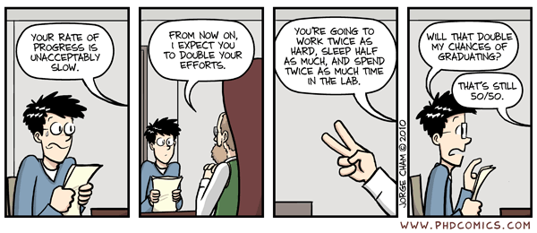
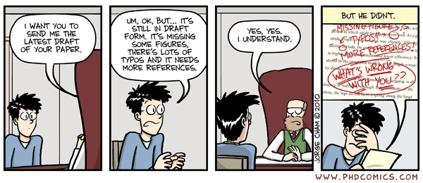

------------------------

Dec 2 – Group Processes

Read: Baumeister & Finkel, Chapter 14 (Forsyth & Burnette)

Wagstaff, G.F., Wheatcroft, J., Cole, J.C., Brunas-Wagstaff, J. , Blackmore, V., & Pilkington, A. (2008). Some cognitive and neuropsychological aspects of social inhibition and facilitation. European Journal of Cognitive Psychology, 20, 828-846.

Sacco, D.F., Wirth, J.H., Hugenberg, K., Chen, Z., & Williams, K.D. (2011). The world in black and white: Ostracism enhances the categorical perception of social information. Journal of Experimental Social Psychology, 47, 836-842.

Kerr, N.L., & Seok, D. (2011). "...With a little help from my friends": Friendship, effort norms, and group motivation gain. Journal of Managerial Psychology, 26, 205-218.

Wilkinson, D., Guinote, A., Weick, M., Molinari, R., & Graham, K. (2010). Feeling socially powerless makes you more prone to bumping into things on the right and induces leftward line bisection error. Psychonomic Bulletin & Review, 17, 910-914.

------------------------

Dec 4 – Windup Stuff

Read: Baumeister & Finkel, Chapter 19 (Taylor)

Ko, D.M., & Kim, H.S. (2010). Message framing and defensive processing: A cultural examination. Health Communication, 25, 61-68.

Averbeck, J.M., Jones, A., & Robertson, K. (2011). Prior knowledge and health messages: An examination of affect as heuristics and information as systematic processing for fear appeals. Southern Communication Journal, 76, 35-54.

Peter, C., Rossmann, C., & Keyling, T. (2014). Exemplification 2.0: Roles of direct and indirect social information in conveying health messages through social network sites. Journal of Media Psychology: Theories, Methods, and Application, 26, 19-28.

Julka, D.L., & Marsh, K. L. (2005). An attitude functions approach to increasing organ-donation participation. Journal of Applied Social Psychology, 35, 821-849.

------------------------

Final Exams Due: Thursday, Dec 11, 10 AM

------------------------

