# Northern Illinois University Huskies Vote!

## EXECUTIVE SUMMARY

A standing committee composed of faculty, staff, students, administrators, and community partners developed the following action plan, completed in December 2023. This document serves as Northern Illinois University's (NIU) voter engagement plan for the 2023-2025 academic years. This action planning aims to deepen NIU's dedication to civic education and democratic involvement, fostering a culture that actively encourages increased political engagement among NIU students. We also seek to explore additional avenues for institutionalizing voter engagement, focusing on supporting and enhancing participation leading up to the 2024 presidential election.

NIU has developed action plans around voter engagement since 2020 and collected NSLVE data since 2016. The following plan was developed utilizing NIU's 2020 NSLVE report since we did not receive our 2022 NSLVE report when this plan was submitted. The 2020 action plan had a few specific and data-driven goals. The first was to increase the registration percentage to 80% of our students. Secondly, for those who were registered, we wanted to increase the voting rate to 55% of those students. We exceeded both of these goals. We can't assume that efforts implemented solely by NIU's Huskies Vote committee and partners were the main reason for our success, as leading up to the 2020 Presidential Election, voter engagement was up across the country for many reasons. We believe that the voter registration and education opportunities we provided had a tangible impact on these results.

The plan is consistent with the university's vision, mission, and values statement and those of several departments and units. The plan will be implemented primarily on NIU's main campus in DeKalb, IL, where most students attend classes. However, we are committed to engaging all students, including those who take classes at NIU's regional centers and online students.

NIU's participation in the ALL IN Huskies Vote is a university-wide supported initiative that, until January 2023, was facilitated by the Office of the President. Huskies Vote was transitioned to the Division of Student Affairs at the beginning of this calendar and assigned as part of the responsibilities of the newly created role of Executive Director of Strategy, Impact, and Academic Partnerships. This plan and the university's NSLVE reports are available to the public on the [Huskies Vote!](https://www.niu.edu/huskies-vote/index.shtml) website and will be presented to a variety of university and external groups.

## LEADERSHIP

The Huskies Vote action plan's leadership includes individuals and groups from the campus and local communities. The Division of Student Affairs staff member Michaela Holtz, Executive Director of Strategy, Impact, and Academic Partnerships, convened the Huskies Vote committee. The membership of the steering committee and campus partners will implement this plan through the 2024 general election. The Huskies Vote is continuing to work on building its membership to ensure that the diverse population of the NIU community is represented. We are focusing our membership recruitment efforts on students and faculty as some members graduated or departed from the university. The Huskies Vote steering committee and campus partners consists of members representing students, faculty, staff, community, and local election offices from the following areas:

* Division of Student Affairs Central Office
* Student Activities Office
* Student Government Association
* Campus Activities Board
* Housing and Residential Services
* Social Justice Education Office
* Undocumented Student Resource Center
* Division of Academic Diversity and Equity and Inclusion
* Center for Nonprofit and NGO Studies
* Division of Outreach and Regional Development
* Center for Innovative Teaching and Learning
* Faculty Senate
* Web and Internal Communications
* Student-Athlete Academic Support Services
* League of Women Voters DeKalb County
* DeKalb County Clerk's Office

### Additional Campus and Community Partners

* Academic Advising Center
* Career Services
* Disability Resource Center
* Division of Academic Diversity, Equity and Inclusion
* Division of Enrollment Management, Marketing, and Communications
* Division of Information Technology
* Division of Intercollegiate Athletics
* Financial Aid and Scholarship Office
* Gender and Sexuality Resource Center
* Office of the President
* Office of the Provost
* Office of Student Engagement and Experiential Learning
* University Honors
* University Libraries

In addition to the leadership listed above, the group will look to national and state resources for support and guidance as the leadership team and the campus implement the 2023-25 action plan:

### National Affiliations and Resources

* ALL IN Campus Democracy Challenge
* Campus Vote Project/NASPA Voter-Friendly Campus
* Campus Compact
* National Study of Learning and Voter Engagement – reports since 2016
* Carnegie Communication Engagement Classification – received in 2020
* Campus Engagement Election Project (CEEP)
* Ask Every Student – Grant Recipient in 2022

## COMMITMENT

NIU[1] promotes civic engagement and learning and democratic and political participation. NIU's mission statement references developing active, engaged, informed citizens who "become global leaders who work to build a better society." The university's commitment to diversity, equity, and inclusion is reflected in its values and is consistent with promoting civic engagement and learning.[2] Several departments and units also mention civic education and democratic participation in their vision, mission, or values statements. For example, the Department of Political Science's mission statement is: "We are committed to providing NIU's diverse undergraduate student body with the knowledge and skills necessary for responsible citizenship and successful careers. Liberal arts education, engaged learning, and global education are important dimensions of this educational mission."[3] The mission statement of the Center for Nonprofit and NGO Studies states, "The center is committed to the growth and development of civil society through research, community engagement, and training the next generation of community leaders."[4]

NIU's curriculum also illustrates a commitment to civic learning and engagement. The university offers a degree in Nonprofit and NGO studies. Numerous academic departments, academic centers, and cultural resource centers offer courses related to civic engagement and learning and democratic and political participation, including the Departments of Communication, Counseling and Higher Education, Curriculum and Instruction, English, History, Mechanical Engineering, Philosophy, Political Science, Public Administration, Sociology, and World Languages and the Centers for Black Studies, Environmental Studies, Latino and Latin American Studies, Nonprofit and NGO Studies, Southeast Asian Studies, and the Study of Women, Gender, and Sexuality. Additionally, the Asian American, Latino, and Gender and Sexuality Resource Centers all offer courses that focus on these subjects. Many classes in the various centers (and even some in the academic departments) have an interdisciplinary focus.

Civic engagement and democratic participation are also reflected in several departments' learning outcomes, including political science, public administration, and nonprofit and NGO studies.

In addition to the strong civic engagement and learning focus of the curriculum, numerous co-curricular opportunities also exist, including programs offered through the Division for Academic Diversity, Equity, and Inclusion, the university's honors program, and the Office of Student Engagement and Experiential Learning, Student Activities as well as various service-learning programs within the academic colleges. For example, the year-long Huskie Service Scholars (HSS) scholarship program offers freshmen and first-semester transfer students the opportunity to develop a supportive peer network and engage in weekly service activities on campus and the community. Students work in teams and are co-hosted by a campus partner based on the social issue their team is addressing. Students in the honors program can participate in the Honors Civic Engagement Project, which curates a series of experiences to develop knowledgeable, thoughtful, caring, and active citizens. Other programs and offerings include the Huskie Food Pantry, NIU Cares, and connections to local volunteer opportunities. The university works through all these experiences to provide a service and educate students about local agencies and social issues.

Finally, the university's commitment to promoting civic engagement, learning, and democratic and political participation is shown by the establishment of presidential engagement professorships, its involvement in the National Study of Learning, Voting, and Engagement (NSLVE), and President Lisa Freeman's signing of pledges such as the Democracy Challenge's Higher Education Presidents' Commitment to Full Student Participation and Wesleyan University's three principles for developing civically engaged citizens and contributing to civic life.[5]

The university highlights its commitment to civic engagement and learning and democratic and political participation regularly in both internal and external communications. Stories on the initiatives mentioned above or faculty teaching or researching these topics are posted on [NIU Today](https://niutoday.info/), the university's internal source for university news, or pitched to national and local media. Faculty in these areas are also quoted frequently in national and local media. Moreover, local governments and community organizations are aware of NIU's commitment to civic engagement and democratic participation, and many benefit from it. The university is asking the city and county of DeKalb to recognize this action plan formally.

NIU has been recognized for its commitment to civic engagement. In 2020, the university received a Carnegie Communication Engagement Classification for the second time. This designation indicates "institutional commitment to community engagement by the Carnegie Foundation for the Advancement of Teaching."[6] Over the past seven years, six NIU students have received Campus Compact's Newman Civic Fellow Award. This national award honors inspiring college students who have demonstrated an investment in finding solutions to challenges facing communities nationwide. [7]

## LANDSCAPE

Over the last four years, the civic engagement at NIU has seen growth in providing voter education resources annually, offering multiple voter registration tables each semester. Still, it has seen the consistent commitment of NIU's leadership to these efforts. NIU is a comprehensive research university with over 15,000 undergraduate, graduate, and law students. Roughly 50% of all students are white (non-Hispanic), 19% Hispanic, 17% African American, and 5.8% Asian. More than 80% of undergraduates receive aid. Roughly 50% are first-generation. Huskies Votes's overall goal is to emphasize the importance of every vote, especially those historically barred. With most students at NIU eligible to vote in Illinois or another state, they must have access to information about democracy and ways to be involved civically.

There have historically been barriers to voting access across the United States and at NIU. However, the NSLVE data shows that absentee voting, or voting by mail, increased by 25% since the 2016 general election. While this increase might have been related to the pandemic in 2020, this is valuable information for Huskies Votes and shows that our students are interested in voting by mail and may need more information on it. We will also be sure to focus more on providing students with request forms and means to vote by mail. We aim to ensure our students know their voting options for all future elections.

One of the biggest takeaways from our efforts in 2020 was that we wanted to move into the next election cycle with more student voices and ideas at the table. NIU has a long history of supporting undocumented students and is recognized as a leader in this effort statewide. Since submitting our last action plan, the university established a new office, [Undocumented Student Support](https://www.niu.edu/undocumented/about/commitment.shtml), that focuses on supporting students and providing resources for the campus and community to understand better how to be an ally and assist NIU's undocumented students. The office partnered with NIU's ALL IN Huskies Vote to provide opportunities for students to volunteer on election day and lead events encouraging student voter engagement on campus over the past two years.

## NSLVE REPORT

The NSLVE Report has been used as a guide to help the Huskies Vote steering committee set their plans and goals each year. The most recent and past reports are publicly shared on the [Huskies Vote](https://www.niu.edu/huskies-vote/index.shtml) website. When submitting this action plan, we did not receive the most recent 2022 NSLVE data and utilized our 2020 NSLVE report. We hope to have updated data as we resubmit our plan in May 2024.

Our 2020 student voter turnout rate increased by almost 13% from 2016. We met or exceeded three of our four short-term goals for 2020. We set a goal of 80% of our students being registered to vote and met that goal with 80.7% of registered students**.** We set a voter turnout goal of 55% for 2020 and exceeded that goal with 63.8%**.** We set a goal of 50% of our students voting early or absentee, exceeding our goal with 57.0%**.** The only goal we did not meet in 2020 was surpassing the mean voter turnout rate for all institutions participating in the NSLVE. We will continue to aspire to exceed the national average.

Additional NIU's NSLVE Data:

**By Age Group:**

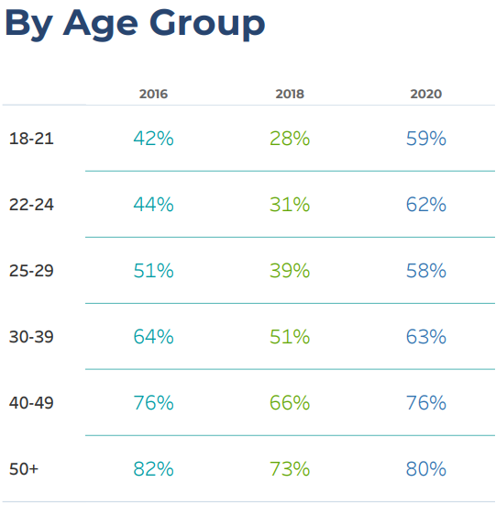

**By Sex:**

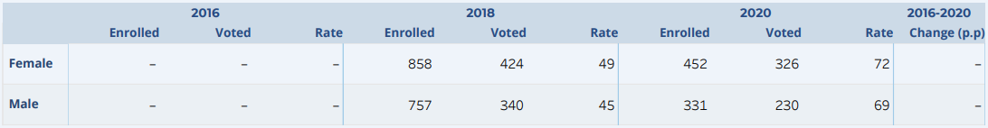

**By Educational Level/Undergraduate Class Year:**

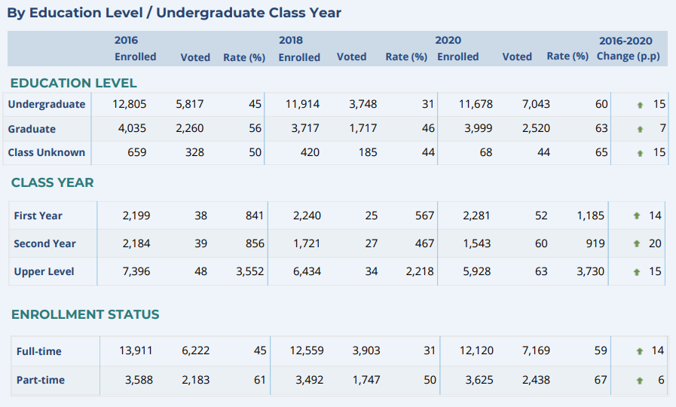

NIU's current data from NSLVE regarding race/ethnicity or gender is not complete, and therefore, there is a knowledge gap in our NSLVE report. NIU does not currently submit biodemographic data to the National Clearinghouse. The Huskies Vote committee continues to advocate for this campus change. We view the NSLVE report as essential as we make calculated decisions to increase voter turnout for underrepresented groups of students.

We are encouraged by the upward movement of overall registration and voting rates, and we are eager to engage the student body further on the importance of voting. By offering a collaborative environment to streamline efforts from across campus, the Huskies Vote Committee will ensure robust participation in future elections.

## GOALS

NIU's long-term goals are centered on expanding civic and voter engagement integration throughout various facets of campus life. As students become more aware of their responsibilities as actively involved global citizens and ethical leaders, NIU strives to achieve increased registration and voting rates. The following goals were identified based on the NIU's 2020 NSLVE data, available at <https://www.niu.edu/huskies-vote/index.shtml>. We did not receive the most recent 2022 NSLVE data when submitting this action plan. The goals for each area are listed below.

**Short-term goals (by the 2024 general election cycle):**

* Increase the percentage of students who register from 80% in 2020 to 85% in 2024.
* Have at least 55% of the first-year student cohort become registered voters.
* Process 500 voter registrations through in-person registration tabling events and NIU's online voter registration portal.
* Increase the percentage of students who voted in the general election from 63.8% in 2020 to 70% in 2024.
* Surpass the mean voter turnout rate for all institutions participating in the National Study of Learning, Voting, and Engagement (NSLVE). NIU did not meet this goal in 2020.
* By fall 2024, a book or a movie related to civic learning/civic education/democratic participation will be selected for the Common Reading Experience.
* 60% of students across all cohorts will vote in the 2024 general election.
* Offer at least three formal voter education workshops related to voter engagement work with marginalized communities.

**Additionally, the university has the following long-term goals (by 2028 election cycle):**

* Voter engagement efforts are tracked and assessed through a co-curricular platform.
* By the 2028 general election, 90% of students will be registered to vote.
* In 2026, NIU will receive the Carnegie Community Engagement Classification again.

## STRATEGY

To meet the short-term and long-term goals outlined below, the following actions will be (or already have been) implemented. This action plan is considered a living, breathing document. Although this plan will be submitted for feedback before the ALL IN Campus Democracy Challenge December 2023 deadline, it will continually be updated and adapted to help NIU meet its goals. We plan to resubmit the plan addressing the feedback we received in May 2024. Most actions related explicitly to political participation will help the university meet its short- and long-term goals. Activities related to curriculum or culture will help the university meet its long-term goals.

### Voter Registration:

* Updated communication and marketing materials - We identified several strategies to improve our communication about Huskies Vote initiatives:
  + - [Huskies Vote](https://www.niu.edu/huskies-vote/index.shtml) - updated website based on students' feedback to provide clear, user-friendly information for students to register to vote and answer frequently asked questions. Digital and Printed Materials
    - Use of campus digital signage on all NIU campuses and large printed banners in high-traffic areas – Holmes Student Center, Founders Library, and Peters Campus Life Building.
    - Huskies Vote printed postcards with QR codes linking to the website and brief information about voter registration distributed at two annual conferences to all participants, located at physical offices of campus and community partners, shared Orientation and Involvement Fair events, and dining and residence halls.
    - Outdoor yard signs with QR codes will be placed around campus starting during the early voting period, as our campus is a location for early voting.
    - Promote the use of #HuskiesVote on social media.
    - Short videos regarding how to register, why voting matters, and other civic engagement
    - Topics. The videos will be shared on various university social media accounts and placed on the Huskies Vote! website.
    - Table tents with voter registration information will be placed at the residence hall and other campus dining venues.
    - Annual letter from SGA President and Speaker of the Senate to students encouraging voter registration in Fall 2024.
    - The annual letter from the Vice President for Student Affairs to students encouraging voter registration will be done again in Fall 2024.
    - The annual letter from the Provost encouraging faculty to mention voter registration deadlines and the importance of voting in their classes will be done again in the Fall of 2024.
* Provide ample amount of voter registration opportunities and support on campus:
  + Recruit and engage student representatives to offer guidance on how best to engage their peers. They will promote voter registration and voter turnout within their respective campus community and among the larger student body, help with tabling events, and attend student group meetings. We will emphasize recruiting student representatives from majors with low voter participation and students from organizations representing minoritized students.
  + We will utilize the ALL IN online portal to provide an accessible form of

voter registration for students, faculty, and staff. This tool will be used by having laptop stations and regular tabling events across campus.

* + - Presentations during freshman orientation will include voter registration and

education-oriented information.

* + - To increase the number of first-year registered voters, voter registration information will be distributed, and voter registration tabling will be available during the 2024 Week Of Welcome.
    - In partnership with community advisors and Residential Life, we will create excitement for the election by asking students what is important to them and what they pledge to do: why vote? We will remind returning students to change their address and make a plan to vote.
* Participation in the "[I Pledge to Vote](https://allintovote.org/take-the-pledge/)" campaign.
* Participation in the National Voter Registration Day (September 2024).
  + Fraternity and Sorority Life outreach/engagement will occur through a partnership with their governing councils, who will have representation on the Huskies Vote committee. We will offer specialized presentations, marketing materials, and resources to mobilize campus fraternities and sororities. These students, in addition to service-based fraternities and sororities, provide a base for volunteer support for election effort events and outreach.
* Identify annual and special events to include presentation on Huskies Vote and/ or distribute voter registration information along with voter registration resources:
  + Student Involvement Fair (January 18-19, 2024 and Fall 2024)
  + POWER Retreat (January 2024)
  + Global Engagement Week (January 22-26, 2024)
  + Conference on Undergraduate Research & Engagement (April 30, 2024)
  + NIU Cares (April, 2024)
  + Coming Out of the Shadows (April, 2024)
  + New Student Orientation (Summer 2024)
  + Resource Center Open Houses (Fall 2024)
  + Welcome Holmes (August, 2024)
  + Campus Meets Community Events (Fall 2024)
  + The Real Talk Conference (Fall 2024)
  + Academic cultural centers' signature events (all year)
  + STEM Fest (October 2024)
  + Conversations on Diversity and Equity (CODE) trainings (all year)
* Mission Mondays.
  + Mission is our famous live Husky mascot, who visits various places on campus each Monday. During the fall 2024 semester, several Mission Mondays will be devoted to voter registration. Mission will have volunteers with him who will promote voter registration, and we will promote and document the event on Mission's popular Twitter and Instagram accounts.
    - Engage faculty members to encourage students to register to vote
      * Reach out to faculty of the large general education courses and ask them to encourage their students to register to vote and/or offer to present to their class. Also, ask them to include the provided voter registration slide in their course BlackBoard page or class session slide deck.
    - In partnership with the DeKalb County Clerk, host a deputy registrar training program in early spring 2024. In the past, this program allowed us to train over 40 new deputy registrars among staff and faculty. In return, they volunteered during our voter registration events.
    - The Division of Intercollegiate Athletics will hold at least two voter registration workshops where students can ask questions regarding voter registration and register to vote. The workshops will be led by campus employees who were trained as deputy registrars.
* Confirm existing and increase the number of our Campus Voter Registration Partners.
  + To be a Campus Voter Registration Partner, the campus unit must have done the following: 1/ Voter registration information brochures need to be made accessible to students in a central location (e.g., lobby, main office). The information will be added to the slide rotation if units have digital signage. 2/ Place an "I can help you register to vote" sign in a visible location. 3/ At least one staff member from the unit must be trained as a deputy registrar (most had multiple staff members trained). The most recent Campus Voter Registration Partners were listed under the leadership section.

### Voter Education - Strategies:

* Voter Education Programming:
* The Civic Action Hour - NIU's Huskies Vote Committee will host at least three voter education programs in collaboration with several cultural centers during the fall of 2024. The workshops will be hosted in a hybrid form (virtually and in-person) to be more accessible. They will require registration and will be facilitated by one of the committee members. The possible topics include:
  + Why Vote? - When encouraging voting registration and civic engagement, a question often asked is, "Why vote?". This event will allow students to grapple with that question and many others through discussion and with panelists present who can assist in getting them answered.
  + The Power of the Latinx Vote - This event will discuss the Latinx vote locally and nationally, examining some of the significant issues for Latinx voters and the data on Latinx voting in Chicago and nationwide. This event can be broaden to other specific communities represented on our campus.
  + How do Elections Work? – panelist of experts and local government representatives discuss the elections process and answer questions.
* Honors Seminars - Voter education information will be shared with help through the Honors Advocacy Initiative (HAI)
* Develop a series of conversation guides for first-year students reading the Common Read Experience book focused on civic engagement for faculty to use in their classes and host at least one significant event. All first-year composition courses and, moving forward, all Communications 100 and English 101 sections will use the Common Read as a required part of the curriculum.
* Debates hosted through a partnership with the DeKalb County League of Women Voters
* Student Opportunities: 
  + Courageous Conversations – Monthly events focused on various topics and organized along with partners in academic colleges fostering dialogues abouts policies, civics, and specific applied examples of civic participation within various disciplines. The events will be set up in a different location each month, offer refreshments, and focus on one "hot topic." Students will be invited to come into the space, enjoy the coffee or donuts, and engage in civil discourse with other students about their views.
  + [People's Organizing Weekend Empowerment Retreat](https://www.niu.edu/social-justice-education/education/empowerment.shtml) (POWER) - The purpose of POWER is to empower student activists who have previous experience organizing and/or participating in activities centered on the tenets of social justice.
  + Establish the IGNITE women's votes chapter at NIU through collaboration with NIU's alumni.
* Faculty and Staff Resources:
* Revise and redistribute the survey used in the past to help the university capture all civic engagement initiatives and document student participation, but extend the distribution to specific staff on campus. Faculty and staff will be asked what kinds of activities they do in courses/programs to increase students' awareness and their social responsibility regarding civic engagement and highlight modules, activities, lectures, and videos used to achieve these goals.
* A downloadable PowerPoint slide was provided to faculty to link students to the Huskies Vote website.
* A campus-community deliberative dialogue utilizing the National Issues Forums Institute issue guide on elections deliberating: how do we encourage and safeguard voting? will be held and made available to faculty for use in the classroom.
* Updated resources for faculty will be available on the website for voter engagement conversation in the classroom (see Appendix B).

### Voter Turnout - Strategies:

* Huskies Vote! stickers will be handed out at all Huskies Vote events and to student voters in campus polling precincts.
* Students will sign "I Pledge to Vote" posters in the Holmes Student Center, Founders Memorial Library, and other places around campus.
* Set up tables in strategic places on campus to remind students to vote. Like our voter registration tables, these tables will be fun ways to increase voter engagement and serve as a resource for anyone confused about how/when to vote.
* Voter information center in the Barsema Alumni and Visitors Center and the Holmes Student Center on election day
* Huskie Service Scholars and staff volunteers will help students determine their appropriate voter location and answer questions on election day.
* Election Day photo booth and recording space will allow students to share pictures and videos on personal social media accounts, encouraging friends and loved ones to head to the polls. Students will be encouraged to use the NIU's hashtag #HuskiesVote.

### Long-term Strategies:

To build an even stronger culture of voter engagement at NIU, we seek to institutionalize these efforts into the campus fabric. This involves building an established and representative Huskies Vote Committee with a sustainability plan addressing changes in membership and continuing to integrate voter engagement messages into existing channels and programs regardless of the election year. Another long-term strategy is to continue to center voter engagement coordination efforts into a staff member's job description and develop a budget to hire a graduate assistant to give the time and resources necessary to meet our long-term goals.

## REPORTING

The final action plan and the NSLVE reports are publicly shared on the Huskies Vote website. This action plan will be our guiding document and will be referenced in campus-wide communications. Brief presentations on the action plan will be presented to several key groups on campus and in the community (e.g., Senior Leadership Team, University Council, Student Senate, Faculty Senate, Presidential Commission on the Status of Women, Student-Athlete Advisory Committee (SAAC), Student Experience Team, College communications professionals, Non-profit and NGO Studies Advisory Board**,** DeKalb County League of Women Voters). As we get closer to the elections in June and November of 2024, we will contact the local newspaper to highlight what is happening on campus and encourage community members to participate. In addition to NSLVE data, we are eager to measure our efforts based on the number of students registered through NIU's ALL IN online portal, in-class presentations, digital and online engagement rates, and participation in activities and events.

## EVALUATION

Continuous evaluation of our action plan is crucial as we increase voter engagement on campus. As we track student engagement on our website and through our communication and events, we can see the fruit of the effort through the NSLVE data. We are committed to using qualitative and quantitative data to help us gather information about our activities to inform our ongoing student engagement. To evaluate progress in encouraging our students to register and vote, our Huskies Vote committee will:

* Use the NSLVE data from the previous year to help inform our activities. We will continue to debrief as a steering committee at each monthly meeting and after each semester to get input, especially from our student members, about new engagement ideas and ways to measure the efficacy of the effort. The data collected from our efforts (as outlined below) will help direct our activities.
* Utilize our Huskies Hub tracking process whereby students will swipe their school ID card at all Huskies Vote program events so we can assess the number of students engaged, but will also be able to analyze that information by year in school, major, number of events attended, etc.
* Employ a post-program student attendee survey to assess how well the program met the program goals, with a separate survey to determine the program's interaction with community and campus partners.
* At all of our tabling and other events (including events on National Voter Registration Day), we will utilize a QR code that directs students straight to our Huskies Vote web page, where they can take the Huskies Vote pledge or click through to check on registration status or through to actual registration. Those QR codes directing students to our site will give us increased engagement data we do not currently have.
* Track views and clicks on our Huskies Vote website, social media platforms, and email communications.
* Track participation in a Huskie' Pledge to Vote' campaign; compare attendance data collected during other events.
* Collect qualitative data on why students registered/why they will vote through exit surveys at registration events. We will also offer opportunities for students to express their reasons for voting through events in conjunction with campus partners (events to include chalking parties, videotaped testimonials, and other events to be determined). We want to hear our students' voices!
* Continue participating in the National Study of Learning, Voting, and Engagement (NSLVE) to track student registration and voting rates.
* These evaluation plans will help us assess efficacy and make necessary adjustments throughout the year. This information will be shared with upper university administration and through social media and other university communication outlets.

**Appendix A: Huskies Vote Postcard**

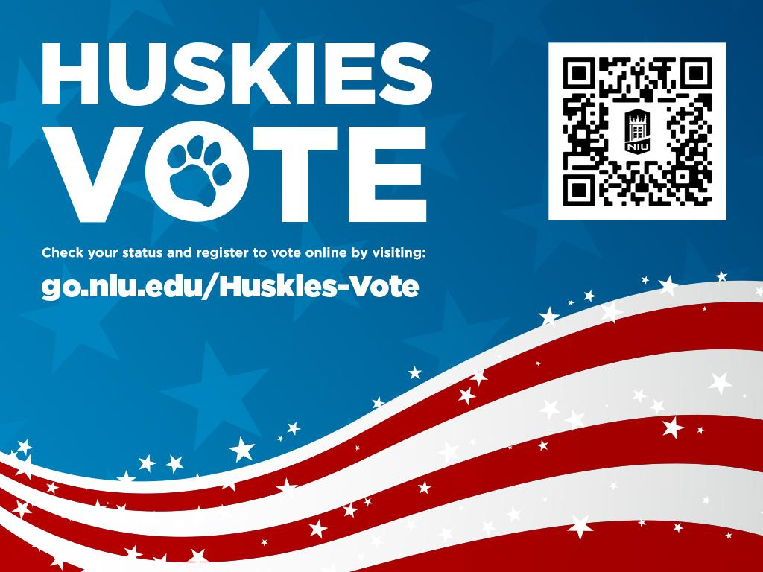

**Appendix B: All IN Democracy Challenge** - **Faculty/Staff Information Sheet**

NIU is engaged in the [All In Democracy Challenge](https://www.allinchallenge.org/) program that seeks to enhance student involvement in voter education, registration and mobilization. This is a nonpartisan effort and all discussion with students should be framed in terms of civic responsibility. Students should not be encouraged to vote for any particular candidate nor join any party.

**Here are some suggestions for promoting civil discourse on these emotionally laden issues — most of which, unsurprisingly, echo good general classroom practice:**

* Don't feel you need to be a political expert, knowing all the answers with perfect responses.
* Remember that your role is to get students talking and thinking, not to lead them toward a particular political viewpoint or electoral outcome.
* Consider having a couple of students facilitate the conversation with you.
* You may supply information, context and sources for further inquiry, but you are mainly providing an environment where all in the classroom are respected. Let the students take the lead as much as possible. Encourage them to listen, hear each other's perspectives and work to understand the experience that generates these perspectives. These resources might be helpful with incorporating these conversations in your classes: [CEEP Faculty Guide](https://campuselect.org/wp-content/uploads/2018/09/Incorporating-Election-Engagement-Into-Your-Courses.pdf), [Living Room Conversations](https://www.livingroomconversations.org/), [Allsides](https://www.allsides.com/unbiased-balanced-news).
* When discussing where candidates stand on key issues of interest to students, be accurate and fair, whatever your personal views. Feel free to use the following [nonpartisan candidate and issues guides](http://campuselect.org/voter-education/candidate-issue-guides/).

If students wish to register to vote, they can contact:

* Deputy Registrars at NIU listed on Huskies Vote website (<https://www.niu.edu/huskies-vote/index.shtml>)
* DeKalb County Registrar: 815-895-7147 or email [elections@dekalbcounty.org](mailto:elections@dekalbcounty.org)

If they have a valid Illinois DL or State ID, they can visit the state's website and register to vote online <https://ova.elections.il.gov/>

To Vote in Illinois

* You must be a United States citizen.
* You must be 17 on or before the date of the Primary Election and turn 18 on or before the date of the General or Consolidated Election.
* You must live in your election precinct at least 30 days prior to Election Day.
* You must not be serving a sentence of confinement in any penal institution as a result of a conviction.
* You may not claim the right to vote anywhere else.

1. NIU is a comprehensive research university with over 15,000 undergraduate, graduate, and law students. Roughly 50% of all students are white (non-Hispanic), 19% Hispanic, 17% African American, and 5.8% Asian. More than 80% of undergraduates receive aid. Roughly 50% are first generation (see [At a Glance | Northern Illinois University (niu.edu)](https://www.niu.edu/at-a-glance/index.shtml)).
2. Northern Illinois University’s “Vision, Mission, and Values” statement. Available at <https://www.niu.edu/at-a-glance/vision-mission-values.pdf>.
3. Northern Illinois University Department of Political Science’s mission statement. Available at <https://polisci.niu.edu/polisci/about/mission.shtml>.
4. Northern Illinois University Center for Nonprofit and NGO Studies mission statement. Available at <https://www.niu.edu/nonprofit/about/mission-statement.shtml>.
5. See <https://www.wesleyan.edu/e2020/index.html>.
6. <https://www.aplu.org/news-and-media/blog/2020-carnegie-community-engagement-classification-recipients-announced>
7. [Newman Civic Fellowship - Campus Compact](https://compact.org/newman-civic-fellowship/)