Table of Contents
  Student hiring manual | Abstract  Everything you need to know about how to post a position and hire a student worker for NIU.  Aimee Walker

Visual Overview of Student Hiring Process …………………………………………………………………………………………… 3
How/Where to Post a Position …………………………………………………………………………………………………………..… 6
Interview Students/Checking Employment Eligibility …………………………………………………………………………… 8
Offer Extended and Accepted by Student ………………………………………………………………………………………….... 9
Checking on Progress of Hire ……………………………………………………………………………………………………………… 17
Addendum …………………………………………………………………………………………………………………………………………. 23

Visual Overview of Student Hiring Process
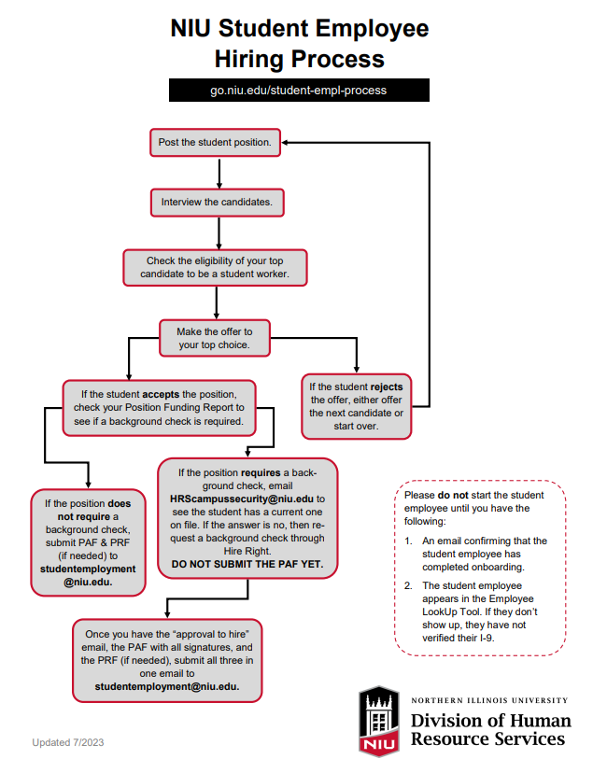

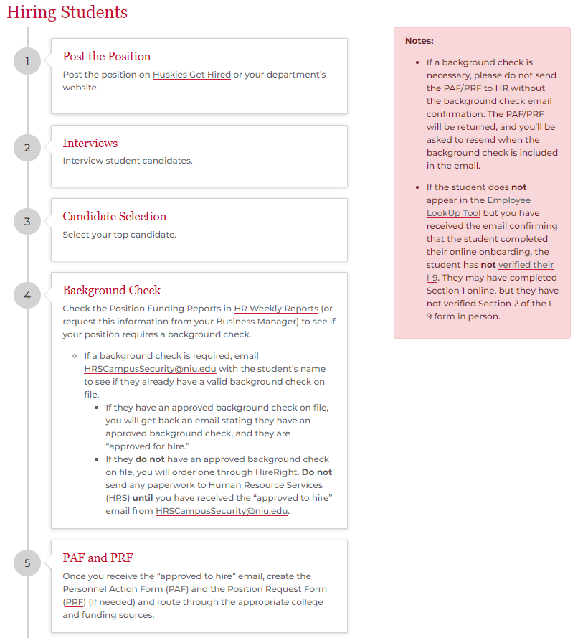

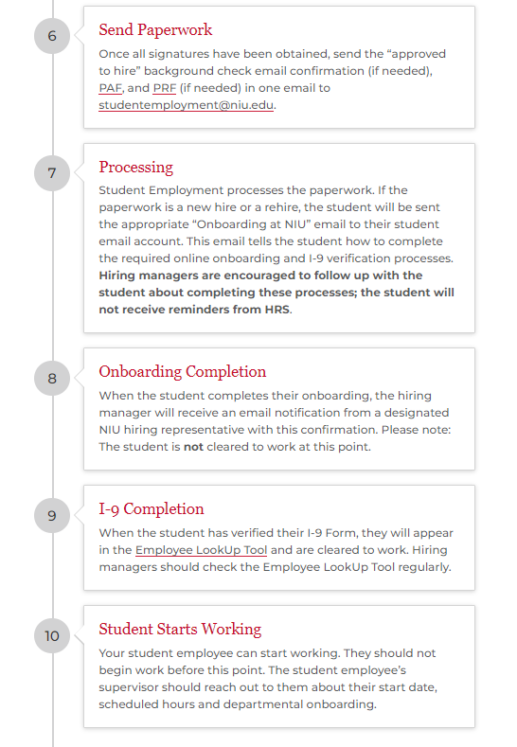

How/Where to Post a Position

Posting on Huskies Get Hired
Step 1: Determine if you have an On-campus Huskies Get Hired employer account. If you do not, request one by:
- Visiting Huskies Get Hired and click on Sign Up and Post Job.
- Completing the employer information, contact information and address sections. Be sure to include NIU at the beginning of your organization name.
- Enter job information. For resume submission method, select Other and include your PeopleAdmin application link and any application instructions in the Requested Document Notes section.
- Click Submit.
Step 2: Once you have an On-campus employer account
- Log in to Huskies Get Hired.
- Click Create Job Posting under Jobs and Internships and complete the required fields. If you're updating or reposting a previous position, you may be able to select the Copy or Repost Position section.
- For resume submission method, select Other and include your PeopleAdmin application link and any application instructions in the Requested Document Notes section.
- Click Submit.
Step 3: Check your posting often.
Notes – You may want to create resume books or search for a certain population of students to send your position to. To do that follow the steps below.

Access Resume Books
- Log in to Huskies Get Hired and click Resume Books in the navigation panel.
- Click Resume Books in the drop-down panel.
- Click on NIU Current Resumes to see a list of students.
- Search and view resumes.
- Select students of interest by checking the box next to their name. You can send an email to selected students, save their information to Excel or generate a resume book (PDF) of selected resumes.

Posting In Your Department

On your department website, bulletin boards, or any other public place put out the job description. You should check with your department on how/where they have previously/historically posted positions.

Interviewing Students/Checking Employment Eligibility
Step 1: Contact all students who you are interested in interviewing to schedule a time. Please provide multiple options for the interview (Teams meeting, phone call, in person). Have all interviewers take notes on interviewee answers to questions. All interviewees should be asked the same questions. Some questions that would be beneficial to ask are:
- Are you currently working another position on campus?
- What is your current enrollment (how many credits are you currently enrolled in)?
- Are you eligible or have you accepted federal work study?

Step 2: After all interviews are conducted, meet with the hiring committee, review interviewee answer to questions, and make a final decision. Before offering the student employment, check the student’s eligibility for student employment. To be eligible for student employment, the student must meet the following criteria:

FALL AND SPRING SEMESTERS
- The student is registered for a minimum of 6 credit hours.

SUMMER SEMESTER
- The student is enrolled for at least 3 credit hours during the summer semester; OR
- The student was enrolled as a student during the spring semester; OR
- The student has indicated their intention to be registered for the Fall semester for a minimum of 6 semester hours.
Step 3: Once you have confirmed the student is enrolled in enough credits and is/is not federal work study eligible, you can extend the offer of employment to the student.

Offer Extended and Accepted by Student

Step 1: Determine an open position number by accessing the HR Weekly Reports online and searching your Position Funding Report found in the HR Weekly Reports section. Vacant position numbers are found on the Position Funding Report under the “Incumbent” column. Any open positions will show as “VACANT”. The position funding report is usually only given to the Business Manager. If you don’t have access you can have your business manager request it through DoIT or you will have to request the information from your business manager.

HR Tool Kit Webpage
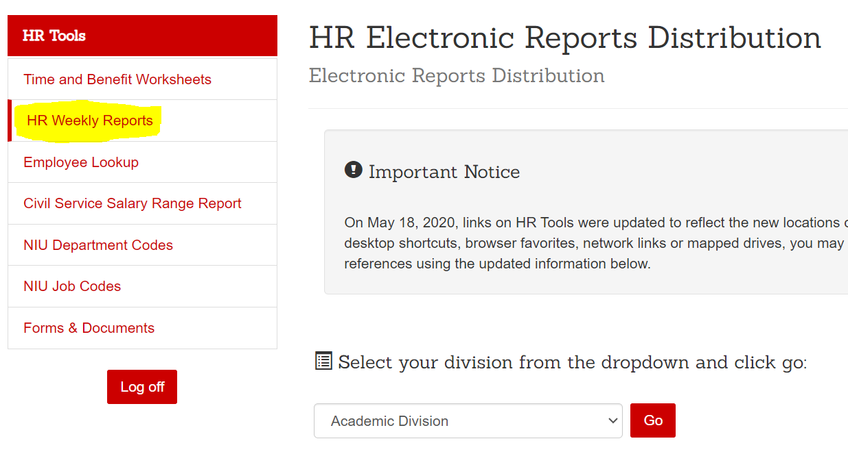

Position Funding Report:
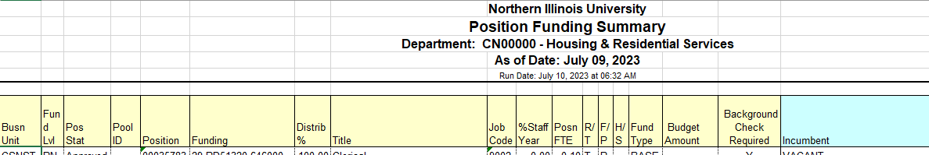

Step 2: While checking for a vacant position on the Position Funding Report, also determine whether your student position requires a background check. This can be found in the “Background check required” column. If a background check is required, the field will read “Y”. If the position requires a background check, send an email to HRScampussecurity@niu.edu including employee first name, last name, date of birth, student ID number and last 4 digits of SSN, asking if the student has a current, valid background check on file. If the student does, they will receive an email like the one below.

Position Funding Report:

Background Check Email Sample:
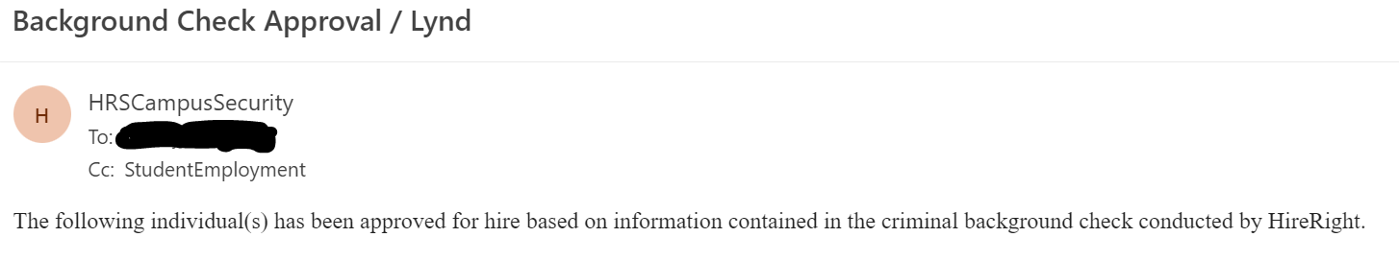
If the student DOES NOT have an approved background check on file, you will need to order one through HireRight.

NOTE: Do NOT send the PAF/PRF for the student until you have the “approved to hire” email from HRScampussecurity@niu.edu. The PAF, background check (if required), and PRF (if required) will be submitted to studentemployment@niu.edu in ONE email.

Step 3: Once you have received the “approved to hire” email from HRSCampusSecurity@niu.edu, create the PAF for the student. Circles 1 through 6 are required. See sample PAFs in the addendum of this manual.






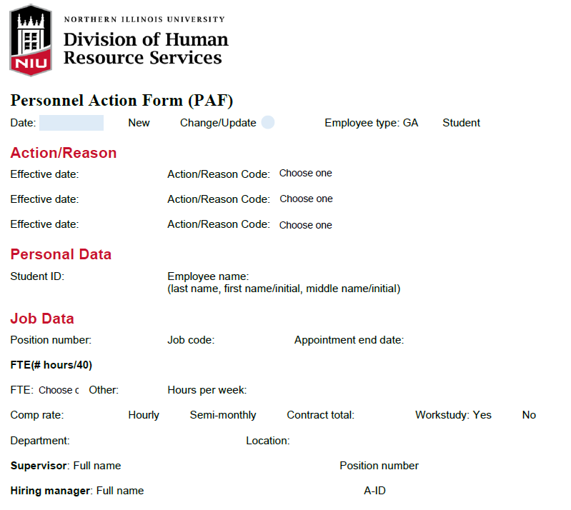
Circle 1: This is the date you are filling out the PAF
Circle 2: Select either “new” or “change/update”. Use “change/update” for any existing employee in an ACTIVE position.
Circle 3: Select either Student or GA. This helps HR ensure that the right student is put into the right position.
Circle 4: The effective date is the date you want the action to take place. For example, a student is going to start work on 16 August 2023 so the effective date would be 8/16/2023. Select the appropriate action(s) you wish to take. Each PAF may do several actions. See sample PAFs in the addendum of this manual. When selecting an Action/Reason, you may be unsure which one to select. Check the Action/Reason Code Cheat Sheet make the correct selection.
Circle 5: Enter BOTH the student’s name and student Z-ID number. Please enter the student name by LAST NAME, FIRST NAME. Excluding the Z-ID number can delay processing.
Circle 6: All items in this section are required. See below for each field and how to fill it out properly to ensure speedy processing and no delays.
Position Number is the vacant position number from the Position Funding Report which you want the student to fill.
Job Code is the job code found on the position funding report and correlates to the job codes and pay rates listed on the Position Classification HR webpage.
Appointment End Date is LAST day you want the student work. If the students last day of work is 15 December 2023 the appointment end date will be 12/15/2023. The appointment end date cannot be more than ONE YEAR OUT.
FTE/Hours Worked refer to how many hours the student will be working in that position. You may either select a drop-down value from the FTE option, put in your own FTE, or simply list the number of hours the student will be working and HR will calculate the FTE. To calculate FTE you take the hours the student will work divided by 40. For example, a student will work 7 hours for your position so their FTE will be .18.
Comp rate is the compensation PER HOUR the student will be paid. Make sure to be cognizant of the minimum wages listed on the Position Classification HR webpage. If the minimum dollar per hour rate is not met, HR will update it to the minimum and alert you when the student has been entered that the minimum hourly wage was updated. All students are HOURLY so you’ll need to put the COMP RATE and enter HOURLY.
Department is where you enter the department the student will work for. Is it imperative that the department in the PAF matches the department of the position number. If the department is changing, the PRF and PAF must reflect the requested department. HR will not be able to process the forms if they don’t match.
Location is where the student will perform their job. Please enter the location so that HR can ensure the position lists accurate information.
Supervisor is who will be supervising the student. You will need to enter the NAME and the POSITION NUMBER (not A-ID) of the supervisor. If you do not know the POSITION NUMBER you can find it on the Employee LookUp Tool.
Hiring Manager is the person submitting and creating the PAF.
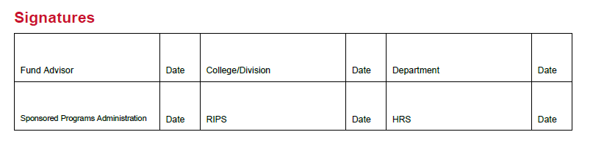
Route the PAF for signatures. Each department is different, so check with your department on if you need College/Division signatures.

NOTE: Once all items are filled in, you will need to route the PAF for signatures. Please DO NOT copy student employment on emails with an unsigned PAF attached asking for approval. Please collect signatures and once all signatures are received send that PAF to studentemployment@niu.edu.
Step 4: If changes are needed to the POSITION, create a PRF. Refer to the PRF Action Code Reason Cheat Sheet. Sample PRFs can be found in the addendum of this manual.

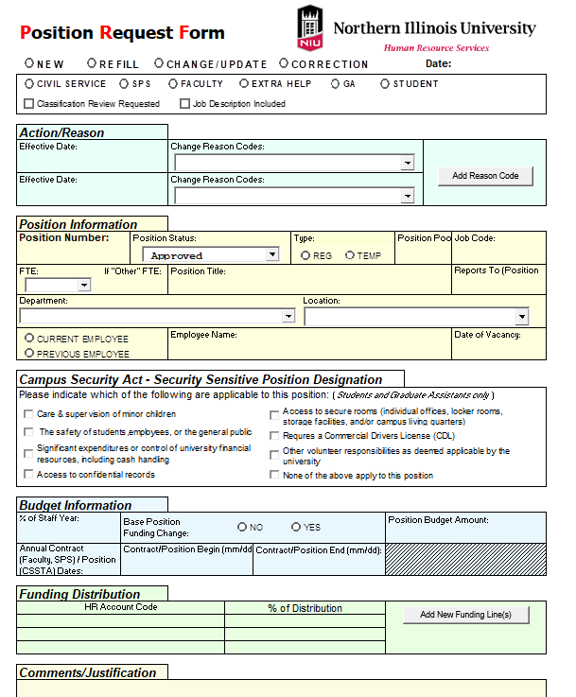

Circle 1: You will need to select one of the following options: New, Refill, Change/Update or Correction. Typically, you be selecting new or change/update for student employees. You will also need to enter the date you are submitting the PRF. This is the day you are actually entering the information.
Circle 2: This is where you will select what actions you want to take on the position you are adjusting. On the far right of the PRF you will notice you have the option to “Add Reason Code” which means you take as many actions as you need on the position with ONE PRF. You’ll want to reference the PRF Action Code Cheat Sheet often to make sure you are selecting the correct reason to prevent a delay in the processing of your PRF.


When you are submitting a PRF for a funding change it MUST take place on the 1st or 16th of the month for payroll purposes! Payroll cannot RETROACTIVELY change funding.

NOTE: If you are changing the FUNDING of a position, you must submit a PRF. Noting the funding change in the PAF will not mean the funding is updated in the system!

Circle 3: Fill in position number and any other fields that are CHANGING and have an action/reason noted in circle 2. For example, if you were updating the FTE of position 12345 from .1 to .25 you would enter position number: 12345 and ONLY FTE .25. No other information in that section is required.
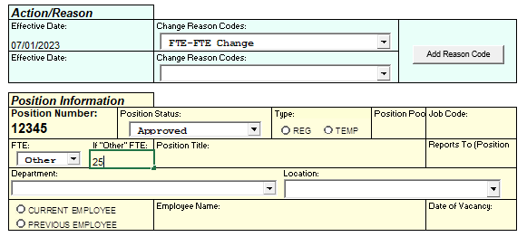
In very rare circumstances, if no reports to has yet been entered for the position HR will also ask for the reports to, but this should be a rare occurrence.
Circle 4: This box is used to indicate IF a background check is required. If you are ADDING a background check requirement, check any of the first SEVEN boxes. If you are REMOVING a background check, check the bottom box on the RIGHT.

ADDING BACKGROUND CHECK
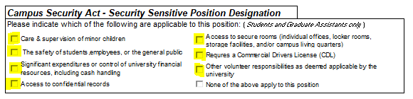

REMOVING BACKGROUND CHECK
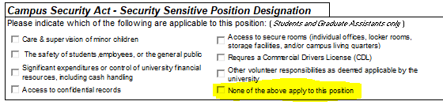

Circle 5: Funding distribution is where you put the funding codes you would like to be charged for the position. Funding codes should all be listed in the following format: XX – XXXXXX – XXXXXX. The first 2 digits are usually 02, 41 or 44 (for grants). The last 6 digits are either 648100 (for a regular student position) or 648120 for a federal work study position. The middle digits are a combination of letters and numbers you will get from your department.
Some appropriate sample codes are:
02-G1A6413-648100
41-SQ16485-648120
44-G3A1654-648100
Entering G3A1645 will delay processing of your request as HR does not know the preceding 2 digits or the ending 6 digits.
Circle 6: This area is for any comments. Comments could be things like telling me to remove pool funding and put in the funding from line 5 or it could noting to remove the background check or it could be telling me to update the supervisor FROM someone TO someone else. Whatever you feel is necessary to make sure the right actions are taken. If the rest of the PAF is accurate, there should not be a lot of information required in the comments section.

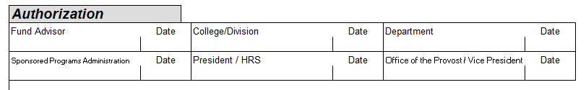

Route the PAF for signatures. Different funding requires different signatures. Please DO NOT copy studentemployment@niu.edu on the email chain gathering signatures. Once all signatures are collected, email the PRF (with the PAF, if needed, and background check, if needed) to studentemployment@niu.edu.

Step 5: After all required forms (PAF/PRF/background check) have been signed and all forms are ready to go submit ONE email with all required forms AS THEIR OWN PDFs to studentemployment@niu.edu. Remember, not every action requires all forms. Sometimes a PAF will suffice, sometimes just a PRF will suffice, sometimes all 3 are required. If you have questions, please reach out to studentemployment@niu.edu.

Checking on Progress of Hire
Step 1: After you submit ONE email to studentemployment@niu.edu per student, you will receive a confirmation email noting that either the form(s) have been processed or there was an error with either the paperwork or the requested action. At this point, if no errors were noted, you will be copied on the “hire” or “rehire” system generated email from Onboarding.
New Hire Intro Email:

Congratulations and welcome!
We have received paperwork to hire you as an employee. You need to complete a few steps before we can enter you in our system. Please follow these instructions carefully to ensure you are completing Onboarding and Orientation correctly.
STEP ONE:
The first step to becoming a Huskie is the completion of the I-9 Employment Eligibility Verification form. This form should be completed, and all necessary verification documents uploaded to the system before your start date (first day on the job).
Have your acceptable identity and employment eligibility verification documents ready before you open the following link. That means having your documents scanned/photographed and ready to upload into the system before you open the next link.
Use this link to complete the I-9 Form and to upload your documents for identity and employment eligibility. Follow these instructions carefully:
- The link will direct you to our I-9 system.
- You must complete Section 1 and upload documents for Employment Eligibility BEFORE your start date (first day on the job). Any delay in completing Section 1 of the I-9 will result in your start date being moved to the next pay period.
- The acceptable documents for determining your Employment Eligibility are listed again in the link. These are the only documents we can accept.
- As required by Federal law, you must meet in-person with an authorized HR representative and present the original, unexpired documents you have uploaded into this system prior to or within 3 business days of your start date (again, start date means your first day of work). To fulfill this requirement, please stop by either the HR Main Building at 1515 West Lincoln Highway in DeKalb, IL, or the HR Satellite Office at 102 Lowden Hall on the DeKalb NIU campus, between the hours of 10:00am – 3:00pm, Monday through Friday.
- If you need assistance with logging in or completing the I-9, please contact me at aimee.walker@niu.edu as soon as possible to avoid any delays in the processing of your start date and/or payroll.
- Once your documents are uploaded, you should continue to Step Two immediately below to continue with the hiring process. Do not delay in progressing to Step Two even if you are unable to immediately appear at the HR office to have your documents verified, because Step Two allows you to complete your initial hiring documents, and those are essential for entering you into our systems.
Note: if you have ever been a student at NIU and had a name change since your last attendance date, HR will need a copy of your updated social security card containing your new name. We will only be adjusting your name on the employment side and not the student side, so if you are ever a student at NIU again, your name may not be updated in the student system.
STEP TWO:
Next, visit our HR Onboarding Portal and log in using your A-ID (same as your Z-ID but with an A instead of Z) and temporary password.
Account: A2008832
Password: NIU.YYYYMmmDD
(sample: birthday - December 31, 2001 = NIU.2001Dec31 )
STEP THREE:
After the HR Onboarding Portal is complete, you will be automatically directed to the HR Orientation Portal where you will learn more about becoming a successful Huskie. This step is imperative to complete, so do not skip it.
NOTE: Your immediate and proper completion of the I-9, onboarding and orientation portals, and all relevant paperwork will help us enter you in the NIU system in a timely manner preventing delays in the processing of your start date, your payroll, and access to other NIU portals.
If you have any questions, please let us know.
Thank you,
Aimee Walker
CONFIDENTIALITY NOTICE: This e-mail message, including any attachments, is for the sole use of the intended recipient(s) and may contain confidential and privileged information. Any unauthorized review, use, disclosure, or distribution is prohibited. If you are not the intended recipient, please inform the sender and destroy all copies of the original message immediately.

Rehire Intro Email:
Congratulations and welcome back!
We have received paperwork to rehire you as an employee. You need to complete a few steps before we can re-enter you in our system.
**If you have previously worked at NIU and your last day of work is less than one year ago, skip Step One and proceed to Step Two.**
Note: if you had a name change since your last employment date OR the last time you attended NIU as a student, if applicable, HR will need a copy of your updated social security card containing your new name. We will only be adjusting your name on the employment side and not the student side, so if you are ever a student at NIU again, your name may not be updated in the student system.
STEP ONE:
The first step to becoming a Huskie is the completion of the I-9 Employment Eligibility Verification form. This form should be completed, and all necessary verification documents uploaded to the system before your first day of employment.
Have your acceptable identity and employment eligibility verification documents ready before you open the following link. Your documents should be ready to upload into the system.
Use this link to complete the I-9 Form and to upload your documents for identity and employment eligibility. These are the requirements:
- The link will direct you to our I-9 system.
- You must complete Section 1 and upload documents for Employment Eligibility BEFORE your start date (first day on the job). Any delay in completing Section 1 of the I-9 will result in your start date being moved to the next pay period.
- The acceptable documents for determining your Employment Eligibility are listed again in the link. These are the only documents we can accept.
- As required by Federal law, you must meet in-person with an authorized HR representative and present the original, unexpired documents you have uploaded into this system prior to or within 3 business days of your start date (again, start date means your first day of work). To fulfill this requirement, please stop by either the HR Main Building at 1515 West Lincoln Highway in DeKalb, IL, or the HR Satellite Office at 102 Lowden Hall on the DeKalb NIU campus, between the hours of 10:00am – 3:00pm Monday through Friday.
- If you need assistance with logging in or completing the I-9, please contact me at aimee.walker@niu.edu as soon as possible to avoid any delays in the processing of your start date and/or payroll.
- Once your documents are uploaded, continue to Step Two below to continue with your hiring process. Do not delay in progressing to Step Two even if you are unable to immediately appear at the HR office to have your documents verified, because Step Two allows you to complete your initial hiring documents, and those are essential for entering you into our systems.
STEP TWO:
Next, visit our HR Onboarding Portal and log in using your A-ID (same as your Z-ID but with an A instead of Z) and temporary password.
Account: A1972685
Password: NIU.YYYYMmmDD
(sample: birthday - December 31, 2001 = NIU.2001Dec31 )
STEP THREE:
After the HR Onboarding Portal is complete, you will be automatically directed to the HR Orientation Portal where you will learn more about becoming a successful Huskie. This step is imperative to complete, so do not skip it.
NOTE: Your immediate and proper completion of the I-9, onboarding and orientation portals, and all relevant paperwork will help us enter you in the NIU system in a timely manner preventing delays in the processing of your payroll and access to other NIU portals.
If you have any questions, please let us know.
Thank you,
Aimee Walker
CONFIDENTIALITY NOTICE: This e-mail message, including any attachments, is for the sole use of the intended recipient(s) and may contain confidential and privileged information. Any unauthorized review, use, disclosure, or distribution is prohibited. If you are not the intended recipient, please inform the sender and destroy all copies of the original message immediately.

STEP 2: Once a student completes onboarding you will get a “congratulations” email.
Receiving the “congratulations” email for onboarding DOES NOT mean the student is cleared to work, it only means they have completed onboarding. Do NOT allow the student to start working until they appear in the Employee LookUp Tool!

Step 3: Check the Employee LookUp Tool daily. If onboarding and the I9 have been completed, the student will be entered into the system within 24 hours and will appear in the Employee LookUp Tool the following day.

Addendum
Sample Hire PAF
Sample Termination PAF
Sample Rehire PAF
Sample Transfer PAF
Sample Multiple Action PAF
Sample FTE PRF
Sample Funding Change PRF
Sample Department Change PRF

