

*NIU Design and Construction Standards*

*Division 12 9300 – Site Furnishings*

March 2012, Draft 00

**12 9300 – Site Furnishings**

PART 1.

1.01

GENERAL

This section includes:

A.

B.

C.

D.

E.

F.

G.

H.

Div 12 9313

Div 12 9323

Div 12 9333

Div 12 9343

Div 12 9343

Site Bollards

Bicycle Racks and Loops

Waste Receptacles, Recycle Receptacles and Ash Urns Manufactured Planters (to be added)

Site Seating

Site Tables

Post and Chain

Div 10 7343 Bus Shelters

1.02

Installation locations for products under this standard shall be approved by A&E Services

PART 2.

2.01

PRODUCTS

Bicycle Racks and Loops

A. Single unit Loops

1. Manufacturer: Wabash Valley Manufacturing, Inc. [www.wabashvalley.com](http://www.wabashvalley.com/)

a).

b).

Model BL100N, 36”, **Black (Figure 5)**

In ground

B. Multiple unit racks

1. Manufacturer: Cora Bike Rack, Inc. [www.cora.com](http://www.cora.com/)

a).

b).

c).

Cora Expo ‘W’ Series Bicycle Rack **(Figure 6)** Length to be determined by A&E Services Surface mount

2.02

Waste and Recycle Receptacles

1. Manufacturer: Victor Stanley, Inc. [www.victorstanley.com](http://www.victorstanley.com/)
2. Supplier: Howard L. White & Associates, Buffalo Grove, IL <http://www.howardlwhite.com/>

1. Waste Receptacles: **(Figure 2)**

Site Furnishings Div 12 9300 Page 1 of 7



*NIU Design and Construction Standards*

*Division 12 9300 – Site Furnishings*

a).

b).

c).

d).

Model S-42, Ironsites, Bethesda Series 36 Gallon (136 Liter) PVC liner Powder coated, **Black**

S-2 Dome top, powder coated, **Black**

2.

Recycle Receptacles: **(Figure 1)**

a).

b).

c).

d).

e).

Model S-42, Ironsites, Bethesda Series 36 Gallon (136 Liter) PVC liner Powder coated, **Blue**

S-2 Dome top, powder coated, **Blue**

Recycle decal produced and applied by NIU Media Services

3.

Ash Urns **(Figure 3, 4)**

a).

b).

c).

d).

Model S-20, Ironsites, Bethesda Series 6 Gallon

Powder coated, **Black**

Standard stainless-steel ashtray

2.03

2.04

Manufactured Planters (to be added)

Site Seating

A.

Manufacturer: Landscapeforms, Inc. [www.landscapeforms.com](http://www.landscapeforms.com/)

1. Benches, (backed) **(Figure 3)**

a).

b).

c).

d).

e).

f).

Scarborough

Backed, horizontal strap seat style 28”x 34”x 72”

28”x 34”x 24”

Surface mount Powder coat, **Black**

2.

Benches, (backless)

a).

b).

c).

d).

e).

Scarborough

Backless, horizontal strap seat style 28”x 34”x72”

Surface mount Powder coat, **Black**

B.

Other style selections, color or bench length must be submitted in writing, to A&E Services.

2.05

Site Tables

A. Manufacturer: Landscapeforms, Inc. [www.landscapeforms.com](http://www.landscapeforms.com/)

1. Carousel **(Figure 7)**

Site Furnishings Div 12 9300 Page 2 of 7



*NIU Design and Construction Standards*

*Division 12 9300 – Site Furnishings*

a).

b).

c).

Table top: Steelhead Perforated

Seat: Perforated (seat pattern must match table top pattern) Number of seats per table unit to be selected by Campus Planning Coordinator.

Surface mount

d).

B. Other style selections, color or bench length must be submitted in writing, to A&E Services.

2.06

Site Bollards

A. Manufacturers:

1. Reliance Foundry Co. Ltd. [www.reliance-foundry.com/](http://www.reliance-foundry.com/)

a).

Cast Iron model R-7589, **Black (Figure 8)**

B. Other style selections, sizes or colors must be submitted in writing, to A&E Services

2.07

Post and Chain

A. Post and Chain shall be manufactured using:

1. 2 inch diameter SS40 gauge galvanized pipe with Black vinyl coating
2. Black vinyl coated Acorn cap
3. Single brace band and end posts
4. Double brace bands on line posts

B. Acorn cap and galvanized pipe suppliers:

1. Merchant Metals - <http://www.merchantsmetals.com/>
2. Master Halco, Inc.- <http://www.masterhalco.com/>
3. Stephens Pipe and Steel - <http://www.spsfence.com/>

2.08

Bus Shelters

A. Bus Shelters as manufactured by:

1. Brasco International - <http://brasco.com/>

a).

Model: Slimline Series

1). 8’ X 6’, **(Figure 9)**

2). 12’ X 6’**(Figure 10)**

3). Example dimensional drawing **(Figure 11)**

Dark bronze anodized aluminum structure

¼” Clear tempered glass

Site Furnishings

b).

c).

Div 12 9300 Page 3 of 7

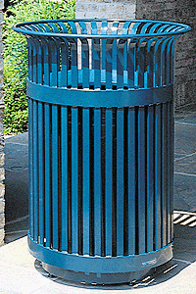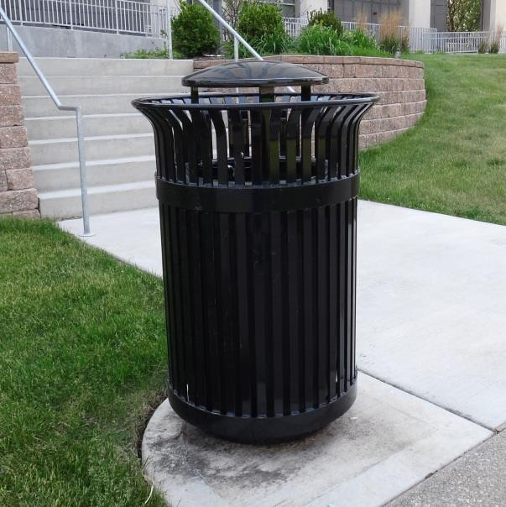

*NIU Design and Construction Standards*

*Division 12 9300 – Site Furnishings*

1. White dome roof with fascia/gutter system
2. Full length aluminum wall mounted bench and backrest

B. Other style selections, sizes or colors must be submitted in writing, to A&E Services

PART 3. EXECUTION

3.01

Installation

A.

Benches, Tables, Trash and Recycle Receptacles and Ash Urns:

1. Installed on concrete slab (available sidewalk or area determined by A&E Services), using corrosion resistant cinch anchors.

B.

Bicycle Loops installed per Manufacturer’s recommendations.

C.

Bicycle Racks installed per Manufacturer’s recommendations.

D.

Bollards installed per Manufacturer’s recommendations.

E.

Post and chain installed as directed by A&E Services

F.

Bus shelters installed per Manufacturer’s recommendations.

**Photographs and Drawings:**

Site Furnishings Div 12 9300

Page 4 of 7

**Figure 2 –** Victor Stanley Model S-42 Waste Receptacle With dome

**Figure 1 –** Victor Stanley Model S-42 Recycle Receptacle Without dome

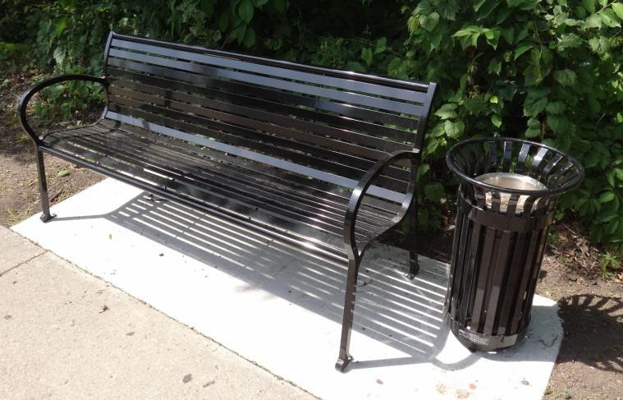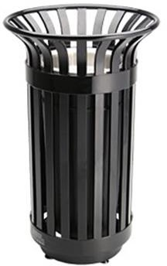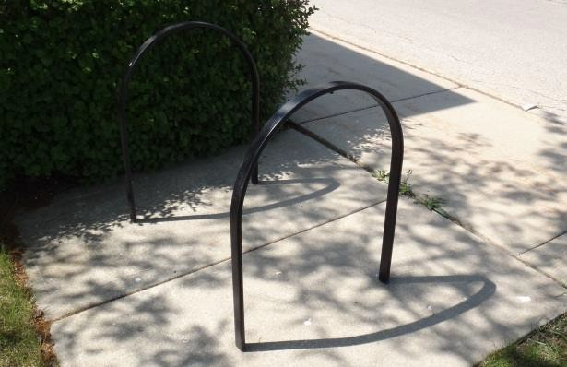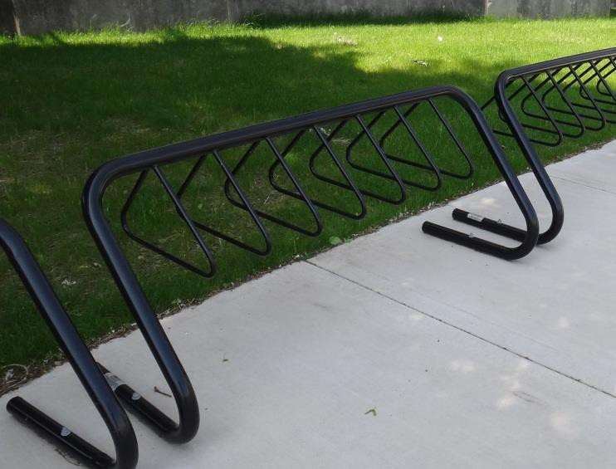

*NIU Design and Construction Standards*

*Division 12 9300 – Site Furnishings*

Site Furnishings Div 12 9300 Page 5 of 7

**Figure 6** – Cora Bike Rack, Cora Expo ‘W’ Series

**Figure 5 –** Wabash Valley, Model BL100N

**Figure 4** – Victor Stanley Model S-20 Ash Urn

**Figure 3** – Landscapeforms Scarbough Model

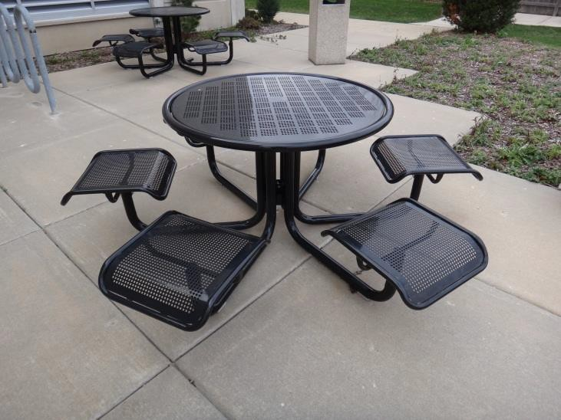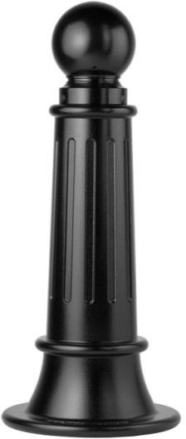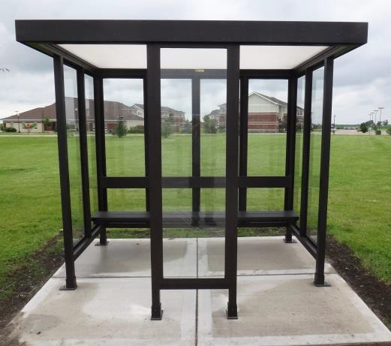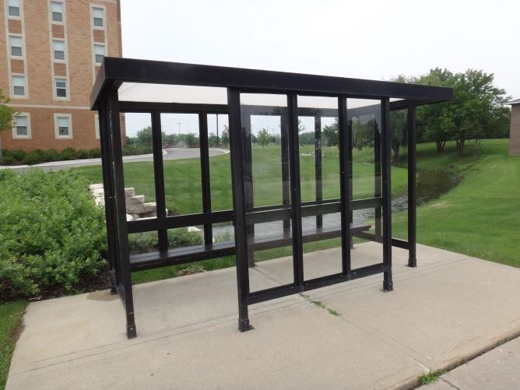

*NIU Design and Construction Standards*

*Division 12 9300 – Site Furnishings*

Site Furnishings Div 12 9300 Page 6 of 7

**Figure 10** –

Brasco Slimline, 12 X 6

**Figure 9** –

Brasco Slimline, 8 X 6

**Figure 8 –** Reliance Foundry Co., Model R-7589

**Figure 7** – Landscapeforms, Carousel Model

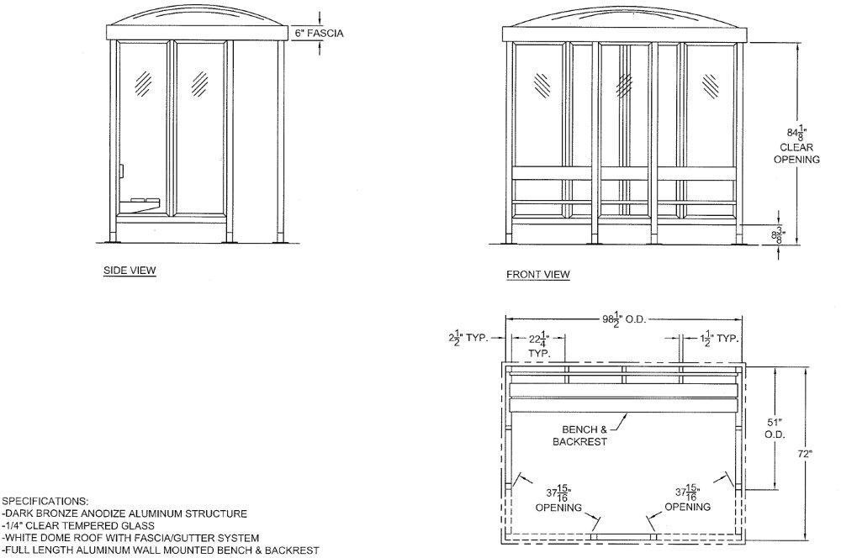

*NIU Design and Construction Standards*

*Division 12 9300 – Site Furnishings*

**Figure 11**

**Example Dimensional Drawing**

End of Division 12 9300

**This section of the NIU Design and Construction Standards establishes minimum**

**requirements only. It should not be used as a complete specification.**

Site Furnishings Div 12 9300 Page 7 of 7