

*NIU Design and Construction Standards*

*Division 10 1000 – Miscellaneous Specialties*

December 2012, Rev. 00

**10 1000 – Miscellaneous Specialties**

PART 1.

1.01

GENERAL

Section Includes

1. Automated external defibrillator and cabinet
2. First Aid cabinet
3. Waste and Recycling receptacles
4. Ground sign
5. Dimensional letter signage

1.02

Coordination

A. Where applicable, furnish templates for placement of electrical or data service embedded in permanent construction by other installers.

1.03

Action Submittals

A. Product Data: Submit for each type of product

B. Shop Drawings: For all work of this section, showing necessary plans, elevations, colors, and finishes. Do not fabricate or install any work before submittals are approved.

1. Include fabrication and installation details and attachments to other work.
2. Show mounting heights, locations of supplementary support to be provided by others, and accessories.
3. Show locations of electrical or data service connections, where applicable.
4. Include diagrams for power, signal, and control wiring.

C. Samples for Verification: Where applicable, submit manufacturer’s full range of colors for selection by Architect.

1.04

Closeout Submittals

A. Maintenance Data: To include in maintenance manuals.

1.05

Quality Assurance

A. Installer Qualifications: Use only personnel who are completely familiar with the manufacturer’s recommended methods of installation and have completed work similar in material, design, and extent to that indicated in this section and whose work has resulted in construction with a record of successful in-service performance.

Miscellaneous Specialties 10 1000 Page 1 of 5



*NIU Design and Construction Standards*

*Division 10 1000 – Miscellaneous Specialties*

1.06

Warranty

A. Special Warranty for dimensional letter signage: Manufacturer agrees to repair or replace components of signs that fail in materials of workmanship within specified warranty period.

1. Failures include, but are not limited to, the following:

1. Deterioration of finishes beyond normal weathering.
2. Separation or delamination of sheet materials and components.

2. Warranty Period: Five years from date of Substantial Completion of project.

1.07

Field Conditions

A. Where applicable, verify location of electrical or data service embedded in permanent construction by other installers, by field measurements before fabrication, and indicate measurements on Shop Drawings.

PART 2.

2.01

PRODUCTS

Automated External Defibrillator (AED) and Cabinet

A. Products:

1.

Provide: Cardiac Science Corporation; Powerheart AED G3 Plus Semi- Automatic Defibrillator

a)

AED Features: Semi-automatic defibrillator with voice prompts, text screen, Battery status indicator, pacemaker pulse detection and pediatric capability, pads, lithium battery, automatic self-tests, and event documentation. Include AED Starter kit and Ready kit.

AED Warranty: 7-year.

b)

2.

Provide: HeartStation RescueCase AED Wall Cabinet #RC5000R or #RC5000W. No substitutions allowed.

a)

Cabinet Features: Alarm that is triggered when the door is opened. Include 12 volt Lithium Battery Pack.

Cabinet Construction: With see-through acrylic window.

Cabinet Mounting: Fully recessed RC5000R (for new construction). Cabinet Mounting: Wall mounted RC5000W (for existing buildings). Cabinet Color: White

Key Code Request: Use HeartStation RescueCase AED Cabinet key #2007.

b)

c)

d)

e)

f)

2.02

First Aid Cabinets

Miscellaneous Specialties 10 1000 Page 2 of 5



*NIU Design and Construction Standards*

*Division 10 1000 – Miscellaneous Specialties*

A. Subject to compliance with requirements and/or specific project contracts.

2.03

Waste and Recycling Receptacles – Within Resident Hall dining facilities and Resident Hall common or public areas:

A. Products:

1. Rubbermaid Silhouette DCR24TSESDL, Recycle Square Container, Blue.

**Figure 1, example**

1. Rubbermaid Silhouette DCR24SPECBK, Landfill Square Container, Black

**Figure 1, example**

2.04

Waste and Recycling Receptacles – Within Resident Hall residential and office areas:

A. Products inside residential clusters:

1. Rubbermaid Untouchable FG26898BLA single stream trash can top, black

**Figure 2, example**

1. Rubbermaid Untouchable FG356988 single stream trash container, black

**Figure 3, example**

1. Rubbermaid Untouchable 1788374 single stream recycle top, blue

**Figure 4, example**

1. Rubbermaid Untouchable FG356973BLU single stream recycle container, blue **Figure 5, example**

B. Products in residential hallways:

1. Rubbermaid Atrium Classic Container FG905800BLA, Funnel Top Imprinted, black **Figure 6, example**
2. Rubbermaid Glutton 1792339 two stream recycling container, blue

**Figure 7, example**

2.05

Ground Signs

A. Subject to NIU Signage Standards

2.06

Dimensional Letter Signage

A. Subject to NIU Signage Standards

PART 3.

3.01

EXECUTION

Examination

A. Examine substrates, areas, and conditions, with Installer present, for compliance with requirements for installation tolerances and other conditions affecting work under this section.

Miscellaneous Specialties 10 1000 Page 3 of 5



*NIU Design and Construction Standards*

*Division 10 1000 – Miscellaneous Specialties*

B. Where applicable verify that electrical or data service is correctly sized and located to accommodate components.

C. Proceed with installation only after unsatisfactory conditions have been corrected.

3.02

Installation

A. General: Install components using mounting methods indicated and according to manufacturer’s written instructions.

3.03

Installation of signs

A. Install interior signs according to manufacturer’s specifications and/or NIU Signage Standards

3.04

Adjusting and Cleaning

A.

Remove and replace damaged or deformed products that do not comply with specified requirements. Replace damaged or deteriorated components that cannot be successfully repaired by finish touchup or similar minor repair procedures.

B.

Remove temporary protective coverings and strippable films where applicable.

C.

On completion of installation, clean exposed surfaces of components according to manufacturer’s written instructions, and touch up minor nicks and abrasions in finish.

Miscellaneous Specialties 10 1000 Page 4 of 5

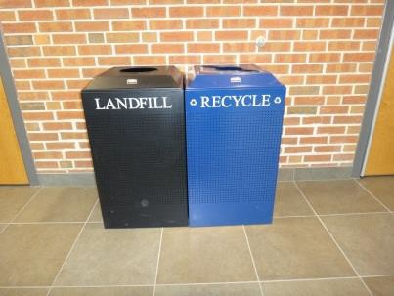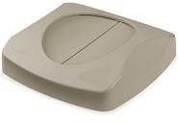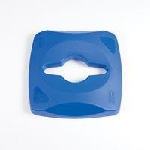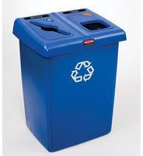

*NIU Design and Construction Standards*

*Division 10 1000 – Miscellaneous Specialties*

**Figure 1, example**

**Figure 2, example**

**Figure 3 and 5, example**

**Figure 4, example**

**Figure 6, example**

**Figure 7, example**

End of Division 10 1000

**This section of the NIU Design and Construction Standards establishes minimum requirements only. It should not be used as a complete specification.**

Miscellaneous Specialties 10 1000 Page 5 of 5