

*NIU Design and Construction Standards*

*Division 01 5600 – Temporary Barricades and Enclosures*

December 2013, rev 00

# 01 5600 – Temporary Barricades and Enclosures

## PART 1. - GENERAL

**1.01**

Barricades shall be comprised of, but not limited to, chain link, plastic snow fencing, silt fencing, natural barriers (i.e. creeks, walls, existing fence).

1.02

Barricades, barriers must be placed around all construction and renovation projects to prevent, as much as practical, intrusion into the work area by personnel not associated with the work being performed.

1.03

Doorways, fire escapes and other potential pathways for unauthorized persons to enter the site should be posted with signs appropriate to the project and indicating the hazard. DO NOT LOCK EXIT DOORS/EMERGENCY EXITS unless approved by the Project Manager.

A. Definitions:

1.

Barricade: A barricade, or barrier, is an obstruction intended to deter the passage of persons or vehicles.

Signs: Signs are the warnings of hazard, temporarily affixed or placed, at locations where hazards exist.

Signals: Signals are moving signs, provided by workers, such as flagmen, or by devices, such as flashing lights, to warn of possible or existing hazards.

2.

3.

## PART 2. - PRODUCTS

2.01

Temporary Fencing

A. The type of temporary fencing used should be based upon the habitual flow of pedestrian traffic prior to the beginning of the project.

B. Acceptable types of temporary fencing:

1. Portable chain link fence

a.

Used where there is a potential of high traffic volume and/or a high potential of intrusion by people not associated with the work being performed and/or where the hazard level is determined to be high.

1. Snow fencing: Orange, plastic safety fence or similar height and quality
2. Silt fencing: Woven fabric fencing generally used to prevent or reduce erosion. (silt fencing used at the perimeter of the project for erosion control may be adequate to fulfill the barricade requirement. Consult Project Manager).

Temporary Barricades and Enclosures Div 01 5600 Page 1 of 3

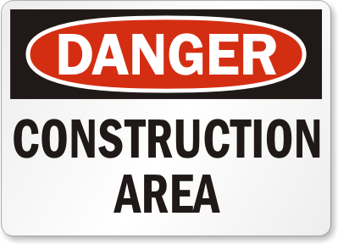

*NIU Design and Construction Standards*

*Division 01 5600 – Temporary Barricades and Enclosures*

2.02

Signs

A. Signs indicating the extent of the hazard/hazards present in the work area may be used in conjunction with the fencing such as:

B. Signs indicating proper direction of travel around the site may also be appropriate.

## PART 3. - EXECUTION

3.01

Site Enclosure Fence:

A. Before construction operations begin, furnish and install site enclosure fence in a manner that will prevent people and animals from easily entering the site except by the entrance gates.

B. Extent of fence:

1. As required to enclose the entire project site or portion determined sufficient by the Project Manager to accommodate construction operations

3.02

Barricades, Warning Signs, and Lights:

A. Comply with requirements of Authorities Having Jurisdiction for erecting structurally adequate barricades, including warning signs and lighting.

3.03

Security Enclosure and Lockup:

A. Install temporary enclosure around partially completed areas of construction. Provide lockable entrances to prevent unauthorized entrance, vandalism, theft, and similar violations of security. Lock entrances at the end of each work day.

3.04

Perform periodic inspections of fencing and repair sections that have fallen or need support.

Temporary Barricades and Enclosures Div 01 5600 Page 2 of 3



*NIU Design and Construction Standards*

*Division 01 5600 – Temporary Barricades and Enclosures*

End of Division 01 5600

**This section of the NIU Design Requirements establishes minimum requirements only.**

**It should not be used as a complete specification.**

Temporary Barricades and Enclosures Div 01 5600 Page 3 of 3