Guidelines for CURE Posters

THe conference on undergraduate research & engagement (cure) is a showcase and celebration of the outstanding research, artistry, and engagement projects that undergraduate students have participated in throughout the academic year. Projects include independent study, capstone projects, SEF, Research Rookies, service-learning related projects and community engagement experiences.

Research-Based poster
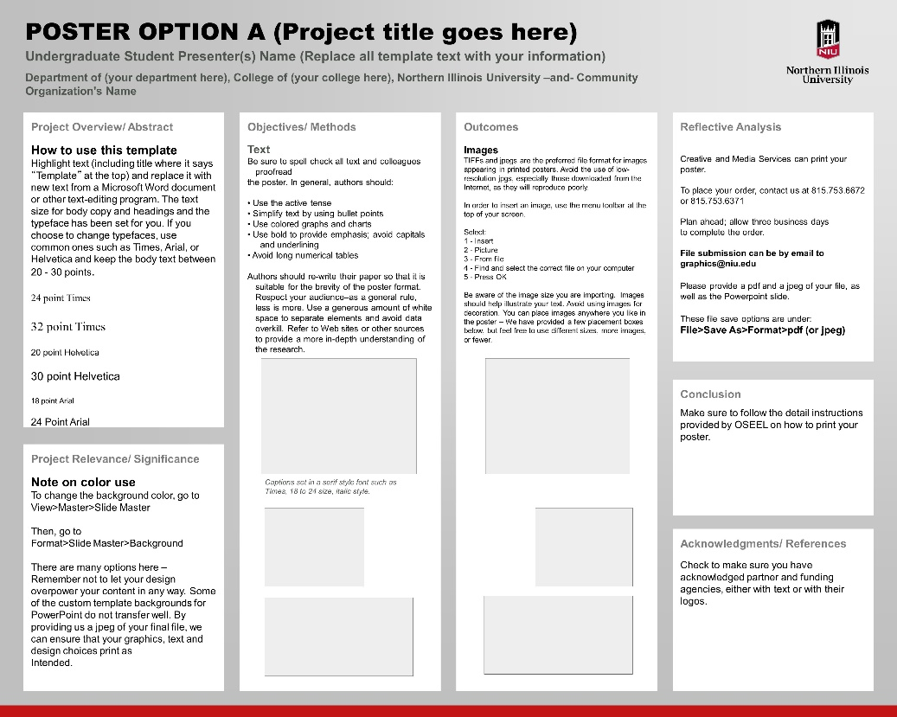
Abstract:

Short summary of your research
- Should match what you submit with registration
- Some disciplines DO NOT put an abstract – check with your mentor

Significance & Rationale:

Provides an overview of what your project entails

How your research addresses a topic

Literature Review (if applicable)
- Puts research into context
- Offers and overview of the field

Methods

Overview of how you conducted your project

Can be understood by an expert as well as someone with no prior experience

May include images/diagrams

Analysis/Results:

Highlights what your research shows

May include graphs, charts, images

Discussion/Conclusion:

Wraps up your findings

Provides ideas for future steps

Final thought you are leaving the viewer with

References & Acknowledgements:

Reference any citations on the poster using your field specific format

Acknowledge your mentor, any program sponsors, and funding sources

Poster “Do’s”
- 32”x40” (URAD required size)
- Include the NIU institutional logo
- Use a plain, solid‐color background
- Have 30‐40% empty space
- Use high quality charts, images, and graphs
Poster “Don’ts”
- Use fancy background options
- Forget to add charts, images, and graphs
- Be text heavy and use multiple fonts
- Use overly technical language
- Forget to acknowledge those that helped you

COmmunity Engagement/SErvice-Learning Based poster

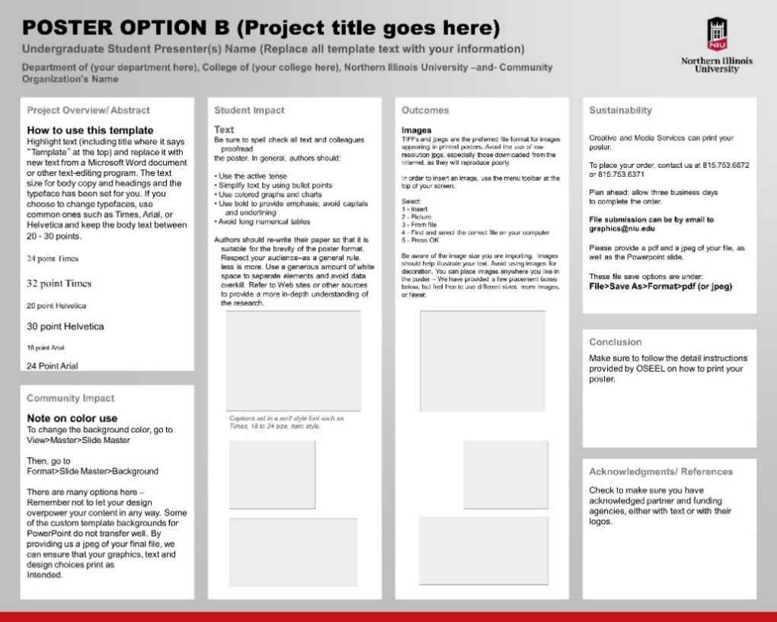
Project Overview (Abstract):
- Short summary of your project or work (no more than one column)
- Include catching facts or information to capture audience
Community Impact:
- What community need(s) have been addressed with your program
- How have the results of your program impacted your partner community?
Student Impact:
- How does the service-learning experience connect to your academic or professional goals
- What did you learn about yourself, the community and the social need you were addressing?
Outcomes/ Results:
- What deliverables or outcomes were made by this community engaged project?
Sustainability:
- How will the program be carried on beyond your time in the community
- How will the community partner continue the service project
Conclusion:
- Explanation of the ways the results satisfy the research objective
- How your findings impact scholars in your field and members of the broader intellectual community.

Acknowledgements:
- Reference any citations on the poster using your field specific format
- Acknowledge your mentor, community partner organization (s), any program sponsors/ office, and funding sources

Poster “Do’s”
- 32”x40” (URAD required size)
- Include the NIU institutional logo
- Use a plain, solid‐color background
- Have 30‐40% empty space
- Use high quality charts, images, and graphs

Poster “Don’ts”
- Use fancy background options
- Forget to add charts, images, and graphs
- Be text heavy and use different fonts
- Use overly technical language
- Forget to acknowledge those that helped you

