Adding Address Books for the Ricoh Printers
Step | Action
 | Login to the printer by using your OneCard.
On the main screen, select the Device functions option.
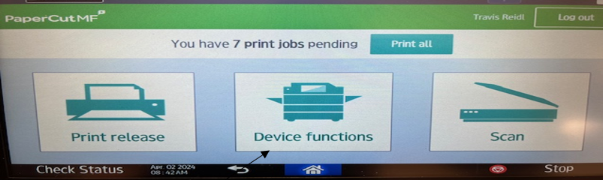
Select the right arrow icon.
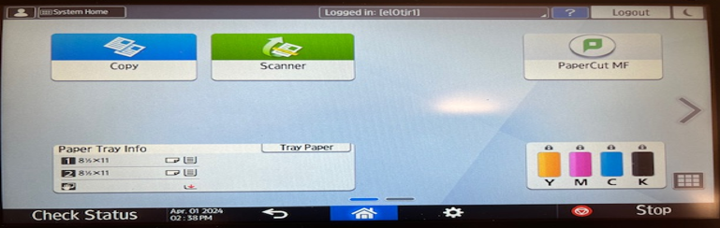
Select the Settings option.

Select the Address Book option.
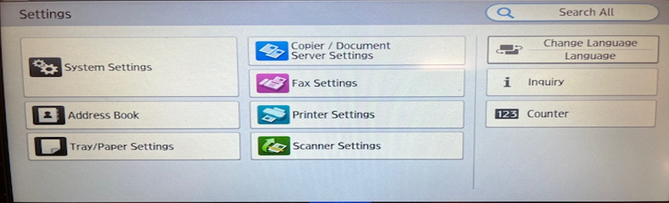
Select the Register option.
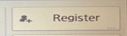
Within the ‘Name’ tab, enter the contacts name (Do Not click OK when done.)
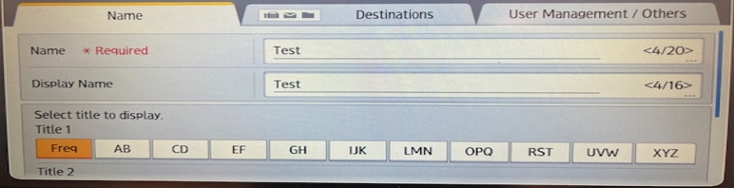
Select the Destinations tab.

Select the Email Address option.
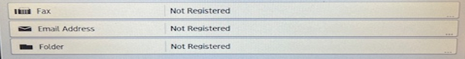
 | Enter the Email addresses.
 | Select the OK button on the email address screen.
 | Select OK on the Destination page.
 | Select the Home Icon.
Select the Left arrow on the Settings screen.

Select Scanner to view the Address book.

You have completed the Adding Address books for Ricoh Printers topic.
End of Procedure.

