Field Tactics and Safety Strategies

Overview:
This guidebook is intended for your reference. It does not take the place of formal training and experience in providing first aid, CPR, or field safety leadership. This information is accurate to our best knowledge and efforts, but no guidebook can replace common sense, good judgment, training, and experience. We welcome your assistance in improving this guide.

Urgent Care basics:
Check:
- Scene (are there additional hazards?)
- One person takes charge
- Identify tasks to be performed
- Approach patient safely
- Do Emergency Moves only if needed
  - Patient (approach safely)
- Urgent First Aid (breathing, pulse, bleeding)
- Initial assessment (ABC)
- Protect the patient
- Prioritize care
- Check for all injuries (head to toe)
  - Resources (people, material)
- People, Communications
- Access, Supplies, Transportation
Call:
- Plan what to do
- Get help
- Call with essential information
- Send team to meet responders
Care:
- Do no further harm, Remain calm
- Provide care
- Transport patient as needed
- Monitor vital signs < every 15 minutes

Table of Contents:
Roadside Stop Overview ……………………....…….. 2
Emergency Response Actions……………….…….... 3
The Ten Essentials for Outdoor Survival....…..……. 4
The Other Ten Essentials for Outdoor Survival......... 5
Defensive Driving Principles..............………..…….... 6
Field Activities Operated by Others………….…….... 7
Wildfire Suppression............................…………....... 8
Heat Exposure & Wind Chill Indices ………...…....... 9
Lightning Safety ……………………………………… 11

Roadside Stop Overview:
- Park on same side of road as stop, if practical.
- Park before (‘upstream’ of) stop:
  - Provides visual warning & physical barrier
  - Participants will be facing traffic when returning to vehicles and they are likely to be less alert
- Last vehicle in line sets out traffic warning devices.
- All participants must wear safety vest.
- Stay off roadway/pavement if safe & practical:
  - Assemble & stay on off-road side of vehicles.
  - Walk on off-road side of guardrail or barrier.
- Designate a lookout (Safety Watch) to stay at ‘upstream’ end of group:
  - Alerts group to significant approaching traffic.
  - Reminds all to stay off roadway!

Emergency Response Actions:

Activate in case of:
- Person injured or ill
- Separation from group
- External threat

Whistle signals:
—— 1 long blast = ATTENTION
- - - 3 short blasts: EMERGENCY-- activate plan:

If injured is part of your group:
- Remain with injured/ill person
- Prevent further harm-DO NOT MOVE injured
- Identify urgent issues: breathing, pulse, severe bleeding

If injured is not part of your group:
- Congregate around Assistant instructor
- Await instructions

Emergency Response Plan responsibilities:

  - ______________ provides first aid

  - ______________ coordinates uninvolved groups

  - ______________ coordinates response, notification, evacuation, group activities

Buddy/Group Responsibilities:
    - Watch out for each other
    - Early Detection of a problem
    - Early Notification of a problem
    - Initial Response to injury/illness

The Ten Essentials for Outdoor Survival

Packing these whenever you step into the field, even on day hikes, is a good habit. On a routine trip you may use only a few of them or none at all. It’s when something goes awry that you’ll truly appreciate the value of carrying these items that could be essential to your survival. Modify the exact items you take for the trip you are going on.

- Navigation: map, compass, altimeter, GPS device, personal locator beacon (PLB) or satellite messenger
- Headlamp: plus extra batteries
- Sun protection: sunglasses, sun-protective clothes and sunscreen
- First aid: including foot care and insect repellent (as needed)
- Knife: plus a gear repair kit
- Fire: matches, lighter, tinder and/or stove
- Shelter: carried at all times (can be a light emergency bivy)
- Extra food: beyond the minimum expectation
- Extra water: beyond the minimum expectation
- Extra clothes: beyond the minimum expectation

The Other Ten Essentials for Outdoor Survival

Just as important are key attitudes and behaviors to go along with gear. These address all the main causes of death, injury, and illness identified by decades of global experience and accident statistics*. Making these essential behaviors part of your outdoor kit will go a long way towards getting you home healthy and in one piece.

- Buckle up: The most dangerous portion of any expedition is on the road. Tens of thousands die every year in vehicle accidents.
- Slow down: While on the road, on the trail, in the heat, give yourself additional time to recognize and respond to hazards.
- Stay Hydrated: Be confident of your water source.
- Watch your step: Loose rocks, steep trails, etc…
- Watch your back: For traffic, fauna & flora, companions, other threats.
- Wash/Watch your hands: Avoid illness, food-related issues, as well as where you put them.
- Keep an eye to the sky: Lightning, flash floods, wind, heat/cold.
- Wear the right stuff: Protective gear (PPE), footwear, insect repellent, hat, sunscreen.
- Take care of your feet: And they’ll take care of you.
- Don’t get killed: It could ruin your whole day.

* Royal Geographical Society, American Alpine Club, U.S. National Weather Service, ExxonMobil Field Safety program, U.S. National Safety Council.

Defensive Driving Principles

Ensure Your Vehicle in Safe Working Condition: Vehicle is able to both stop and go. Pay special attention to tire pressure and brake conditions.
Practice Defensive Driving: Keep calm, don’t insist on your right of way, leave yourself an escape route at all times.
Watch Out for the Other Guy: Assume the worst for the other drivers on the road. Avoid tunnel vision, maintain 360 degree awareness.
Don't Follow Too Closely: Give yourself time to react: 3 seconds separation in good weather, 6 seconds at night or in bad weather.
Be Extra Careful in Bad Weather: Heavy rain, snow, fog, ice all contribute to accidents. Drive slower, maintain extra distance, be especially careful on curves. Find a safe place to wait for clear weather.
Buckle Up: More than half of all accident fatalities are people who weren't using seat belts [source: NHTSA]. Wear your seat belt at all times.
Don't Drive Drowsy: Sleepiness is a contributing factor in 20% of accidents. Get a full night’s sleep, have someone else drive, take a break/short nap.
Avoid Distractions: Talking, texting, eating, applying makeup, fiddling with electronics or interacting with passengers are all hazardous.
Don't Speed: Speeding is one of the most common factors contributing to traffic crashes. For every mile per hour you drive, the likelihood of your being in an accident increases by four to five percent. Slow down or leave earlier.
Don't Drive Drunk: More than 30 percent of all auto accident fatalities in the United States involve drivers impaired by alcohol. Use a designated driver.

Field Activity Operated by Others:
When participating in a field activity run by another organization, the following are key questions to ask to determine the level of preparation and response capability. If there is any question about the adequacy of preparations, it is advisable to provide your own resources to supplement those available from the trip sponsors.
- Communications equipment that works at all stops? (Sat Phone/Cell Phone/Radio)
- Emergency response plan with medical/rescue contact numbers for each area?
- First Aid Equipment and Training?
- PPE supplied? (reflective vests, head protection, life jacket, etc.)
- Driver’s training required for everyone who will drive on field activity?
- If boats used:
  - Boats registered and certified as appropriate?
  - Operators licensed?
  - Required PPE and safety equipment supplied?
- Is aviation (helicopter, charter plane) involved? If so, do equipment and operators comply with your organization’s Aviation guidelines?

- Any special risk considerations? (dogs, bears, snakes, or other wild animals; in-water activity such as snorkeling\diving; camping; river rafting, etc.)

Wildfire Suppression
In the event of a very small ground cover fire:
-Immediately alert everyone in group
-Directly attack the edge of the fire using water, if safe to do so
-Shovels and picks can be used to smother and beat out the fire or remove fuel from the path of the fire.
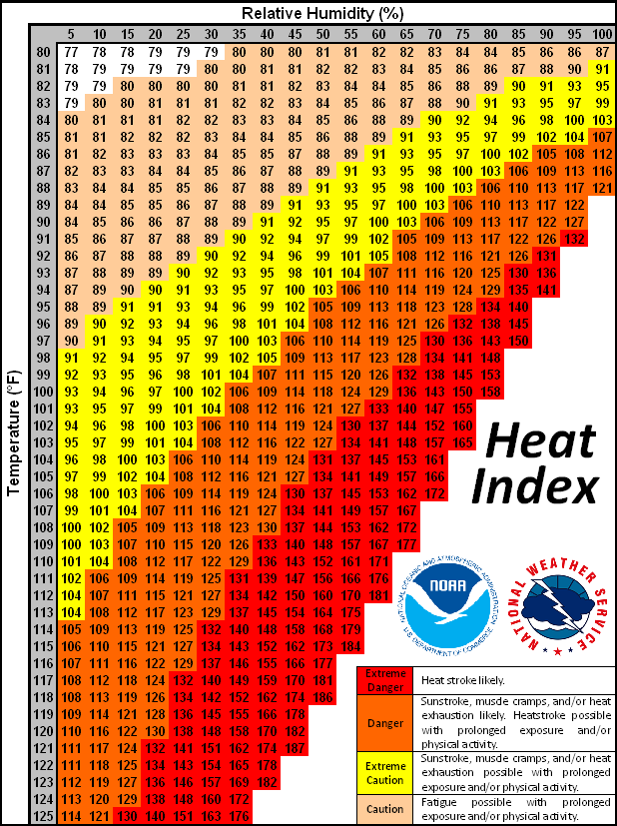
Heat Exposure Index
The Heat Index is a measure of how hot it really feels when relative humidity is factored in with the actual air temperature.
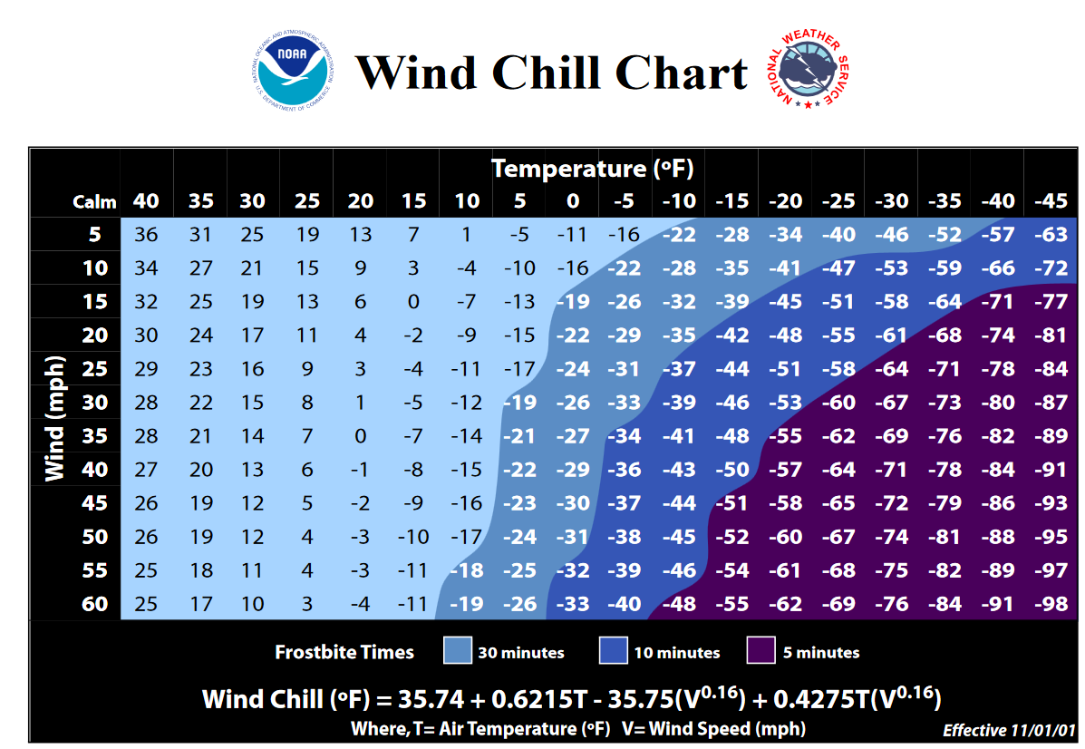

The NWS Wind Chill Temperature (WCT) index uses advances in science, technology, and computer modeling to provide an accurate, understandable, and useful formula for calculating the dangers from winter winds and freezing temperatures. The index does the following:
- Calculates wind speed at an average height of 5 feet, the typical height of an adult human face, based on readings from the national standard height of 33 feet, which is the typical height of an anemometer
- Is based on a human face model
- Incorporates heat transfer theory based on heat loss from the body to its surroundings, during cold and breezy/windy days
- Lowers the calm wind threshold to 3 mph
- Uses a consistent standard for skin tissue resistance
- Assumes no impact from the sun, i.e., clear night sky.

Lightning Safety
The 30-30 Rule, Where visibility is good and there is nothing obstructing your view of the thunderstorm:
30 Seconds: When you see lightning, count the time until you hear thunder. If that time is 30 seconds or less, the thunderstorm is within 6 miles of you and is dangerous. Seek shelter immediately.
30 Minutes: Wait at least 30 minutes after the last clap of thunder before leaving shelter. Don't be fooled by sunshine or blue sky. At least 10% of lightning occurs without visible clouds in the sky.
Safety Rules
1. Keep an eye on the sky. (darkening skies, increasing wind)
2. When you hear thunder. Determine if it is approaching and seek shelter immediately. Do not wait for rain.
3. Go quickly inside a completely enclosed building or a hard topped vehicle.
4. Be the lowest point. Lightning hits the tallest object. Make sure you are below the treeline and find shelter.
5. If you can't get to a shelter, stay away from trees, and crouch down in lowest point possible.
6. Move away from a group of people. Stay several meters away from other people.
7. If your hair stands on end, crouch down immediately.
8. Avoid metal. Drop metal equipment, metal-framed backpack, stay away from fences, power poles, etc.
9. Get out of the water. Stay off the beach and out of small boats. If caught in a boat, crouch down in the center of the boat, away from metal hardware.

