Procedure Owner: | Controller’s Office
Point of Contact: | Jason Askin
Last Updated: | 12/8/21

When requesting a Service Center in accordance with the Service Center Policy, the Service Center administrator should request a cost center to capture the income and expenses for services provided using the Cost Center Information Form (see NIU Financial Management System Forms to obtain the form and detailed instructions). The Budget Office will assign a unique cost center to the Service Center.

Accounting Structure:
Services can be provided to internal customers (NIU departments) or external customers (e.g. other Universities, corporations, etc.). The entries for Service Center expenses incurred and income earned for services should be posted to the Service Center account as follows:

Cost Center for Service Center (account range aa-58xxx-02x):
64xxxx – Personnel | 400100 – Income from internal customers
66xxxx – Fringe Benefits | 400200 – Income from external customers
68xxxx – Services
800xxx – Supplies
890300 – Depreciation₁

Cost Center for Unit or Grant Receiving the Service:
670100 – Recharge Internal Services

Billing Procedure for Internal Customers:
As services are provided, the Service Center administrator should process entries not less frequently than monthly using an Interdepartmental Sales Journal (ISJ). (See NIU Financial Management System Forms to obtain the form and detailed instructions).

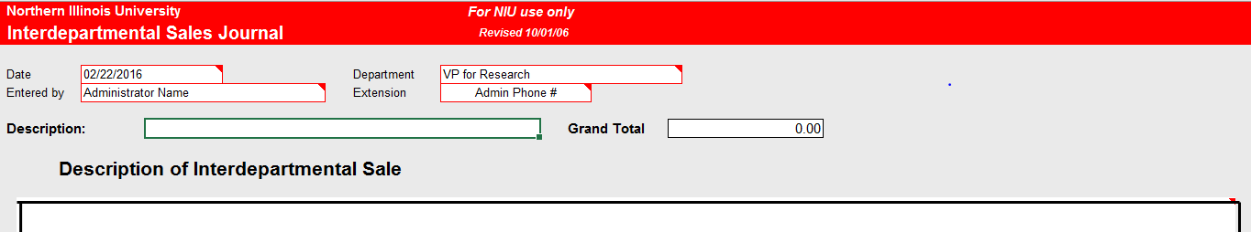
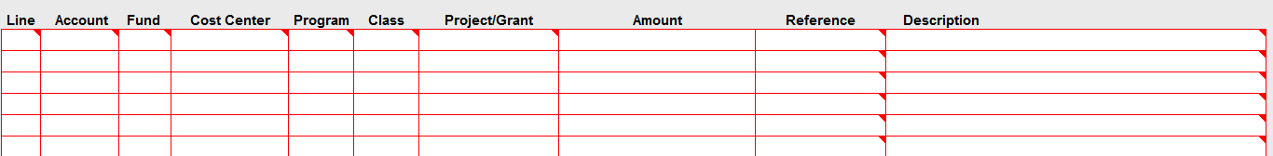

When processing an ISJ, enter the Funding Distribution from the department receiving the service and the associated amount as a debit (positive amount). The last line is entered as a credit (negative amount) to represent the total amount billed and is the Funding Distribution for the Service Center. The journal should net to zero. This form allows for 10 lines of transactions.

E-mail the completed form to the Outlook email address for the Controller’s Office,
JournalEntries@niu.edu, and copy the billed departments on the e-mail.

The Service Center administrator should maintain the documentation (e.g. internal invoice) to support each of the charges on the journal in accordance with NIU’s Records Management Policy.

Billing Procedure for External Customers:
If services will be provided to customers outside of NIU, an Interdepartmental Sales Journal should not be used to process the income received. The Service Center administrator should follow Accounts Receivable Procedure No. 6-1 in the Business Procedure Manual. The detailed process for billing outside entities can be provided by the Commercial Accounts Receivables Office within the Office of the Bursar.

Reporting to Sponsoring Department and Accounting for Subsidies Provided:
If the Service Center is receiving a subsidy from a sponsoring University department, the Service Center administrator should provide a copy of the cost center ledger report to the sponsoring department on a quarterly basis. The sponsoring department is identified at the time the Service Center is established.

If a subsidy entry is needed, the Service Center administrator should process the following entry to account for any subsidy provided at least at fiscal year-end close or more frequently as required by the sponsoring department:

Debit: Sponsoring department cost center – aa-xxxxx-xxxxxxx

Credit: Service Center cost center – aa-58xxx-xxxxxxx

The Controller’s Office will provide the specific account codes for the transfer.

Central Annual Review:
On a periodic basis, no less frequent than annually, the Controller’s Office will review the Service Center accounts for compliance with this procedure and the Service Center Policy. Service Center administrators should be prepared to provide any supporting documentation requested by the Controller’s Office for this review and for any audit requirements. Service Center administrators should also be prepared to adjust Service Center rates as identified during the Controller’s Office review.

¹Recording Depreciation Expenses:
If a large capital purchase is required for the Service Center, the full amount of the purchase price can be spread across the useful life of the asset and included in the annual Service Center’s rate review and calculation. The Service Center administrator should charge the Service Center cost center for the full price of the asset provided that the asset will be utilized solely by the Service Center.

The Controller’s Office will process an annual entry to account for the annual depreciation expense by crediting the Service Center cost center for the full price of the asset and debiting the Service Center cost center for the annual depreciation expense. The Service Center administrator should contact the Controller’s Office to determine the appropriate property procedure for tracking the asset.

