NIU Commencement Mobile Ticket Guide
(this is how graduates can access and share tickets):
Use your MOBILE DEVICE to access your tickets.
- This includes a cell phone or tablet. Please do not try to access your tickets on a desktop computer as the user interface will not look the same.
- Note, if you do not own a smartphone or tablet, please contact HuskiesTickets@niu.edu to request an accommodation.
Navigate to NIUHuskies.eVenue.net and click on Student Tickets
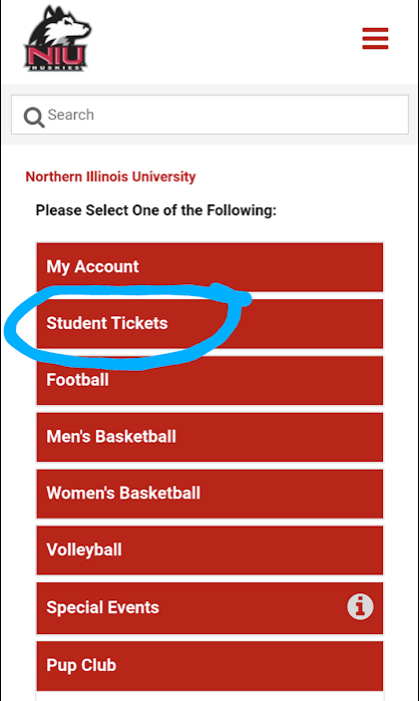

If you have NEVER logged in to your Student MyHuskies Account (remember this is not your NIU system login and is a different system), click on “Register Your Student Account”. You will enter your ZID WITHOUT the letter Z. (Example: your ZID is Z123456. Please enter 123456 in the field after you click on Register Your Student Account).
- After you activate your account, you will log in using the email and password you supply during activation.
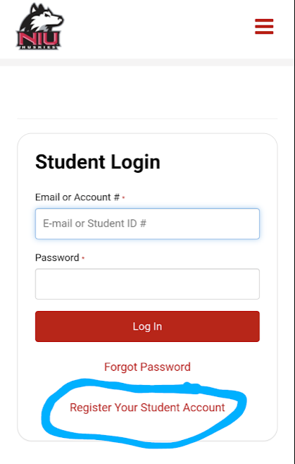

If you have logged in prior, go right to the login and please fill out the login fields with your email and password. This is usually your ZID Student email, but you may have changed it to a personal email when you originally activated it. If you are having trouble accessing your student account after you have activated it, first try Forgot Password. If you continue to be unable to access your account, or you have trouble accessing it, contact the Huskie Ticket Office via email at HuskiesTickets@niu.edu. Please contact us as soon as you realize there is a problem so we can fix the issue as soon as possible.
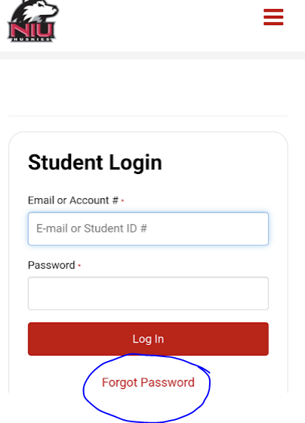

Once you have logged in to your account, click on the hamburger (the three lines in the top right of the screen) menu in the upper right-hand corner and choose My Account.
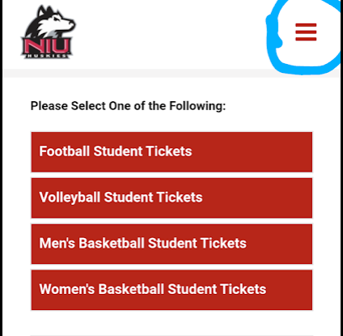
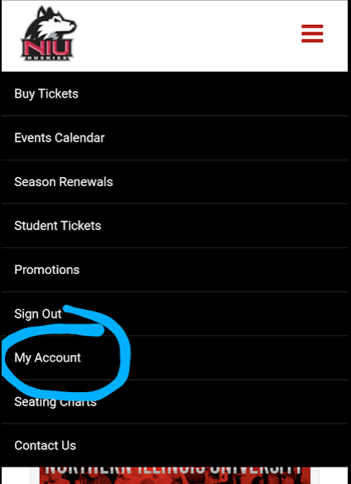
You should see your name and email at the top of the page. To transfer your tickets to your guests click on Transfer Tickets from the menu below your name and email.
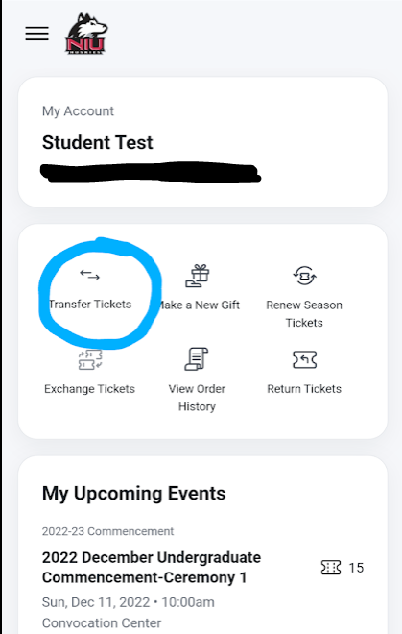

Please DO NOT click on My Upcoming Events and download the tickets to your Google/Apple wallet at this time unless YOU will be scanning the ticket on commencement day. You must transfer the tickets to your guests through your account first, and they will download the tickets to THEIR wallet later.
After you have clicked on Transfer Tickets you will see your graduation event. Click on the event.
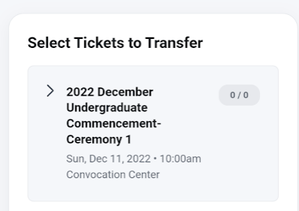
You will now choose which tickets to transfer to each guest. All tickets are general admission within the Convocation Center arena. If multiple guests are arriving together you may send multiple tickets to the same email address and they can scan them all off of one device when they arrive. An example of this is if your mother, father, and younger sibling are all coming together. You can send all three tickets to your mother, for example, and event staff will scan all three tickets off of her phone when they arrive.
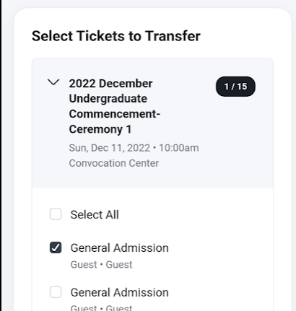
Please note that once a ticket is transferred and has been accepted by the receiving party, you will no longer be able to access that ticket from your account and the recipient must now access the ticket through their account.
Enter the name and email of the recipient you want to send the ticket to and click Review Transfer
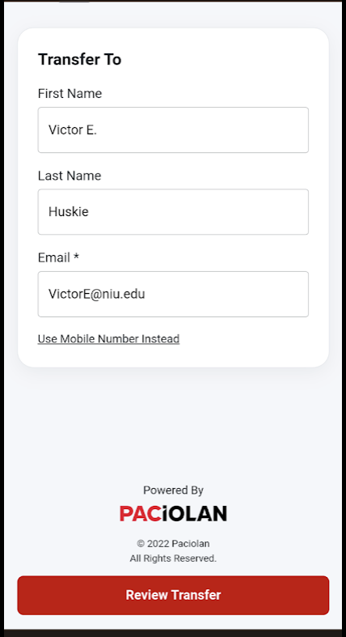
You will see the name, email, and number of tickets on the review screen and if that is correct. Click Transfer Tickets at the bottom of the screen.

How your guests will access their tickets:
Your guests MUST BE USING A MOBILE DEVICE to access their tickets. Your guests will receive an email from no_reply@paciolan.com entitled “YOUR NAME wants to send you # ticket” with YOUR NAME replaced with your name and # replaced with the number of tickets you’re sending. When they open the email they will click Accept Transfer.
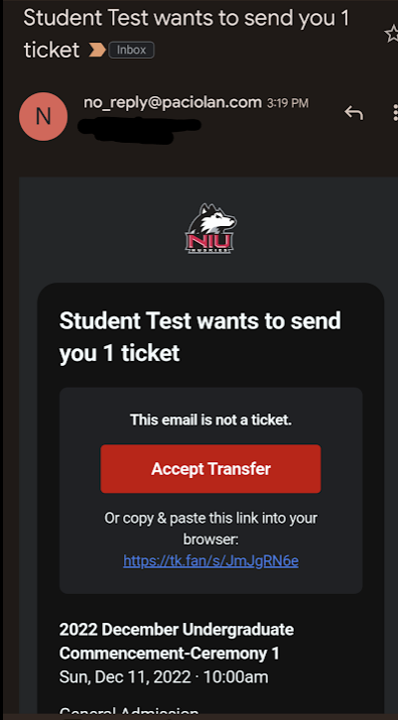
They will then be prompted to sign in. If they do not have an account they will need to create one. If they already have an account they can click “Forgot Password” and get a temporary password via email to access their account.
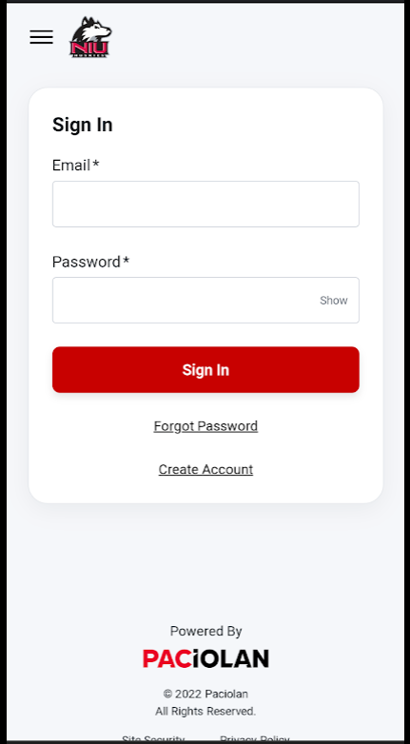
Once they have created their account or logged in, they will be prompted to download the tickets to their mobile wallet (Google Wallet or Apple Wallet). Click this link to download the tickets and access the barcodes.
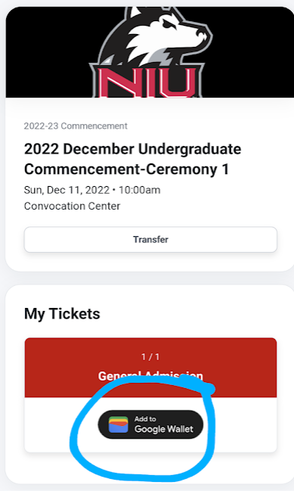
They will then be redirected to their mobile wallet app (they may need to sign in or create an account) and will click “Add” to add the ticket to their mobile wallet. They can now access the ticket/s DIRECTLY from their device. They do not need to log in to their account and will have seamless access of their tickets the day of the event. They simply open the wallet app on their phone and the ticket barcodes will be there to click on. The Apple Wallet and Google Wallet app icons are below. If they do not have an Apple Wallet or Google Wallet app. Both are available on the App Store or Google Play. Downloading tickets in advance is VERY IMPORTANT as wireless internet at the Convocation Center can get overwhelmed if many people are attempting to log on to their online account once they arrive.
