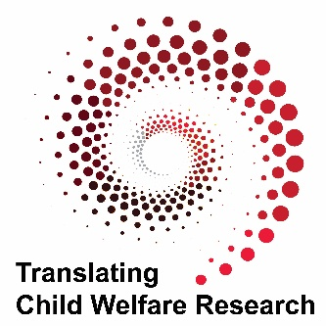

# Translating Child Welfare Research Podcast Introduction

## Dr. Robin LaSota

Welcome to the Translating Child Welfare Research podcast. I'm Robin LaSota, and I'm here with Heather Fox. We’re co-producing this podcast as part of the Office of Translational Research in the Psychology Department at Northern Illinois University. One of our primary functions is to support research translation for the Illinois Department of Children and Family Services. Our goal today is to provide you with a brief overview of this podcast.

In your work as social workers, you focus on providing the best possible services for the children and families you serve. As applied researchers, we are driven by a shared goal of helping children and families heal, grow, and thrive. Our role is to build and promote research-practice partnerships to support co-creation of knowledge and its application. In this podcast, researchers share findings from their work as a way to create dialogue with you in the field of child welfare.

Our hope is that the dialogue we bring with researchers will spark inspiration for you in talking with your colleagues about practical challenges you face in promoting the well-being of children, youth, and families. In our busy professional lives, it’s difficult to create time to delve into finding and reading new research to answer our pressing questions. Through our interviews with researchers, we provide you with a way to quickly learn about findings from new or ongoing studies, and discover practical applications for your everyday work.

## Dr. Heather Fox

Our podcast features child welfare researchers who share their thoughts on translating their work into policies and practices that are family-centered and equitable, and support our shared goal of improving the well-being of the children, youth, and families we serve. The interviews are brief, but we will provide additional materials on our website for those interested. Each episode is independent, choose the topics that interest you or listen to each episode in turn. We are interested in your feedback and ideas of topic areas to cover. If you have suggestions or would like to be a guest, contact us at [dcfspodcasts@niu.edu](mailto:dcfspodcasts@niu.edu).

Northern Illinois University’s Department of Psychology is providing the content of this podcast series with funding and support from the Illinois Department of Children and Family Services. The views, thoughts, and opinions expressed in this podcast are the speakers’ own and do not represent the views, thoughts, and opinions of Northern Illinois University, the University’s Board of Trustees, the State of Illinois or the Illinois Department of Children and Family Services. The material and information presented here is for general information purposes only; is presented “as is” and not as a guarantee that the information is complete or accurate; does not imply endorsement of or opposition to any specific organization, product, or service; and is not to be construed as a substitute for personal, individualized advice or guidance.  The information contained in this podcast series may not be used or reproduced without the express, written authority of Northern Illinois University and/or the Illinois Department of Children and Family Services and does not grant anyone permission to use the name, logos, or other intellectual property of Northern Illinois University, the Illinois Department of Children and Family Services or the State of Illinois.  All rights reserved.