CSEAS Weekly Bulletin
Center for Southeast Asian Studies at Northern Illinois University • Week of May 9, 2022

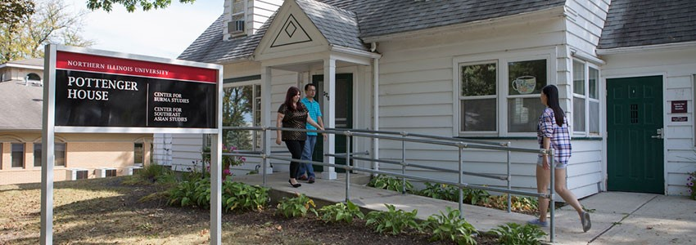

This is the last weekly bulletin of 2021-22. Best of luck to all on final exams, graduation, future endeavors, and research near and far. Interested in taking a summer SEAS course? There is still time to sign up for CSEAS associate Trude Jacobsen Gidaszewski’s HIST 387/591, The History of Genocide. Details below.

We shall not pass this way again

CSEAS Quick Links
√ CSEAS website
√ Southeast Asia Crossroads podcast
√ Mandala 2020-21
√ CSEAS Facebook page
√ CSEAS Twitter feed

- Cheers for summer and 2022-23 FLAS awardees NEW
- Student news: Graduation kudos and a Fulbright to Indonesia NEW
- What’s on for summer, fall 2022 courses
- Short-term homestay hosts needed for SEAYLP, PYLP programs NEW
- Notes from all over: Alumni updates and story time with FLTAs
- Save the dates: What’s on display NEW
- Latest on Crossroads: Check out three new podcasts
- Abstract deadline July 1 for COTS conference
- Conferences, workshops, webinars
- Money for study
- Careers

Cheers for summer and 2022-23 FLAS awardees
CSEAS has awarded 10 summer Foreign Language and Area Studies (FLAS) scholarships to graduate students Peter Alexander (Burmese), Sue Dar (Tagalog), Jerry Hansen (Khmer), Jade King (Tagalog), Eden Maxey (Burmese) and Mitchell Rigert (Thai), and to undergraduate students Austin Cowan (Thai), Gavin Fox (Indonesian), Say Paw (Thai) and Anne Rutherford (Thai).
In addition, CSEAS has awarded 15 AY2022–23 FLAS fellowships to graduate students Peter Alexander (Burmese), Thomas Brown (Khmer), Sue Dar (Thai), Jerry Hansen (Khmer), Haiying Li (Thai), Eden Maxey (Burmese), Thomas Mejdrech (Indonesian), Sydney Naro (Thai). Undergraduate FLAS recipients are Mitchell Rigert, and Gavin Fox (Indonesian), Nuam Kim (Burmese), Jade King (Tagalog), Kelsey Kinne (Indonesian), Connor Knutson (Khmer) and Say Paw (Thai).

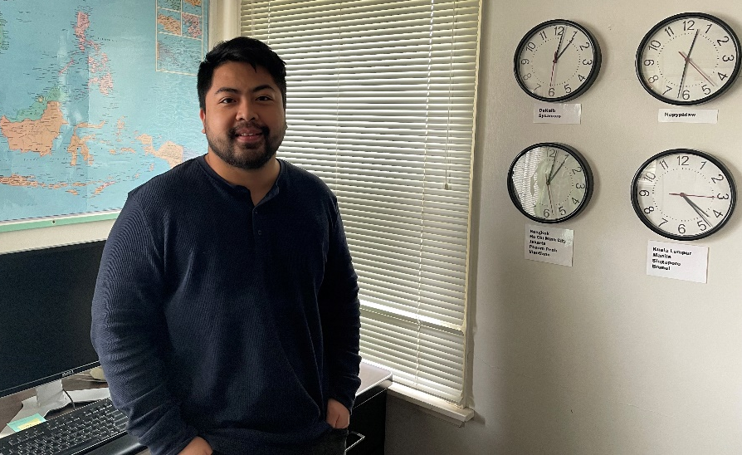
Political Science doctoral student Rithiya Serey will be the graduate assistant for the Center’s Southeast Asia survey course, SEAS 225, for the 2022-23 academic year.

Student news: Graduation kudos and a Fulbright to Indonesia
Two graduate students and eight undergraduate students in the CSEAS community are set to receive their degrees in May. Receiving a Graduate Certificate in Southeast Asian Studies in addition to their advanced degrees are Christopher Bechtel (AuD., audiology) and Glynnis White (M.M. music education). Undergraduate students receiving bachelor’s degrees with an SEA Studies minor are Sue Dar (management), Christopher Frey (political science), Courtney Huhta (journalism), Elayna Lachs (political science), Tommy Mejdrech (political science), Biak Thang (history), Holly Young (anthropology-Honors) and Bennett Zima (environmental studies). Congratulations to all. ● ● ● Congratulations to History doctoral student Dan McCoy, who has won a Fulbright award to conduct a year of fieldwork in Indonesia from September 2022-23. McCoy’s research focuses on Indonesia’s role within the Association of Southeast Asian Nations (ASEAN) during the Third Indochina War (1978-1991). While in Indonesia, McCoy will study the actions of political, military, state and non-state actors in shaping Indonesia’s national policy toward the conflict’s principal belligerents, particularly Vietnam. These include the Ministry of Foreign Affairs, the Ministry of Defense, and the Centre for Strategic and International Studies. “Ultimately, my dissertation and fieldwork to come in Indonesia intend to revise prior viewpoints arguing Indonesia did the most diplomatic legwork of any ASEAN nation to bring Vietnam to the peace table,” McCoy said. McCoy’s Fulbright sponsor in Indonesia is NIU alumnus Philips Vermonte (Ph.D. political science, 2011), head of the political and international relations department for CSIS. ● ● ● Limeng Ong (Ph.D. candidate, political science) has been awarded the 2022-23 Clark and Arlene Neher Graduate Fellowship for the Study of Southeast Asia. Ong is the 21st advanced-level graduate student to receive the endowed Neher fellowship. NIU political scientist emeritus and CSEAS Director Clark Neher and CSEAS associate emerita Arlene Neher established the award, a $5,000 fellowship plus tuition waiver, in 2002. ● ● ● Burmese language graduate assistant Maw Maw Tun won the Outstanding English Department Thesis Award given by the Graduate School at its April 26 awards program. Tun is a doctoral candidate in Educational Technology and Research Assessment. ● ● ● Undergraduate Honors student Holly Young (B.A. anthropology, SEA minor) received the Outstanding Humanities Capstone Award, and CSEAS associate Kanjana Thepboriruk received an Outstanding Capstone Mentor award for her work with Young, at the NIU Honors Program April 24 awards ceremonies. Earlier in the month, Young presented her Senior Thesis research April 8 at the 2022 Society of Linguistic Anthropology annual meeting in Boulder, CO. “She was the only undergraduate student on the panel and really held her own amongst Ph.D. students and doctoral candidates,” Thepboriruk said.

What’s on for summer, fall SEAS courses
Registration is open to sign up for summer and fall SEA classes. This summer CSEAS associate Trude Jacobsen Gidasewski (History) will be offering HIST 387/591, The History of Genocide, for undergraduate and graduate students. This eight-week online course explores genocide, mass violations of human rights, and crimes against humanity, and include discussions of the controversial application of the term “genocide,” as well as paths to justice and reconciliation. Students taking this for Southeast Asian Studies credit should consult with Professor Gidasewski (tjacobsen1@niu.edu) beforehand. Class starts June 13.
In the fall, CSEAS announces that Lao language classes will be offered at both beginning and intermediate levels. Taught as synchronous online classes by Samlon Inthaly, beginning Lao will be offered from 5 to 7:15 p.m. Monday, Wednesday and intermediate Lao will be offered from 5 to 7:15 p.m. Tuesday, Thursday. Also of note, the Center’s foundation course, SEAS 225, Southeast Asia: Crossroads of the World, will also include an Honors section. Two undergraduate classes, POLS 378, Political Islam, and POLS 395, Ethnicity, Religion and Global Politics, taught by Kikue Hamayotsu, will be open to graduate students (contact Professor Hamayotsu, khamayotsu@niu.edu, for details).
In addition to our SEA language classes in Burmese, Indonesian, Khmer, Lao, Tagalog and Thai, fall SEA courses include:
- ANTH 333, The Art of Living and Dying: A Cross-Cultural Perspective (Micah Morton)
- ANTH 422/522, Gender in Southeast Asia (Judy Ledgerwood)
- ARTH 370/570, Studies in Asian Art: South and Southeast Asian Art (Catherine Raymond)
- FLBU 300, Special Topics in Burmese Language, Literature, Linguistics or Culture (Tharaphi Than)
- FLIN 300, Special Topics in Indonesian Language, Literature, Linguistics or Culture (Rahmi Aoyama)
- FLIN 400, Special Topics in Indonesian Language, Literature, Linguistics or Culture (Rahmi Aoyama)
- FLTH 400, Special Topics in Thai Language, Literature, Linguistics or Culture (Kanjana Thepboriruk)
- HDFS 384, Asian American Families (Florensia Surjadi)
- HIST 480, Spies, Lies, and Secret Wars: CIA in the World (Eric Jones)
- PHHE 351, Elements of Environmental Health (Tomoyuki Shibata)
- POLS 285, Introduction to International Relations (Aarjen Glas)
- POLS 378, Political Islam (Kikue Hamayotsu)
- POLS 395, Contemporary Topics in Politics – Ethnicity, Religion and Global Politics, (Kikue Hamayotsu)
- MUHL 431/531, Music of Southeast Asia (Jui-Ching Wang)
- MUSE 321/621, Thai Music Ensemble (Chamni Sripraram, instructor)
- MUSE 370/670, Gamelan Ensemble (Alex Yoffe, instructor).
- SEAS 225, Southeast Asia: Crossroads of the World (Eric Jones).

Learn about another culture without leaving home by volunteering as a short-term homestay host for either the Southeast Asia Youth Leadership Program or the Philippine Youth Leadership Program. Homestays are just a few days, but the rewards are lifelong.

Short-term homestay hosts needed for SEAYLP, PYLP programs
CSEAS is actively seeking homestay hosts in May and June for two State Department-sponsored exchange programs that bring talented high school students and young adults from Southeast Asia to NIU for leadership training. There is still time to join other local families and individuals who have signed up for this engaging cultural opportunity.
If you are interested in hosting participants, who will be coming from eight SEA countries, the homestay dates for the Southeast Asia Youth Leadership Program (SEAYLP) are May 14–20. Students are placed in pairs while adults in pairs or singles. Hosts provide a bed for each participant, breakfast and most dinners, meals during any weekend days at home, and transportation to and from class sessions at NIU. See SEAYLP website for hosting details and online application. Contact Homestay Coordinator Jenny Ruff at jenny@jennyruff.com or SEAYLP Administrative Director Anastasia Kocher at akocher1@niu.edu.
If you would be more interested in hosting participants from just one country, the homestay dates for the Philippine Youth Leadership Program (PYLP) are May 27-June 5. PYLP brings young people and adult leaders from Mindanao in the Philippines. See the PYLP website for hosting details. Contact Homestay Coordinator Celia Chabolla at mommychabolla@gmail.com or PYLP Program Director Rhodalyne Gallo-Crail at rgallocrail@niu.edu. The U.S. Department of State’s Bureau of Educational and Cultural Affairs funds both SEAYLP and PYLP.

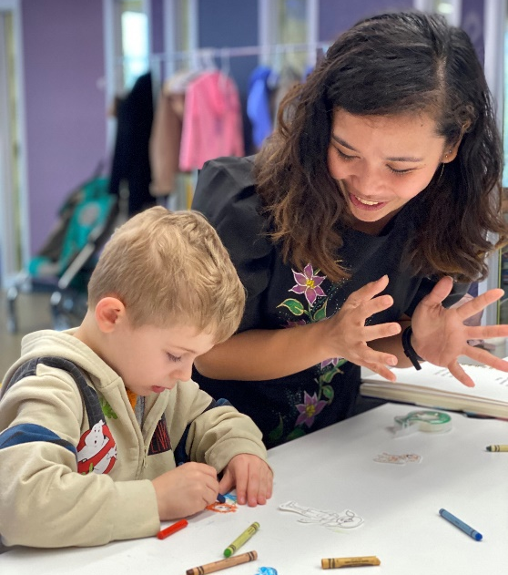
Tagalog Foreign Language Teaching Assistant Kay Arden Gallo hosts a Filipino story time May 3 at the DeKalb Public Library.

Notes from all over: Alumni updates and story times with FLTAs
In alumni news, Thomas Rhoden (Ph.D. political science, 2017) has been promoted to director of federal proposals for UNCOMN, a business management and technology consulting firm specializing in “elegant solutions to wickedly complex organizational, logistic, process, data and technical problems.” Anthonie Tumpag (M.A. anthropology, 2016), regional director of Illinois ATAYAL, published the article “From Family Photos to Filipiniana: Piecing Together My Filipino American Identity” May 2 in the Smithsonian Center for Folklife and Cultural Heritage digital magazine. ● ● ● The DeKalb and Sycamore public libraries hosted Southeast Asia story times for children May 3-5, led by this year’s Fulbright Foreign Language Teaching Assistants. Each featured a story and a game or dance. On May 3, Tagalog FLTA Kay Arden Gallo hosted a Filipino story time at DeKalb Public Library and Thai FLTA Sunchada Sangmas introduced children to Thai storytelling at Sycamore Public Library. On May 4 it was Myanmar story time with Burmese FLTA Khaing Wai Wai Zaw at DeKalb Public Library and on May 5 Indonesian FLTA Imelda Husein shared Indonesian story time at the DeKalb Public Library.

Save the dates: What’s on display
- Through May 14: Exhibit of nine textile-making practices from around the world including SEA at Pick Museum of Anthropology. 10 a.m. to 4 p.m. Tuesday-Friday.
- Through May: Southeast Asia children’s literature exhibit, Donn V. Hart Southeast Asia Collection, Founders Memorial Library.
- Oct. 21–23: 50th anniversary meeting of the Council on Thai Studies, University of Wisconsin-Madison.
- Nov. 17–Feb. 18, 2023: “Food for the Soul: Believe and Healing in Burma/Myanmar in the Age of COVID” exhibition, NIU Art Museum.

Latest on Crossroads: Check out three new podcasts
Learn about Cambodian public and private health care, Indonesian gamelan in America, and Vietnamese influence in classical guitar music in the latest episodes of Southeast Asia Crossroads podcast series. Host Eric Jones and CSEAS Director Judy Ledgerwood talk with Jenna Grant, a cultural anthropologist in the fields of medical anthropology and humanities, changing health care in Cambodia in “Pressure and Freedom: Technology and Formations of Public and Private Health Care in Phnom Penh.” Jones and NIU world music graduate student Glynnis White talk with Elizabeth Clendinning, assistant professor of music at Wake Forest University, about her research on space, time, cultural representation and pedagogy within transnational Balinese gamelan communities in “New Flowers: Indonesian Gamelans, American Educations.” Jones, joined by History Department colleague Taylor Atkins, speak with NIU applied guitar artist An Tran about his classical guitar playing infused with Vietnamese style in “An Tran: Vietnamese Influence in Classical Guitar Music.” With 84 episodes, Southeast Asia Crossroads’ following has grown to more than 83,000 listens since its 2016 debut with listeners in 100 countries; topics range from history and politics to art and culture. Tune in also to Napalm in the Morning, an exploration of films dealing with the Vietnam War. And this just in, CSEAS has created teacher resources for 14 Crossroads podcasts. Check them out.

Abstract deadline July 1 for COTS conference
The Council on Thai Studies (COTS) announces a call for papers for the 50th annual COTS conference set for Oct. 21–23 at the University of Wisconsin-Madison. This special anniversary meeting will feature keynote speakers Thongchai Winichakul (University of Wisconsin-Madison) and Pinkaew Laungaramsri (Chiang Mai University), and mark the founding of COTS at NIU in 1972. The deadline for abstracts is July 1. Submit brief abstract of 300 words and include contact information and institutional affiliation to conference organizer Ian Baird, ibaird@wisc.edu.

Conferences, workshops, webinars

Conferences
- Southeast Asian Linguistics Society Annual Meeting, May 19–21, University of Hawai’i-Manoa, virtual and in-person. Call for papers. See website.
- Southeast Asian De/Neo/Inter/Post-Colonialism, May 20, University of California-Riverside, virtual. See website.
- Aquatic Powers: Divine Animals of the Asia-Pacific, June 1–3, Oslo, Norway. University of Oslo, virtual and possibly in-person. For details, email Dr. Aike P. Rots, a.p.rots@ikos.uio.no.
- Society for Historians of American Foreign Relations, June 16–18, New Orleans, in-person. Online sessions, June 10–11. See website.
- Asia Pacific Political Science Research and Publication Conference, July 21–23, Bangkok. Sponsored by the American Political Science Association Asia Program in partnership with Thammasat and Chulalongkorn universities. Held alongside Southeast Asia Research Group (SEAREG) summer conference. Airfare and hotel covered for invited scholars. See website.
- 2nd AIFIS-MSU Conference on Indonesian Studies, June 21–25, virtual. See website.
- EuroSEAS, June 28–July 1, Paris. See website.
- Singapore Graduate Forum on Southeast Asian Studies, July 18–22, National University of Singapore. See website.
- International Council for Traditional Music, July 21–27, Lisbon, hybrid. View the preliminary program or see conference website.
- Chulalongkorn Asian Heritage Forum, Aug. 25–26, Bangkok, Institute for Thai Studies at Chulalongkorn University. See website.
- Midwest Conference on Asian Affairs, Sept. 16-18, University of Kansas. Hosted by UK Center for East Asian Studies. Call for papers. Open to undergraduate and graduate students and scholars. Abstracts due: May 31. See website.
- Rethinking the Center and the Margin in Southeast Asian Religions, Nov. 10–22, Denver. See website.

Money for study
St. Catharine’s College-Cambridge
- Bowring Scholarships in Malay World Studies: Open to St. Catherine’s students of any nationality. Funding supports master’s or Ph.D. students studying history, geography or culture of Indonesia, Malaysia and the Philippines. For details, email Dr. Liana Chua at lclc2@cam.ac.uk. Rolling application dates: March 31 and Sept. 30.
Rotary International
- Rotary Peace Fellowships: Fully paid fellowships for master’s degree (up to two years) or professional development certificate studies (three months) offered through seven universities worldwide for 2023-24 academic year. Deadline to apply: May 15. See website.
Center for Indonesian Policy Studies
- Visiting research fellowships: Opportunities for Indonesian and non-Indonesian students completing their Indonesia-related doctorate and post-graduate theses to conduct field research in Indonesia over 3-6 month period. No deadline to apply. See website.
ProFellow
- Dissertation Research Fellowships: Check the ProFellow website for 30 different opportunities for dissertation research funding.

Careers
U.S.-ASEAN Business Council
- Policy and research internships: Semester internships based in Washington, D.C. Recent graduates encouraged to apply. Email internships@usasean.org. See website.
Bridge to Success
- English Teachers in China: Ten-month- internships and jobs for English speakers with bachelor’s degree minimum. See website.
Center for Strategic and International Studies
- Internships: Full- and part-time internships for undergraduates, advanced students and recent graduates interested in gaining practical experience in public policy. Rolling deadlines to apply. See website.
Eurasia Group
- See website for job opportunities.
Globaljobs.org
- Job/internship opportunities: Turn area studies into an internship or a career. See job listings at NGOs, think tanks, government, and private-sector employers. See website.
Chinese Mutual Aid Association
- Interns: Pan-Asian social service organization accepting candidates for interns for business development, grant writing and workforce development and outreach liaison duties. Compensation in college credit. See website.
US Department of State
- Student internship program: Internship opportunities for undergraduate and graduate students at Washington headquarters and US embassies, consulates and missions worldwide. Explore postgraduate civil-service career paths as well. See program website. Career opportunities: Internships and jobs posted regularly on website.
Association of Southeast Asian Nations
- Jobs listed under Opportunities tab of ASEAN website.
Devex: Do Good. Do It Well
- International aid and development jobs in 1,000 agencies, companies and NGOs in 100 countries. See website.
DevMetJOBS.org
- International development jobs and consulting opportunities. See website.
Hess International Educational Group
- Teach English across Asia: Taiwan-based organization offers free training, benefits, and flex scheduling. See website.
Idealist.org
- Privately funded website offers searchable database of nonprofit international jobs and volunteer opportunities. See website.
Learn How to Become
- Privately funded website offers searchable database of meaningful volunteer and nonprofit career options and resources. See website.
ReliefWeb
- Specialized digital service of the UN Office for the Coordination of Humanitarian Affairs that posts jobs regularly. See website.
World Health Organization
- Global health agency in the United Nations system encourages online applications for potential employment. See website.

The future calls
You can help keep Southeast Asian studies program at NIU going strong with your contribution through the NIU Foundation. To contribute online, see How to Give and where indicated, specify the Center for Southeast Asian Studies. If your employer matches your charitable donations, please take a moment to fill out that form and double your contribution. We appreciate every gift. Thank you!

Persons with a disability who need assistance at any Center event may contact CSEAS at 815-753-1771 or by email at cseas@niu.edu. If you no longer wish to receive this bulletin, reply to this e-mail with a request to remove your name. Thank you.

‌Center for Southeast Asian Studies • 520 College View Court • Northern Illinois University • DeKalb, IL 60115 •
815-753-1771 (office) • 815-753-1776 (FAX) • cseas@niu.edu (e-mail) • www.niu.edu/clas/cseas/ •
Facebook • Twitter

