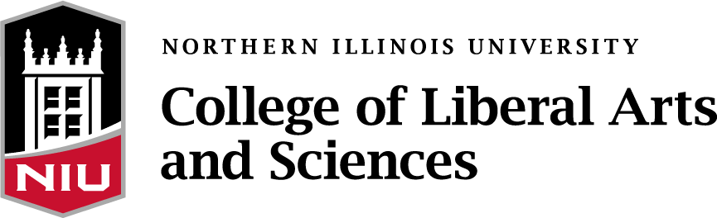

2023 Annual Distinguished Alumni Award Nomination Form

You are invited to nominate alumni who have distinguished themselves after earning academic degrees (undergraduate or graduate) in programs of the College of Liberal Arts and Sciences at Northern Illinois University. The College particularly seeks to honor alumni who have achieved (or are in the process of achieving) prominence in one of the following areas:

- In their professional fields or through public service
- Through advocacy efforts related to education, making education accessible, diversity and inclusion
- Through their involvement in civic, cultural, or charitable service

Distinguished alumni awardees will be honored on campus, along with distinguished faculty and staff of the College, in the Fall of 2023.

Nominations must include: (1) this nomination form, (2) a nomination letter (up to two pages), and (3) a maximum of five additional pages of supplemental support materials which address the nominee’s accomplishments and contributions. For example:

- A career summary or professional resume | - Media articles or excerpts
- Biographical information | - Professional awards and recognition
- List of publications or professional achievements | - Civic or volunteer awards and recognition

Nominee’s Name:
Current postal address:
E-Mail:
Phone(s):
Nominee’s CLAS Degree(s), including academic department(s) and date(s) awarded (if known):

Individual Submitting Nomination:
Current postal address:
E-Mail:
Phone(s):

Questions? Drop an e-mail to CLAS-Communication@niu.edu

Submit nominations by E-Mail: CLAS-Communication@niu.edu . All nomination materials must be submitted electronically by Monday, April 3, 2023.

