Wheel of Life
The Wheel of Life divides into eight categories. Rate your satisfaction in each of these areas of your life (on a scale of 1-10; 0 is low, 10 is high).

Personal Growth 1☐ 2☐ 3☐ 4☐ 5☐ 6 ☐ 7☐ 8☐ 9☐ 10☐
Career 1☐ 2☐ 3☐ 4☐ 5☐ 6 ☐ 7☐ 8☐ 9☐ 10☐
Academics/College Life 1☐ 2☐ 3☐ 4☐ 5☐ 6 ☐ 7☐ 8☐ 9☐ 10☐
Fun and Recreation 1☐ 2☐ 3☐ 4☐ 5☐ 6 ☐ 7☐ 8☐ 9☐ 10☐
Relationships 1☐ 2☐ 3☐ 4☐ 5☐ 6 ☐ 7☐ 8☐ 9☐ 10☐
Physical Environment 1☐ 2☐ 3☐ 4☐ 5☐ 6 ☐ 7☐ 8☐ 9☐ 10☐
Health 1☐ 2☐ 3☐ 4☐ 5☐ 6 ☐ 7☐ 8☐ 9☐ 10☐
Money 1☐ 2☐ 3☐ 4☐ 5☐ 6 ☐ 7☐ 8☐ 9☐ 10☐

To visualize these ratings, draw a line that matches your level of satisfaction across each wedge of the wheel below. You can print this page or use Word’s insert shape function to draw lines in this document (open the “Insert” tab, select a line from the “Shapes” dropdown menu and place a line in each wedge).
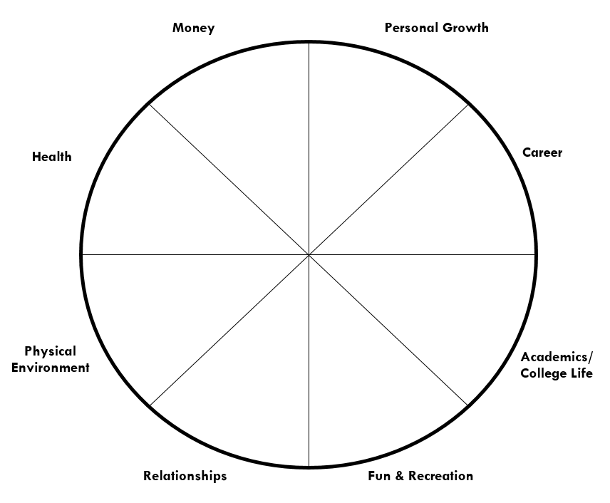

Look at your wheel.
Which areas of your life contribute to your satisfaction? Click or tap here to enter text.
Which areas of your life detract from your satisfaction? Click or tap here to enter text.
How satisfied are you with your life in general? Click or tap here to enter text.
How balanced is it? Click or tap here to enter text.
What do you want to change? Click or tap here to enter text.

