BUDGET

FLEX

SYSTEM

PURPOSE

&

PROCEDURE

Budget Flex System

The Budget Flex System is an automated system that issues budget loans between an administrative cost center and local cost center within the same unit (Divisions or Colleges) for journal entries that would otherwise not post due to insufficient budget. However, loan eligible journal entries via this automated system are only transactions from secondary or tertiary systems posting to FMS via campus-wide batches that the Controller disclosed as necessary to operate on a campus-wide basis per enacted Automatic Override Policy. Below is a list of eligible source codes for transactions that get captured by B-Flex:

HRS: Payroll Journals | BSR: Bursar Journals | HSC: HSC Ctr Acct Office
PCD: P-Card Journals | HSC: HSC Ctr Acct Office
PDS: Printing & Doc Srvcs | TEL: Telecom Journals | TEL: Telecom Journals
WKO: Work Order System | TRN: Transportation | UTL: Utilities Journals
MAT: Material Mgmt & Central Stores | PST: Postage | CPS: Campus Parking Srvcs

Thus, the Budget Flex System is intended to afford local flexibility in addressing any issues with journal entries, while avoiding operational challenges of transactions posting in campus-wide badges on the general-ledger-side. Smaller batches, compared to campus-wide transactions, typically have less or no impact on reporting accuracy, financial statements or corresponding audit issues; thus would not be eligible for treatment under B-Flex and remain unposted until budgetary deficit is resolved or journal entry is posted otherwhere. Below is the transactional and informational flow to automate the B-Flex System:

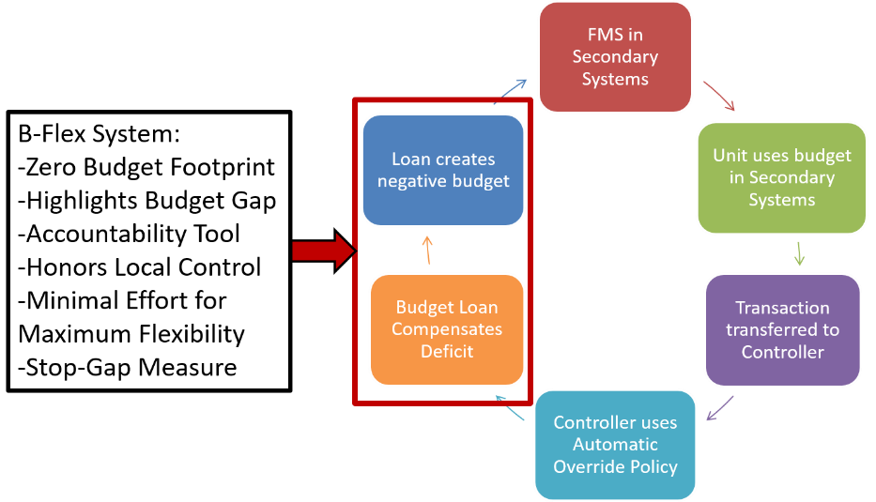

As loan origination serves the XB-cost-center-series, launched as tool for operational budget flexibility when implementing Local Control. The XB-cost-center experiences negative budget in exchange to a local expense budget increase. Thus, the net budget footprint for B-Flex is zero and is mainly intended to highlight budget gaps across a unit overall, honor local control and establishes easier visibility or accountability. Thus B-Flex does not resolve or diminish the risks posed by the Automatic Override Policy and can lead to actual expenses to be in deficit compared to budget, or inadvertently even to an unapproved university-wide budget expansion or unauthorized priority spending in disagreement of Board of Trustee directions.

Finally, as journal entries rarely fail budget checking in cost center with $0 budget availability, B-Flex compensates for the individual budget-to-actual situation in a philosophical extension to its implementation in a continuation of the spirit B-Flex is intended in: “Extend flexibility needed (timing, turnaround time, operations, etc.), honor local control, cover the gap in operational inefficiencies and keep adverse impacts at the same level than without B-Flex.”

Thus, along with transactional loans for journal entries, there might be following other balanced budget transfers issued under B-Flex under miscellaneous loans (“LOAN: MISC”):

- Loan for previous deficits for budget to be sufficient to cover the additional journal entry
- Refund via B999 in XB for available budget in the local cost center via reducing it’s BLOANs

Hence, the local cost center’s budget is never distorted other than adding the expense budget to the b-code BLOAN that is needed to be at break-even, while the XB-series always establishes the proper accounting of the cause of an budget imbalance, while not distorting the budget with miscellaneous adjustments. Consequently, it is recommended to exclude the XB-series cost center but include b-code BLOAN in summary reporting to portray the potential risk of budget-overrun accurately, while not distorting the original budgets.

