STEP-BY-STEP

GUIDE

LAUNCHING

A

BALANCED

BUDGET TRANSFER

  - (OVERALL BUDGET IMPACT
  - IS NET ZERO)

  - Budget and Financial Planning
  - Northern Illinois University
- Navigate online to myniu.niu.edu and click “MyNIU Financial Management System”

- Authorize with you A-ID and Password

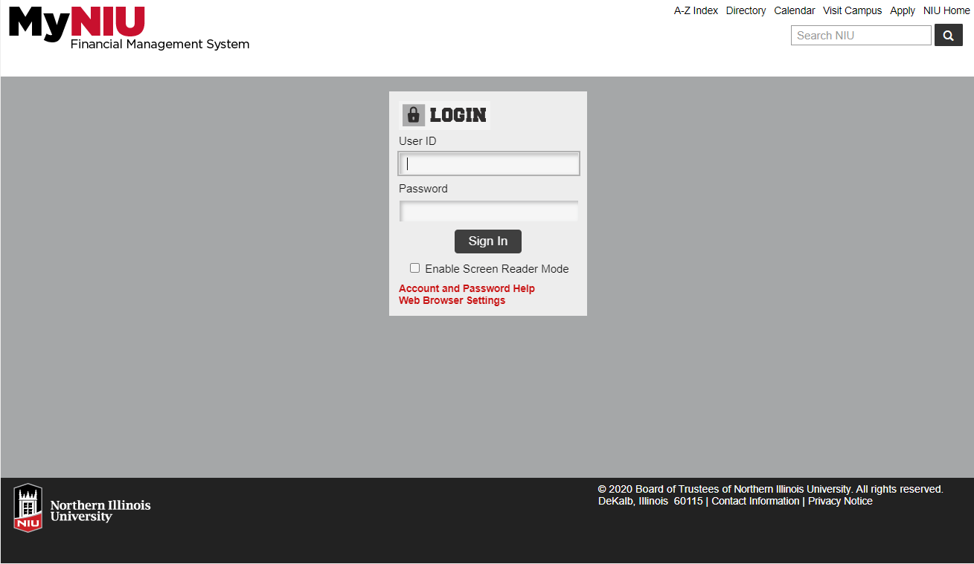

- If not defaulting to it, navigate to “MyNIU Budgets” in drop-down. Then click on “MyNIU Balanced Budget Transfer” tile.

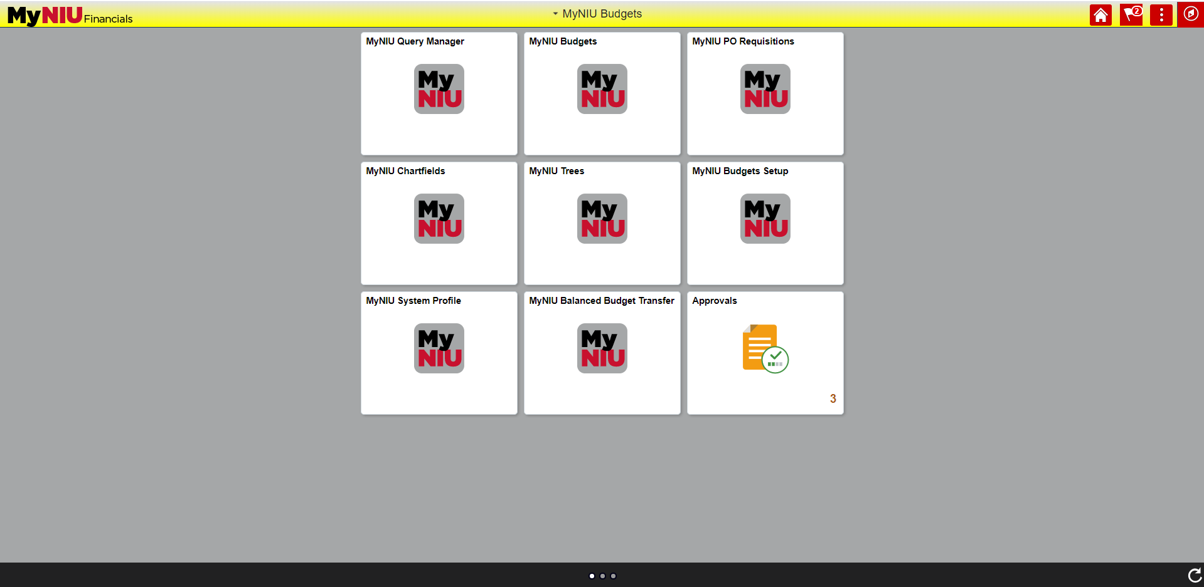
Select “MyNIU Budgets”
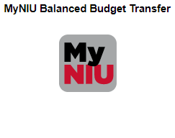
Select “MyNIU Balanced Budget Transfer”

- Enter Budget Transfer should be selected (green highlighted)

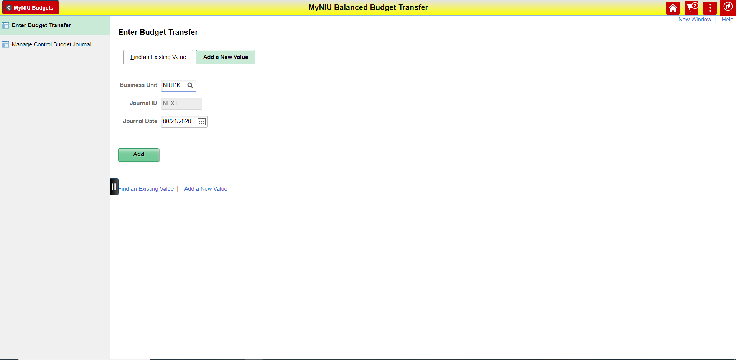

- By default, you should be seeing the “Add a New Value” (should be green) tab.

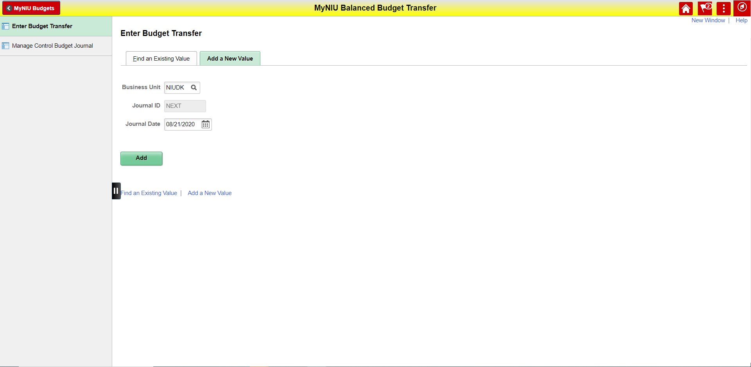
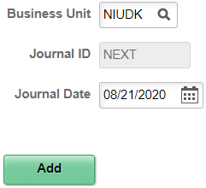

- Business Unit should default to “NIUDK” (should not be changed)
- Journal ID should default to “NEXT” (cannot be changed)
- Journal Date is by default today’s date, but can be changed as needed
  - Most often the default should not be changed
  - Back dated after a fiscal year lapsed
  - Forward dated to match an actual transaction
- Click “Add” upon making changes as needed above

HINT: For progress review or potential changes you can select the “Find an Existing Value” tab
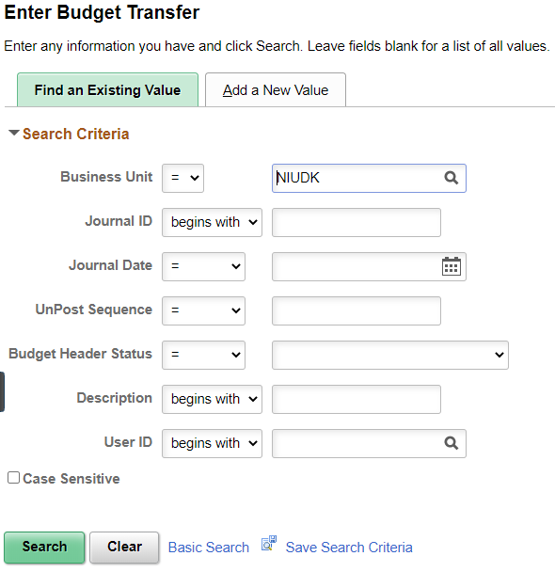
6. Budget Header with descriptions
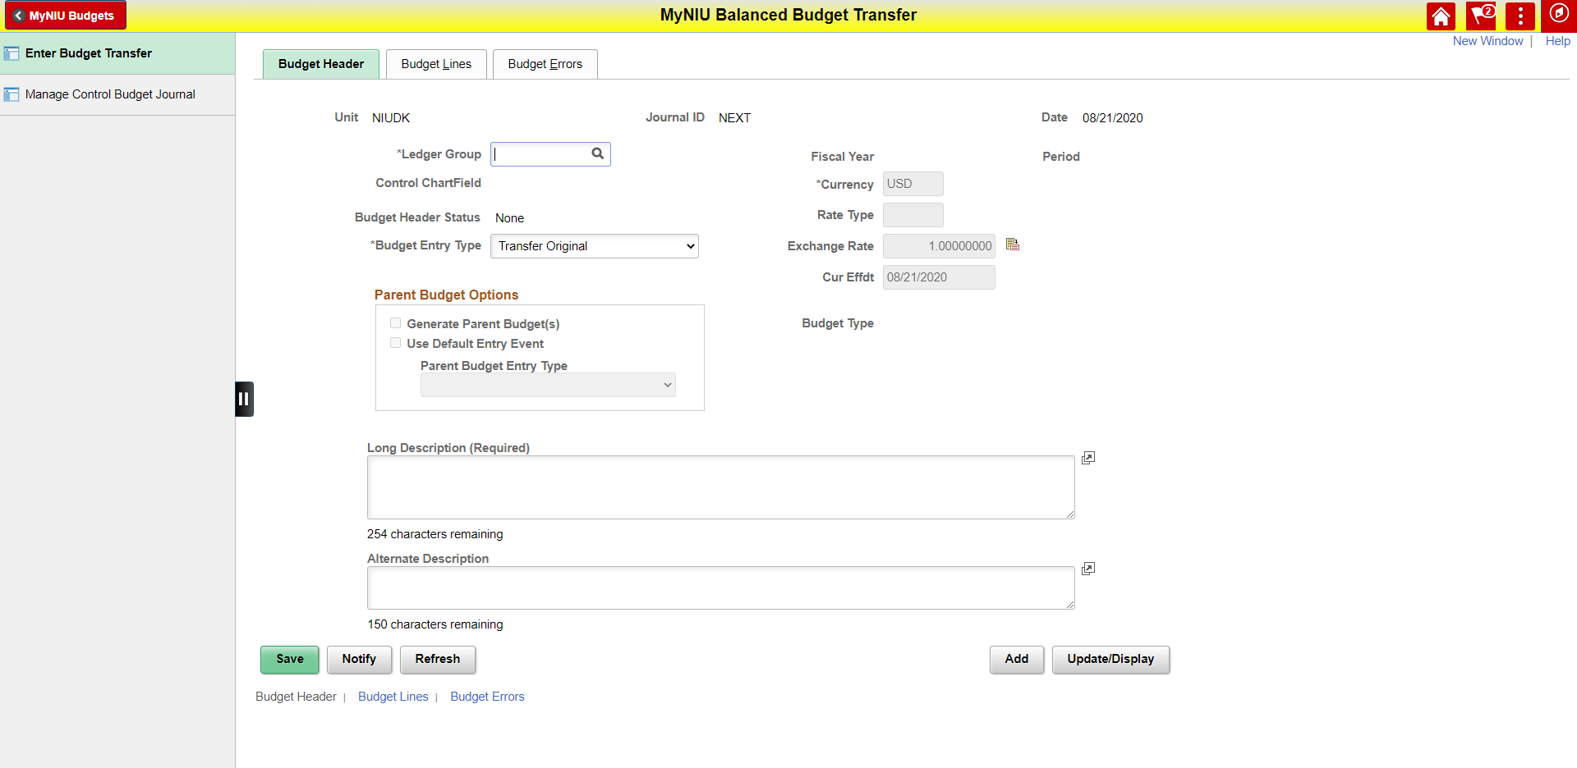
“Long Description” required & “Alternate Description” is optional (Note: Character counts below)

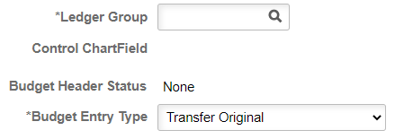
“Ledger Group” and Budget Entry Type” is required (via selection of values)
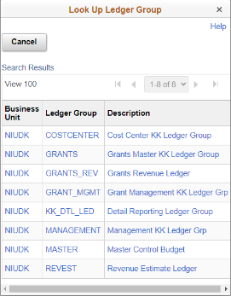
- Ledger Group (only values pertinent discussed)
- Expenditure Authority:
MANAGEMENT = MGMT_BUD = Expense Budget
- Revenue Goal:
REVEST = REVEST_BD = Revenue Budget
- Budget Checking (of expenses)
COSTCENTER = Ledger for Annual Budget Checking
- Should not be selected as any MANAGEMENT transfer automatically posts to COSTCENTER
- Budget Entry Type
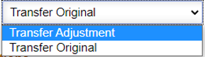
- Transfer Adjustment
- Optional Choice
- Transfer Original
- Default Value
- Long Description (was also on Excel-form system)
- This is a required field now
- Limited to 254 Characters
- Use language to summarize transfer overall
- HINT: Can be used via “Find an Existing Value” as search field which might be a useful feature, especially if you often copy transfers from one year to another
- Alternate Description – Optional Field for additional information
- Conclude input of transfer header information by clicking tab for “Budget Lines”

- This is the input mask for the “Budget Lines” (overview of components)
c) Workflow Information

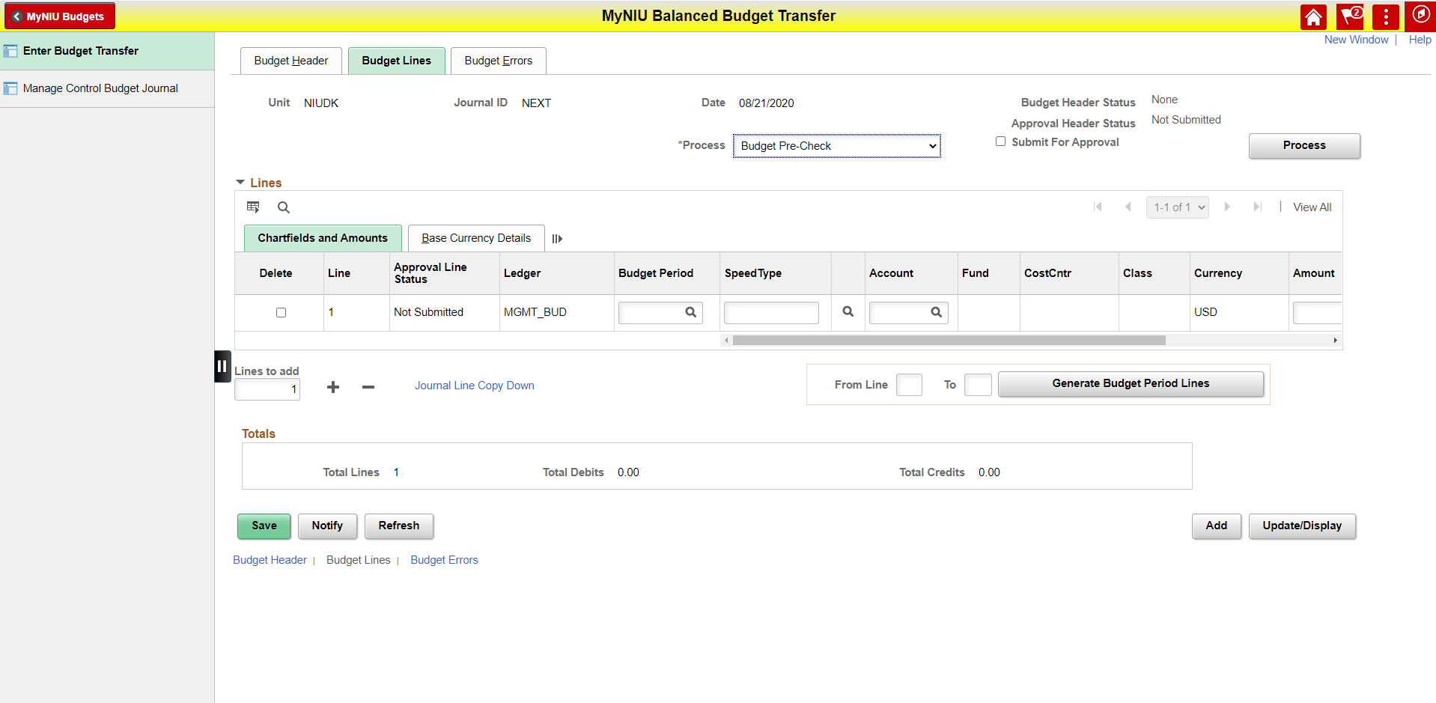
b) Check & Total Function
a) Part for Input of Line Information

- Line Input (all fields listed required unless noted)

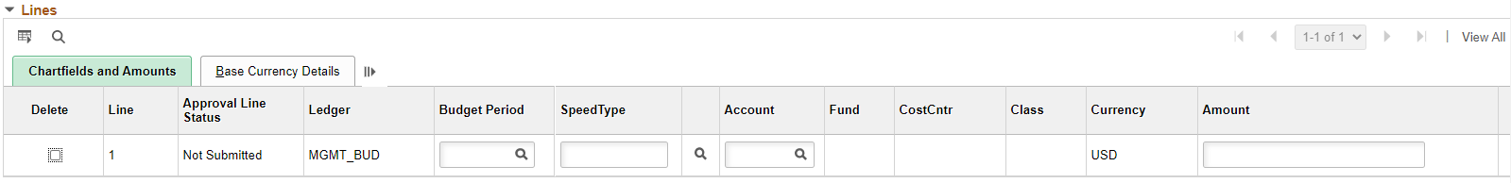
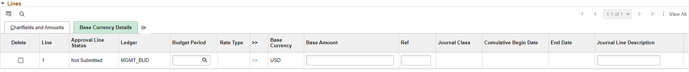

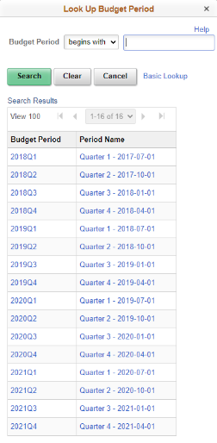
- Budget Period (in Quarters)
- Date listed in selection is start date of quarter
- End date of quarter is day prior to start date of next quarter
- Should agree with Date previously input for Budget Transfer
- SpeedType (makes input of Fund, CostCntr and Class obsolete)
- New feature to make input easier and expedient
- REVEST input R and 5-digit cost center number
- MANAGEMENT input E and 5-digit cost center number
- Account (HINT: Commonly referred to as B-Code for budget)
- Note if using the magnifying glass for selection only applicable account codes are listed (REVEST_BD - B4xxxx through B5xxxx & MGMT_BUD B600 through B999 or BLOAN are listed)
- Keep in mind there is a guide to identify the right B-Code for an C-Code (six-digit number that is used for journal entries)
- Amount (or Base Amount as fields are linked to be in sync)
- Positive amounts increase Expenditure Authority and Revenue Goal
- Negative amounts decrease Expenditure Authority and Revenue Goal
- Ref (Optional)
- Limit to 10 characters
- Mostly used to reference information (i.e. a JE could be input for reference)
- Journal Line Description
- Limit to 30 characters
- Use language to summarize the information for each line
- “Line to add” Function
- Minus Sign Delete lines (every line check-marked in lines)
- “Line to add” Number of lines to be added
- Plus Sign adds lines
- HINT: If you are often using the same/ common information, fill in the first line, before adding additional lines as information is copied into added lines (can be customized on link “Journal Line Copy Down”)
- HINT: If you enter a larger transfer with different sections of common information fill out first line of information and then add the exact number of lines needed for this batch before continuing to the next batch and repeating this process

- Check & Total Function
- Transfer must balance
- Credits = Debits
- Decreases are Debits
- Increases are Credits
- Does the number of the total lines make sense?
- Min should be 2 lines
- Most commonly should be even number
- This would be a good time to save
- Make sure that a green box opens at top confirming saving
- Note: Upon saving you should notice the Journal ID was assigned that should start with BUC (BUdgt Community Journal vs. BUD for Budget Office i.e.)

- Workflow Function & Information (Approval of Transfer)
- Functionality of the workflow is via the “Process” drop-down. The workflow is like the submission and approval of an assembled form and has following sequential steps (previously in via form in a different sequence):
- Budget Pre-Check: Check accuracy of information and budget availability
- Submit Journal: Route for approval
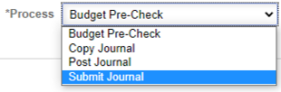
  - Note: Balanced Budget Transfers need to be approved by the Divisional Business Manager, except for Division 40 in which it is approved by the College Business Manager
  - Note: Balanced Budget Transfers need to be approved regardless of net effect to expenditure authority or revenue goals (recipients and sender needs to approve)
  - Note: If the requestor and approver of a transfer are the same individuals, it would be auto approved
  - Note: If a budget transfer(s) only affect(s) one division/college the Division/College Business Manager approves both; the receiving and the sending
- Post Journal: After a transfer was completely approved, posting is the process by which the transfer is executed. Either requestor or any approver can manually post a transfer instantly via “Find an Existing Value”
  - Automatic processing cycles are scheduled to run each hour, on the hour, from 7 a.m. to 7 p.m., Monday through Friday
  - Copy Journal: Is offering an ability to copy a previously launched/posted Balanced Budget Transfer that can be used via “Find an Existing Value”
- There is also a mini dashboard for each Balanced Budget Transfer.
  - Budget Header Status: Status of Transfer
- Not Balanced: Credit ≠ Debit | - Checked Only: No Workflow Approval
- None: No action taken | - Error/Errors: Budget or chart field issues
- Posted: Approved & Executed | - Unposted: Posted entry reversed
  - Approval Header Status: Status of Approval
- Not Required | - Not Submitted
- Pending | - Approved
- Denied | - Canceled
  - Submit For Approval: Checked if requestor submitted for approval

- Confirmation E-Mail for Requestor Upon Routing for Approval (Submission)

From: no-reply@niu.edu <no-reply@niu.edu>
Sent: Date-Time Stamp of Action
To: [Requestor of Balanced Budget Transfer]
Cc: TransfersExceptions <TransfersExceptions@niu.edu>
Subject: Confirmation of Balanced Budget Transfer Request [Transfer Number]

[Name of Requestor]:

Your request for a balanced budget transfer has been received and routed for approval.

Once all necessary approvals are obtained through the workflow system, the transfer will post in the next processing cycle. Processing cycles are scheduled to run each hour, on the hour, from 7 a.m. to 7 p.m., Monday through Friday. Alternatively, the budget transfer may be manually posted after all necessary approvals are entered. Any approver may execute this manual posting process.

To see the status of the transfer please review the approval routing at: [Paste Link to Balanced Budget Transfer in PeopleSoft]
Thanks,
The Budget Office
Budget & Financial Planning | Division of Administration & Finance
230 Altgeld Hall | DeKalb, IL 60115
815-753-1909 | budgetandplanning@niu.edu
www.niu.edu

