STEP-BY-STEP

GUIDE

APPROVING

A

BALANCED

BUDGET TRANSFER

  - (OVERALL BUDGET IMPACT
  - IS NET ZERO)

Budget and Financial Planning
Northern Illinois University
- Navigate online to myniu.niu.edu and click “MyNIU Financial Management System”

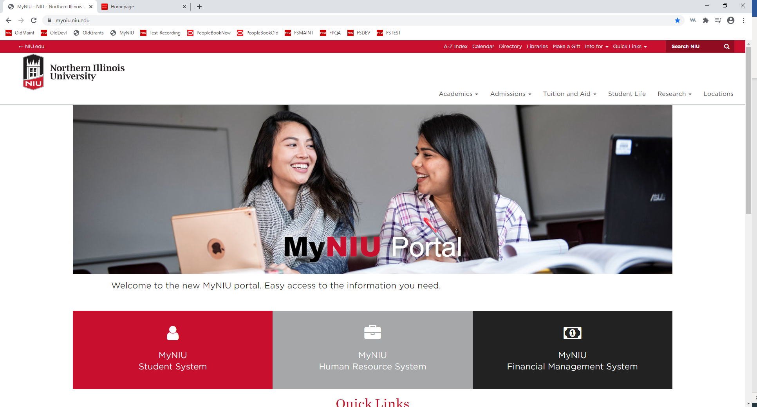

HINT: Approval via Call-to-Action E-Mail’s Direct Link (link to individual approval highlighted red below)
From: no-reply@niu.edu <no-reply@niu.edu>
Sent: Date-Time Stamp of Action
To: [Approver(s) of Balanced Budget Transfer]
Cc: TransfersExceptions <TransfersExceptions@niu.edu>
Subject: Action Requested: Review Balanced Budget Transfer Request [Transfer Number]
[Name of Approver n]:

A balanced budget transfer has been requested by [Name of Requestor] that requires your attention and approval before it can be posted. Please review the budget-neutral transfer at: [Link to PeopleSoft Workflow Routing Module]

Once all necessary approvals are obtained through the workflow system, the transfer will post in the next processing cycle. Processing cycles are scheduled to run each hour, on the hour, from 7 a.m. to 7 p.m., Monday through Friday. Alternatively, the budget transfer may be manually posted after all necessary approvals are entered. Any approver may execute this manual posting process.

To see the status of the transfer please review the approval routing at: [Paste Link to Balanced Budget Transfer in PeopleSoft]

Thanks,
The Budget Office
Budget & Financial Planning | Division of Administration & Finance
230 Altgeld Hall | DeKalb, IL 60115
815-753-1909 | budgetandplanning@niu.edu
www.niu.edu

- Authorize with you A-ID and Password

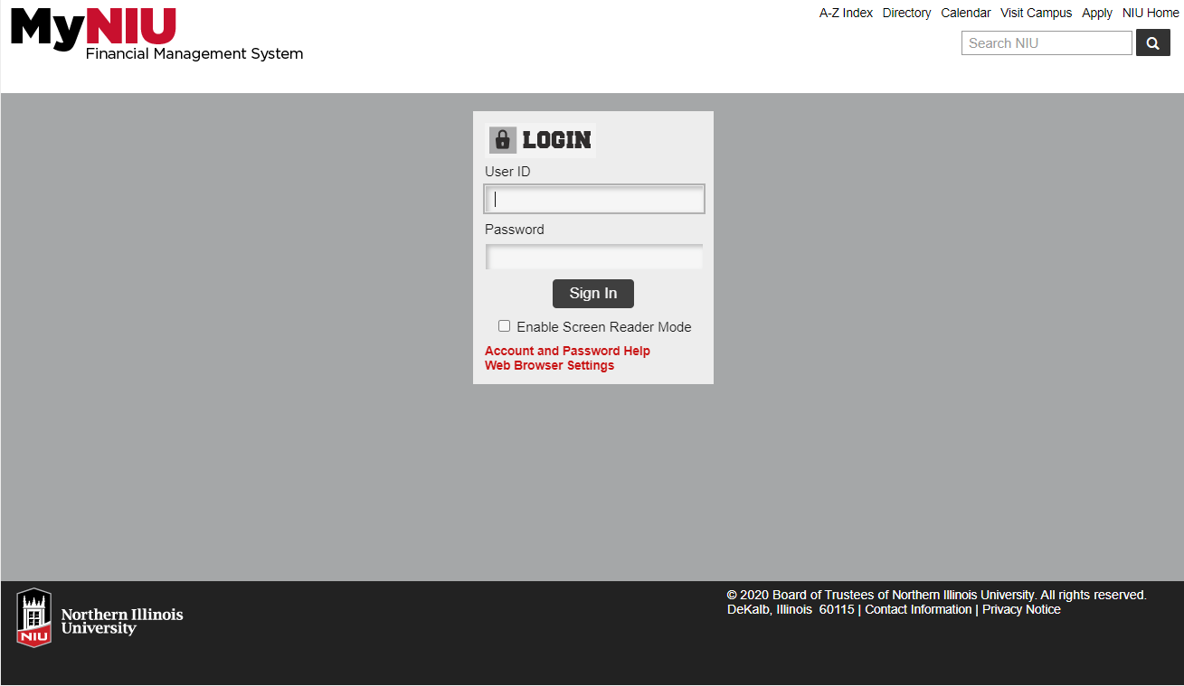
- Navigate to Approvals (Note: Number Denotes Outstanding Approvals of All Source Docs)

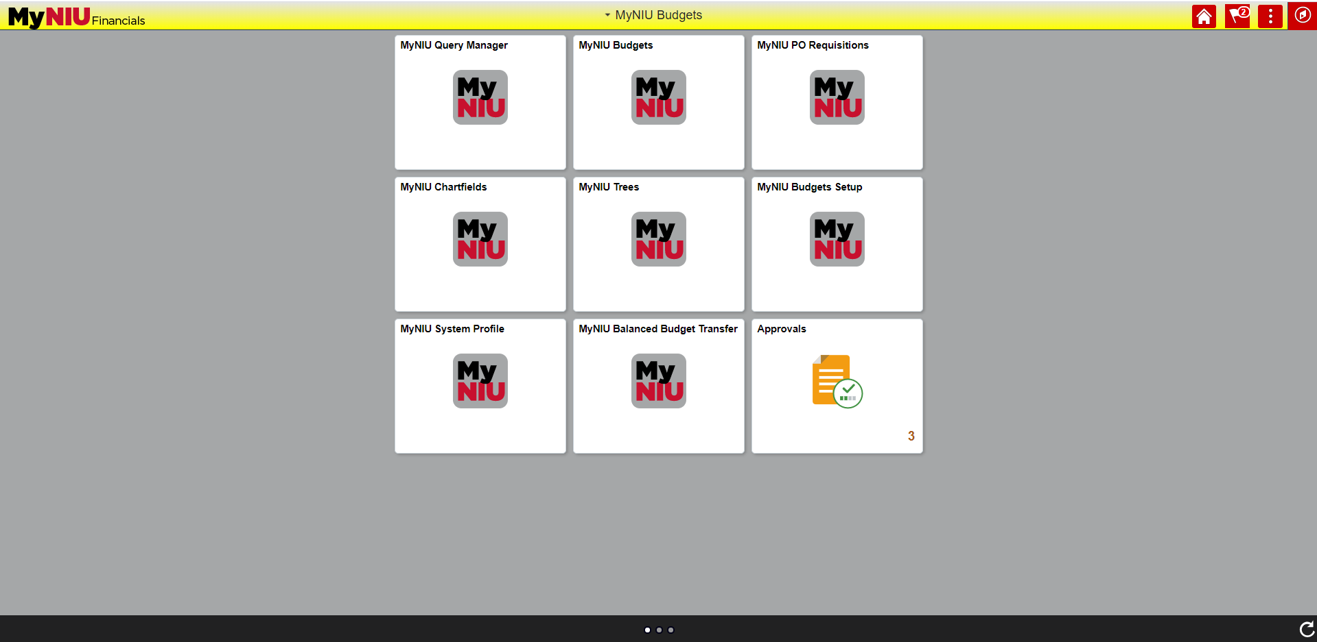
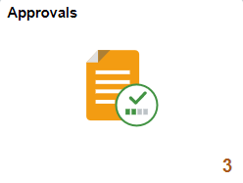
Select “Approvals”
Select “MyNIU Budgets”

NOTE: Approval via Call-to-Action E-Mail’s Direct Link omits this step
- Approval Dashboard

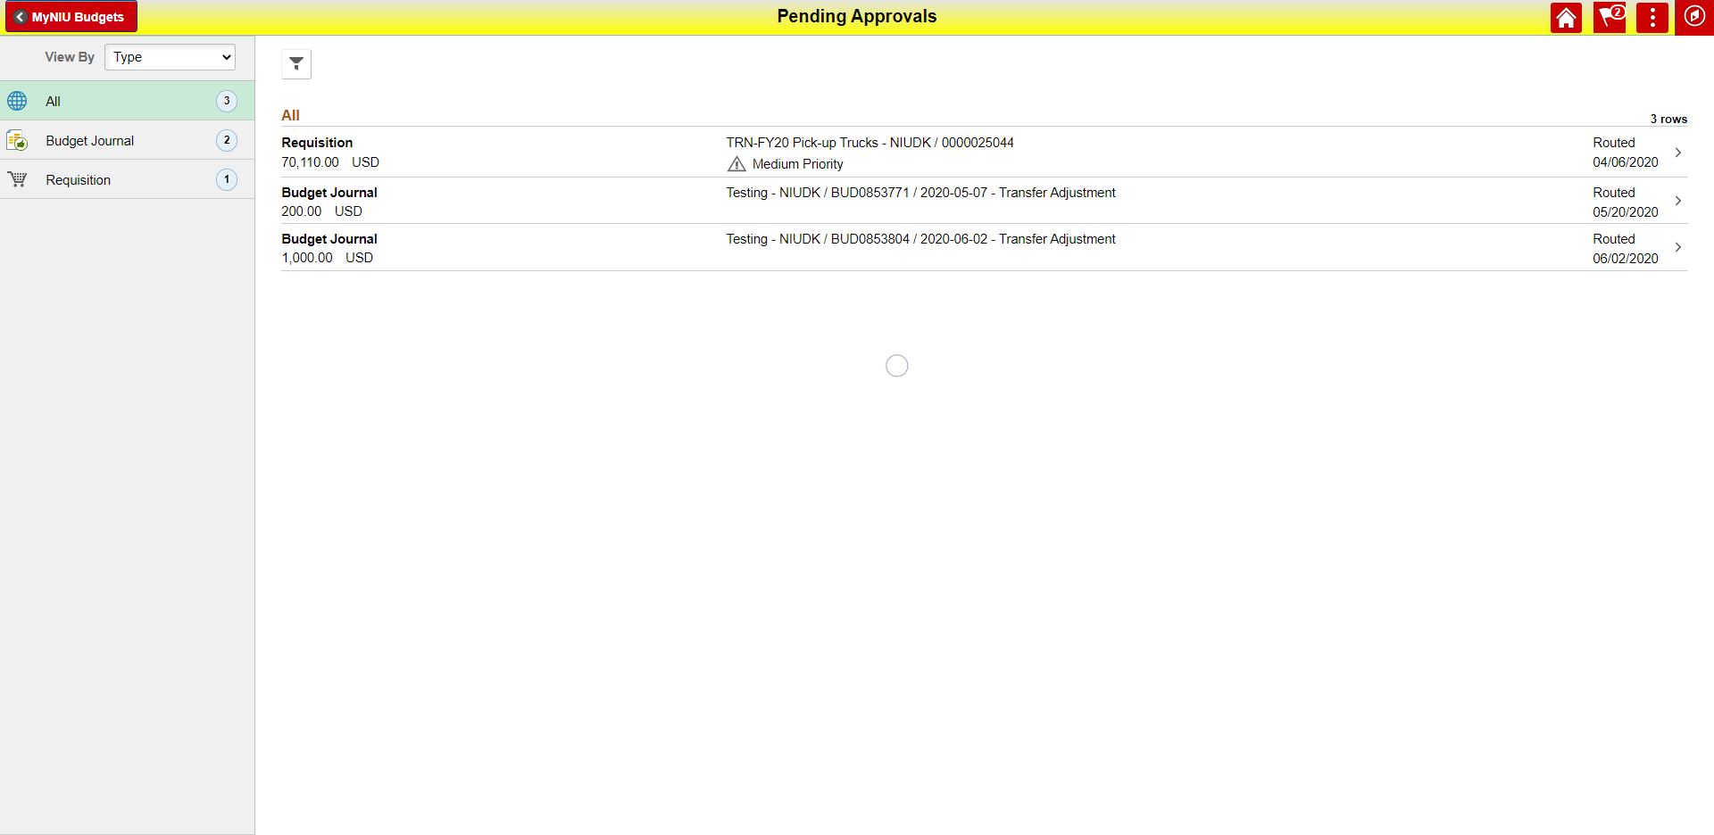
Button to Review Detail of Transaction and Execute Individual Approval^{b}
Most pertinent Information about Transaction like Description, Org, Source Doc Number, Date and Budget Transaction Type (i.e. “Transfer Adjustment”)*
Transaction Type and Amount Displayed*
Button to Filter for Budget Journals or Execute Mass Approvalsª

NOTE: Approval via Call-to-Action E-Mail’s Direct Link omits this step 4. and automatically direct to 4.b.
- Mass Approval

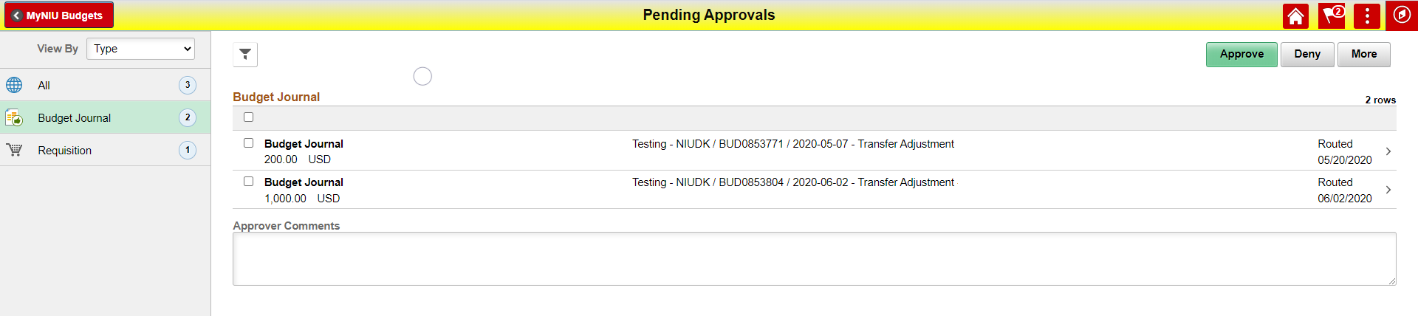
v.
iv.
iii.
ii.
^{i.}

- Selection for Mass Approval Highlighted in Green (Validate to Avoid Accidents)
- Only Checked Transactions will be Executed
- Box for Approval Comments processed for Checked Budget Items
- Buttons to Mass Execute
- Like the “All Dashboard Overview” this can be selected to navigate to individual item for review and individual approval

- Individual Approval

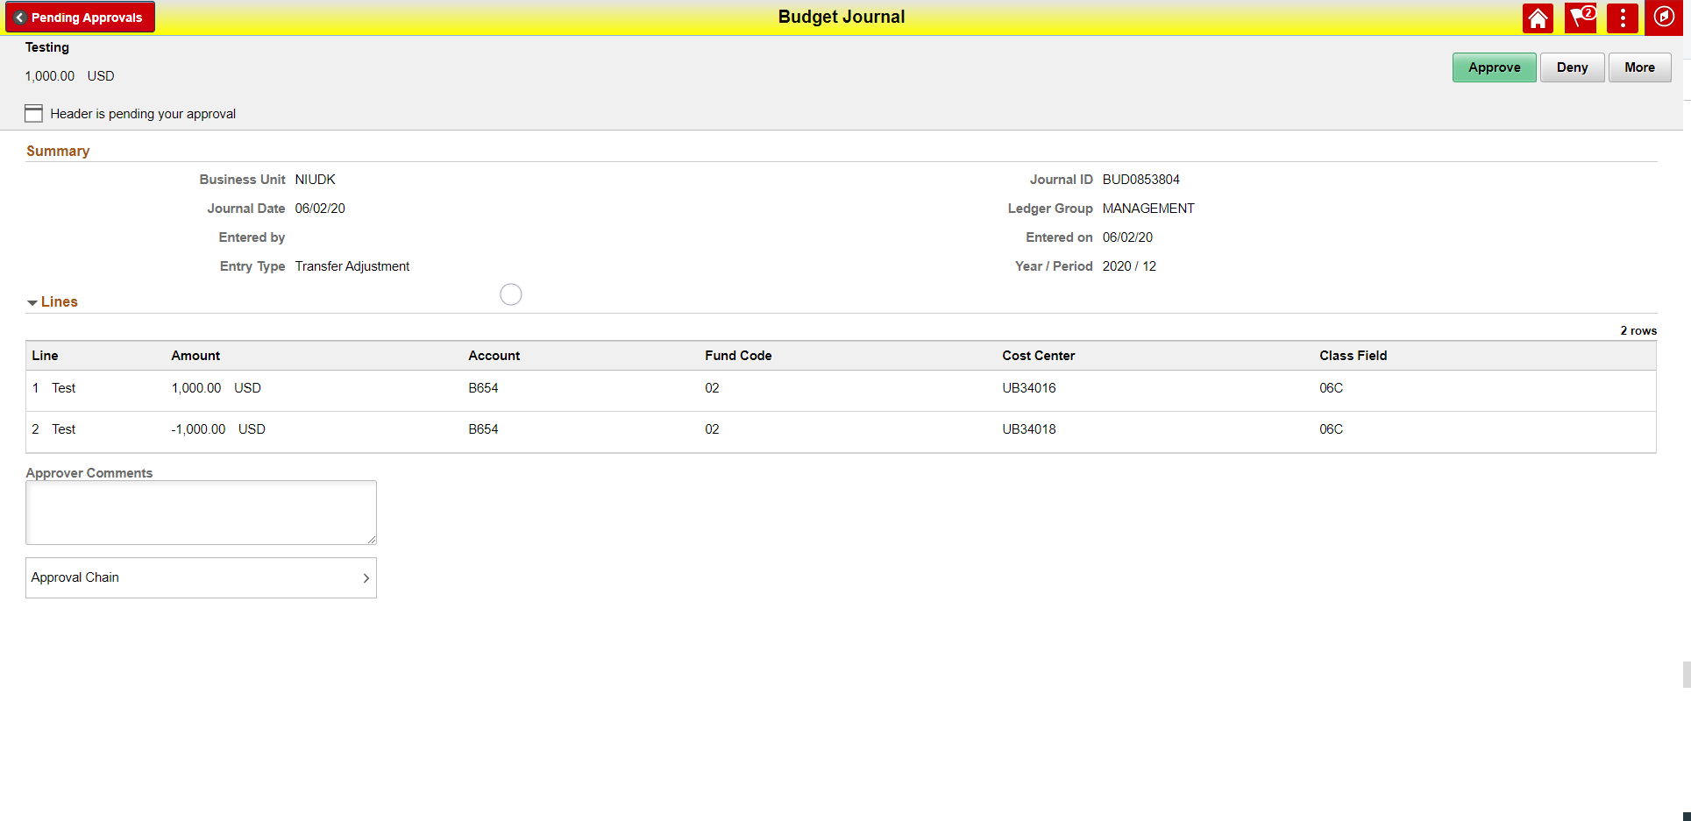
iv.
iii.
v.
ii.
i.

- Same information (more detail) than in “All-View” described in step 4. *
- Same information (more detail) than in “All-View” described in step 4. *
- Approval Comment for Checked Budget Items
- Review of Approval Chain and Progress (Place to choose ad-hoc approver)
- Buttons to Individually Execute

