NORTHERN ILLINOIS UNIVERSITY

PHYSICS DEPARTMENT

Physics 374 – Junior Physics Lab Fall 2020

Excel Visual Basic Tutorial #1

Introduction to Toolbox Controls

The version of Excel used in this Tutorial is Excel 2013 for the PC. Excel 2013 for the MAC has a crippled version of Visual BASIC that does not allow any programming. MAC users will have to run Excel 2013 in a virtual machine (like Virtual Box (free), Bootcamp (free), or Parallels Desktop). All students at NIU can download from MyNIU for free Windows 10 and the current version of Excel.

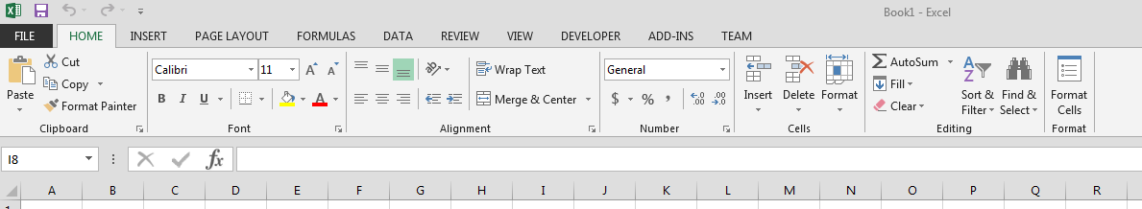

If you do not see the Developer menu tab above, you can create it by clicking on File OptionsCustomize Ribbon and checking the Developer box.

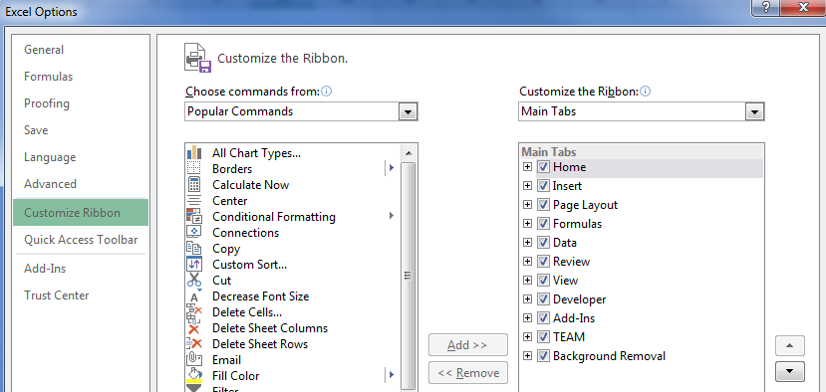

The Developer menu tab should now be visible. The figure below shows the menu items when the Developer tab is clicked:
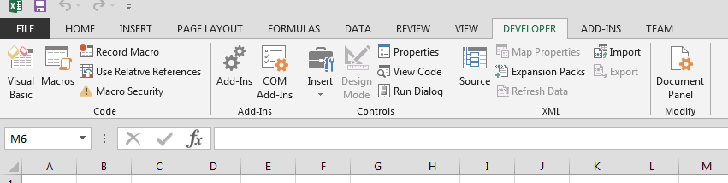

Click on View Code and the following window will appear:

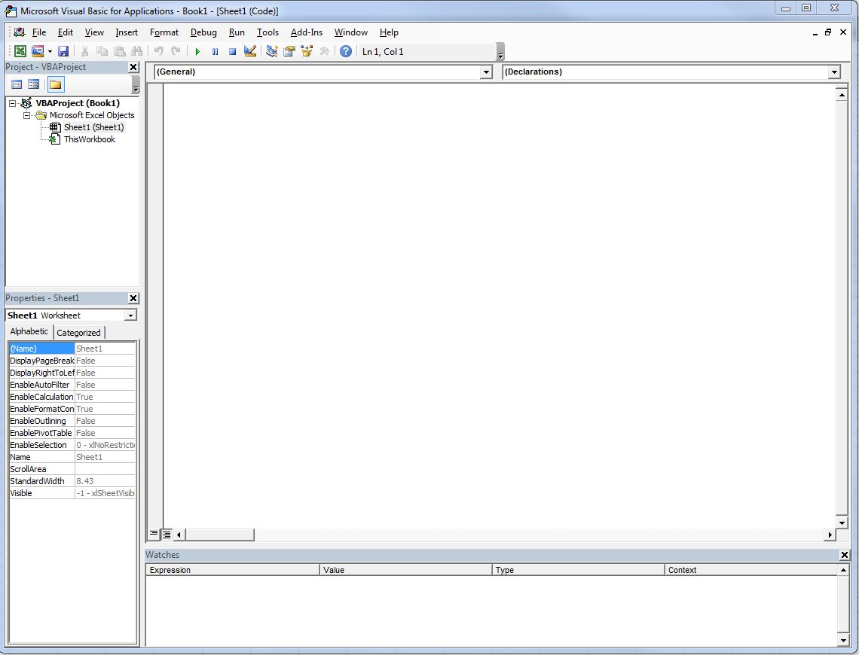

To start coding, click on InsertUserForm on the Visual Basic menu. The following should appear—see figure below. To see the Properties box for the control, you must select (click on) the item—it then acquires a gray shaded boundary. Change the name “UserForm1” to “Hello_World” and change the caption to “My Hello World Program”):
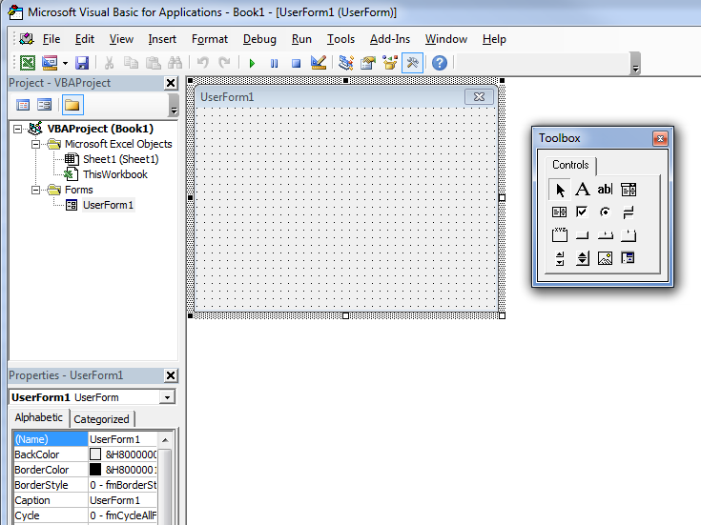

Change the name “UserForm1” to “Hello_World”

Change the caption “UserForm1” to “My Hello World Program”

We are now going to write a simple program that puts the character string “Hello World” into cell C5 in Excel. When you hover over any of the controls in the Toolbox above, text will appear describing the control. We want to drag a TextBox control to the UserForm above. Do this by right-clicking on the “ab|” control and dragging it to the UserForm. The result is shown below:
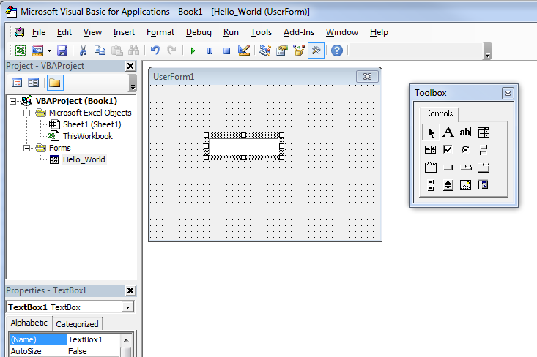

Change the name “TextBox1” to “Voice”

Change the name of the TextBox control from the generic name “TextBox1” to something more useful like “Voice”. Then drag a CommandButton control to the Userform and name it “Run” and give the button a name called “Start Program”.
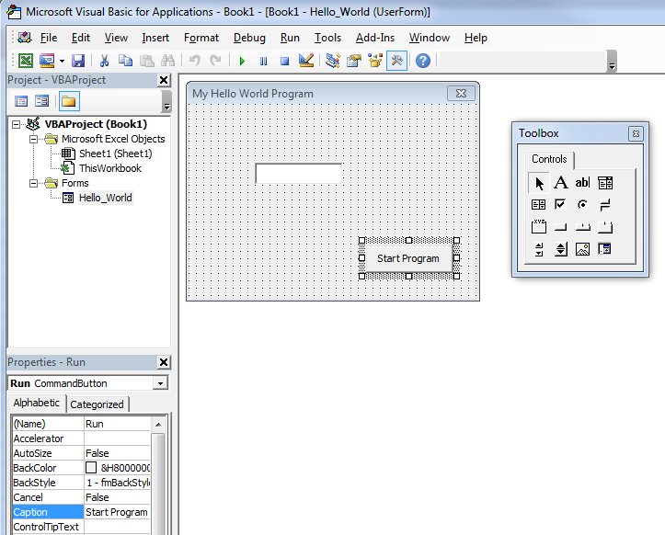

Change the name “CommandButton1” to “Run”

Change “CommandButton1” caption to “Start Program”

Then (making sure you have the “Run” command button selected) click on ViewCode and you should see the following code:

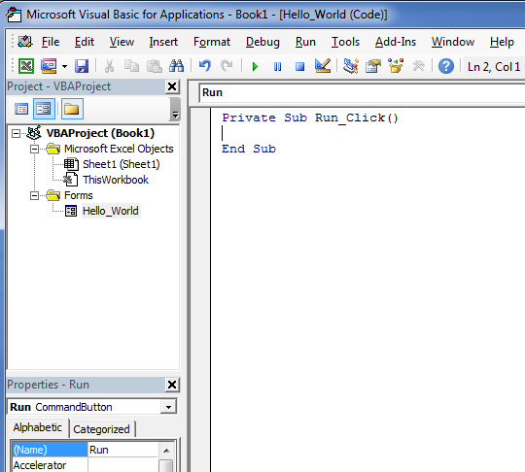
The code is a Visual Basic subroutine ready for some code to tell what the “Voice” textbox should do when you run the program. Write the following code to put what you type in the TextBox into Cell C5:

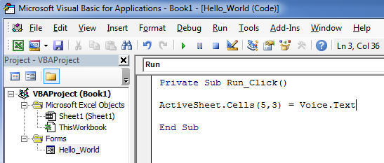

Click on the green Run button begin, then write “Hello World” in the TextBox, and then click on the “Start Program” button. You should see “Hello World” show up in Row 5, Column 3 of the Excel Worksheet [ActiveSheet.Cells(row,column)].

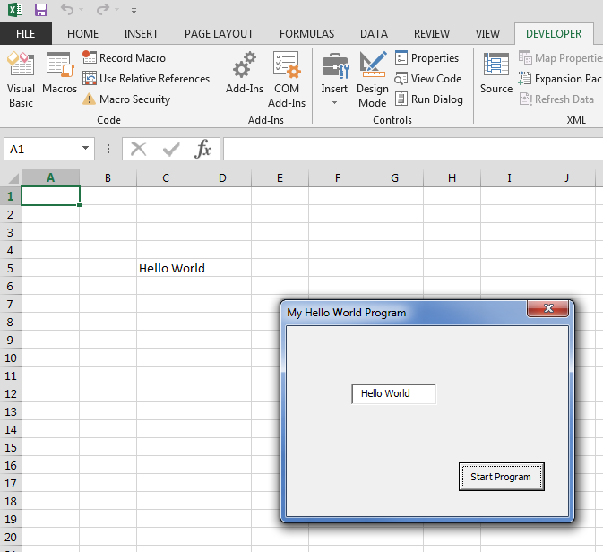

You can go back to the code by clicking on View Code, and when you are in the Visual Basic window you can switch between viewing the code and object by clicking on ViewCode or ViewObject. You have now completed writing your first visual basic code.
Finally to save the code so that it can be used in other Excel worksheets, click on FileExport File and save the Hello_World.frm code to an appropriate place on your computer hard drive. You will see both a Hello_World.frm (a text file which you can read) and a Hello_World.frx file (a binary file).

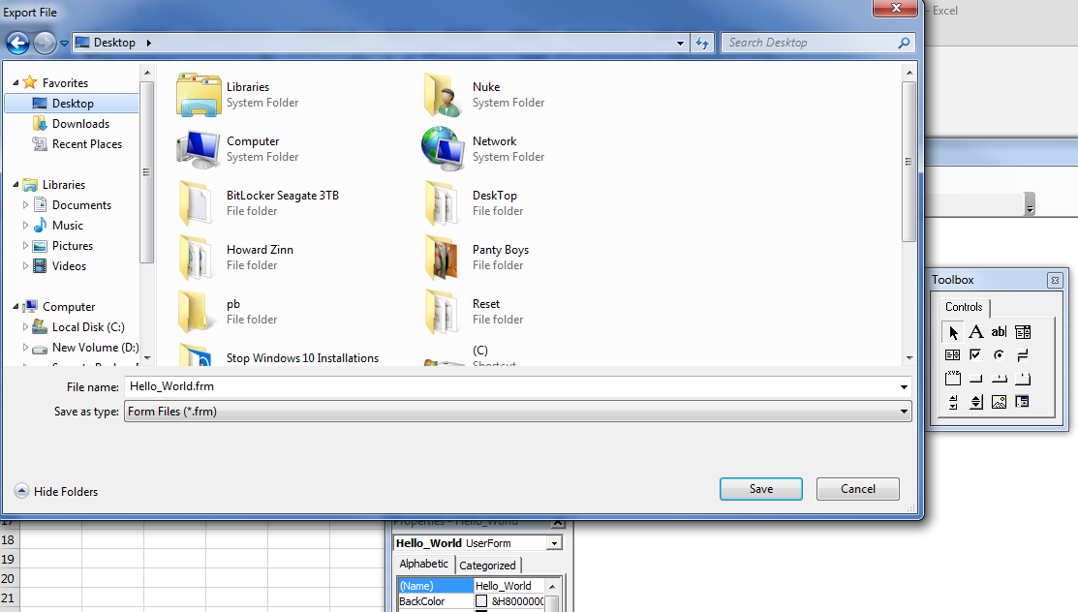

Then, upload your code to Blackboard.

