NORTHERN ILLINOIS UNIVERSITY

PHYSICS DEPARTMENT

Physics 580 – Solid State Physics Fall 2020

Excel Visual Basic Tutorial #2

Variables, Arithmetic, and Debugging

In this lab, we will perform some basic math functions to get an understanding of variables and loops.

For variables (go to https://msdn.microsoft.com/en-us/library/47zceaw7.aspx to see all the different types), it is usually recommended to declare them at the top of your program. For example, to declare a variable as an integer and set its value to 52, use:

Dim x As Integer

x = 52

To declare variable as a single precision real number and set its value to 52.7, use:

Dim y As Single

y = 52.7

To declare variable as a character string and set its value to “Hello World”, use:

Dim z As String

z = “Hello World”

To declare variable as an array holding 4 integers, use:

Dim a(4) as Integer

a(1) = 49
a(2) = 50
a(3) = 51
a(4) = 52

If you do not know what the size of the array should be, use the “Variant” dimension declaration (the following places the numbers 49, 50, 51 into array ):

Dim b as Variant

b = Array(49, 50, 51)

We will use the Debugger feature in Visual Basic to see how variables are assigned values. Click on the Developer menu tab and then click on View Code to enter the Visual Basic editor. Click on InsertUserForm on the Visual Basic menu. In the Properties box for Userform1, change the name “UserForm1” to “Variables” and change the caption to “Using Debugger to Watch Variables”):

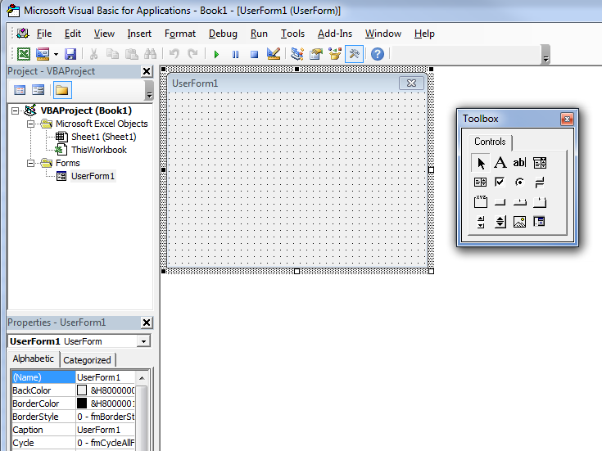

Change the name “UserForm1” to “Variables”

Change the caption “UserForm1” to “Using Debugger to Watch Variables”

Scroll down the Properties window and set “ShowModal” to “False”. This is very important so that you can write in your Excel spreadsheet when your Dialog (or program) is active.

Drag a CommandButton control to the Userform and name it “Run” and give the button a name called “Start Program”.
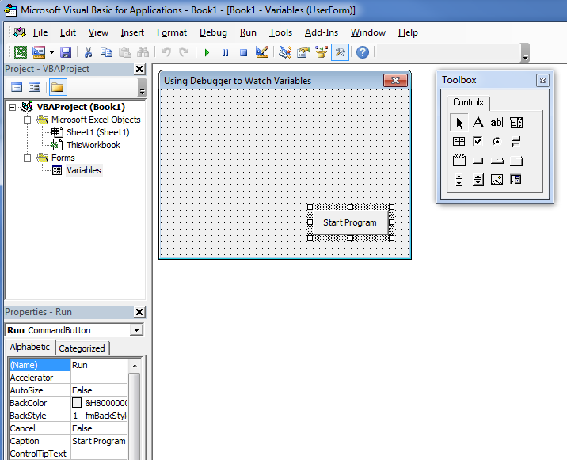

Change “CommandButton1” caption to “Start Program”
Change the name “CommandButton1” to “Run”

Then right-click on the “Start Program” button and select View Code. Then copy and paste following code into the Run_Click subroutine:

Dim x As Integer ' Declaring variable x as an integer
Dim y As Single ' Delclaring variable y as a real number (32-bit floating point)
Dim z As String ' Declaring variable z as a string of characters
Dim xyz As Variant ' Variable xyz does not know whether it is an Integer, Floating point #,
' a string, or an Array (that contains a set of elements)

x = ActiveSheet.Cells(2, 1)
y = ActiveSheet.Cells(3, 1)
z = ActiveSheet.Cells(1, 1)

xyz = Array(x, y, z) ' Storing the values of x, y, and z into the Array xyz

w1 = xyz(0) ' Examining the 1st element of Array xyz (it starts at index 0)
w2 = xyz(1) ' Examining the 2st element of Array xyz
w3 = xyz(2) ' Examining the 3rd element of Array xyz

Add = x + 2 ' Adding
subtract = x - 2 ' Subtracting
multiply = 2 * x ' Multiplying
divide = x / 2 ' Dividing

square = x ^ 2 ' the square of x
squareroot = Sqr(x) ' the square rood of x
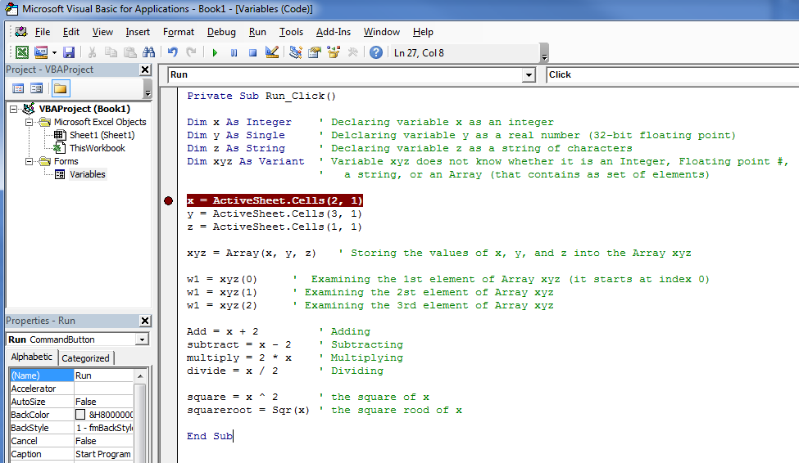

Notice that each comment statement starts with an apostrophe: ‘ . The program does not execute any commands following the apostrophe (everything in “green” is ignored by the program). The brown circle is where the program will stop (break) when you start running the program. To set this breakpoint, click in the border area on the line where you wish the program to stop (clicking on the circle again removes the breakpoint). With your spreadsheet in the background, click on the green Run button to start the program.

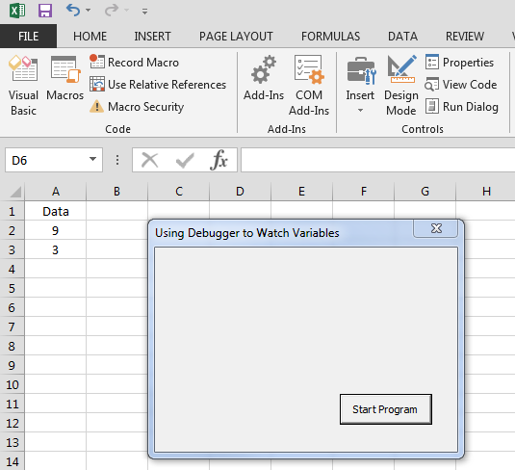
In your Excel spreadsheet write “Data” in cell A1, 9 in cell A2 and 3 into A3 as shown to the left.

Then, click the “Start Program” button. The program will stop at the breakpoint position shown above. Press the function button “F8” at the top of your keyboard. This allows you to step through the program line by line.
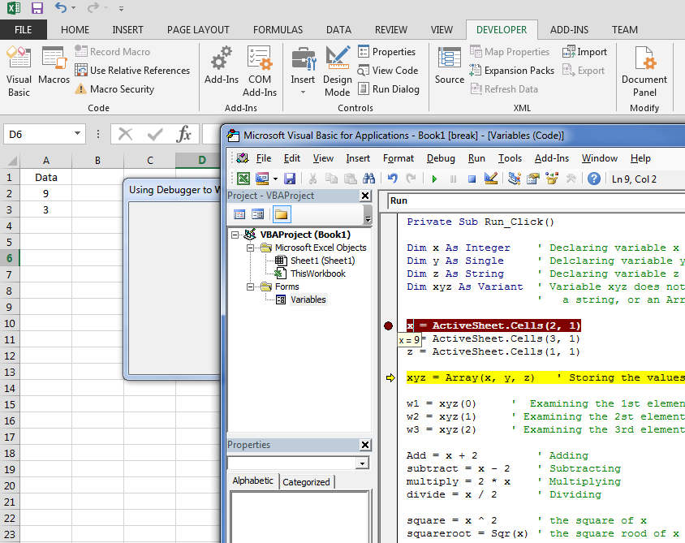

Press F8 until you get to the line “xyz = Array (x, y, z)”. Then, with your cursor, hover over the variable “x”. You should see a box appear with the value stored in the variable “x” (which is 9, which is the value in cell A2 or ActiveSheet.Cells(2,1)). If you hover the cursor over the variable “y”, the value 3 should appear, and hovering over “z” should show the value “Data”. This is a simple way to debug your program to make certain correct values are stored and math operations are made. Press F8 again so that the values stored in x, y, and z are placed into the array xyz. To see the values in the array, press F8 until you get to the line “Add = x + 2”. Then hover the cursor over w1, w2, and w3 and you should see the values for x, y, and z: 9, 3, “Data”. Next, us F8 to step through the remaining calculations, and hover over the variables “add”, “subtract”, “multiply”, etc. to see their resultant values.

Save the code by clicking on on FileExport File, and upload your code called Variables to your Physics 374 OneDrive folder (make a folder within your Physics 374 folder called “Programs” and stuff all your programs there).

To see other math functions, this wikibooks link is a good source: https://en.wikibooks.org/wiki/Visual_Basic/Simple_Arithmetic.

