NORTHERN ILLINOIS UNIVERSITY

PHYSICS DEPARTMENT

Physics 580 – Solid State Physics Fall 2020

Excel Visual Basic Tutorial #4

Do's and If 's

In this lab, we will examine the properties of If-Then-Else conditional structures and Do Loops.

Several sources I referred to on the internet are

https://www.tutorialspoint.com/vba/vba_operators.htm

http://www.homeandlearn.org/if_statements.html

http://www.homeandlearn.org/excel_vba_for_loops.html

http://www.globaliconnect.com/excel/index.php?option=com_content&view=article&id=123:ifthenelse-statements-vba&catid=79&Itemid=475

http://www.globaliconnect.com/excel/index.php?option=com_content&view=article&id=122:excel-vba-loops-with-examples-for-loop-do-while-loop-do-until-loop&catid=79&Itemid=475

If-Then-Else Structures

If-Then-Else structures handle logical conditional statements. The structure is of the form:

If (this statement is TRUE) Then (do this step) Else (do this other step)

There are a few Comparison and Logical Operators you should become familiar with:
(from: https://www.tutorialspoint.com/vba/vba_operators.htm)
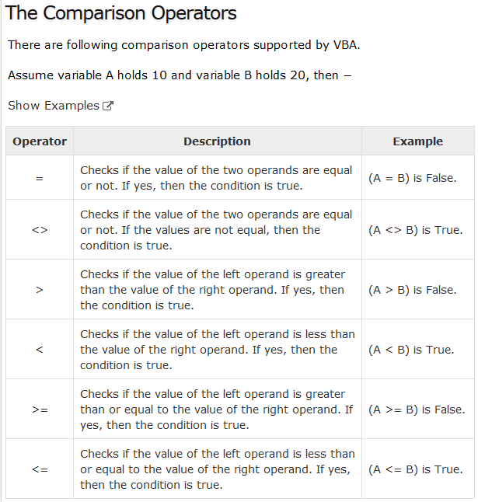
Is A less than or equal to B?
Is A greater than or equal to B?
Is A less than B?
Is A not equal to B?
Is A greater than B?
Is A equal to B?

and a few Logical Operators you should become familiar with;

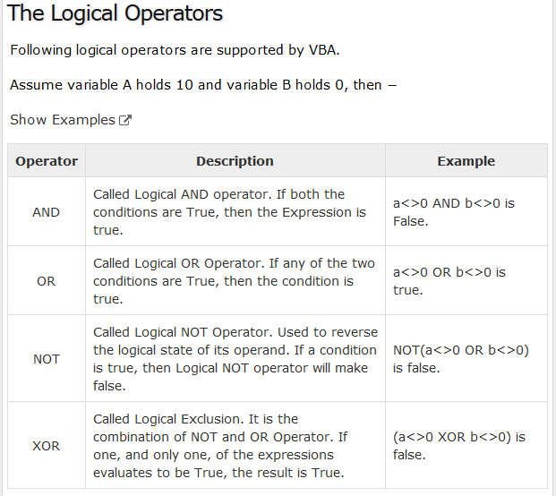
I rarely use NOT or XOR
thus I will skip these
Is (A not equal to zero) Or (B not equal to zero)?
Is (A not equal to zero) And (B not equal to zero)?
We will write a Visual Basic program to examine these relational and logical operators with the If-Then-Else construct. Click on the Developer menu tab and then click on View Code to enter the Visual Basic editor. Click on InsertUserForm on the Visual Basic menu. In the Properties box for Userform1, change the Name "UserForm1" to "StructuredProgramming" and change the Caption to "Do's and If's"):

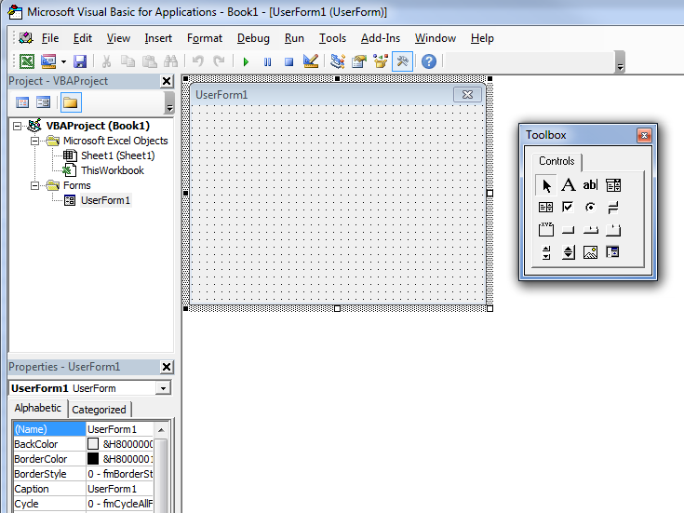

Change the Name "UserForm1" to "StructuredProgramming"

Change the Caption "UserForm1" to "Do's and If's"

Scroll down the Properties window and set "ShowModal" to "False". This is very important so that you can do other things on your computer when your Dialog (or program) is active.

Drag a CommandButton control to the Userform, set the Name to "CloseProgram", and give the button a Caption called "Close" (like what you did in the last tutorial).

Create the following Controls on your UserForm: (see figure below)

(1) Create a CommandButton and set Name = IFs and Caption = IF's.
(2) Create a CommandButton and set Name = Dos and Caption = Do's.
(3) Create a CommandButton and set Name = Do_And_If and Caption = Do And If.
(4) Create a CommandButton and set Name = StanDev and Caption = Standard Deviation.
(6) Create a TextBox and set Name = LowCutOff.
(7) Create a Label and set Caption = Low CutOff Number (do not change its Name).
(8) Create a TextBox and set Name = HighCutOff.
(9) Create a Label and set Caption = High CutOff Number (do not change its Name).
(10) Create a TextBox and set Name = BegRow.
(11) Create a Label and set Caption = Beginning Row (do not change its Name).
(12) Create a TextBox and set Name = EndRow.
(13) Create a Label and set Caption = Ending Row (do not change its Name).

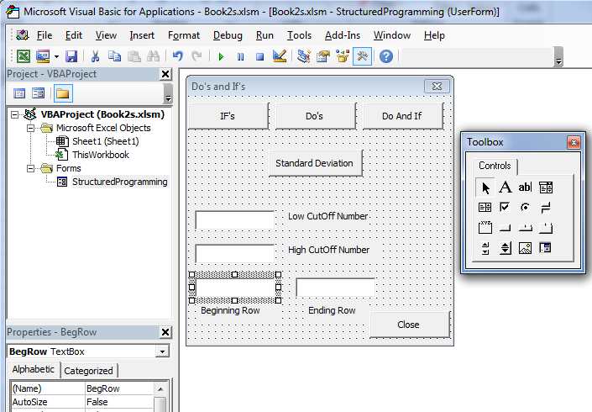

Enter all the data from the Data.txt file attached to this Tutorial into your spreadsheet as shown below:

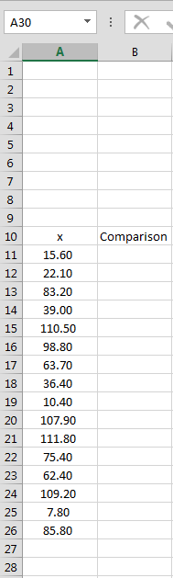

Put data from Data.txt file into Rows 11-26, Column 1
In Row 10, Column 1 put the label: x
In Row 10, Column 2 put the label: Comparison

(1) Right-click on the "Close" OptionButton and select View Code. Enter the following code into the subroutine CloseProgram_Click ( ) (you can copy & paste):

Unload StructuredProgramming

Now, for the "IF's" button, let's write code so that when a "LowCutOff " number is entered, a comparison is made to see whether the spreadsheet number is less than, greater than, or equal to your "LowCutOff " number.

(1) Right-click on the "IF's" OptionButton and select View Code. Enter the following code into the subroutine IFs_Click ( ) (you can copy & paste):

Dim x, y As Single ' Declare x & y as Single Precision numbers

x = LowCutOff.Text + 0 ' Set x to the value in "LowCutOff" TextBox
y = ActiveSheet.Cells(11, 1) + 0 ' Set y to the value of the 1st Data point (Row 11, Column 1)

If (x > y) Then
ActiveSheet.Cells(11, 2) = Str(x) & " > " & Str(y) ' If x > y write character string "x > y"
ElseIf (x = y) Then
ActiveSheet.Cells(11, 2) = Str(x) & " = " & Str(y) ' If x = y write character string "x = y"
ElseIf (x < y) Then
ActiveSheet.Cells(11, 2) = Str(x) & " < " & Str(y) ' If x < y write character string "x < y"
End If

' The symbol "&" is the Concatenation Operator allowing us to join Character Strings together

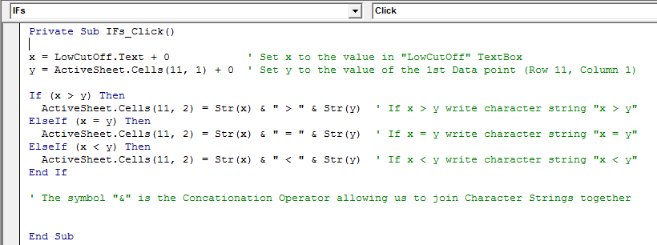

Now, run the code by pressing the Run button. Enter a value in the "LowCutOff " TextBox and then press the "IF's" CommandButton. A result will appear in the Comparison column. Notice the use of the concatenation operator that combines character strings together. For instance, if you wish to combine the string "Hello" with the string "World", use the concatenation operator as follows:
"Hello" & "World"
produces
"HelloWorld"
Notice that spaces are placed in the strings " > ", " = ", and " < " so that the numbers are not right next to the operators when written into the spreadsheet Comparison column.

See this tutorial for more examples: http://www.homeandlearn.org/else_else_if.html

(2) Right-click on the "Do's" OptionButton and select View Code. Enter the following code into the subroutine Dos_Click ( ) (you can copy & paste):

Dim Sum As Single ' Declare Sum as a Single Precision number

iBeg = BegRow.Text + 0 ' Set iBeg to the value in "BegRow" TextBox
iEnd = EndRow.Text + 0 ' Set iEnd to the value in "EndRow" TextBox
Sum = 0# ' Set Sum to the initial value 0.0
' Notice when you write 0.0, Visual Basic changes it to 0# to
' indicate that the variale is a real number and not an integer

For i = iBeg To iEnd ' Loop starts at i = iBeg and ends when i > iEnd
Sum = Sum + ActiveSheet.Cells(i, 1) ' Increase Sum by value in (Row i, Column 1)
Next i ' increment the value of i by 1 (i is set to i + 1)

Npoints = iEnd - iBeg + 1 ' Number of Data points is calculated

ActiveSheet.Cells(2, 1) = "# of Points =" ' Put results at the top of the spreadsheet
ActiveSheet.Cells(2, 2) = Npoints
ActiveSheet.Cells(4, 1) = "Sum ="
ActiveSheet.Cells(4, 2) = Sum
ActiveSheet.Cells(6, 1) = "Average ="
ActiveSheet.Cells(6, 2) = Sum / Npoints

For i = 2 To 6 ' Color matrix of cells from Row = 2 to 6, Column = 1 to 2
For j = 1 To 2 ' a light green color
ActiveSheet.Cells(i, j).Interior.ColorIndex = 35 ' 35 = light green
Next j ' j = index of inner Loop
Next i ' i = index of outer Loop

This code finds the (a) number of data points, (b) sum of all the data points, and (c) the average of your data. The Loop structure is of the form:

For i = (Beginning #) to (Ending #)
Loop
Do stuff

Next i: Increment i by 1: i = i + 1
Start from the beginning again

For example, if the (Beginning #) was equal to 1, the 1st time the loop is executed, i=1. The 2nd time the loop is executed, i=2. The 3rd time, i=3, etc. For the code above:

(Beginning #) = iBeg = 11 (loop starts at Row 11 in the spreadsheet)
(Ending #) = iEnd = 26 (when i > 26, the program exits the loop)
Within the loop:
the (new value of Sum) is set to the (previous value of Sum) + (the value in the i^{th} row).

To see more examples of loops: http://www.homeandlearn.org/excel_vba_for_loops.html

The # of points, sum, and average is put into colored boxes at the top of the spreadsheet.
ActiveSheet.Cells(i,j).Interior.ColorIndex = 35 colors the (Row,Column) cell in the spreadsheet light green. To see all the Color Indices, see the webpage:
http://www.homeandlearn.org/else_else_if.html

Now run the code by pressing the Run button and:

(a) enter 11 into the "BegRow" TextBox
(b) enter 26 into the "EndRow" TextBox
(c) then press the "Do's " CommandButton

You should see the results below:

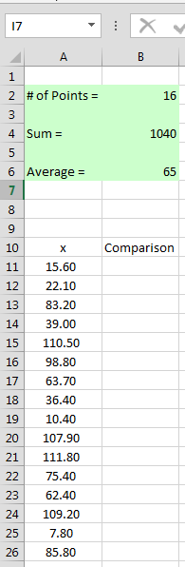

You can check your results by using the COUNT( ), SUM( ), and AVERAGE( ) internal functions of Excel.
(3) Right-click on the "Do And If" OptionButton and select View Code. Enter the following code into the subroutine Do_And_If_Click ( ) (you can copy & paste):

Dim Npts As Integer ' Declare Npts as an Integer
Dim Sum As Single ' Declare Sum as a Single Precision number

Npts = 0 ' Set Npts to zero
Sum = 0# ' Set Sum to 0.0

iBeg = BegRow.Text + 0 ' Set iBeg to the value in "BegRow" TextBox
iEnd = EndRow.Text + 0 ' Set iEnd to the value in "EndRow" TextBox

Lowest = LowCutOff.Text + 0 ' Set variable Lowest to the value in "LowCutOff" TextBox
Highest = HighCutOff.Text + 0 ' Set variable Highest to the value in "HighCutOff" TextBox

For i = iBeg To iEnd ' Loop starting at Row 11 (iBeg) and ending at Row 26 (iEnd)
y = ActiveSheet.Cells(i, 1) ' Data point in (Row = i, Column = 1)

If (y < Lowest) Then ' Flag all points less than our cutoff and color the cells Red
ActiveSheet.Cells(i, 2) = Str(y) & " < " & Str(Lowest)
ActiveSheet.Cells(i, 2).Interior.ColorIndex = 3 ' Color Cell Red
End If

If (y > Highest) Then ' Flag all points greater than our cutoff and color the cells Blue
ActiveSheet.Cells(i, 2) = Str(y) & " > " & Str(Highest)
ActiveSheet.Cells(i, 2).Interior.ColorIndex = 33 ' Color Cell Sky Blue
End If

If (y >= Lowest And y <= Highest) Then ' If data lies in the cutoff region, ignore
Npts = Npts + 1 ' Find the # of point within the good region
Sum = Sum + ActiveSheet.Cells(i, 1) ' Find sum of all points within the good region
End If
Next i

ActiveSheet.Cells(15, 4) = "# of Points ="
ActiveSheet.Cells(15, 5) = Npts
ActiveSheet.Cells(17, 4) = "Sum ="
ActiveSheet.Cells(17, 5) = Sum
ActiveSheet.Cells(19, 4) = "Average ="
ActiveSheet.Cells(19, 5) = Sum / Npts ' Find the average for the good data points

For i = 15 To 21 ' Rows 15 to 21
For j = 4 To 5 ' Columns 4 to 5
ActiveSheet.Cells(i, j).Interior.ColorIndex = 24 ' Color these new values Ice Blue
Next j
Next i

The code above discards data that is considered too poor to be of use. Thus data points lower than the "LowCutOff " value and higher than the "HighCutOff " value are ignored, and a new average is calculated.

Now run the code by pressing the Run button and:

(a) enter 30 into the "LowCutOff " TextBox
(b) enter 100 into the "HighCutOff " TextBox
(c) enter 11 into the "BegRow" TextBox
(d) enter 26 into the "EndRow" TextBox
(e) then press the "Do And If " CommandButton

You should see the results below:

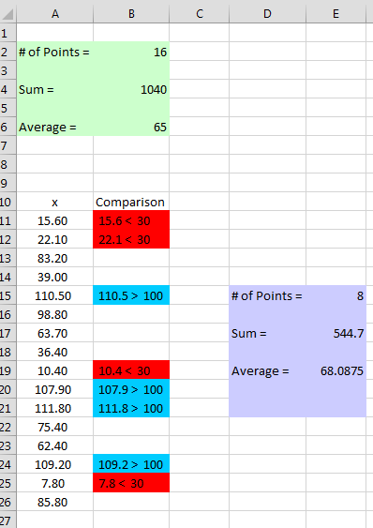

Homework

No code has been written for the "Standard Deviation" CommandButton.

- For this button, write the code to perform a standard deviation calculation for the data on your spreadsheet (lines 11 to 26). Use the formula:

- On Row 8, the program should write the standard deviation when all the data is considered (like the Average on Row 6) and color the cells the same light green.

- On Row 21, the same program should write the standard deviation when considering only the good data between 30 and 100 (like the Average on Row 19, and color the cells the same ice blue).

- Check your results by using the STANDARD DEVIATION internal function of Excel.

Save the code by clicking on FileExport File, and upload your code called StructuredProgramming to Blackboard.

