NORTHERN ILLINOIS UNIVERSITY

PHYSICS DEPARTMENT

Physics 580 – Solid State Physics Fall 2020

Excel Visual Basic Tutorial #3

Dialog Controls

In this lab, we will examine the properties of Dialog Controls.

There are many sources of information on Visual Basic dialog controls on the internet (via Google). A couple of places are:

http://www.homeandlearn.org/index.html (for this tutorial, click on the “Excel VBA and User Forms” or the “An Excel Picture Viewer Project” menu items)

http://www.globaliconnect.com/excel/index.php?option=com_content&view=article&id=127:excel-userform-controls-label-textbox-and-commandbutton&catid=79&Itemid=475
(if you go to the “Excel VBA Online Tutorial” you can Google each of the tutorial chapters without having to sign up online).

We will write a basic program to do simple arithmetic. Click on the Developer menu tab and then click on View Code to enter the Visual Basic editor. Click on InsertUserForm on the Visual Basic menu. In the Properties box for Userform1, change the Name "UserForm1" to "Arithmetic" and change the Caption to "Doing some simple Math"):

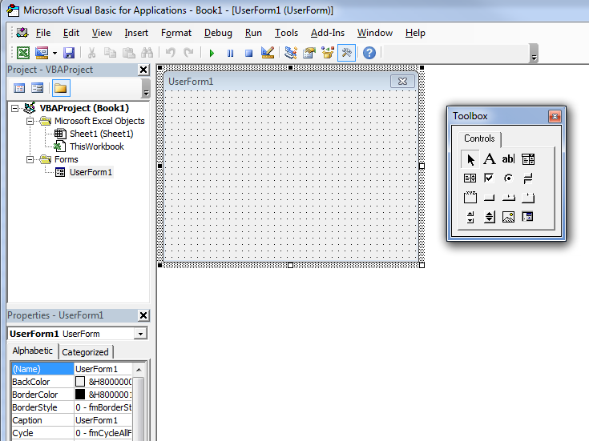

Change the Name "UserForm1" to "Arithmetic"

Change the Caption "UserForm1" to "Doing some simple Math"

Scroll down the Properties window and set "ShowModal" to "False". This is very important so that you can do other things on your computer when your Dialog (or program) is active.

Drag a CommandButton control to the Userform, set the Name to "CloseProgram", and give the button a Caption called "Close".

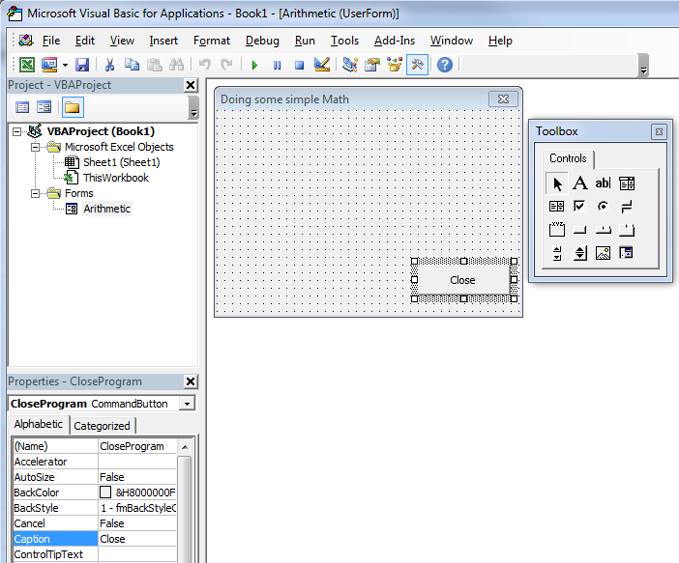

Change the Name "CommandButton1" to "CloseProgram"

Change "CommandButton1" Caption to "Close"

Create the following Controls on your UserForm:
Name = Result
leave Caption blank

Name = Value1

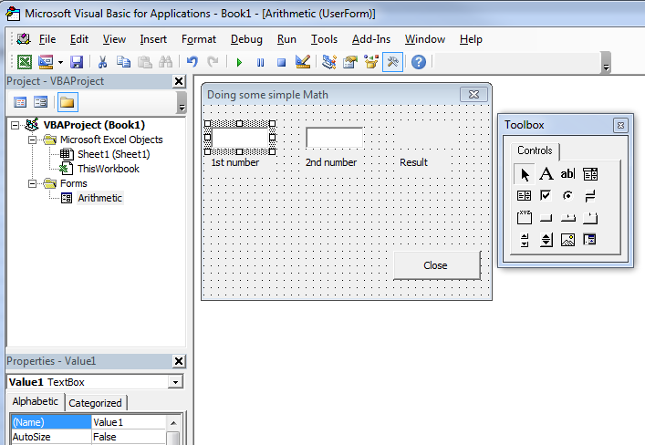
Name = Value2
Caption = 2nd number
Caption = 1st number
Caption = Result

(1) Create a Textbox and set Name = Value1.
(2) Create another Textbox and set Name = Value2.
(3) Create a Label and set Name = Result and leave the Caption blank.
(4) Create a Label and set Caption = 1st number (do not change the Name).
(5) Create a Label and set Caption = 2nd number (do not change the Name).
(6) Create a Label and set Caption = Result (do not change the Name).

Example: 1 + 3 = 4

Result
Value2
Value1

Labels 4, 5, and 6 are given Captions to help the user of your calculator.

Next, we want to put in simple math operations like add and multiply. We will allow the user to press a button to make the choice to either add or multiply. To couple the buttons together so that only one button is selected at a time, we need to add a Group box control called a Frame in Visual Basic—it groups all the buttons together. Drag a Frame control to your UserForm—you will have to resize it to make it fit in the space shown below.
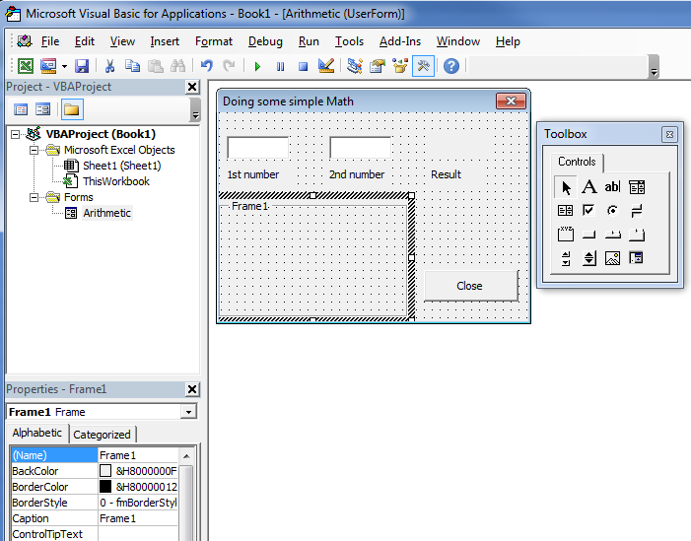
Change the Caption "Frame1" to "Arithmetic Operations"
Do not change the Name

Next, drag three button controls into the Frame region (see figure on next page):

(1) Create an OptionButton and set Name = Add and Caption = Add.
(2) Create an OptionButton and set Name = Multiply and Caption = Multiply.
(3) Create an OptionButton and set Name = Clear and Caption = Clear.

The "Clear" button will allow us to clear all the results just like we do on a regular calculator.
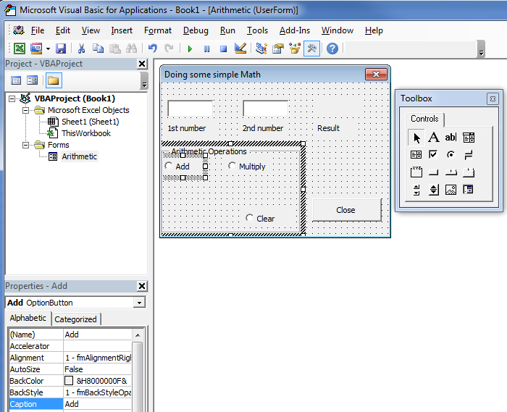

You can now run the Visual Basic program just to see how the TextBoxes and Buttons work. You can press buttons and write numbers into the TextBoxes, but nothing will happen since there is no code written. Now we are ready to write the code for each Control.

(1) Right-click on the "Add" OptionButton and select View Code. Enter the following code into the subroutine Add_Click ( ) (you can copy & paste):

x = Value1.Text + 0 ' Variable x is given the value of whatever is entered in "Value1" TextBox
y = Value2.Text + 0 ' Variable y is given the value of whatever is entered in "Value2" TextBox
' Adding + 0 changes the variables x & y from string variables to real numbers

Z = x + y ' Simple addition

Result.Caption = Str(Z) ' The Caption of the "Result" Label is set as Z
' The Str( ) operator changes Z from a real number to a string variable

' Note: TextBox and Label values can only be string variables

Result.TextAlign = fmTextAlignCenter ' Align Text in the center of the TextBox
Result.Font.Size = 14 ' Font Size 14 pnt
Result.Font.Bold = True ' Bold Font
Result.ForeColor = RGB(0, 0, 255) ' Blue text
Result.BackColor = RGB(255, 255, 0) ' Yellow background
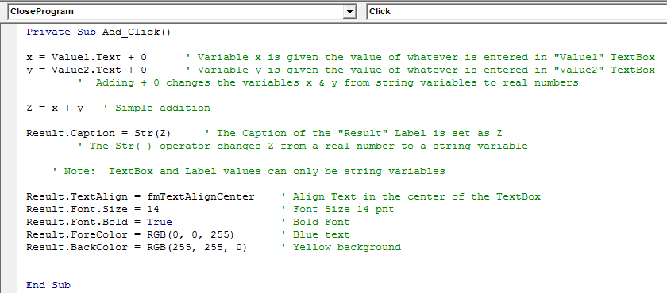

(2) Right-click on the "Multiply" OptionButton and select View Code. Enter the following code into the subroutine Multiply_Click ( ) (you can copy & paste):

x = Value1.Text + 0 ' Variable x is given the value of whatever is entered in "Value1" TextBox
y = Value2.Text + 0 ' Variable y is given the value of whatever is entered in "Value2" TextBox
' Adding + 0 changes the variables x & y from string variables to real numbers

Z = x * y ' Simple multiplication

Result.Caption = Str(Z) ' The Caption of the "Result" Label is set as Z
' The Str( ) operator changes Z from a real number to a string variable

' Note: TextBox and Label values can only be string variables

Result.TextAlign = fmTextAlignCenter ' Align Text in the center of the TextBox
Result.Font.Size = 14 ' Font Size 14 pnt
Result.Font.Bold = True ' Bold Font
Result.ForeColor = RGB(255, 255, 0) ' Yellow text
Result.BackColor = RGB(255, 0, 0) ' Red background

(3) Right-click on the "Clear" OptionButton and select View Code. Enter the following code into the subroutine Clear_Click ( ) (you can copy & paste):

Value1.Text = " " ' "Value1" TextBox is cleared by writing to it a blank character string: " "
Value2.Text = " " ' "Value2" TextBox is cleared by writing to it a blank character string: " "
Result.Caption = " " ' The Caption to the "Result" Label is cleared with a blank character
Result.ForeColor = RGB(224, 224, 224) ' Light Grey text
Result.BackColor = RGB(224, 224, 224) ' Light Grey background

(4) Right-click on the "Close" CommandButton and select View Code. Enter the following code into the subroutine CloseProgram_Click ( ) (you can copy & paste):

Unload Arithmetic ' Closes the Program (the "Arithmetic" UserForm Dialog)

(5) Right-click on the "Value1" TextBox and select View Code. Enter the following code into the subroutine Value1_Change ( ) (you can copy & paste):

Add.Object.Value = False ' Clear the "Add" OptionButton state (so that it is no longer selected)
Multiply.Object.Value = False ' Clear the "Multiply" OptionButton state
Clear.Object.Value = False 'Clear the "Clear" OptionButton state

Result.Caption = " " ' The Caption to the "Result" Label is cleared with a blank character
Result.ForeColor = RGB(224, 224, 224) ' Light Grey text
Result.BackColor = RGB(224, 224, 224) ' Light Grey background

(6) Right-click on the "Value2" TextBox and select View Code. Enter the following code into the subroutine Value2_Change ( ) (you can copy & paste):

Exactly the same code given in Part (5) above.

Explanations to Steps (1) to (6):

- For the UserForm all inputs are character strings. So Value1.Text is a character string. Setting: x = Value1.Text would set x to a character string.
To make x a real number, add 0 to the string: x = Value1.Text + 0. Now Visual Basic understands that the programmer wants x to be a real number.

Example: x = "15" + 0. Visual Basic sets the variable x to the real number 15.

Notice that the program crashes when you try to add or multiply when the TextBox fields are blank. That is, Visual Basic does not know what to do with the statement: x = " " + 0, and thus the program crashes. If the program crashes and you decide to go into Debugger mode, when you are done Debugging, click on the Reset button to exit the Debugger mode.

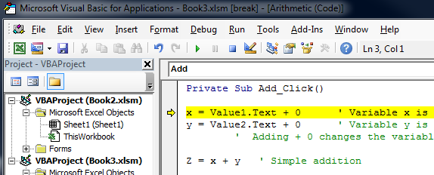

- The Str( ) function sets a real number to be a string. This must be done to put a number into a TextBox or a Label as a character string. Only character strings can be put into TextBoxes and Label Captions.
- String characters are denoted by double quotation marks.
For example: "Hello World" is a character string. A blank character string has nothing between the double quotation marks. For example: " " is a blank (or null) character string. Thus, the character strings in the "Value1" and "Value2" Textboxes and the "Result" Caption are set to zero with the blank character string.

- To close the UserForm Dialog program, use the Unload function.

- When a user inputs new numbers into one of the TextBoxes, it is necessary to clear all OptionButtons. When an OptionButton is pressed, it stays pressed until another OptionButton is pressed in the Frame box. To put it back in the unpressed state, the .Object.Value of the OptionButton is set to False. The "Result" Caption is also cleared.

- The Result.TextAlign, Result.Font.Size, etc. functions allows us to change text alignment, size, bold font, and color of font and background. When you type "Result." (with the period at the end) when editing a subroutine, a window will pop up and give you a list of options as to what to type. It is impossible to remember all these options, thus I usually end up doing a Google search if there is a property I wish to use. The following website is where I got the idea to use these functions:
http://www.globaliconnect.com/excel/index.php?option=com_content&view=article&id=127:excel-userform-controls-label-textbox-and-commandbutton&catid=79&Itemid=475

Homework

The Arithmetic Dialog program is missing the arithmetic operation of division.

- Insert a "Division" OptionButton into the program so that the user can do division arithmetic operations.

- Modify the Clear_Click subroutine so that the "Division" button is no longer selected when "Clear" is pressed.

- Modify the Value1_Change and Value2_Change subroutines so that the "Division" button is no longer pressed when a user inputs new numbers into the TextBox fields.

- Make the program work so that when a division operation is performed, the background and text color is different than that for addition and multiplication (do a Google search on RGB colors to find out the other possible colors).

Save the code by clicking on FileExport File, and upload your code called Arithmetic to Blackboard.

