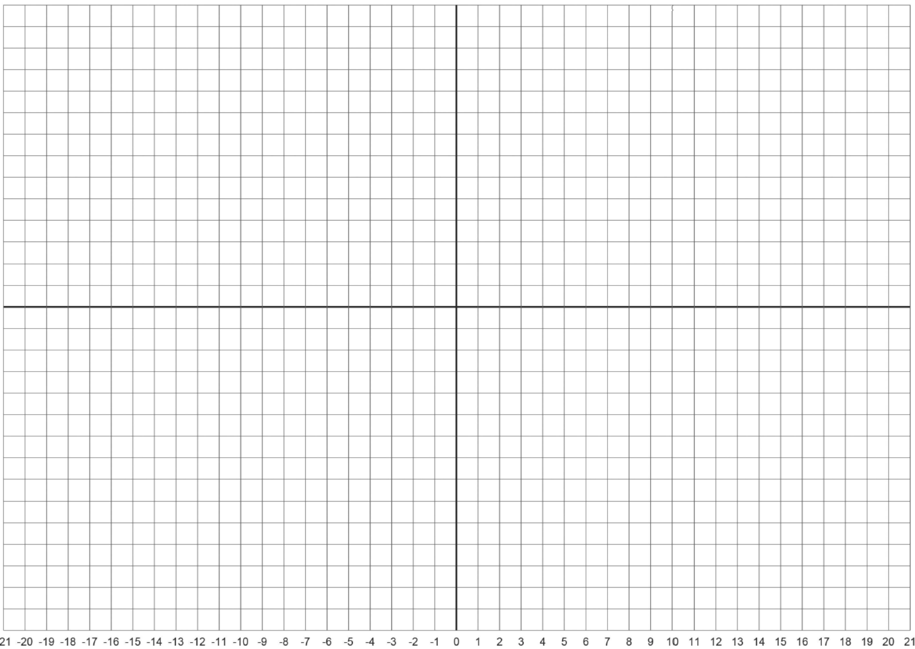
Problem 108, Chapter 2 in Openstax: Use ray-tracing to find final image and show that results agree with the (numerical) lens equation results.
to draw lines, use Microsoft Word Draw: “Insert”, “Shapes”, select line

Quiz #3, Problem #4 (worth 25 points)
C
F₂
F₁
O

