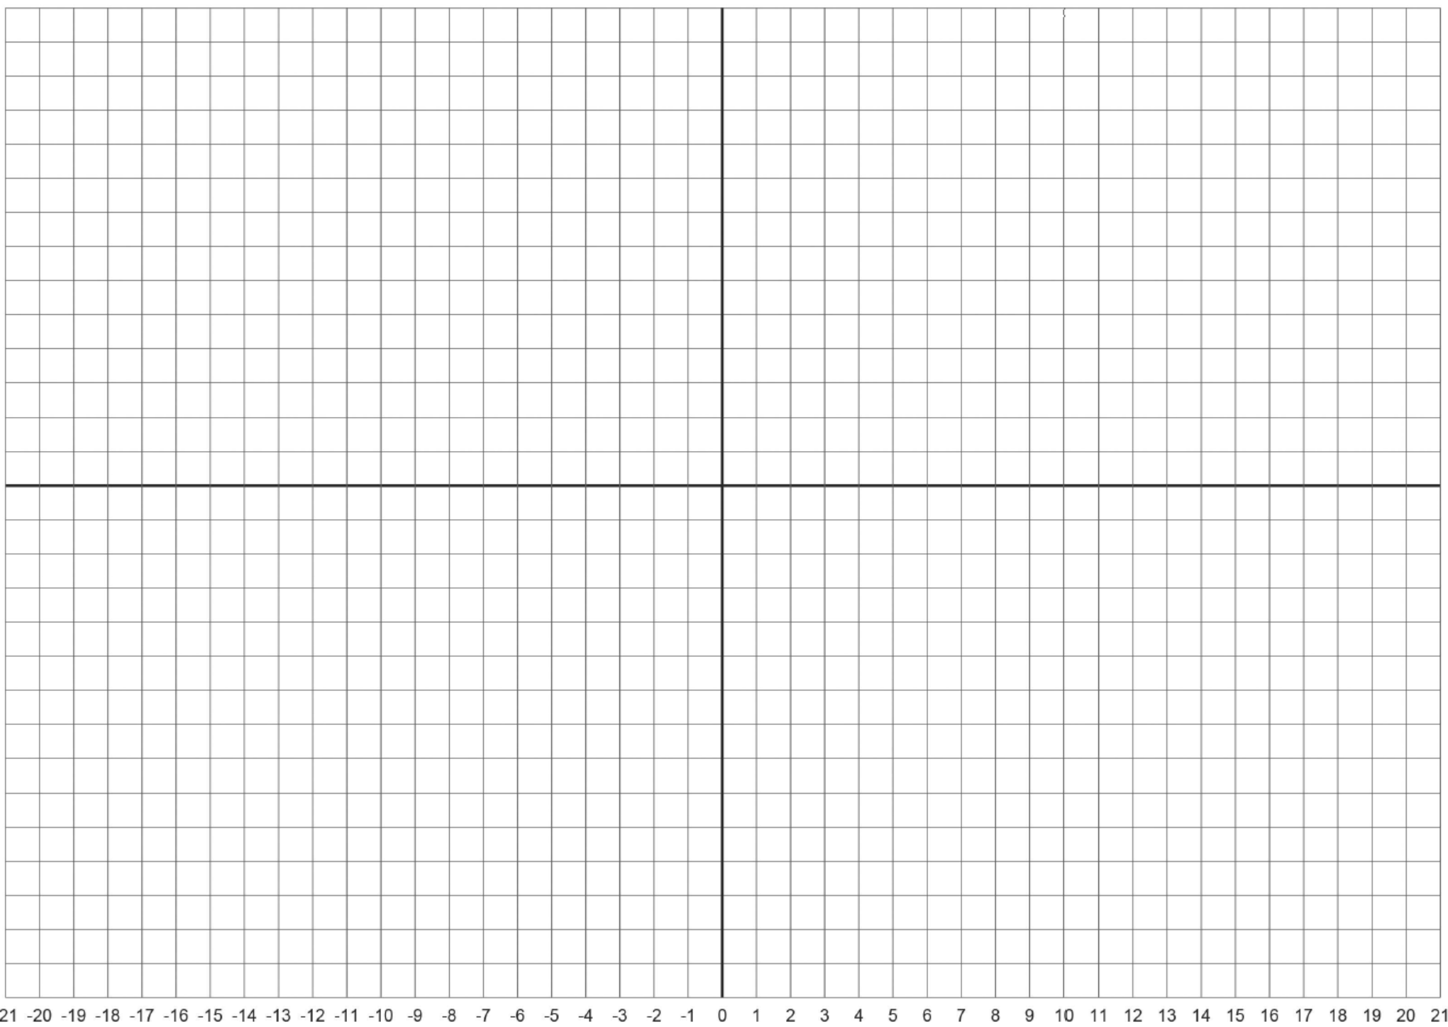
Each division is 1cm. Object is 2.5 cm tall. Find the height and position of the final image relative to the diverging lens (draw it as an arrow). Show that results agree with the (numerical) lens equation results on a separate sheet of paper. Further instructions given below (scroll down to the bottom):

To draw lines, use Microsoft Word: “Insert”, “Shapes”, select line. To draw straight lines, hold the “shift” key while drawing line. Also, you can hold the “shift” key to elongate or shorten a line.
F₁ = 5cm (converging lens), F₂ =12 cm (diverging lens)
F₂
F₁
O
Quiz #3, Problem #4 (worth 25 points)

