Plotting with Excel Pre-Lab
Name: ______________________________________ Lab Section: ______________
Date: __________________

PreLab Activity (10 points) – Complete prior to your lab session

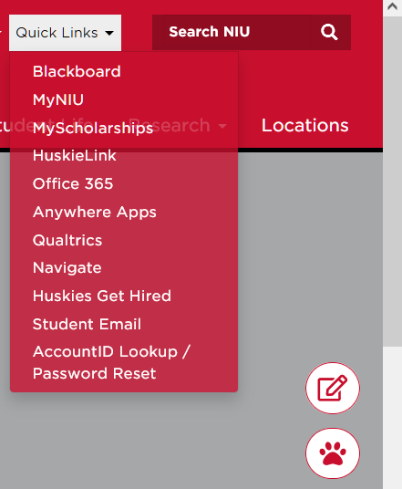
- Get Microsoft Word up and running on your PC or Mac laptop or desktop. All students have access to NIU’s sitewide license to Office 365. If you do not have it installed, go to Quick Links on the NIU homepage (www.niu.edu) and select the Office 365 link. You will see on the Office 365 page in the upper right hand corner an Install Office dropdown:


Follow the instructions and download and install it on your computer. We will have a computer lab this week, so if you have a laptop (Mac or PC) you may want to bring it to lab.

- Download the “Plotting with Excel Pre-Lab” from the Physics 210 Webpage:

https://www.niu.edu/brown/courses/physics-210-f21/index1.shtml

Open up the “Plotting with Excel” Word document in your Office 365 Word app. Fill out your name, lab section, and date at the specified place at the top of the Word document. You will upload your Pre-Lab Word document to Blackboard at the end of the lab.

- Do Part E of the “Plotting with Excel” lab where you are to draw the block on a slide. Show your result below:

- Do Part G of the “Plotting with Excel” lab where you are to type and equation in Word. Show your result below:

- For the more adventuresome, try your hand at typing the following equation:

End of Prelab – UPLOAD THIS WORD DOCUMENT TO BLACKBOARD AT THE END OF THE LAB SESSION

