Legislative Report
25 February 2022
Jim Lockard
Northern Illinois University Annuitants Association

Springfield has been mostly quiet since my last Legislative Report. There have been no truly significant actions by the General Assembly (GA) that affect most NIUAA members, to the best of my knowledge. Perhaps the following information items will be of interest.
Of primary concern to most members are issues and actions related to pensions. Legislatively, there has been little to report for months. A couple of developments are worth noting.
First, the state’s financial picture benefitted greatly from federal “covid relief” funding, such that the governor projected a $1.7 billion surplus for the fiscal year, the first in 25 years. The state also has received credit upgrades for the first time in at least 20 years. Gov. Pritzker plans to add an additional $500 million to the state’s payments to the state retirement systems, over and beyond the normal “full” (or more accurately, minimal) funding. That’s hardly a major dent in the state’s unfunded liabilities, but still worth noting and appreciating. Due to the strength of investments, the unfunded liabilities decreased from $144 billion at the end of 2020 to “only” $130 billion last year. Source: Chicago Tribune
Second, Gov. Pritzker has repeatedly stated that he will not support any effort to amend the Pension Protection Clause of the Illinois Constitution. That is precisely the change constantly demanded by groups like Wirepoints and the Illinois Policy Institute. The latter, in particular, disseminates anti-pension, anti-union, anti-covid-mitigation, and anti-General Assembly reports and messages regularly. It’s proposed “hold harmless” pension reform plan would “not hurt retirees” and is described as follows:
A “hold harmless” pension plan developed by the Illinois Policy Institute can save taxpayers nearly $2.4 billion in its first year and nearly $50 billion through 2045.
The plan is modeled off the 2013 legislation and reduces future benefit growth for current workers and retirees.
It still treats benefits earned for work already performed as an inviolable contract. What changes is adjustments can be made going forward to ensure pensions are sustainable and affordable in the long term, with a goal of being 100% funded as opposed to the current state goal of 90%.
The plan would replace the 3% compounding post-retirement increase with a measure attached to inflation. This allows the state to fully fund employee pensions and keep its promise to young workers far from retirement.
Polling showed 61% of voters across party lines support the plan. Hold-harmless reform is the best chance at controlling Illinois’ growing pension debt.

Perhaps I missed the documentation for that final claim about voter support for the plan, but I have to wonder how the poll was conducted, presumably by the IPI. I find it’s claim of being a “nonpartisan 501(c)(3) research organization” amusing, at best, though it has convinced the IRS that it deserves that tax-advantaged categorization.
Third, despite relatively modest participation, the governor and the General Assembly are contemplating extending the pension buyout program to 2026, while borrowing another $1 billion to fund it. HB4292 passed the House on Feb 24, 2022 and is under consideration in the Senate.
Organizations like the IPI that clamor for “pension reform” seem to be unaware of the reforms that already have taken place, notably the Tier II pension plan that has applied to all new-hires since 2011. Yet to be implemented by SURS is Tier III, an optional, hybrid combination of Defined Benefit and Defined Contribution plans, which became law in 2017 as Public Act 100-0023. Implementation of the plan was to be “as soon as possible” for each retirement system. Thus far, only two small Chicago pension systems have implemented Tier III.
For your information, in its July 2021 report (starting on page 9) the Commission On Government Forecasting and Accountability summarized the plan’s benefits:
Tier 3 Benefit Summary
• Retirement Annuity: 1.25% for each year of service credit multiplied by final average salary
• Normal Retirement: determined by Social Security Administration, but no earlier than 67 years of age with at least 10 years of service COLA: Beginning 1 year after annuity start date and equal to 50% of the CPI-W
• Survivor’s/Widow’s Annuity: 66 2/3% of participant’s retirement annuity
• Employee Contribution for the DB component: 6.2% of salary (cannot exceed normal cost)
• Employee Contribution for the DC component: 4% minimum
• Employer Contributions for the DC component: between 2% and 6% of salary o Employer contributions vest when they are paid into a participant’s account. o Employee and employer contributions are transferrable into other qualified plans.
• For SURS and TRS o Employer Contribution: DB Normal Cost - Employee Contribution + 2% (expressed as a % of payroll)
I have not been able to determine where implementation of Tier III within SURS stands, but if/when that happens, a comparison of the Tiers will be warranted. Tier II
In my last report, I wrote about the 2020 Census. Among my points was this: “While there will be much talk of the evils of gerrymandering, you can expect that those in power in Springfield will do everything possible to maintain, even increase their hold on state government and in DC…. A Federal court invalidated a new map drawn in June and will be looking at another drawn in September.” The revised map was challenged as “racially gerrymandered” because it broke up “a cohesive Black community in the East St. Louis area” among other districts. However, a federal court in late December 2021 upheld the map.
The old (2010) and new (2020) maps are shown below, with the 2022 map reflecting the loss of one house seat in Congress due, not to population loss in Illinois, but slower growth than in states such as Texas and Florida. Clearly, Illinois is not a blue state geographically.
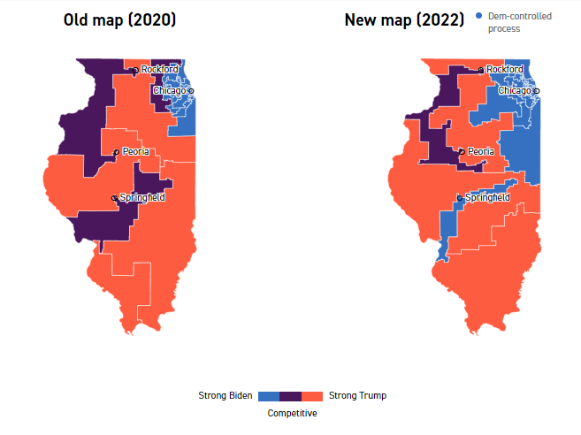

The impact on Illinois’ Congressional seats is show in this graphic:
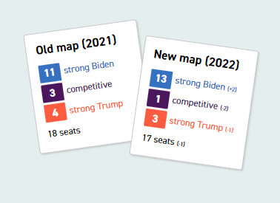
Source: Politico

Previously I wrote about the little-known Health Care Right of Conscience Act (HCRCA), which was being used to justify refusal to take the COVID vaccine. The General Assembly did amend the Act (with the governor’s signature) to clarify that employers may adopt and enforce measures to reduce COVID spread in the workplace, effective June 1, 2022. Until then, employees can still avoid vaccination for “conscience-based objections.” With the constantly changing landscape of COVID, the long-term significance of the amendment is unclear. Source:JDSUPRA
In the interest of keeping our membership informed, I will continue to share the kinds of information provided above and will watch closely for any pension attacks that seem to be gaining traction. We must be prepared to support measures that will be helpful to the state and the pension systems and to fight against proposals that would harm the future well-being of all public employees.
If you are not receiving my periodic Google Groups emails with the most up-to-date information, please alert me (jalockard@gmail.com) and I’ll be sure you are on my special email list. (There have been no such emails for a number of months now, due to lack of information to share.)

