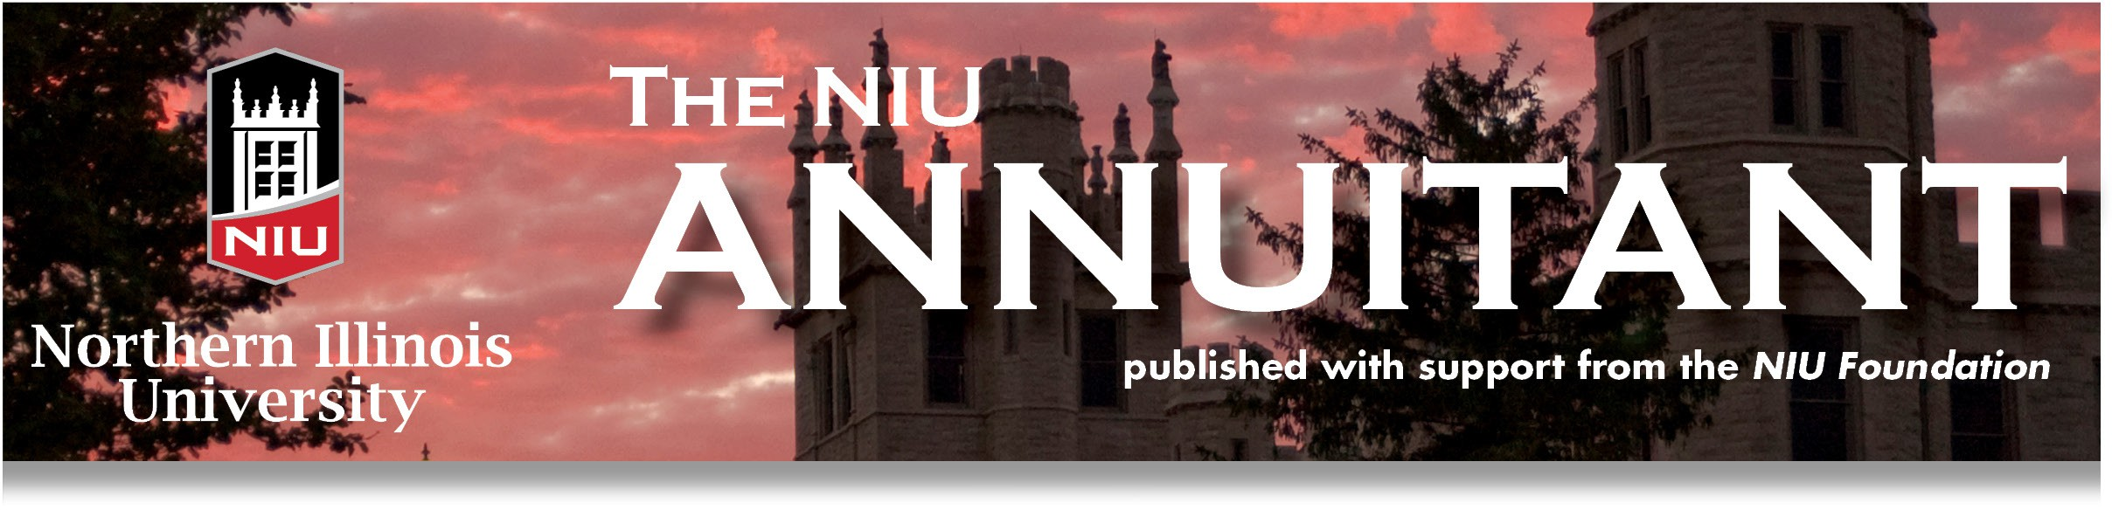

# The NIU Annuitant – May 2025

## A Note from the President

The birds are starting to sing and the grass is turning green. Signs of spring and of hope are present even among the many changes and unknowns in our world. NIUAA continues to move forward and is gaining momentum since our COVID setbacks. To that end, I am pleased to report on the two Social Coffees we hosted in December at Faranda’s in Dekalb (see pictures) and in March at Oak Crest. Over 70 people joined us for conversation with new and old colleagues, legislative updates from Steve Cunningham, and a short but wonderful presentation by Dave Sinason on senior fraud. The Board hopes to continue these social opportunities next season, so watch your news for dates and places.

On Tuesday, July 1st we will be hosting our Annual Membership Meeting Luncheon at Barsema Visitor’s Center from 11:30-2:00 PM. Mark your calendars now! Our special guests will include a representative from President Freeman’s office, legislative updates from Steve Cunningham, and a special report from Bryan Soady, Executive Director of SUAA. Bryan spoke to us last year, but so much has happened and changed with SUAA that we believe you will want to hear his latest information. I encourage you to bring a colleague or friend to the luncheon to continue growing our state-leading membership and empower our members with critical information about health care, retirement, and more. Applications to join NIUAA will be available at the event.

A reservation is needed if you plan to attend the luncheon, so please get that to Chris Doe at AnnuitantsAssoc@niu.edu or call 815-753-1508 as soon as you can so we have enough food. Like last year, we will ask attendees to donate whatever they can toward the lunch to offset the event cost.

These are exciting times. I hope you all learned in December/January of the Social Security Fairness Act and, for those who qualified for Social Security benefits, you have already received them. SUAA continues to help advocate for Tier II retirement benefits. Watch for legislative updates from SUAA and Steve Cunningham, legislative chair, that come to you. We have identified five delegates from our Board who will attend the SUAA Assembly in June to represent our chapter in decision-making.

Finally, I want to share that it has been my honor to be your president for the past two years. Thanks to all of you for your support and continuing to be members of our great chapter. Special thanks to Andy Small (who will be retiring from the Board) for his leadership and help in all matters of the organization. He stepped up numerous times to chair meetings when others were incapacitated. Special thanks to Ferald Bryan, who has served on the board for four years and has been a tremendous asset as our representative on the Parking Committee. I welcomed Terry Borg as Vice President in July and believe we are in great hands under his leadership. And thanks to those who have served as board members, committee chairs, task force members, and all who make us a strong and vibrant presence in the state. To ALL our members, current and future, watch out for spam emails or phone calls, stay healthy and safe, and I’ll see you at the Annual Membership Luncheon on July 1st!!! --*Toni Tollerud*

## Annual Meeting - NIU Annuitants Association July 1, 2025, 11:30 a.m. to 2 p.m. Sandwich buffet luncheon 12 p.m. Guest speaker: Bryan Soady, Executive director, SUAA; Legislative updates; NIU updates Barsema Alumni and Visitors Center Northern Illinois Univeristy 231 N Annie Glidden Rd, DeKalb RSVP by June 23, 2025 AnnuitantsAssoc@niu.edu or 815-753-1508 If you are unable to attend in person please email RSVP for the zoom link.

## Vice President’s Report

Teamwork accomplished two major projects this quarter:

The first project was the finalization of our Bylaws revision. This project involved many over the past two years. Building on the report developed last year by Mike Peddle, Clair Williams, Paul Stoddard, and Toni Tollerud, then receiving additional input from Andy Small, Debbie Haliczer, and myself, we codified the changes in preparation for discussion at the July 1, 2025, NIUAA Annual Business Meeting. The revisions/updates are mainly “housekeeping" and no changes are made to the operation of NIUAA.

The second project was establishing a slate for elections. Again, with the help of many, a team of NIUAA supporters, including Toni Tollerud, Pat Vary, Andy Small, and myself, found members to volunteer for leadership roles. Come to the Annual Business Meeting and vote for these committed individuals.  My thanks to all for the support I received in this task.

*Terry Borg*

## A group of people sitting at a table

**NIUAA social coffee at Oak Crest**

## University Benefits Committee Report

The NIU University Benefits Committee meets monthly to discuss benefits updates and issues impacting current employees and annuitants. Spring Semester 2025 hot topics included:

--The Health Alliance Plan will no longer be a medical insurance option for State of Illinois employees after June 30, 2025. If you are impacted, SURS should have communicated with you. Contact SURS should you have any questions.

--Tier II Pension Reform continues to be discussed in the Legislature. Currently being considered are four potential changes that will align it more with Social Security.

--The actuarial review of the Money Purchase formula for pension calculation resulted in a change effective July 2, 2025. This is not a significant change, so it will only take a couple of months to make up the difference.

*Terry Borg*

NIUAA Vice President and UBC Chair

**A group of people standing on a sidewalk outside of an airport
**

**Return from Vietnam**

## Trips and Travel Schedule

Organized by *Steven Johnson*

Culture and Travel Committee Chair

Director, LA&S External Programming (retired)

### Travel Report

Our small group of 12 recently returned from a Vietnam and Cambodia trip. While there, we cruised Ha Long Bay, toured Hanoi, visited Angkor Wat temple in Cambodia, went to the Royal Palace in Phnom Penh, cruised the MeKong River from Phnom Penh to Vietnam, and toured Saigon. The slogan of the trip was “Boy, is it hot!” Our group included six NIU retirees: Jeanette Biava, Mitra Mohabbat, myself, Patricia Perkins, George Tarbay, and Mark Cordes.  As usual, a donation has been made to the NIUAA scholarship fund on behalf of the travelers on this trip.

We did not reach the minimum number of travelers for the summer trip to Mount Rushmore.  The trip has been rescheduled as a fall trip, departing from DeKalb on September 21. The travelers who signed up for the trip look forward to others joining us in the fall.

### 2025 Schedule

|  |  |
| --- | --- |
| **Dates** | **Travel Event** |
| May 14-24 | Portugal and Douro River Cruise |
| May 30-June 7 | Greek Islands & Turkish Coastlines  by SuperYacht |
| June 6-22 | Atlantic cruise, Fort Lauderdale to Montreal |
| July 21-25 | Stratford Festival 2025 (WAITLIST) |
| September 11-17 | New York City & The Statue of Liberty, $1125 |
| September 21-27 | Mount Rushmore, the Badlands & Black Hills of South Dakota |
| October 1-12 | The Best of Ireland (SOLD OUT) |
| November 10-14 | Branson Show Extravaganza |
| November 30-December 8 | Christmas markets cruise on the Danube (SOLD OUT) |

### 2026 Schedule

|  |  |
| --- | --- |
| **Dates** | **Travel Event** |
| January 8-31 | South America & Antarctica |
| July 27-31 | Stratford Festival 2026 |
| October 3-18 | Arctic Journey & the Northern Lights Cruise |
| November 8-December 6 | Far East Discovery: Tokyo to Singapore |

**In Memoriam**

|  |  |
| --- | --- |
|  |  |
| Evangeline (Angie) Agnos  Patricia Aiello  Carl Albright  Byron Anderson  Larry Anderson  Donald Brod  Patricia Bute  Jeanne Chakraborty  Donald Claude  E. Rod Deihl  Loreata Dye  Wenke Hansen  Carol Hertzner | John Hetland  Elaine Hohmann  Kathleen Johnson  Evelyn Luoma  Robert Martens  Clark Neher  Lorys Oddi  Philip Rider  Merilyn Scholl  Suzanne Sedlacek  Tomasina Stephon  Shaikh Tissa  Arthur Young |

**A group of people sitting at a table
**

**NIUAA social coffee at Oak Crest**

## Legislative Report

It has been a very busy time for SUAA as 2024 had gotten underway, including a productive transition with our new Executive Director, Bryan Soady. Bryan is actively engaging with the State Legislature and governmental agencies in Springfield, while simultaneously getting to know our different chapters and SUAA leadership across the state.

First, congratulations to NIU for advancing to be the largest SUAA chapter in the state. NIU has always been close to the UIUC membership number but has now taken the lead, and NIU has always led the state in percentage of SUAA membership

in proportion to the number of employees. Statewide, I want to acknowledge and express appreciation on behalf of SUAA for Andy Small’s work and leadership as Co-Chair of our Membership Committee. Membership and participation are essential to the strength of the SUAA organization and our ability to fulfill our mission of defending and advocating for the retirement benefits of all higher education personnel (over 250,000 SURS participants).

The SUAA Finance Committee, originally proposed by and with the active participation of Clair Williams, has also been diligently reviewing SUAA finances and opportunities for cost savings in coordination with Bryan and SUAA Treasurer, Larry Kloc. The Finance Committee is especially productive as part of our Executive Director transition process. The work of our Membership and Finance Committees is closely related and both will help inform a SUAA strategic planning process anticipated later this year.

On a very positive note, SUAA recently enthusiastically endorsed Governor Pritzker’s proposed FY25 State budget, which clearly reflects the full scope of funding requirements for SURS and the State pension systems, proposes adjusting the funding target for the resolution of unfunded liabilities from 90% to a 100% funding ratio, and simultaneously provides solid funding for Illinois’s system of higher education. With these multiple objectives, the FY25 legislative budget process offers a great opportunity for SUAA to work in partnership with the leadership of Illinois higher education in advocating for Governor Pritzker’s FY25 budget.

Several issues related to the Aetna MAPD continue to be reported and fielded by SUAA’s State Office in Springfield, including concerns about new costs associated with the Silver Sneakers wellness program, that we are working on addressing.

Meanwhile, we are starting the planning process for SUAA’s Annual Meeting in Springfield scheduled for June 20. We will be assembling a Nominating Committee to recruit candidates for upcoming Board position turnovers. As I approach the conclusion of my two-year term as SUAA President, it has been a very eventful year, and I will always appreciate the endorsement and support of NIUAA.

*Steve Cunningham*

Chair, Legislative Committee

## A group of people sitting at a table

**NIUAA social coffee at Oak Crest**

## Treasurer’s Report for 2024

Total Income: $13,541.35

Total Expenses: 9,482.31

Income minus expenses: $4,059.04

CD Balances (as of 2/22/25): $25,545.92

*Paul Stoddard*

NIUAA Treasurer

## Membership Report

Congratulations, NIUAA Members!

NIUAA is the number one chapter in the state, with the highest number of members of any of the chapters! Of 53 chapters reporting, NIUAA continues to lead the way due to the commitment and dedication of our members. At the state level, SUAA continues expanding its services to enhance members’ benefits. On a personal note, I am completing my term as Past President and would like to take this opportunity to thank all the dedicated NIUAA Board members I have worked with. NIUAA is in great hands as we continue to lead the way in our state.

*Andy Small*

NIUAA Membership Chair

SUAA Membership Co-Chair

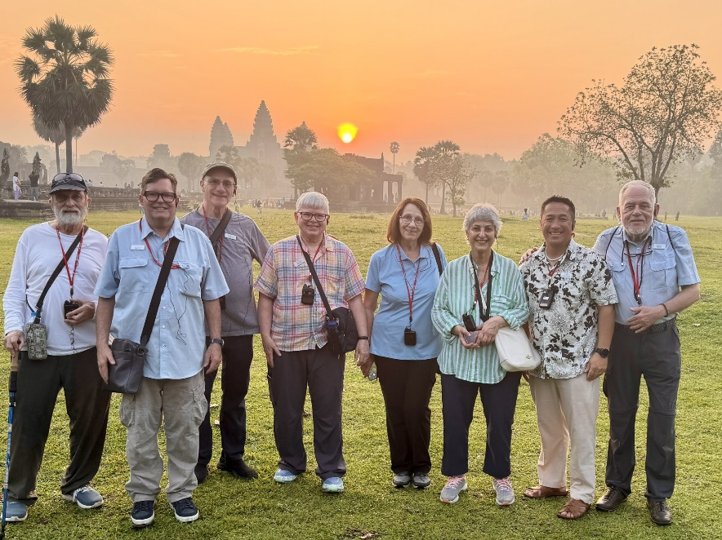

**Angkor Wat**

**Wellness Fair May 9, 2025**

**9 AM to 4 PM**

CMS and NIU will host the 2025 Wellness Fair in the Holmes Student Center Regency Room on May 9, 2025, from 9 AM to 4 PM. The fair is primarily aimed at current employees; however, annuitants will have the opportunity to speak with representatives of various benefits providers. CMS will make presentations at 11 AM and 2 PM.

**CMS Enacts Split Family Coverage July 1, 2025**

CMS is moving to split family coverage effective July 1. This means that individual family members will move to the Medicare Advantage TRAIL program when they are eligible and not when all family members are eligible. Thus, a single-family household could have a mixture of medical insurance providers. Current annuitants in this situation should have received a letter from CMS in March. More information will be available during the May Benefits Choice Members Wellness Fairs. NIU’s Fair will be held on May 9, 2025. Other dates and locations can be found in the Benefits Choice booklet.

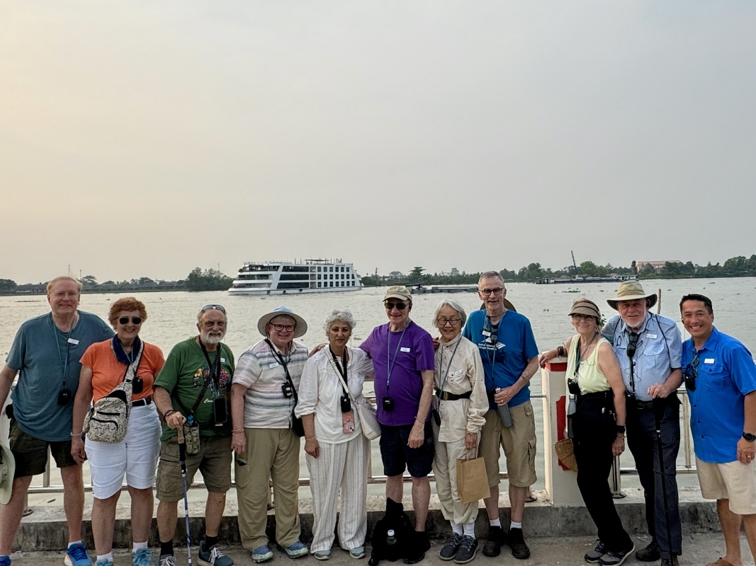

**Mekong River**

**A group of people posing for a photo
in front of the Royal Palace**

**The Royal Palace**

**the NIU ANNUITANT**Northern Illinois University Foundation  
DeKalb, Illinois 60115-2882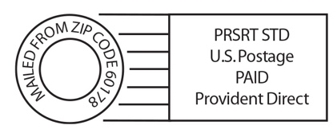

## NIUAA 2024-2025 Officers, Directors and Committee Chairs

### Officers

|  |  |  |  |
| --- | --- | --- | --- |
| **President** | Toni Tollerud | 815- 501-4784 | [tonitollerud@gmail.com](mailto:tonitollerud@gmail.com) |
| **Vice President** | Terry Borg |  | [tborg2@niu.edu](mailto:tborg2@niu.edu) |
| **Secretary** | Pat Wielert |  | [pwielert63@gmail.com](mailto:pwielert63@gmail.com)) |
| **Treasurer** | Paul Stoddard |  | [prs17@yahoo.com](mailto:prs17@yahoo.com) |

### Directors

|  |  |  |
| --- | --- | --- |
| Ferald Bryan | 815-753-7100 | [fbryan@niu.edu](mailto:fbryan@niu.edu) |
| Paul Crawford |  | [ptcrawford59@gmail.com](mailto:ptcrawford59@gmail.com) |
| Jay Monteiro |  | [jmonteiro@niu.edu](mailto:jmonteiro@niu.edu) |
| David Sinason |  | [dsinason2@gmail.com](mailto:dsinason2@gmail.com) |
| Andy Small, Past President | 815-762-5971 | [asmall1@niu.edu](mailto:asmall1@niu.edu) |
| Pat Vary | 815-762-1505 | [psvary@gmail.com](mailto:psvary@gmail.com) |

### Committee Chairs

|  |  |  |  |
| --- | --- | --- | --- |
| **Audit and Finance** | Michael Fortner |  | [mikefortner@earthlink.net](mailto:mikefortner@earthlink.net) |
| **Benefits** | Terry Borg | 815-762-1310 | [tborg2@niu.edu](mailto:tborg2@niu.edu) |
| **Communication/ Newsletter Editor** | Diane Johns | 815-758-6259 | [ladybugdgj@aol.com](mailto:ladybugdgj@aol.com) |
| **Culture and Travel** | Steven Johnson |  | [sjohnso11@niu.edu](mailto:sjohnso11@niu.edu) |
| **Education** | Debbie Haliczer | 815-793-1487 | [dhhaliczer@gmail.com](mailto:dhhaliczer@gmail.com)) |
| **Legislation** | Steve Cunningham |  |  |
| **Membership** | Andy Small | 815-762-5971 | [asmall1@niu.edu](mailto:asmall1@niu.edu) |
| **Parliamentarian** | Ferald Bryan | 815-753-7100 | [fbryan@niu.edu](mailto:fbryan@niu.edu) |
| **Scholarship** | Clair Williams |  | [cdw0845@comcast.net](mailto:cdw0845@comcast.net)) |
| **Social** | Pat Vary |  | [psvary@gmail.com](mailto:psvary@gmail.com)) |
| **University Liaison** | Christina Doe | 815-753-1508 | [annuitantsassoc@niu.edu](mailto:annuitantsassoc@niu.edu) |