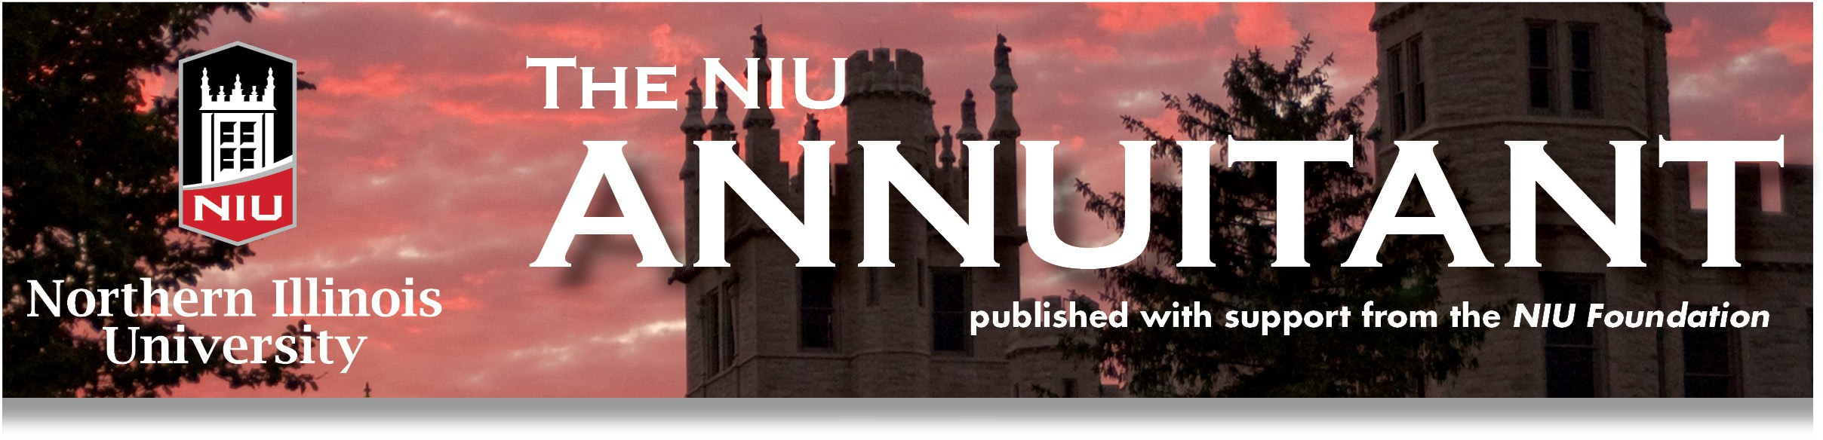

The NIU Annuitant - Spring 2026

President's Remarks

What’s the best medicine?

About a year ago I returned from a trip with what I thought was traveler’s stomach. After a week without relief, I went to the doctor. She ordered a CT scan and a day later I had emergency surgery removing 6” of my colon along with a tumor. While recovering at Delnor Hospital, I received the pathology report and was diagnosed with Non-Hodgkin’s Mantle Cell Lymphoma. After additional testing, it was determined I was Stage 4. I was told that without treatment my life expectancy would likely be 12-18 months. Immediately I thought of all the things that I needed to get done. At the top of the list was cleaning the basement, clearing out the garage, and organizing my files.

In the weeks that followed, I sought multiple second opinions to identify the best treatment and oncology team. During that time, many friends and family members reached out with support. Each conversation gave me strength and hope. Once I began a treatment plan that offered the possibility of ten more years, the conversations multiplied with many acquaintances, and sometimes strangers, who have lived the same experience and just wanted to share. People simply wanted to connect and encourage. I had always intellectually understood the importance of social engagement in retirement; now I was living it. Social engagement is powerful and energizing. It shapes your mindset. And in my case, it became a key part of my recovery.

NIUAA needs your social engagement. We need your involvement for as little or as much as you would like to give.
- Do you like planning parties? Join Pat Vary (Social Chair) in planning and implementing NIUAA coffees.
- Do you like sharing your knowledge and expertise? Join Debbie Haliczer (Education Chair) in conducting presentations for NIUAA members.
- Do you like creating and maintaining spreadsheets? Assist Holly Nicholson (Scholarship Chair) in tracking and forecasting awards.

These are just a few of the opportunities available. If you have other ideas where you would like to be involved, please share. We want your ideas so we can provide greater value to our members. Please contact me at tborg2@niu.edu with your involvement ideas.

After six months of chemotherapy, I am now in remission. Our Aetna Medicare Advantage PPO has been outstanding, covering my chosen medical treatment and team. It is even providing me medical transportation at no cost from DeKalb to Chicago for treatments. By the way, the basement and garage can wait. I have a new list, and at the top is to stay healthy, socially engage, and be involved!
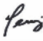

Terry Borg
NIUAA President

Vice President’s Report (with bonus comments on Membership)
Back when I was more current with professional literature, several books and articles were written about “learning organizations.” One of the key principles for such an enterprise is fostering “mental models” that produce new ways of perceiving the world we live and work in. Refreshed models can promote unconventional conversations that yield new
solutions. Today the NIU Annuitants Association is learning to renew itself–its “mental models” and practices–in the face of social change.

The term “wicked problem” describes complex challenges that are difficult to solve because available information is incomplete. The issue of NIUAA membership, while not a wicked problem per se, has now become more complex. As a community-based learning association, NIUAA is grappling with the question of remaining the most robust chapter within the State Universities Annuitants Association (SUAA). Alas, the current trend for almost all SUAA chapters is one of decline. This is due to such realities as retiree deaths, decreasing employee rolls, and the shift from Tier I to Tier II annuitants. Additionally, younger (predominantly Tier II) employees have a different view of community-based associations in general. Post-baby boomer generations are more individualistic; they are not habituated “joiners.” Finally, today’s social communication framework is multifarious: printed newsletters and end-of-the-day social gatherings are less convenient for our younger colleagues.

As Vice President and Chair of the Membership Committee, I have come to see the importance of developing new mental models for fostering NIUAA membership. Membership recruitment efforts cannot be completed using methods that were successful when NIU boasted over 24,000 students (vs. approximately 16,000 today) and had an annuitant-eligible employee population of over 3,400 (as compared with today’s 3,036).

What steps is NIUAA taking? We have engaged in a bit of head-scratching but we’re not wringing our hands! We are in communication with the SUAA Membership Committee (where our Chris Doe holds a position) and we have had exploratory conversations with Brian Soady (SUAA’s Executive Director/CEO) and his staff. To be clear, other SUAA chapters are grappling with the same issues as NIUAA. There are certain forms of technology that might be deployed (e.g., a digital communication method called “geofencing” that produces text messages to invite individuals to membership), but these need more examination before we invest accordingly. SUAA is also modernizing its print and digital resources (more website and less paper). We have all come to a new place and are having to map the terrain; this will take some time. But we’re on the case as we watch the sun rise. Do visit the new SUAA website at www.SUAA.org!

Our future approaches to membership will, of necessity, look different. We’re not clear on those approaches just yet; we are going to have to engage in some experimentation.

Turning to a cloud on the horizon, there is a lingering threat to the Illinois Constitution, which currently protects our state’s pension systems. In 2028, a ballot initiative will be inviting citizens to consider the “Illinois Constitutional Convention Question.” This is a clear and present danger to our pension system; certain politicians are keenly interested in scaling back our hard-won benefits. While this is a threat, it offers us an opportunity to craft a message to our younger member-prospects: become engaged to protect your future retirement benefits and secure your family’s best possible future.

Terry Borg and Matt Volk are engaged with the Membership Committee, and we are planning to have routine meetings with the various employee councils this calendar year, such as with the Operating Staff Council on May 7th. Additionally, we hope to begin working with Liz Guess in HR to engage with employees stepping into retirement, perhaps our best option for garnering “enlightened self-interest.”

Our colleague Clair Williams has also been diligent in ensuring that we are in communication with members whose membership fees are past due and are thus in danger of falling off our rolls. This, therefore, is a big thank-you to Clair for his outstanding service.

Paul Crawford
NIUAA Vice President

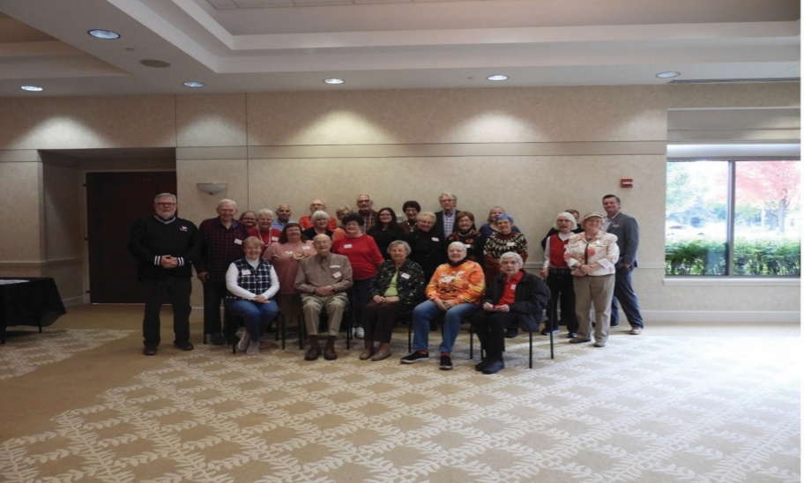
NIU Foundation event, October 2025

Treasurer’s Report
Ah, high finance. Arbitrage, hedge funds, short sales, day trades. But with total assets of about $34K, this is not the world we play in. Our financial situation is much simpler, consisting of a checking account with a balance currently sitting at just under $7700, and four CDs with a total value of $26.5K. The big news is that we are moving the CDs from First State Bank to Resource Bank. Resource Bank allows us much more flexibility in accessing our funds. We should be able to withdraw money with as little as a week’s notice, rather than having to wait until the next maturation date. We’ve already transferred about half of our vast portfolio (2 CDs) and will transfer the rest as they mature later this spring. We will also be transferring checking from FBNO to Resource, so that all our banking needs will be provided in the same place. This will make moving money around much easier when needed.

Paul Stoddard
Treasurer

Scholarship Committee Report
This past October, the NIU Foundation generously sponsored a social gathering for our members with a fine continental breakfast. During that gathering we learned about the NIU Forward Campaign via presentations by Michael Daigler (President/CEO) and Steve Slocum (Director of Planned Giving). We also had a personal presentation from one of our NIU Annuitant Scholars, Ms. Isabella Rodriguez, and a letter from the other recipient, Ms. Marlen Hueramo.

This year’s scholarships will be awarded to two students from the College of Visual and Performing Arts: one for $2,150 and the other for $1,000. Beginning in the fall of academic year 2026 we will be offering three scholarships to students in the College of Business.

The committee has developed a communications plan to encourage current employees to give to the fund. Payroll deduction is available through a simple form on NIU’s website. Under “NIU Foundation Gift Allocation,” select “Other.” Under “Specify ‘Other’ Gift Allocation,” enter “Annuitants Association Scholars.” You can also download a gift form from the Annuitant Association’s website (the form works best when using Chrome as a browser).

Holly Nicholson
Scholarship Committee Chair

Legislative Report
During the past year, Bryan Soady has continued to enhance and emphasize our State Governmental Relations team in Springfield, and I want to acknowledge the extent of coverage and engagement that our Springfield Office is now capable of undertaking in the State Governmental Relations context. The 2026 Illinois Legislative Calendar has scheduled only 50 session days, consistent with election year schedule trends. Accordingly, we do not anticipate significant legislative initiatives in relation to State Pension benefits. Nor do we anticipate potential action to establish a SURS DROP (Deferred Retirement Option Plan). A DROP program provides options for participants to implement their retirement options and elect to continue working for a specified time period (typically 5 years or less) while the retirement benefits are deposited into a holding account distributed as of the future retirement date. Representative Katie Stuart (working with SUAA) introduced a DROP plan bill (HB2920) in 2025.

Likewise, Representative Stephanie Kifowit (working with SUAA) introduced a bill this year (HB5134) to expand SURS mailings to include email distributions for associations like SUAA. Senator Robert Martwick (working with SUAA) introduced SB3413 this year, which would create the Healthcare Ombudsperson(s) role at the Illinois Department of Central Management Services.

Tier II reform continues to be emphasized in SUAA’s Legislative Platform and proprieties. However, we do not anticipate significant Legislative Tier II initiatives during the 2026 Session, just as we do not expect significant movement on HB2920, HB5134, or SB3413 during this election year cycle. A Third-District Appellate Court decision was published on March 9 that declined to require Tier II amendments for the Judges Retirement System (JRS) and, by extension, for the General Assembly Retirement System (GARS).

As of March 5, the Commission on Government Forecasting and Accountability released its updated FY26 and FY27 revenue projections. For FY26, COGFA revised its estimate of General Fund revenues to $55.98 billion, increasing the projection by
$686 million. For FY27, COGFA estimates General Fund revenues of approximately $55.52 billion, which is $458 million less than its revised FY26 estimate. The reduction is attributed to slowing growth in the national and Illinois economies and changes in federal tax policies.

As of the date of this report (March 11), significant events continue to occur at the federal level that may have long-term implications for our National and State economies. In February, Governor Pritzker published the FY27 State Budget proposal. The 639-page document highlights and emphasizes the status of the State Pension System funding ratios and the continuation of responsible funding plans to fulfill both current and long-term actuarial financial obligations. Governor Pritzker has also adopted a 100% long-term actuarial Funding Ratio by 2048 (versus the 90% target outlined for 2045 in existing statutes).

Finally, with the Illinois Primary Election Day scheduled for March 17, SUAA will continue to monitor the Primary results, and we encourage our members to support candidates committed to State Pension benefits integrity and funding.

Steve Cunningham
Legislative Committee Chair
In Memoriam
Andrea Bonnicksen
A. Lisa Parts
Brent Wholeben
Darlene Royer
Dawn Ericksen
Dorothy Mortell
Frank Bazeli
Gordon Kresheck
James Giles
John Engstrom
Judith Young
Laurine Laplanche
Linda Liston
Lois Self
Patricia Sherman
Stanley Trail

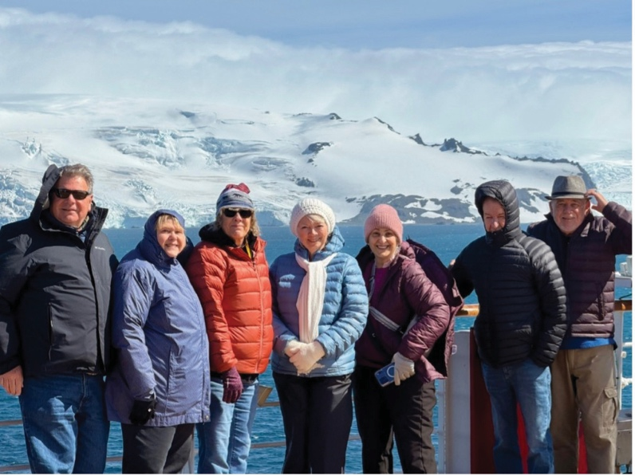

Travels to South America and Antartica, January 2026

NIUAA Trips to Europe, South America and Antarctica
December 2025: Our small group began in Munich and visited Christmas markets in Germany, Austria, Slovakia and Hungary. NIU retirees included: Dianna Strink (and Daniel Strink); Professor David Ballantine and Diane De Mers; Kathy Higgerson (and Bob Higgerson), Julie Weber (and Tom Weber). The weather was warmer than DeKalb: no snow but also no sun until Budapest. We all enjoyed the river cruise and there were only some minor incidents (one trip on a staircase, one broken handle on a suitcase).

January 2026: We returned to Winter having spent most of January in South America and Antarctica. It was summer there, so we missed some bad weather in DeKalb. We had a few issues on this trip. Some luggage got delayed by the cruise line
so some folks were without luggage for two days; however, the group experienced only minor illnesses and few visits to the onboard medical center, and we saw millions of penguins—more than anyone could count. In addition to the whales and seals plus the glaciers, it was an amazing trip/cruise. A donation to the NIUAA Scholarship Fund has been made on behalf of the group.

The NIU annuitants participating included: Kathy Higgerson, Steven Johnson, Mitra Mohabbat, Susan Russell, Michael and Robin Rothamer, Dianna Strink, George Tarbay, and Robert Zerwekh.

Steven Johnson
Culture and Travel Committee Chair, NIU Annuitants Association
Retired Director of LA&S External Programming

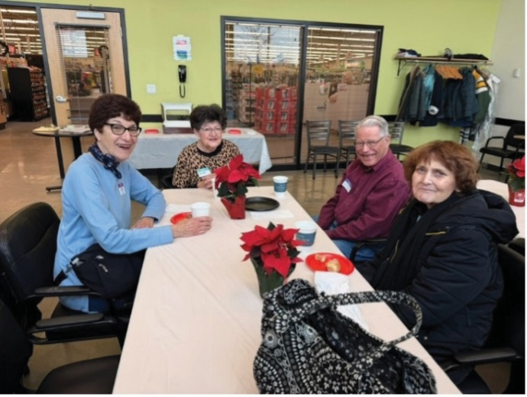
NIUAA Coffee Social, December 2025

Trips and Travel Schedule

2026 Schedule
Dates | Travel Event
May 19 – 29 | Italy from Sorrento to Rome
June 8 –12 | Nashville (value trip, $949)
June 18 – 25 | Trains and Canyons of the West (SOLD OUT)
July 27 – 31 | Stratford Festival 2026 (LIMITED SPACE)
September | New York City (value trip, $1,125)
October 3 – 18 | Arctic Journey & the Northern Lights cruise with the History Channel
November 8 – December 6 | Far East Discovery cruise: Tokyo to Singapore

2027 Schedule
Dates | Travel Event
January 8 – 31 | Panama Canal cruise: Miami to San Diego plus Acapulco
February 18 – March 2 | Treasures of the Pharaohs Nile River cruise with Jordan extension
June 16 – 26 | Sensations of the Seine & Normandy with Paris

2028 Schedule
Dates | Travel Event
January | Australia, Coral Sea and Fiji
June | Voyage of the Vikings

For more information, contact Steven Johnson at (815) 756-1547
Steven Johnson
Culture and Travel Committee Chair | Retired Director of LA&S External Programming

Ideas Welcomed
A great benefit of retirement is that we’re free to indulge our appetite for knowledge. Every day we wake up to a smorgasbord of tasty ideas for our hungry curiosity to gobble up, if we so choose. One day we might gnaw on a meaty existential question, such as “What was here before the Big Bang?” or “Where does consciousness come from?” Another day we may graze on lighter fare, like “How come horses sleep standing up, and what keeps them from falling over?” or “Why is the sky blue?” or “What’s the difference between a troll and an ogre?” Regardless of our individual tastes in gathering and digesting information, the truth is that none of us ever stops learning. To stretch this metaphor even further, it’s more satisfying to feast with others than dine alone. So here’s a succulent tidbit to ponder: What kinds of interesting events would you like our Educational Committee to offer? No topic is off limits! The possibilities are endless! You can even volunteer to share the fruits of your labor (see the President’s Remarks)! Send your suggestions to Deborah Haliczer, Education Committee Chair, at dhhaliczer@gmail.com.

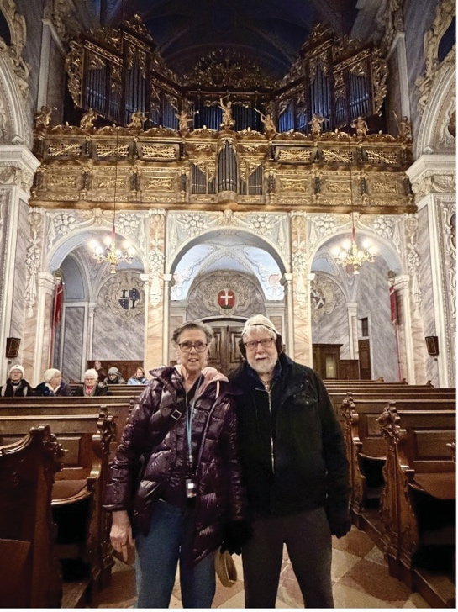
Dan and Dianna Strink, December 2025

Briefly Noted
- Be sure to visit the newly updated State Universities Annuitants Association website at www.SUAA.org

- Take note of purchasing options (and savings) through SUAA purchasing programs: www.suaa.org/savings-discounts

- View a recent interview with Andrew Bodewes, SUAA’s new Contractual Lobbyist: www.youtube.com/ watch?v=6H7Uartrd40

- View a recent Q & A interview with the Illinois House Minority Leader, Rep. Tony McCombie (R): www.youtube.com/ watch?v=0JzeE3PZKfk

- Are you receiving NIU Today news? If not, sign up at enroll.niu.edu

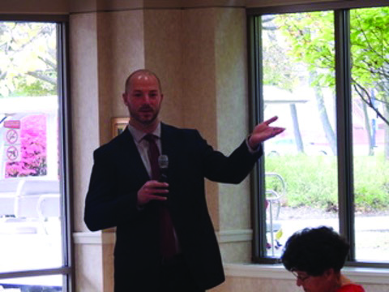

Steve Slocum at NIU Foundation event, October 2025

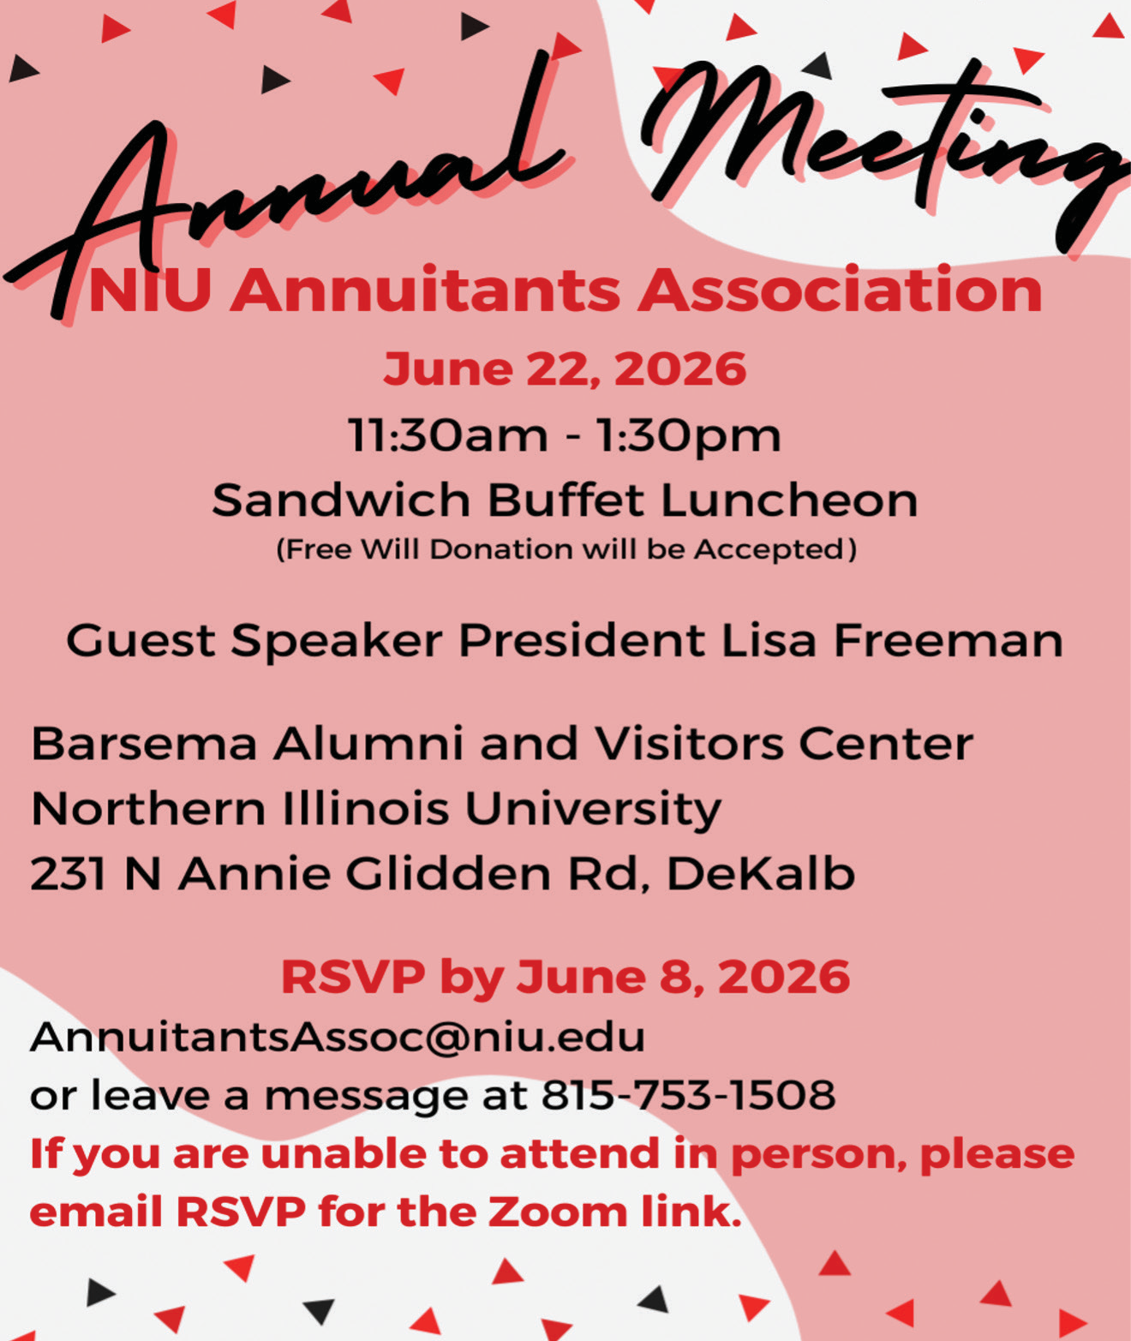

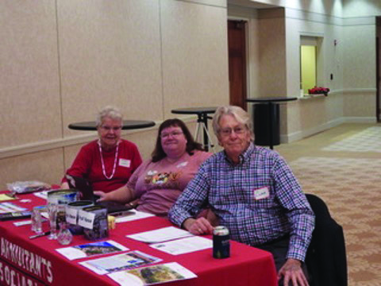
Pat Vary, Chris Doe, & Clair Williams, October 2025

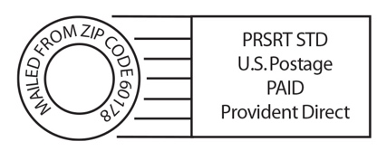
the NIU ANNUITANT
Northern Illinois University Foundation
DeKalb, Illinois 60115-2882

NIUAA 2025-2026 Officers, Directors and Committee Chairs
Please Note: When phone contact is necessary, please call Chris Doe at 815-753-1508 and leave a voicemail. Chris or another officer will make every effort to respond within 48 hours.
Officers | Name | Term | Email Address
President | Terry Borg | 2025-2027 | tborg2@niu.edu
Vice President | Paul Crawford | 2025-2027 | ptcrawford59@gmail.com
Secretary | Pat Wielert | 2025-2027 | pwielert63@gmail.com
Treasurer | Paul Stoddard | 2025-2027 | prs17@yahoo.com
Directors | Name | Term | Email Address
Civil Service | Joanne Dillman | 2025-2027 | jdgazebo@comcast.net
Civil Service | Jay Monteiro | 2024-2026 | jmonteiro@niu.edu
Civil Service | Matt Volk | 2025-2027 | lowes48Fan1@yahoo.com
Civil Service/SPS | Donna Smith | 2025-2027 | deeemms929@gmail.com
Faculty | David Sinason | 2024-2026 | dsinason2@gmail.com
Faculty | Pat Vary | 2025-2027 | patsvary@gmail.com
Faculty | Suzanne Willis | 2025-2027 | uusuzanne@yahoo.com
Past President | Toni Tollerud | 2025-2027 | tonitollerud@gmail.com
Committee Chairs | Name | Term | Email Address
Audit & Finance | David Sinason | 2025-2026 | dsinason2@gmail.com
Awards | TBD
Communication/Newsletter | Jay Monteiro | 2025-2026 | jmonteiro@niu.edu
Culture & Travel | Steven Johnson | 2025-2026 | sjohnso11@niu.edu
Education | Debbie Haliczer | 2025-2026 | dhhaliczer@gmail.com
Legislative | Steve Cunningham | 2025-2026 | cunninghamstevend@gmail.com
Membership | Paul Crawford | 2025-2026 | ptcrawford59@gmail.com
Nomination | Paul Crawford | 2025-2026 | ptcrawford59@gmail.com
Scholarship | Holly Nicholson | 2025-2026 | hnicholson@niu.edu
Social | Pat Vary | 2025-2026 | patsvary@gmail.com
Representatives | Name | Term | Email Address
Campus Parking | Suzanne Willis | 2025-2026 | uusuzanne@yahoo.com
Newsletter Editor | Diane Johns | N/A | ladybugdgj@aol.com
SUAA Foundation | Paul Stoddard | 2025-2026 | prs17@yahoo.com
University Benefits | Debbie Haliczer | 2025-2026 | dhhaliczer@gmail.com
University Liaison | Chris Doe | N/A | annuitantsassoc@niu.edu

