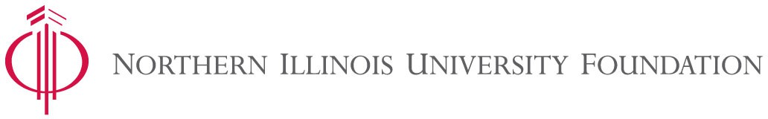

Please print form and mail it with your donation to the address at the bottom of this page. Name:
First Middle Last Maiden Mailing Address:
City State Zip Code
Telephone E-mail address
Spouse’s name:

I am a(n):
Δ
Δ
Δ
Alumnus(a) (grad year ) NIU Parent NIU Faculty/Staff Student Friend Other
Δ
Δ
Δ

Gift Information:
A check for my gift $ is enclosed.
(Check should be made payable to the Northern Illinois University Foundation.)
Please charge my gift of $ to the following credit card: Check one:  VISA MasterCard  Discover American Express
Account Number: Expiration Date:

Signature:

Gift Designation:
Where the need is greatest (Strategic Priorities) The Student Scholarship Fund
Δ
Δ
Δ
Other: _Annuitants Association Scholars
In Memory
Card To:
In Honor Name: Name:
Address:
City, State, Zip:
This Gift is:
Mail Tribute

I am responding to:
A call from the Northern Fund
a letter from the Northern Fund/NIU Annuitants Association
an email from the Northern Fund/NIU Annuitants Association

Please mail this form and your gift to: Northern Illinois University Foundation
P.O. Box 746
DeKalb, IL 60115-0746

