

COMMERCIAL
CARD PROGRAM
ONLINE APPLICATION
Guide for Users
Revised: April 1, 2026

Table of Contents
Purpose 3
Workflow 3
Approvers 3
Applicant 3
Completing the Application 3
Step 1: General Application 4
Step 2: Administrative Information 6
Step 3: Cardholder Acknowledgement 7
Final Submission 8
Approver 1 9
Approving an Application 9
Reviewing an Application 9
Processing an Application 9
Approver 2 11
Approving an Application 11
Reviewing an Application 11
Processing an Application 12

Purpose
This document provides an overview of the Commercial Card Program’s online application, submission, approval, and fulfillment process.

Workflow
Below is the quick overview of the Commercial Card application process.
- Applicant clicks on Application link and completes the application online.
- Applicant submits the completed application to the Approving Manager (Approver 1) for approval. (Must be the cardholder’s direct supervisor or hold a position at a higher level than the cardholder).
- Approving manager (Approver 1) approves it and submits it to Approver 2.
- When the last approver (Approver 2) has approved the application, it is routed to the Program Administrator final review and processing.
- Approved Application is submitted to J.P. Morgan Chase.
- J.P. Morgan Chase creates the cards and sends them to Card Services.
- Card Services notifies applicants of card collection and training.
Approvers
The electronic process requires separate approvers; Approver 1 and Approver 2 must be two different individuals. Below is a chart with examples describing the application workflow for cardholders in varying positions:
Table 1: Roles of the Cardholder, Approver 1 and Approver 2
Cardholder | Approver 1 | Approver 2
Office Manager | Supervisor | Dean or Division Head
Account Tech | Business Manager | Dean or Division Head
Associate Dean | Dean | Division Head
Dean | Provost | Card Services Manager
AVP | VP | Card Services Manager
VP | President | Card Services Manager
The Card Service Manager is currently Antoinette Bridges, abridges3@niu.edu. Applicants and Approvers who are unsure how to route the application should contact Card Services at Cardservices@niu.edu. Deans and Division Heads who wish to designate their approval process to another individual should email Cardservices@niu.edu with the information.

Applicant

Completing the Application
After clicking on the application link on the Card Services website you will be taken directly to the online application. When the application opens in your browser, complete the fields. Required fields are marked with a red asterisk. If there are specific field requirements, additional help text explains how to enter the requested information. 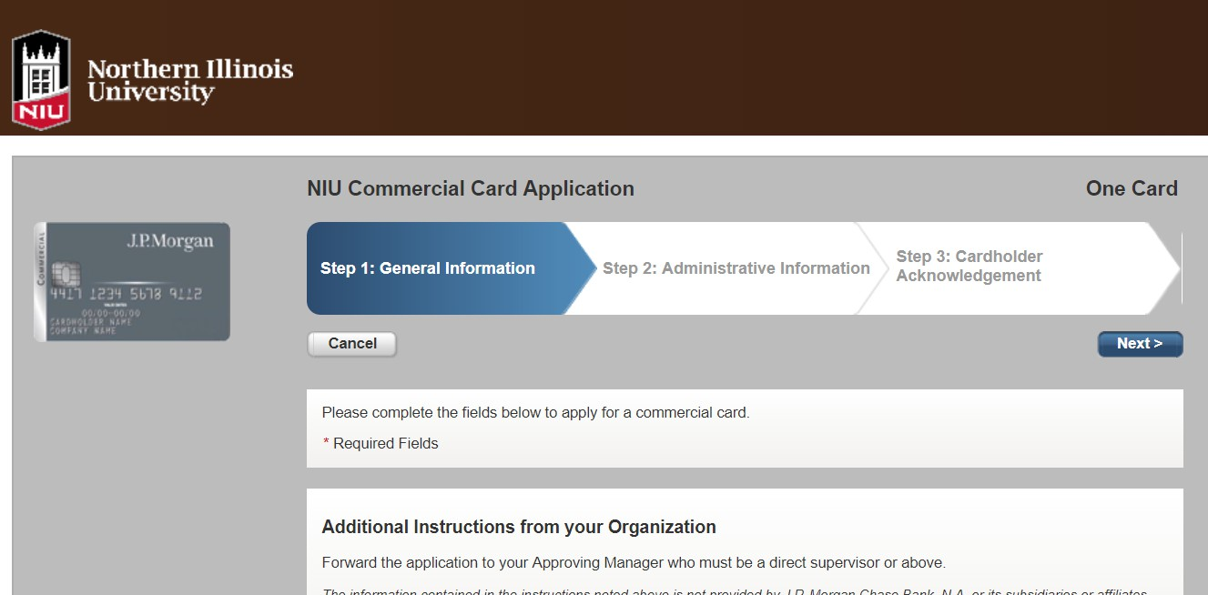

Step 1: General Information
In Step 1: General Information, you provide card type, your name, address, contact information, and other details to ensure the security of your account.

Card Type
The first question in the application is to choose the card type you are applying for. There are two main Commercial card types available.
- One Card Purchasing + Travel (P-Card)
P-Cards are used to acquire items, including travel, which do not have to be purchased with a purchase order through the university’s Procurement Services and Contract Management office (PSCM). A detailed list of allowable, allowable with restrictions (AWR), and prohibited items is located in the Commercial Card Policy which can be found on the NIU Policy Library website.
- One Card Travel only (T-Card)
T-Cards are used to acquire travel-related purchases only. Travel purchases must be made in accordance with the University’s travel policy.
- T-Card for Graduate Assistants
This card is intended for, as the name suggests, Graduate Assistants to use only for Travel purposes and all the travel policies remain the same.
If you would like to apply for the Declining Balance feature to be added to a commercial card, currently it is not available as an online application but can be submitted electronically by submitting the PDF application form available on the Procurement Services and Contract Management website.

Applicant Information
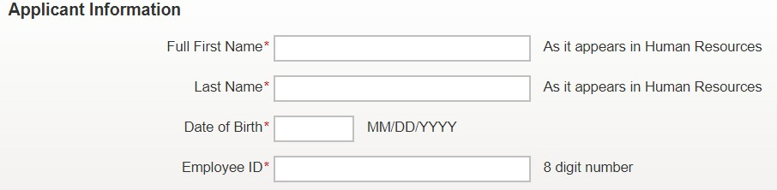
- Full First Name and Last Name — Enter your full, first and last names as it appears in Human resources. The combined number of characters in these fields may not exceed 23 characters.
- Date of Birth — Enter your date of birth in the requested format.
Note: To improve compliance with The Office of Foreign Assets Control (OFAC) of the U.S. Department of the Treasury, the Date of Birth field is mandatory. It is used to verify access to a commercial card as well as validate your identity when you call J.P. Morgan for customer support or use the online tools.
- Employee ID — Enter your 8-digit employee ID, if it is less than 8 digits (i.e. has an ‘A’ preceding it), insert leading zeros to reach 8 digits.

Account Security
The field labels and help text on the application will clarify the information you are expected to provide in the fields below. You cannot enter the same value in both fields.
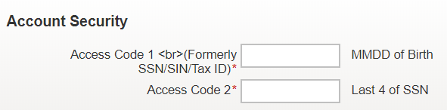
- Access Code 1 — Enter a four-digit security identifier in the format of MMDD of your DOB. Only numeric characters can be entered in this field.
- Access Code 2 — Enter a four-digit numeric identifier (last 4 digits of SSN) for security purposes.

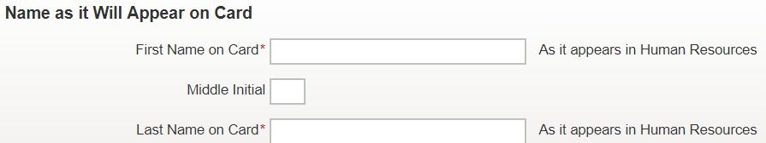
Name as it will appear on card
- First Name on Card, Middle Initial, and Last Name on Card — Enter your first name, middle initial if applicable, and last name exactly as it appears in Human Resources. The combined number of characters in these fields may not exceed 23 characters due to space limitations on the actual card.

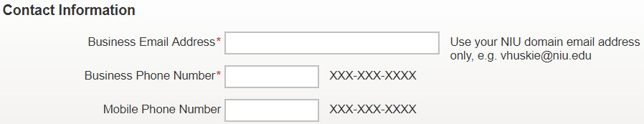
Contact Information
- Business Email Address, Business Phone Number, and Mobile Phone Number — Enter your business email address (Use your NIU domain email address only, e.g. vhuskie@niu.edu), business phone number, and mobile phone number (optional). These fields may be required to ensure appropriate servicing of your account by J.P. Morgan.

Address Information
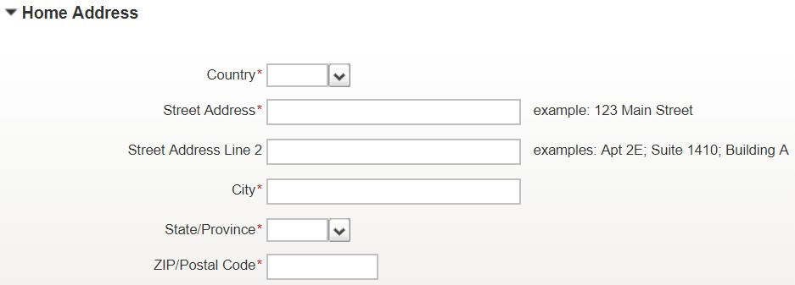
- Home Address — Provide your home address.
Note: To improve compliance with The Office of Foreign Assets Control (OFAC) of the U.S. Department of the Treasury, the Home Address is mandatory. It is used to verify access to a commercial card as well as validate your identity when you call J.P. Morgan for customer support or use the online tools.
When you have provided all the required information in Step 1, click the Next button. You will be asked to verify all the information in Step 1 before you can proceed to Step 2. If necessary, you may return to Step 1 to edit your application and then continue with the application process.

Step 2: Administrative Information
In Step 2: Administrative Information, you provide additional information regarding Cost Center, credit limit etc. You are also required to specify an approver for your application (Must be the cardholder’s direct supervisor or hold a position at a higher level than the cardholder)

Administrative Information
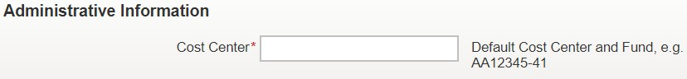
- Cost Center — Provide your default Cost Center and Fund in the specified format only, e.g. AA12345-41. Fund 44 (Grants) may not be used as default

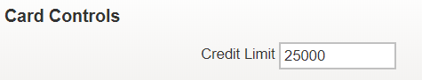
Cost Controls
- Credit Limit — This is the Maximum allowed Credit Limit, you can lower it to any required amount. Please note that your Approving Manager or Dean/Division head can also change this during approval.

Approval
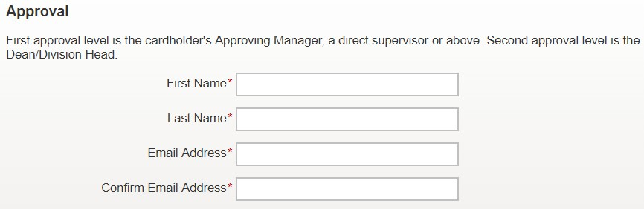
- First Name and Last Name — Enter the First and Last name of your approving manager
- Email Address — Enter the email address of your Approving Manager (Must be the cardholder’s direct supervisor or hold a position at a higher level than the cardholder) and only email addresses with @niu.edu domain can be entered.

Comments
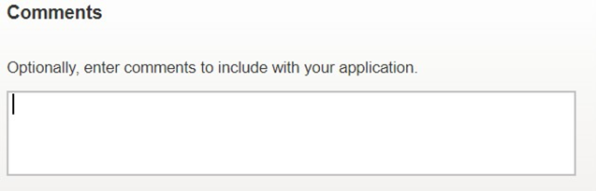
If you like, you can enter comments related to your application. Comments are optional and will be visible to all approvers who review your application and to your Program Administrator.
When you have provided all the required information in Step 2, click the Next button. You will be asked to verify all the information in Step 2 before you can proceed to Step 3. If necessary, you may return to Step 2 to edit your application and then continue with the application process.
Note: If any data fields are incomplete or have invalid entries, a red bar with an error message will appear at the top of the screen. Hover your cursor over the red exclamation mark to view the reason for the error, then make the necessary corrections. You must correct all errors before you can successfully submit your application.

Step 3: Cardholder Acknowledgement
In Step 3: Cardholder Acknowledgement, you must review and accept the cardholder acknowledgements that appear.
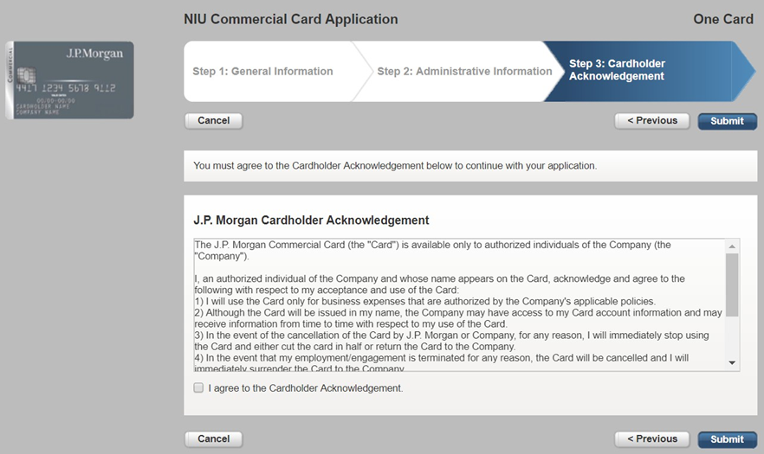
J.P. Morgan Cardholder Acknowledgement — You will be prompted to review and accept the J.P. Morgan Cardholder Acknowledgement. You must agree to the terms by clicking the box.
Once you have completed Step 3, you can click the Previous button to return to previous steps of the application and make any necessary edits. When your application is complete, click the Submit button.

Final Submission
After you complete Step 3, a screen confirming the successful submission of your application will appear and you can then exit out of system.
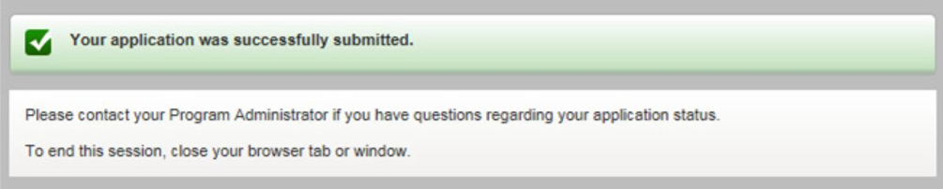
You will also receive an email confirming your submission.
As your application moves through the approval workflow process, you will receive additional emails alerting you of its progress. These emails will have the following subject lines:
- Application Approved — Your application has been approved and now awaits final signoff by your Program Administrator.
- Card Account Processing — Your Program Administrator has completed the final approval step and processing of your card will begin.
- Application Rejected — Your application has been rejected by the approver for the reason stated in the email. You will need to submit a new application. If you need more information, contact your Program Administrator.

Approver 1

Approving an Application
When an employee submits an application for a commercial card through the system to Approver 1, an email notification (from no.replies@paymentnet.jpmorgan.com) along with a link to the application is sent to the approver. An example of the email notification is shown in the following figure.
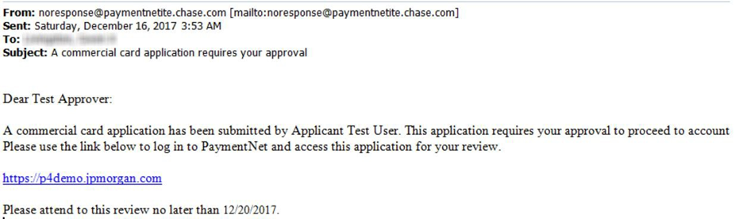

Reviewing an Application
Click the link contained in the email or copy and paste the link into a browser window to open the application. While reviewing the application, you can contribute information in the fields as necessary. Required fields will be identified by a red asterisk and will only appear in the Approval section if they are required for your review, e.g. Credit Limit. You can change the Credit Limit to any amount less than the maximum allowed $25,000.
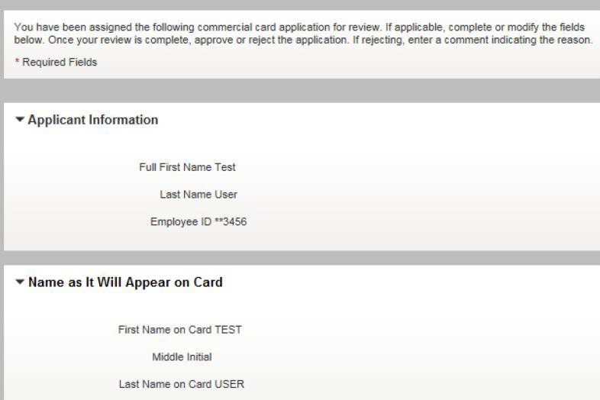

Processing an Application
Once your review is complete, you can take one of the following actions:
- Assign the next approver (Approver 2).
- Approve the application.
- Reject the application.
For additional support resources, or if you have any questions about the approval process for a commercial card application, please contact your Program Administrator.

Next Approval
The Next Approval section will appear only if you are the level 1 approver. If this section appears for you, you need to direct applications to the next approver (Approver 2) by entering the approver’s email address.
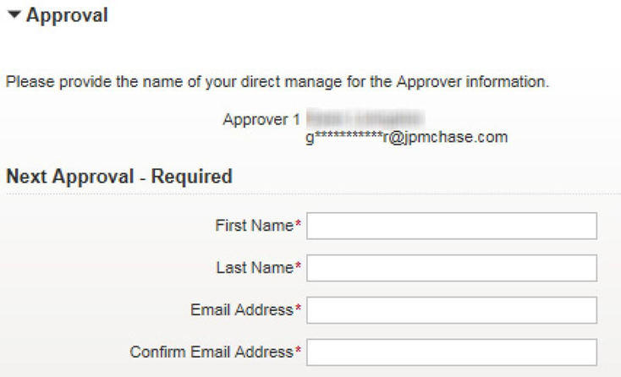

Approving an Application
After reviewing the application, if you determine that the information is accurate, click the Approve button. The application will be routed to the next approver (Approver 2).
You can also enter comments in the New Comment field. These comments will be visible to the subsequent approvers (if any) and the Program Administrator.
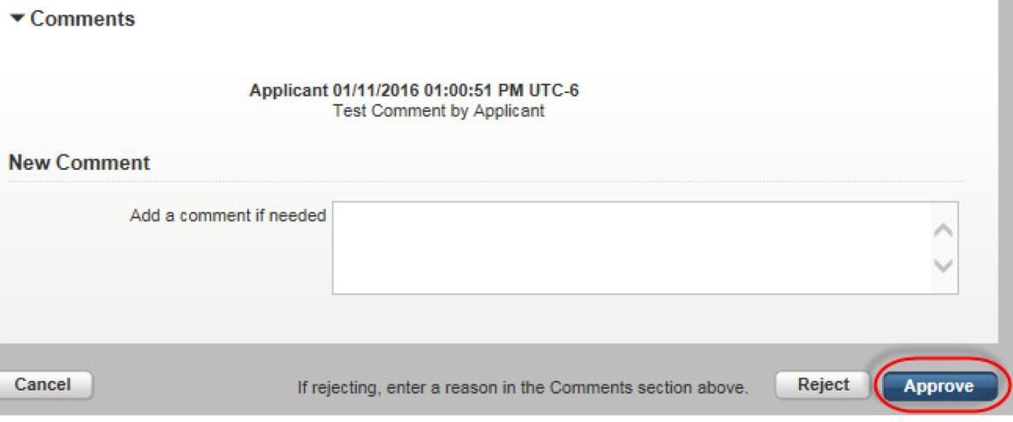

Rejecting an Application
After reviewing the application, if you determine that there are issues with it, click the Reject button. You will see a message confirming that the application has been rejected.
You are required to add an explanation in the New Comment field when you reject an application. If you do not add a comment, you will be prompted to do so with an alert message at the top of the screen.
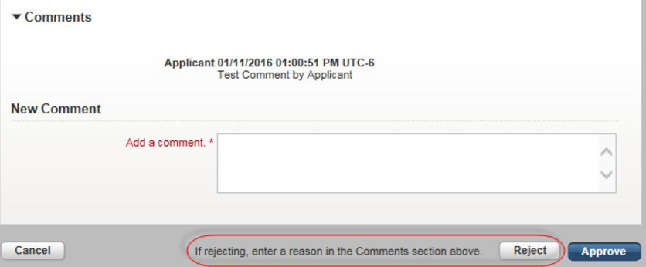
After rejecting the application, the applicant will receive an email notification and will need to reapply if a card is still desired.

Approver 2

Approving an Application
When a second level approver (Approver 2) is assigned by the approving manager (Approver 1), an email notification (from no.replies@paymentnet.jpmorgan.com) along with a link to the application is sent to the approver. An example of the email notification is shown in the following figure.

Reviewing an Application
Click the link contained in the email or copy and paste the link into a browser window to open the application. While reviewing the application, you can contribute information in the fields as necessary. Required fields will be identified by a red asterisk and will only appear in the Approval section if they are required for your review, e.g. Credit Limit. You can change the Credit Limit to any amount less than the maximum allowed $25,000.
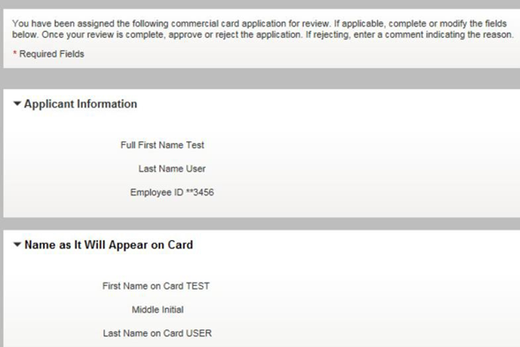

Processing an Application
Once your review is complete, you can take one of the following actions:
- Approve the application.
- Reject the application.
For additional support resources, or if you have any questions about the approval process for a commercial card application, please contact your Program Administrator.

Approving an Application
After reviewing the application, if you determine that the information is accurate, click the Approve button. The application will be routed to Program Administrator for final authorization.
You can also enter comments in the New Comment field. These comments will be visible to the subsequent approvers (if any) and the Program Administrator.
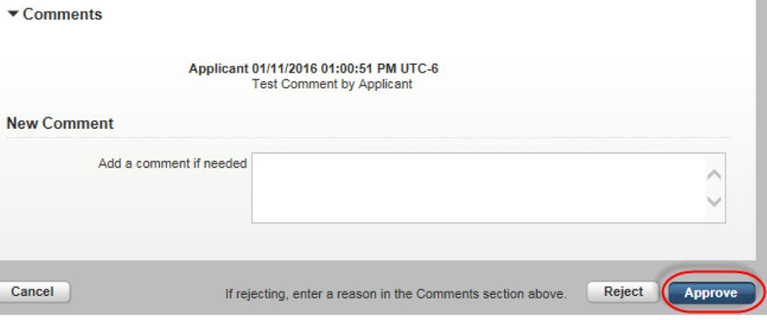

Rejecting an Application
After reviewing the application, if you determine that there are issues with it, click the Reject button. You will see a message confirming that the application has been rejected.
You are required to add an explanation in the New Comment field when you reject an application. If you do not add a comment, you will be prompted to do so with an alert message at the top of the screen.
After rejecting the application, the applicant will receive an email notification and will need to reapply if a card is still desired.

