Microsoft Windows
Instructions for printing a document using PaperCut
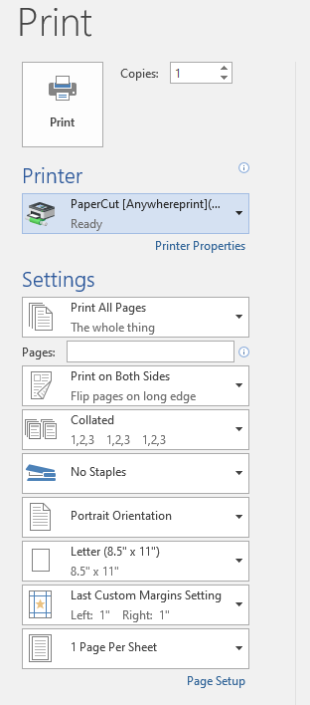
- Select the printer – PaperCut [Anywhereprint](Mobility)

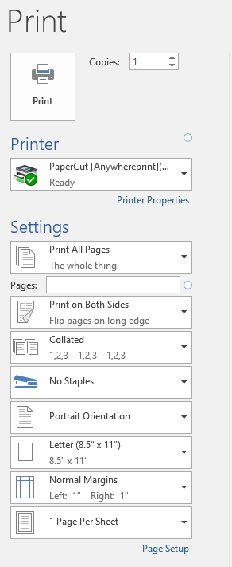
2. Select Print

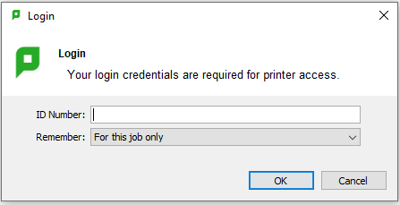
- Enter_user ID - this would be your AID. (Typically begins with an “A” or “el0”)

- Select your Charge to Account - My Personal Account or Dept Account
5. Select Print
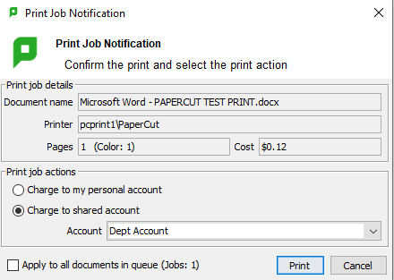

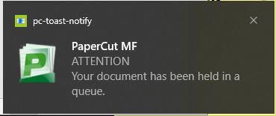
6. Screen notification of pending document ready for release at an AWP printer

